The Fourth Sunday in Lent
March 19, 2023

Communion Announcement
The Lord’s Supper is celebrated at this congregation in the confession and glad confidence that, as our Lord says, He gives into our mouths not only bread and wine but His very body and blood to eat and to drink for the forgiveness of sins and to strengthen our union with Him and with one another. Our Lord invites to His table those who trust His Words, repent of all sins, and set aside any refusal to forgive and love as He forgives and loves us, that they may show forth His death until He comes.
Holy Communion is a confession of the faith which is confessed at this altar, any who are not yet instructed, in doubt, or who hold a confession differing from that of this congregation and the Lutheran Church – Missouri Synod, are asked to first speak with the pastor before communing.

To aid in your preparation for the Lord’s Supper, please pause to consider Dr. Martin Luther’s “Christian Questions with their Answers.”

- I confess that I have sinned, as I examined myself according to the Ten Commandments.
- I understand that if I have offended another person, I should seek reconciliation and then come to the Lord’s altar.
- I believe that in this Sacrament, Jesus offers me His true body and blood, under the bread and wine, for us Christians to eat and drink.
- I believe that in this Sacrament, forgiveness of sin, life, and salvation are offered to me in Christ’s promise: “Given and shed for you for the remission of sins.”
- By communing I bear witness to the unity of faith which I have with my fellow communicants.
- I shall, with the aid of God the Holy Spirit, seek to change my sinful life and serve my Savior.

411 I Want to Walk as a Child of the Light
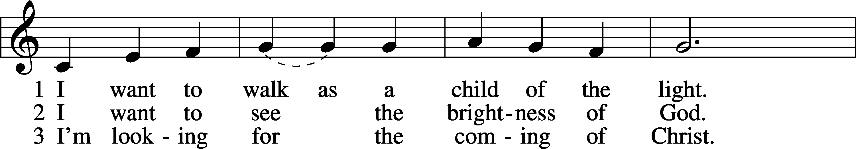
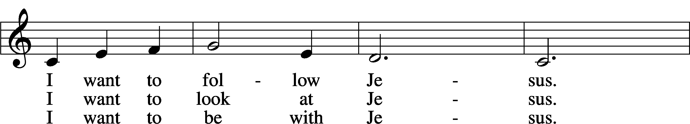
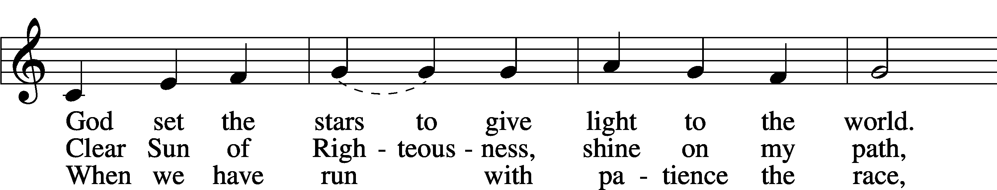
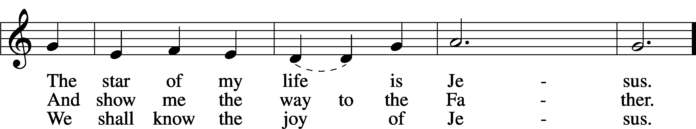
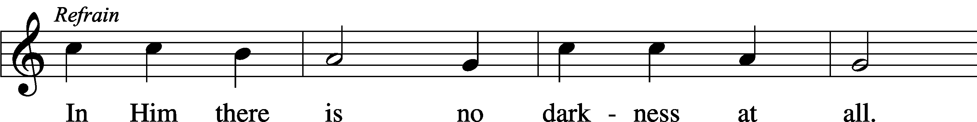
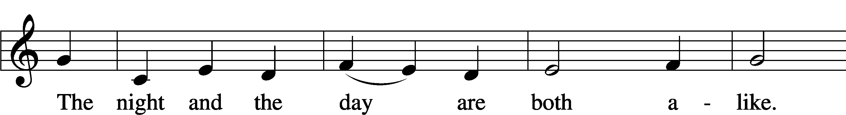
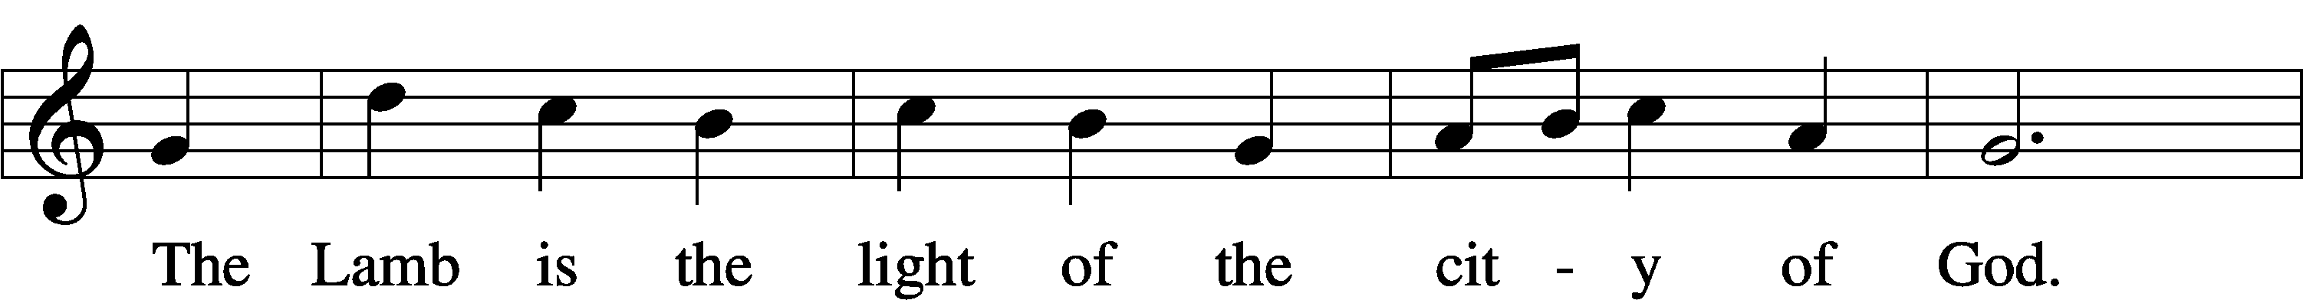
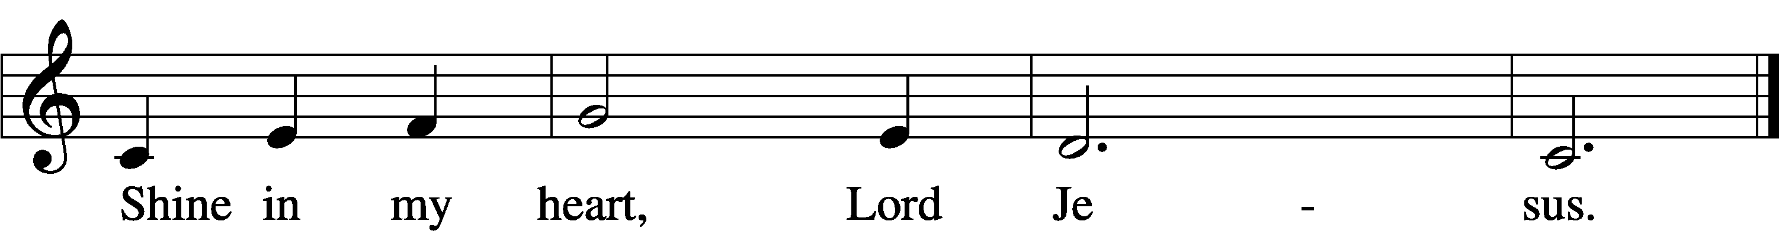
Text and tune: Kathleen Thomerson, 1934
Text and tune: © 1970, 1975 Celebration. Used by permission: LSB Hymn License no. 110004388

P In the name of the Father and of the T Son and of the Holy Spirit.
C Amen.

P Beloved in the Lord! Let us draw near with a true heart and confess our sins unto God our Father, beseeching Him in the name of our Lord Jesus Christ to grant us forgiveness.

P Our help is in the name of the Lord,
C who made heaven and earth.
P I said, I will confess my transgressions unto the Lord,
C and You forgave the iniquity of my sin.

P O almighty God, merciful Father,
C I, a poor, miserable sinner, confess unto You all my sins and iniquities with which I have ever offended You and justly deserved Your temporal and eternal punishment. But I am heartily sorry for them and sincerely repent of them, and I pray You of Your boundless mercy and for the sake of the holy, innocent, bitter sufferings and death of Your beloved Son, Jesus Christ, to be gracious and merciful to me, a poor, sinful being.

P Upon this your confession, I, by virtue of my office, as a called and ordained servant of the Word, announce the grace of God unto all of you, and in the stead and by the command of my Lord Jesus Christ I forgive you all your sins in the name of the Father and of the T Son and of the Holy Spirit.
C Amen.

Service of the Word

Introit Psalm 27:4–6; antiphon: Psalm 25:15
My eyes are ever toward the Lord,
for he will pluck my feet out of the net.
One thing have I asked of the Lord, that will I seek after:
that I may dwell in the house of the Lord all the days of my life, to gaze upon the beauty of the Lord and to inquire in his temple.
For he will hide me in his shelter in the day of trouble;
he will conceal me under the cover of his tent; he will lift me high upon a rock.
And now my head shall be lifted up above my enemies all around me, and I will offer in his tent sacrifices with shouts of joy;
I will sing and make melody to the Lord.
Glory be to the Father and to the Son
and to the Holy Spirit;
as it was in the beginning,
is now, and will be forever. Amen.
My eyes are ever toward the Lord,
for he will pluck my feet out of the net.
Kyrie LSB 186
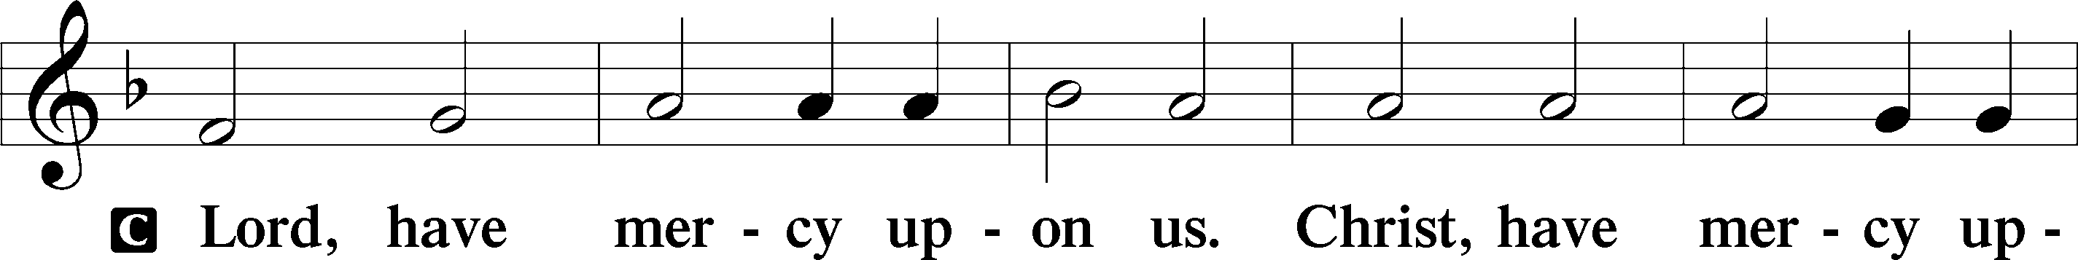
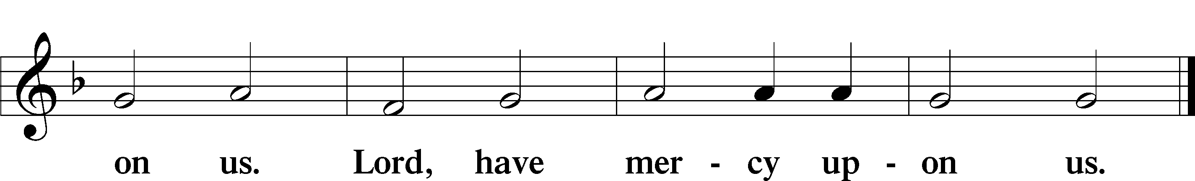

Salutation and Collect of the Day
P The Lord be with you.
C And with thy spirit.

P Let us pray.
Almighty God, our heavenly Father, Your mercies are new every morning; and though we deserve only punishment, You receive us as Your children and provide for all our needs of body and soul. Grant that we may heartily acknowledge Your merciful goodness, give thanks for all Your benefits, and serve You in willing obedience; through Jesus Christ, Your Son, our Lord, who lives and reigns with You and the Holy Spirit, one God, now and forever.

C Amen.

Old Testament Reading Isaiah 42:14–21
14For a long time I have held my peace;
I have kept still and restrained myself;
now I will cry out like a woman in labor;
I will gasp and pant.
15I will lay waste mountains and hills,
and dry up all their vegetation;
I will turn the rivers into islands,
and dry up the pools.
16And I will lead the blind
in a way that they do not know,
in paths that they have not known
I will guide them.
I will turn the darkness before them into light,
the rough places into level ground.
These are the things I do,
and I do not forsake them.
17They are turned back and utterly put to shame,
who trust in carved idols,
who say to metal images,
“You are our gods.”
18Hear, you deaf,
and look, you blind, that you may see!
19Who is blind but my servant,
or deaf as my messenger whom I send?
Who is blind as my dedicated one,
or blind as the servant of the Lord?
20He sees many things, but does not observe them;
his ears are open, but he does not hear.
21The Lord was pleased, for his righteousness’ sake,
to magnify his law and make it glorious.

A This is the Word of the Lord.
C Thanks be to God.

Epistle Ephesians 5:8–14
8For at one time you were darkness, but now you are light in the Lord. Walk as children of light 9(for the fruit of light is found in all that is good and right and true), 10and try to discern what is pleasing to the Lord. 11Take no part in the unfruitful works of darkness, but instead expose them. 12For it is shameful even to speak of the things that they do in secret. 13But when anything is exposed by the light, it becomes visible, 14for anything that becomes visible is light. Therefore it says,
“Awake, O sleeper,
and arise from the dead,
and Christ will shine on you.”

A This is the Word of the Lord.
C Thanks be to God.

Holy Gospel John 9:1–7, 13–17, 34–39
P The Holy Gospel according to St. John, the ninth chapter.
C Glory be to Thee, O Lord.

1As [Jesus] passed by, he saw a man blind from birth. 2And his disciples asked him, “Rabbi, who sinned, this man or his parents, that he was born blind?” 3Jesus answered, “It was not that this man sinned, or his parents, but that the works of God might be displayed in him. 4We must work the works of him who sent me while it is day; night is coming, when no one can work. 5As long as I am in the world, I am the light of the world.” 6Having said these things, he spat on the ground and made mud with the saliva. Then he anointed the man’s eyes with the mud 7and said to him, “Go, wash in the pool of Siloam” (which means Sent). So he went and washed and came back seeing. . . .
13They brought to the Pharisees the man who had formerly been blind. 14Now it was a Sabbath day when Jesus made the mud and opened his eyes. 15So the Pharisees again asked him how he had received his sight. And he said to them, “He put mud on my eyes, and I washed, and I see.” 16Some of the Pharisees said, “This man is not from God, for he does not keep the Sabbath.” But others said, “How can a man who is a sinner do such signs?” And there was a division among them. 17So they said again to the blind man, “What do you say about him, since he has opened your eyes?” He said, “He is a prophet.” . . .
34They answered him, “You were born in utter sin, and would you teach us?” And they cast him out.
35Jesus heard that they had cast him out, and having found him he said, “Do you believe in the Son of Man?” 36He answered, “And who is he, sir, that I may believe in him?” 37Jesus said to him, “You have seen him, and it is he who is speaking to you.” 38He said, “Lord, I believe,” and he worshiped him. 39Jesus said, “For judgment I came into this world, that those who do not see may see, and those who see may become blind.”

P This is the Gospel of the Lord.
C Praise be to Thee, O Christ.

Nicene Creed
C I believe in one God, the Father Almighty, maker of heaven and earth and of all things visible and invisible.

And in one Lord Jesus Christ, the only-begotten Son of God, begotten of His Father before all worlds, God of God, Light of Light, very God of very God, begotten, not made, being of one substance with the Father, by whom all things were made; who for us men and for our salvation came down from heaven and was incarnate by the Holy Spirit of the virgin Mary and was made man; and was crucified also for us under Pontius Pilate. He suffered and was buried. And the third day He rose again according to the Scriptures and ascended into heaven and sits at the right hand of the Father. And He will come again with glory to judge both the living and the dead, whose kingdom will have no end.

And I believe in the Holy Spirit, the Lord and giver of life, who proceeds from the Father and the Son, who with the Father and the Son together is worshiped and glorified, who spoke by the prophets. And I believe in one holy Christian and apostolic Church, I acknowledge one Baptism for the remission of sins, and I look for the resurrection of the dead and the life T of the world to come. Amen.
697 Awake, O Sleeper, Rise from Death
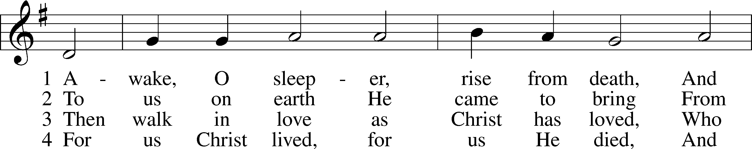
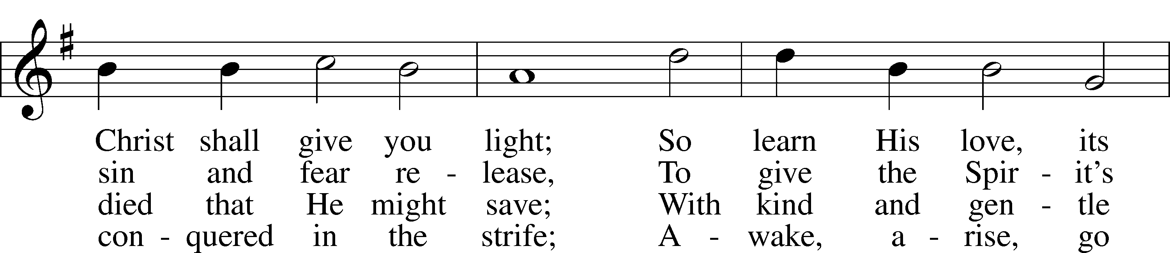
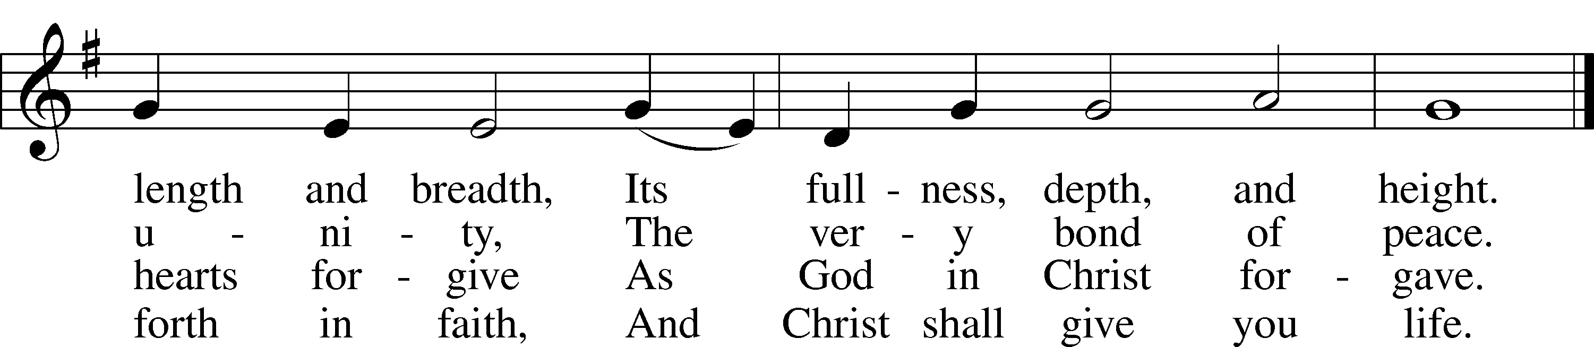
Text: F. Bland Tucker, 1895–1984
Tune: Carl G. Gläser, 1784–1829
Text: © 1980 Augsburg Publishing House. Used by permission: LSB Hymn License no. 110004388
Tune: Public domain

Sermon: “No Longer Blind and Deaf” Isaiah 42:14-21

Offering

Offertory LSB 192
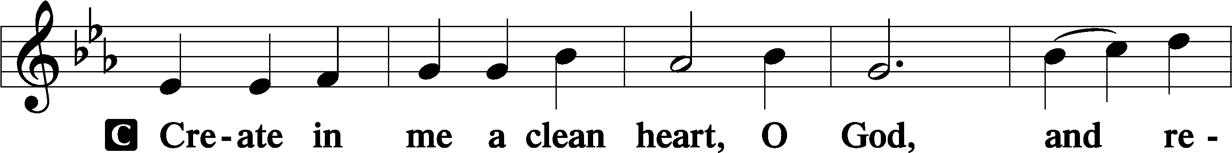
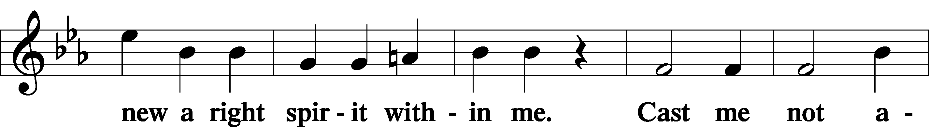
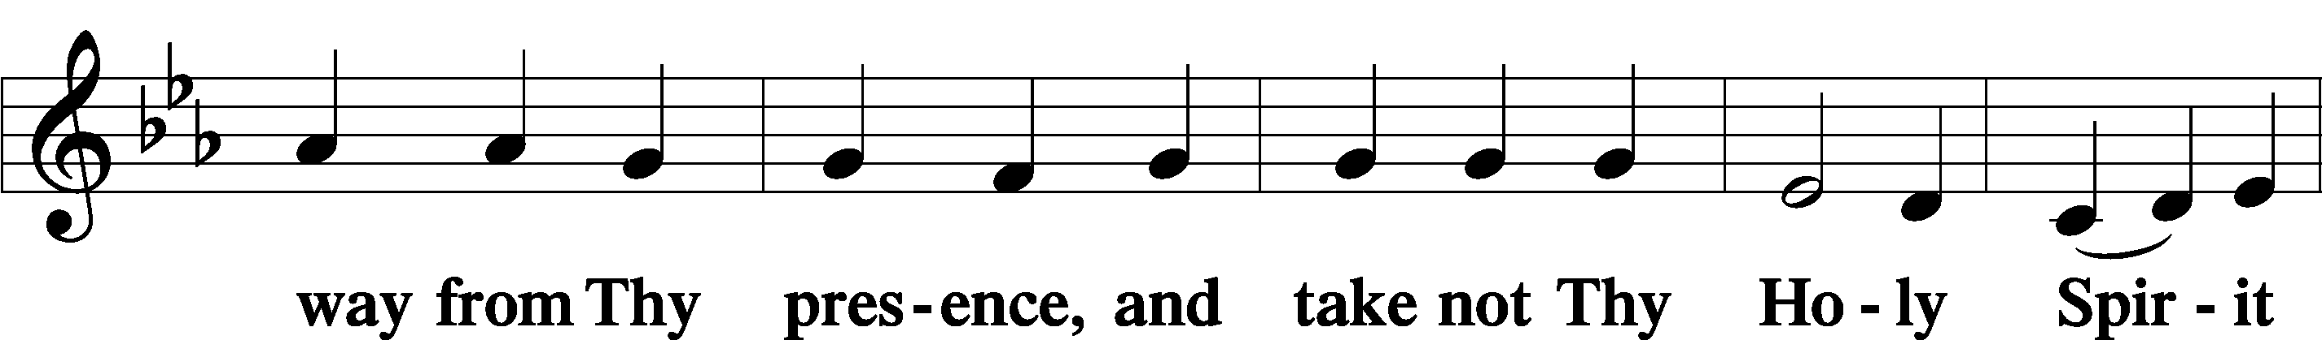
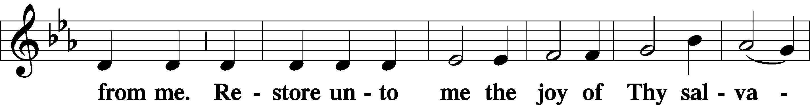
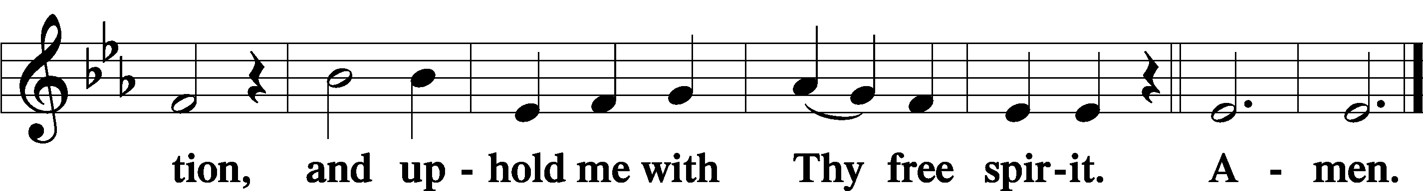

Prayer of the Church

Service of the Sacrament

Preface LSB 194
P The Lord be with you.

P Lift up your hearts.
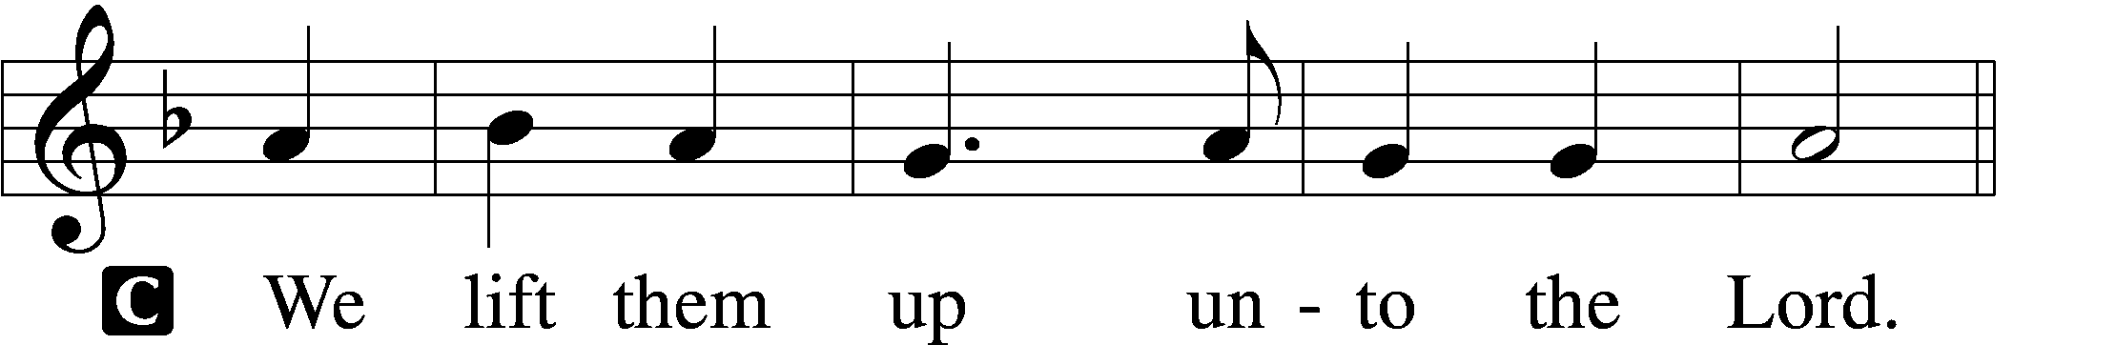

P Let us give thanks unto the Lord, our God.
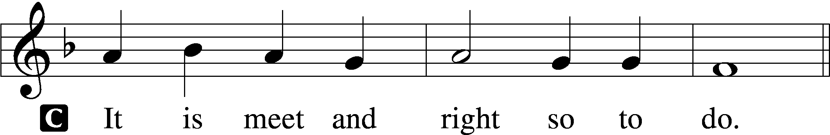

P It is truly meet, right, and salutary that we should at all times and in all places give thanks to You, holy Lord, almighty Father, everlasting God, through Jesus Christ, our Lord, who overcame the assaults of the devil and gave His life as a ransom for many that with cleansed hearts we might be prepared joyfully to celebrate the paschal feast in sincerity and truth. Therefore with angels and archangels and with all the company of heaven we laud and magnify Your glorious name, evermore praising You and saying:

Sanctus LSB 195
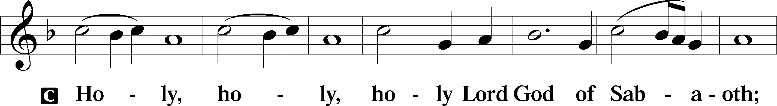
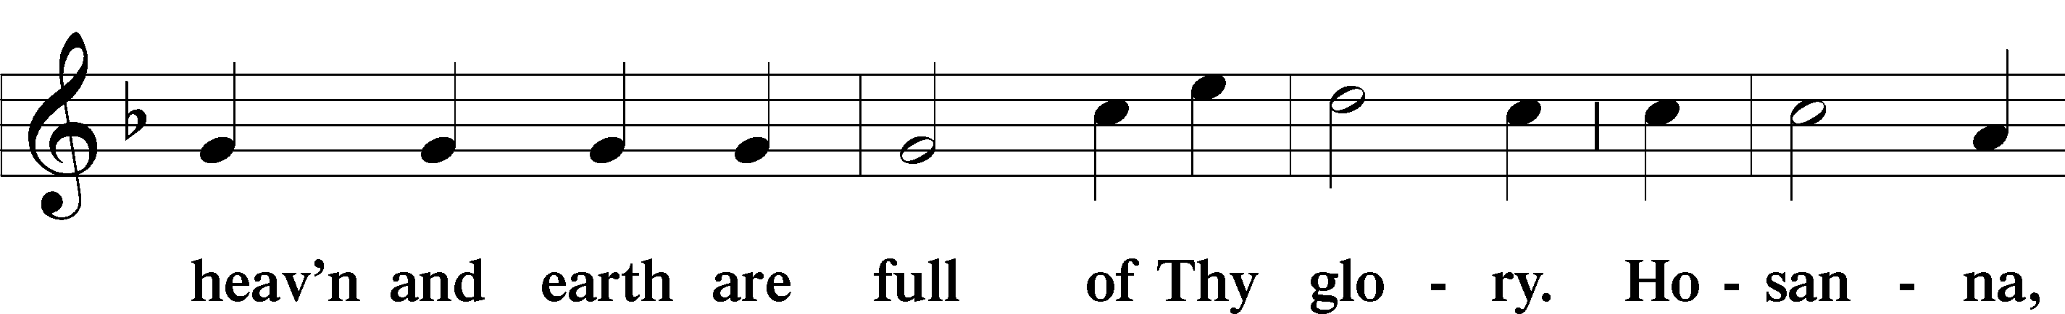
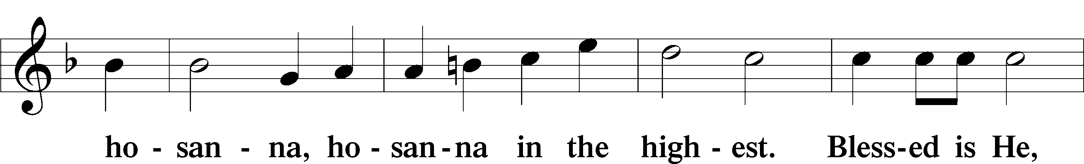
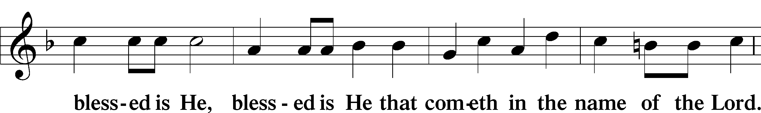
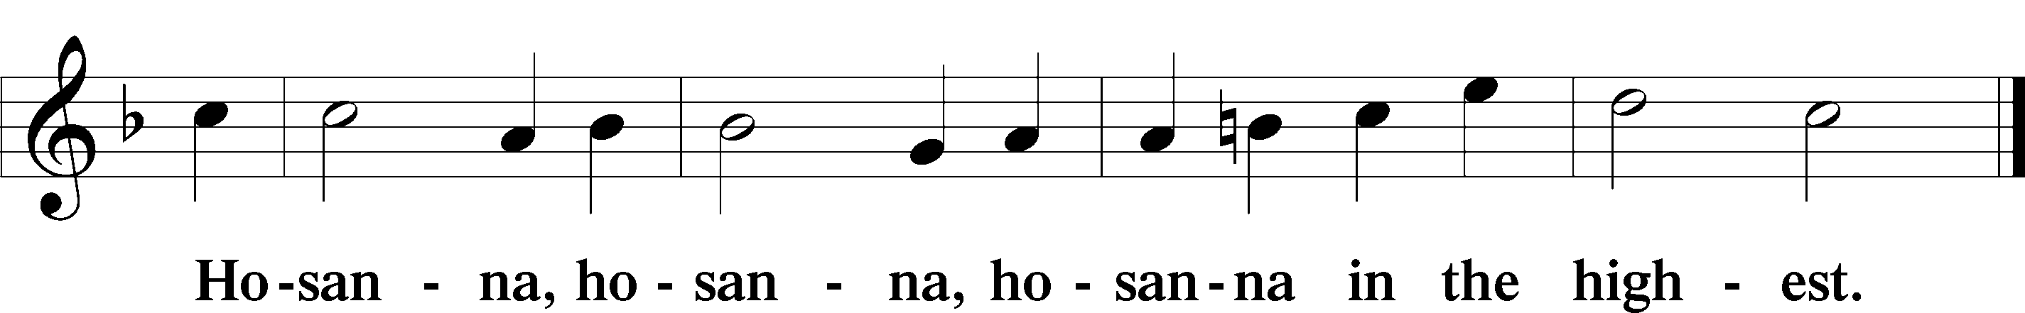

Lord’s Prayer LSB 196
P Our Father who art in heaven,
hallowed be Thy name,
Thy kingdom come,
Thy will be done on earth as it is in heaven;
give us this day our daily bread;
and forgive us our trespasses as we forgive those who trespass against us;
and lead us not into temptation,
but deliver us from evil.
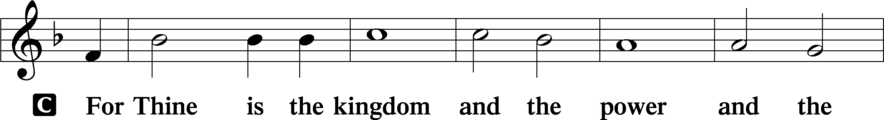
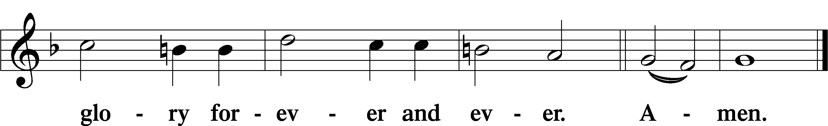
The Words of Our Lord LSB 197
P Our Lord Jesus Christ, on the night when He was betrayed, took bread, and when He had given thanks, He broke it and gave it to the disciples and said: “Take, eat; this is My T body, which is given for you. This do in remembrance of Me.”

In the same way also He took the cup after supper, and when He had given thanks, He gave it to them, saying: “Drink of it, all of you; this cup is the new testament in My T blood, which is shed for you for the forgiveness of sins. This do, as often as you drink it, in remembrance of Me.”

Pax Domini LSB 197
P The peace of the Lord be with you always.

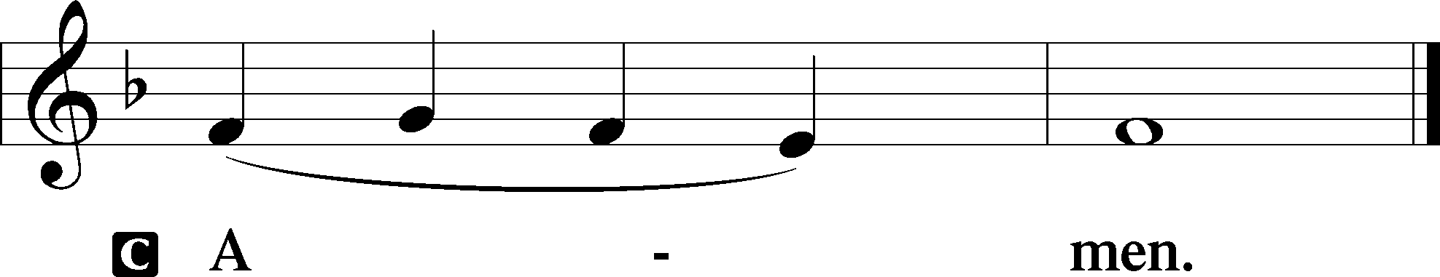

Agnus Dei LSB 198
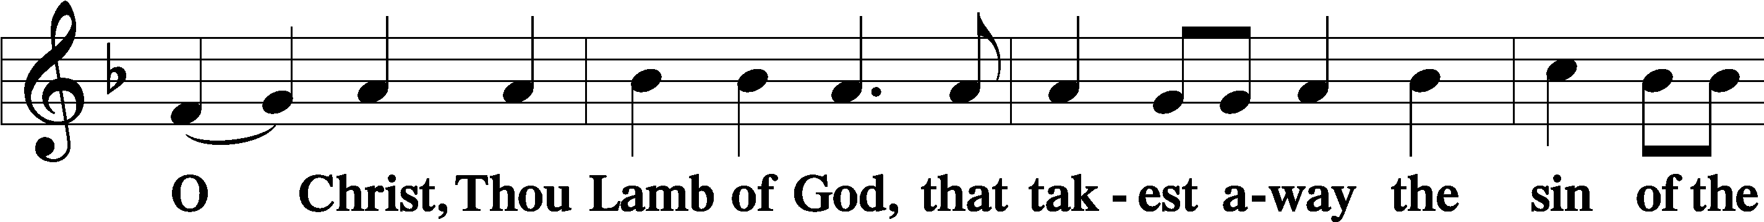
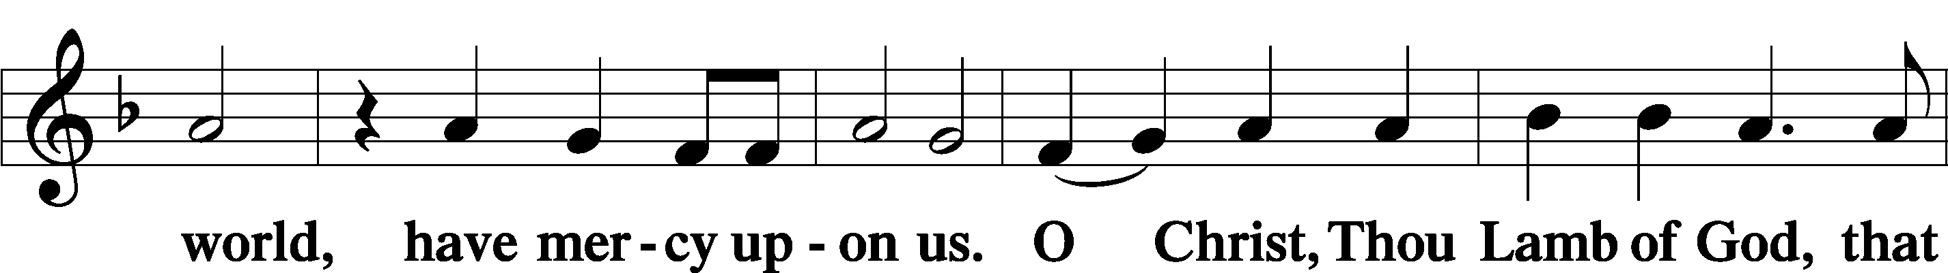
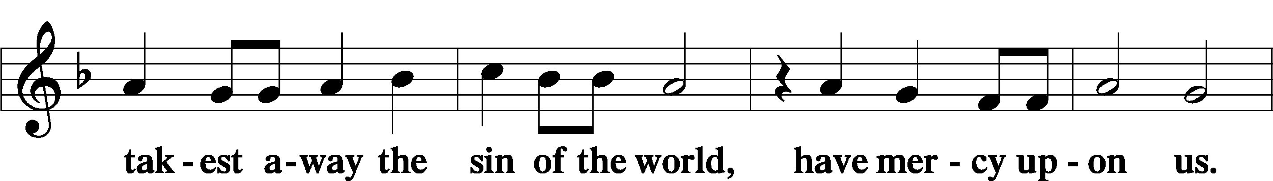
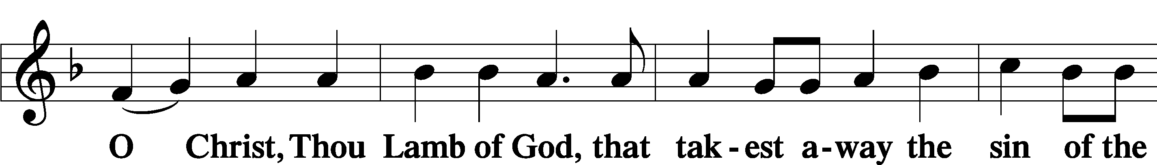
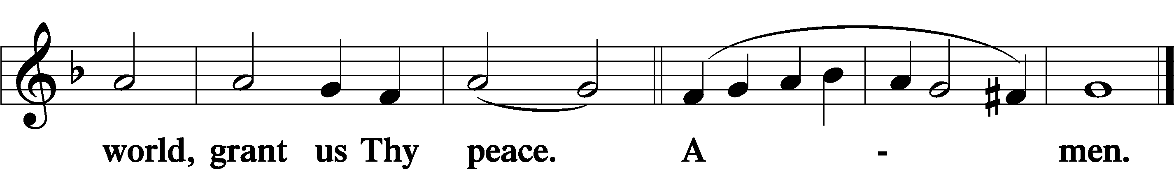

Distribution

537 Beautiful Savior
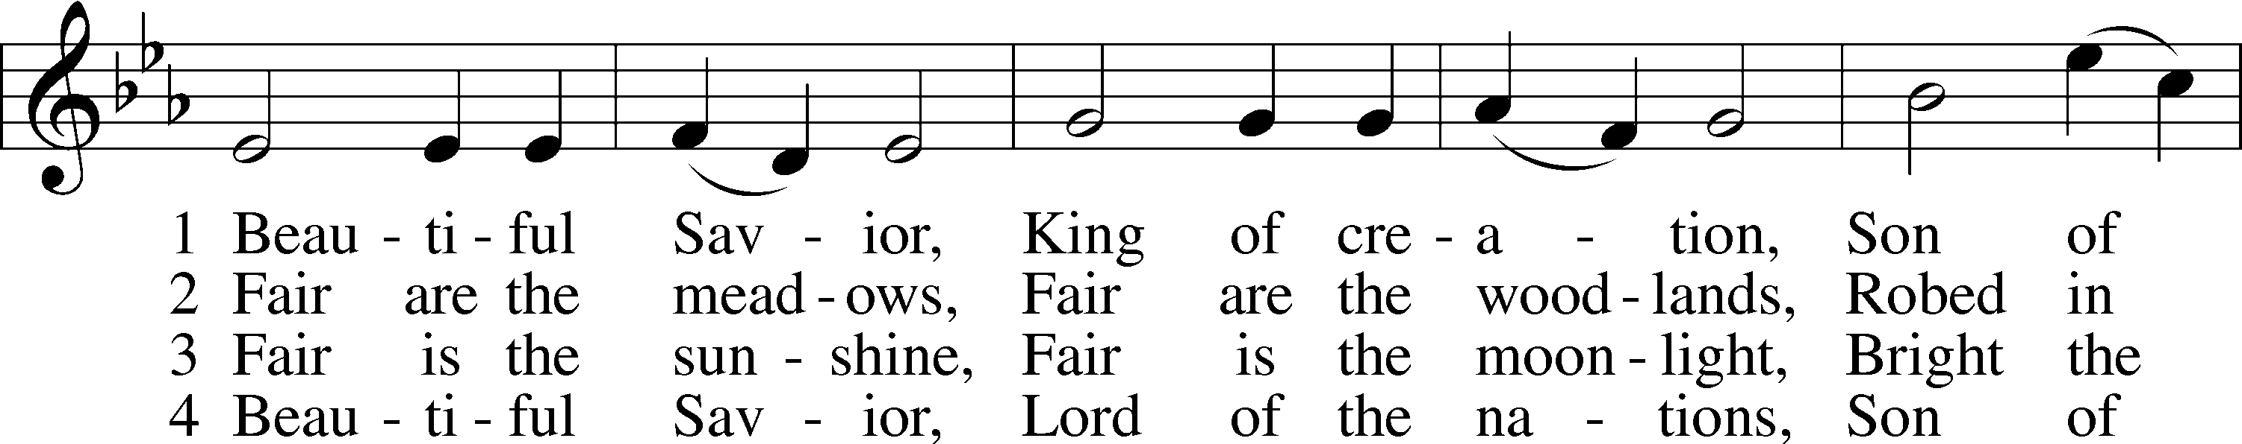
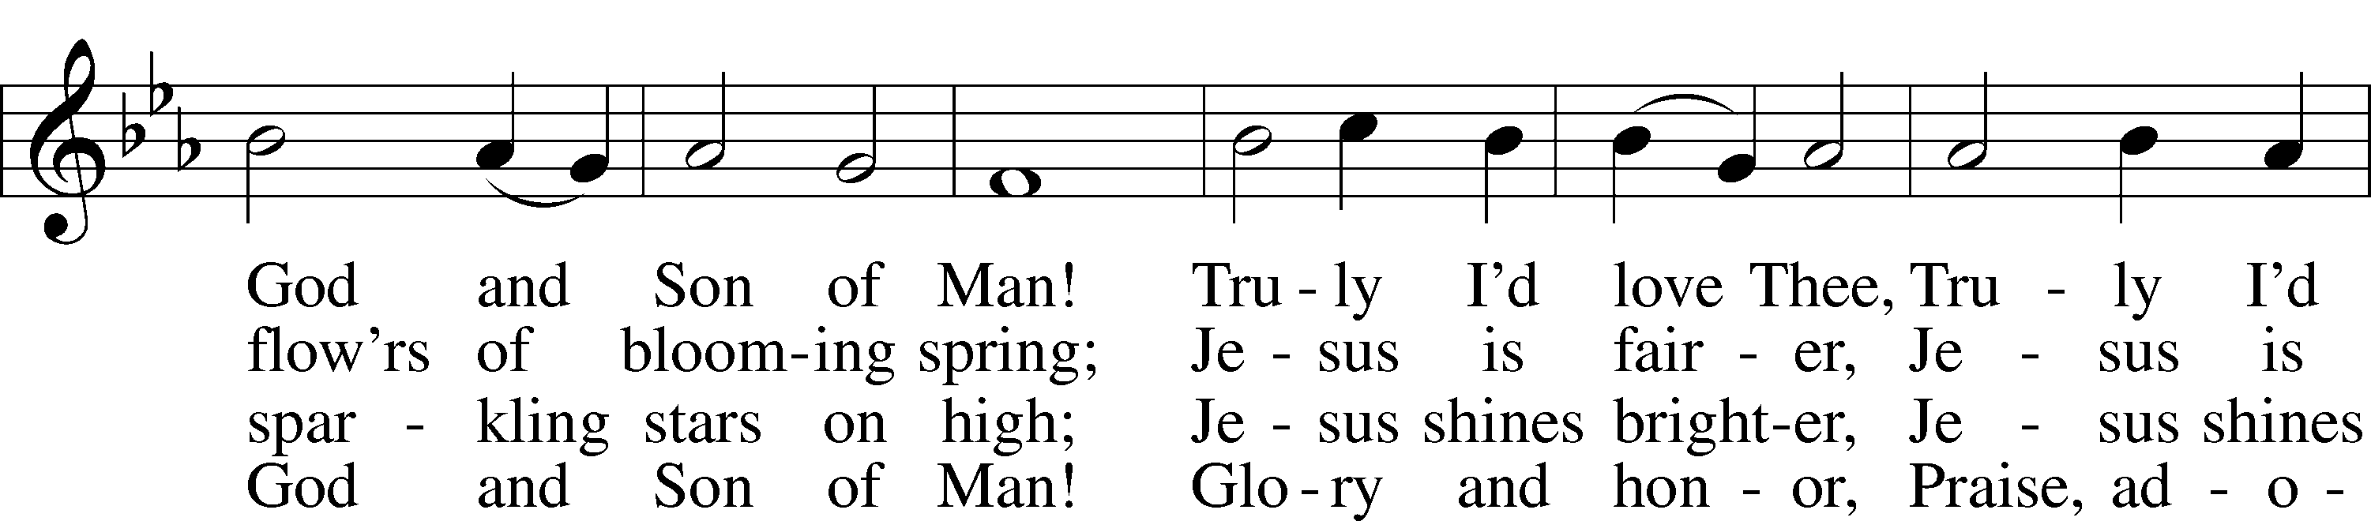
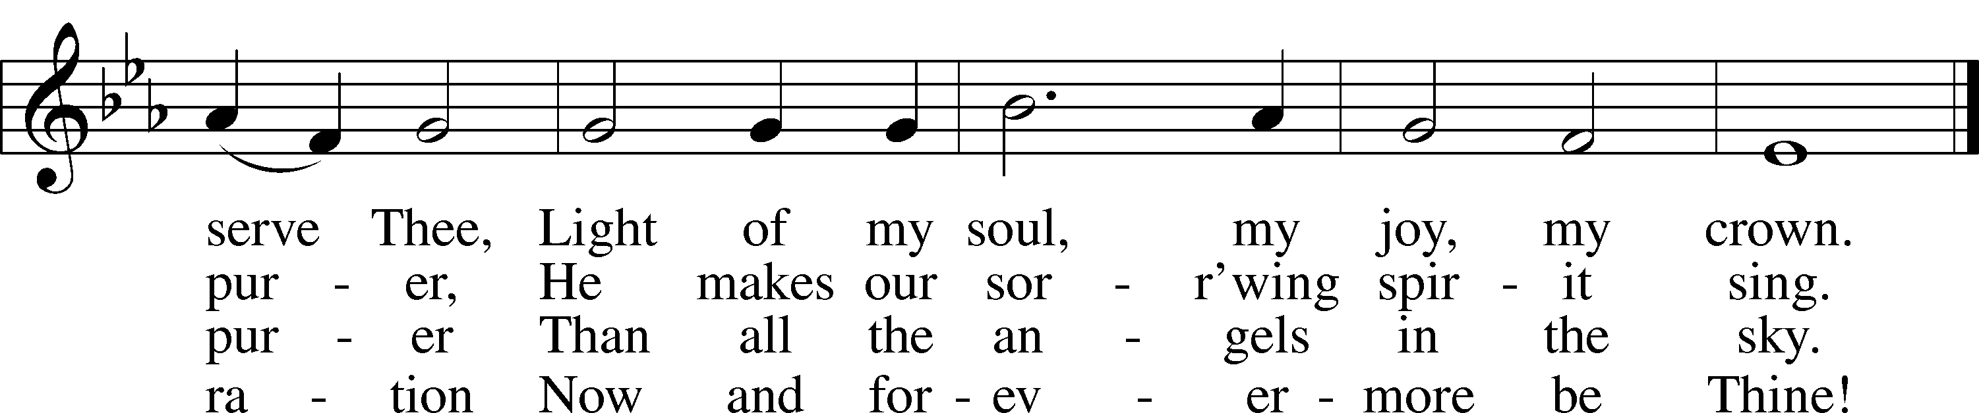
Text: Münsterisch Gesangbuch, 1677, Münster; tr. Joseph A. Seiss, 1823–1904
Tune: Silesian, 19th cent.
Text and tune: Public domain

646 Church of God, Elect and Glorious
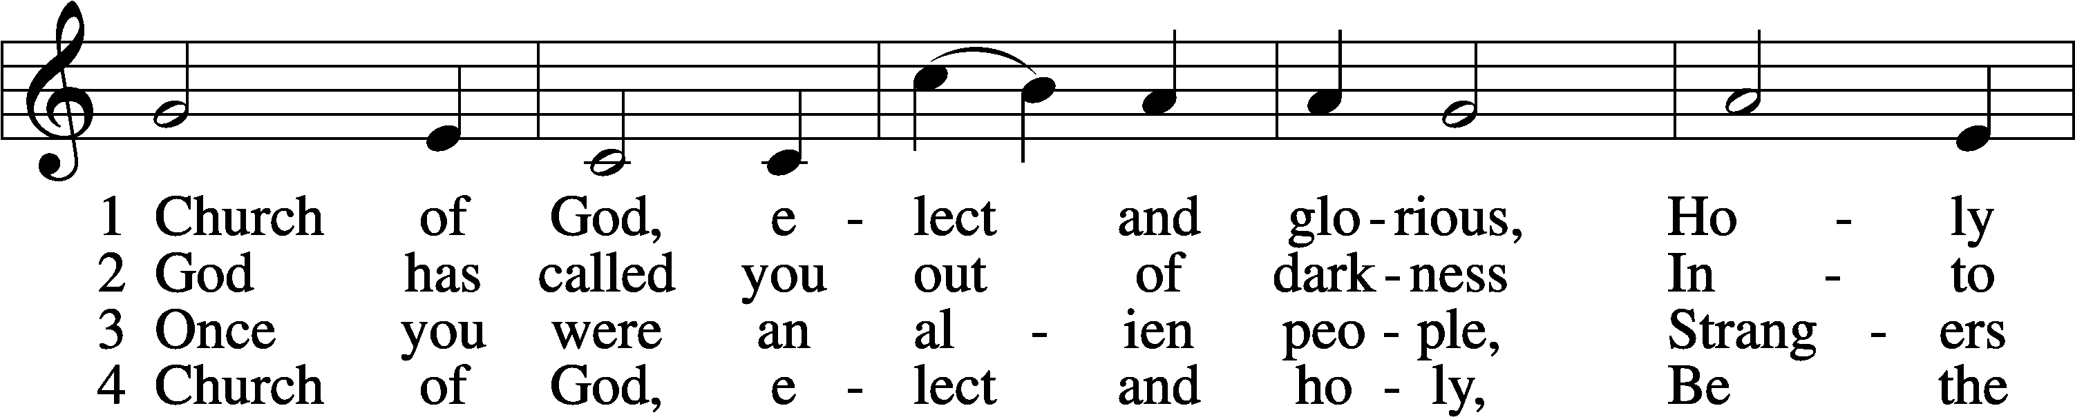
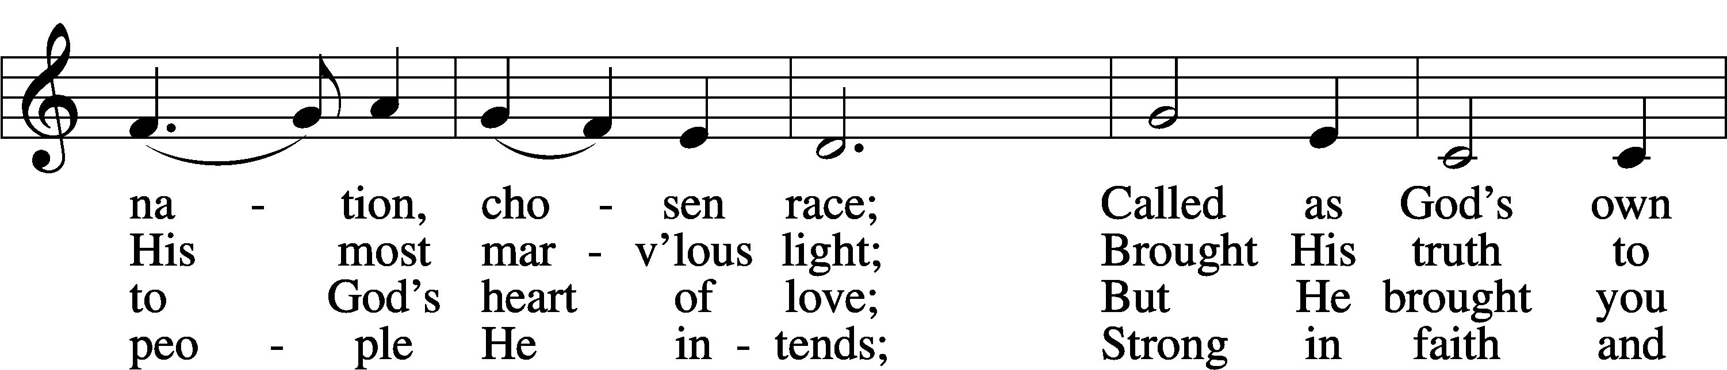
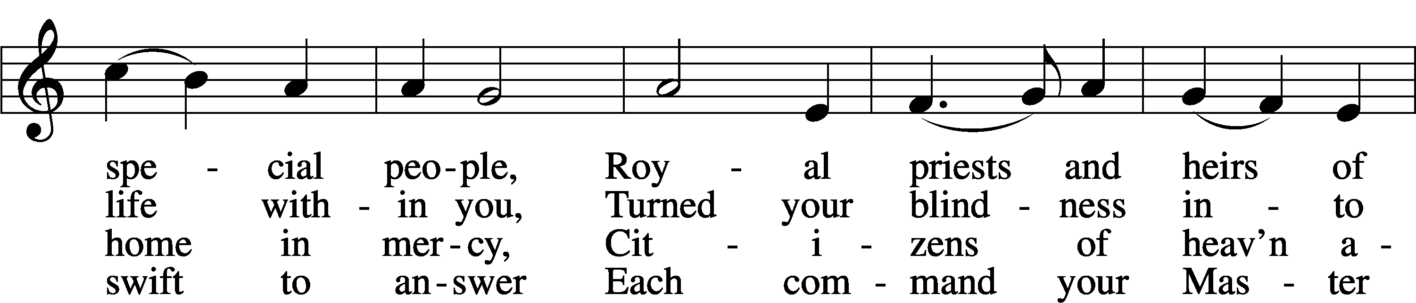
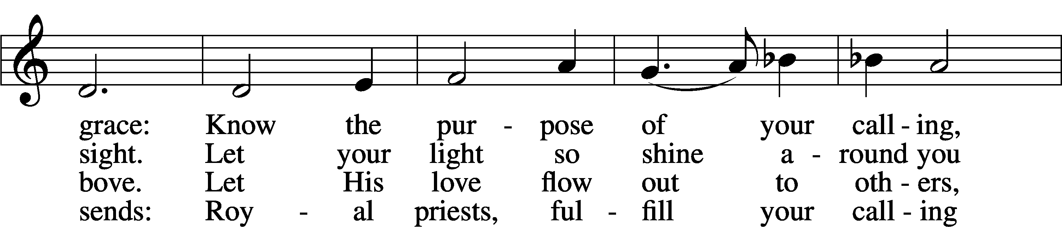
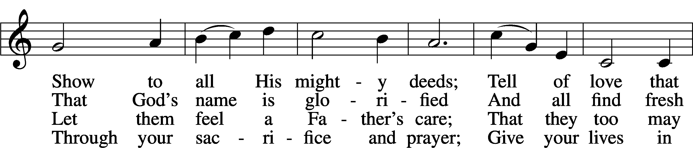
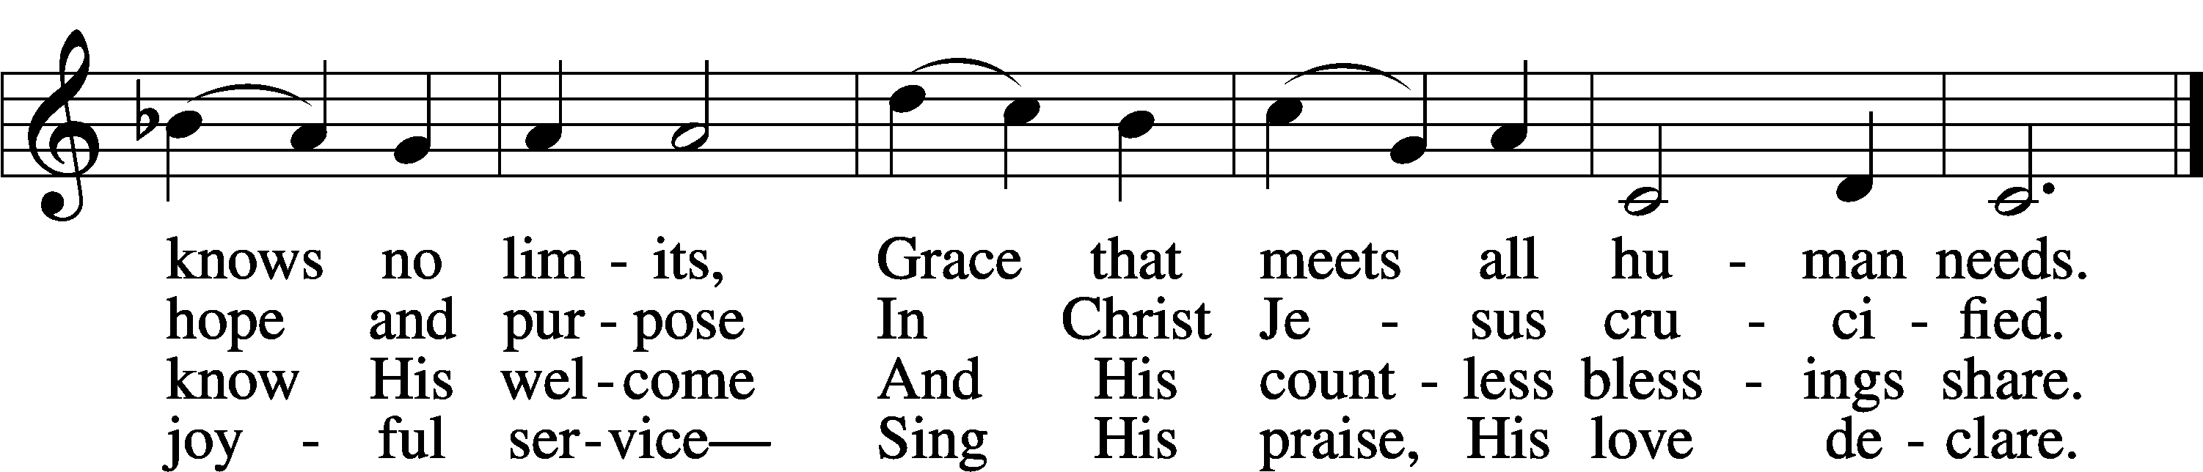
Text: James Edward Seddon, 1915–83
Tune: Cyril V. Taylor, 1907–92
Text: © 1982 The Jubilate Group, admin. Hope Publishing Co. Used by permission: LSB Hymn License no. 110004388
Tune: © 1942, renewed 1970 Hope Publishing Co. Used by permission: LSB Hymn License no. 110004388

744 Amazing Grace sts. 1–5
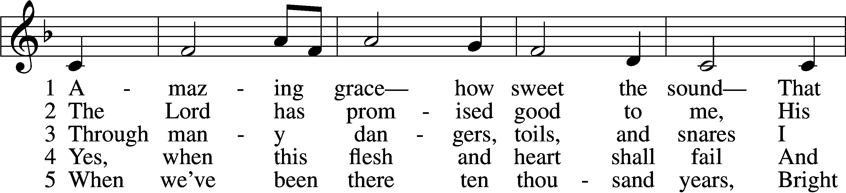
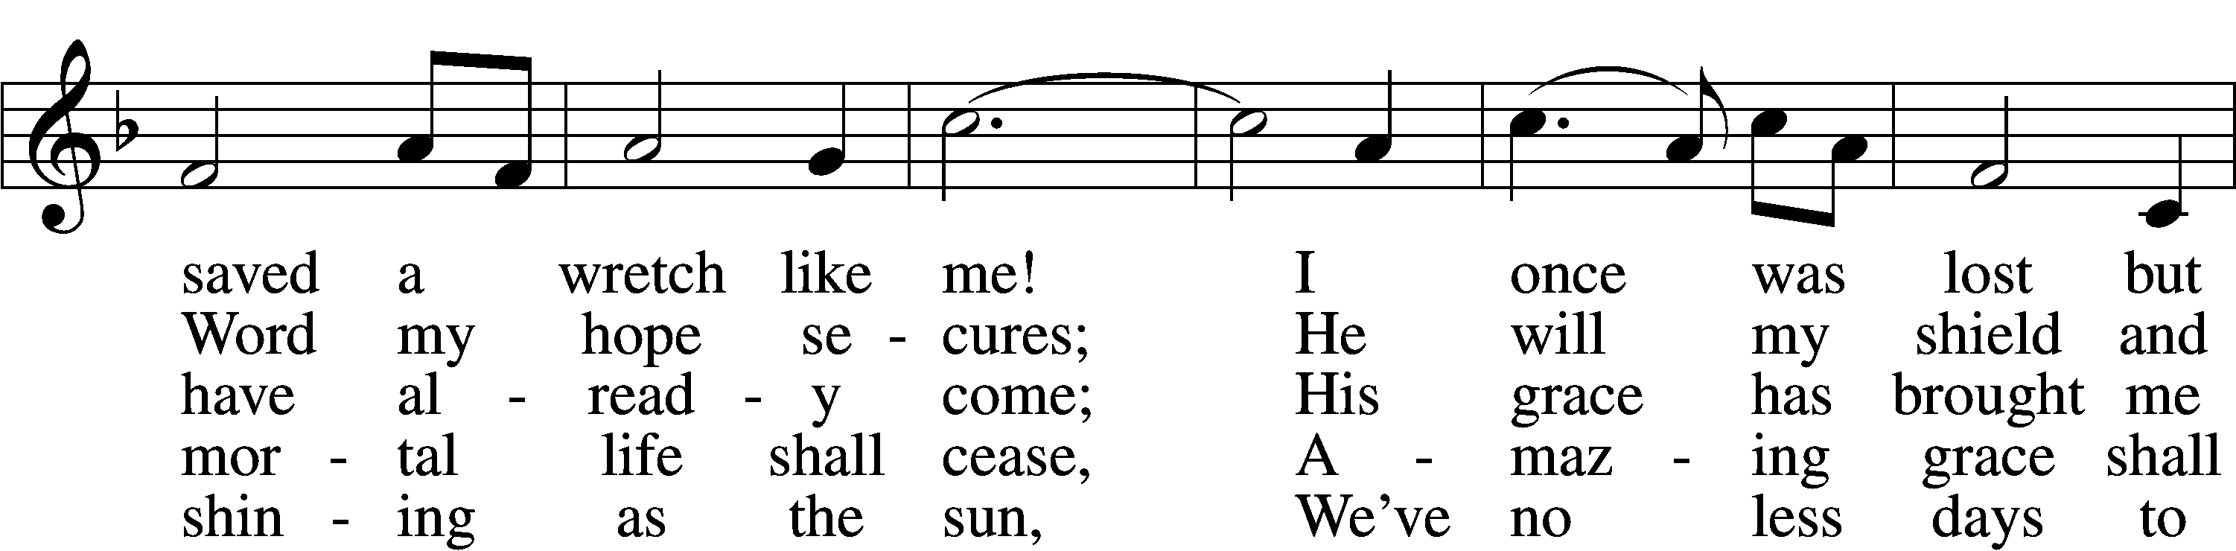
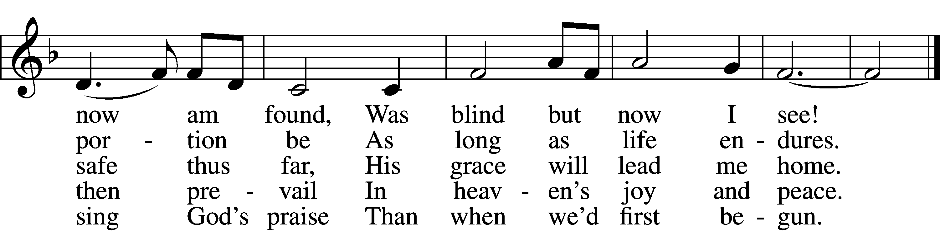
Text (sts. 1–4): John Newton, 1725–1807, alt.; (st. 5): A Collection of Sacred Ballads, 1790, Richmond
Tune: Columbian Harmony, 1829, Cincinnati
Text and tune: Public domain

Nunc Dimittis LSB 199
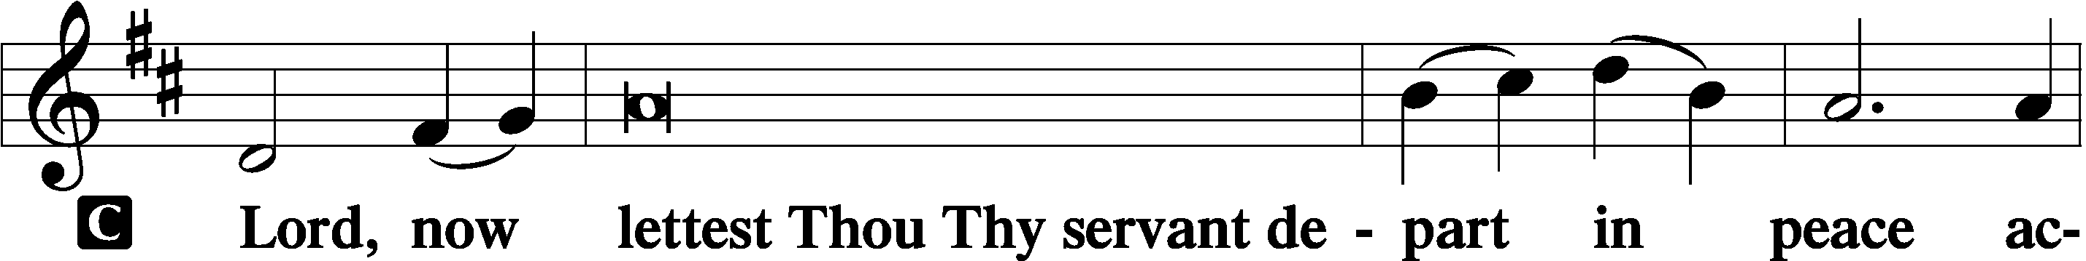

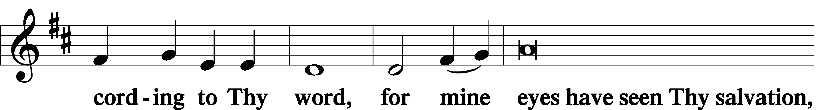

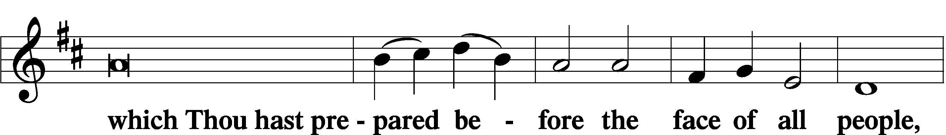

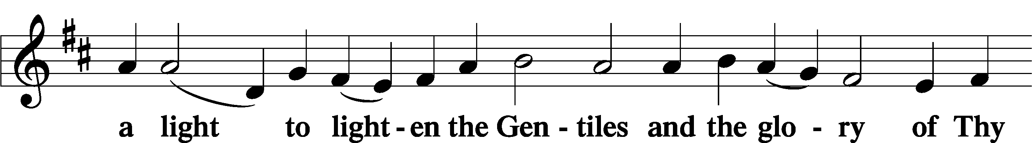

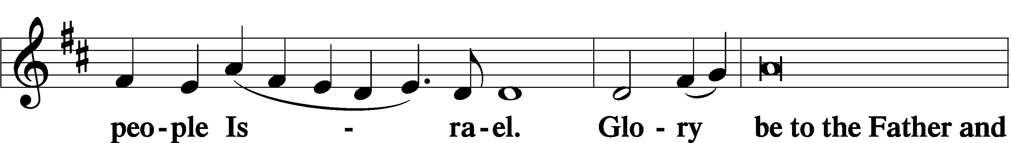

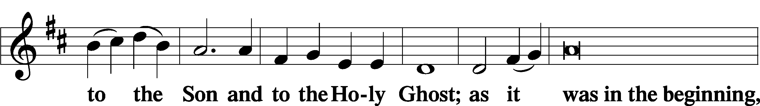

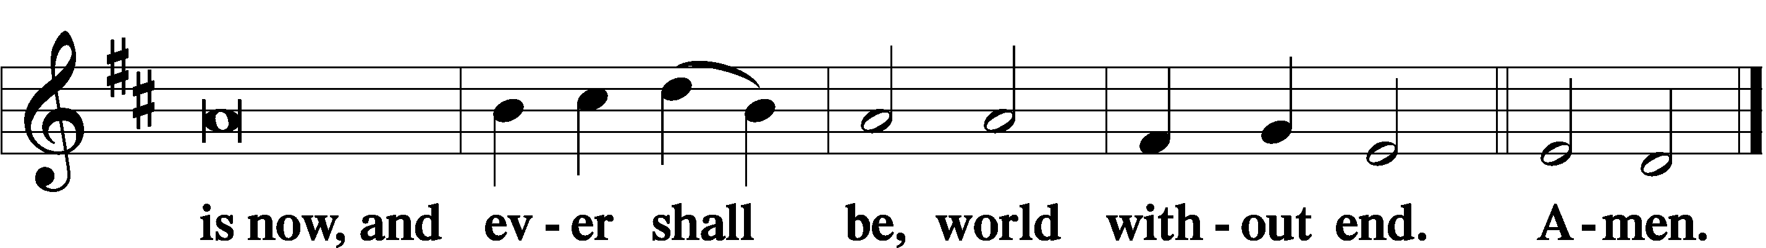

Thanksgiving LSB 200
A O give thanks unto the Lord, for He is good,

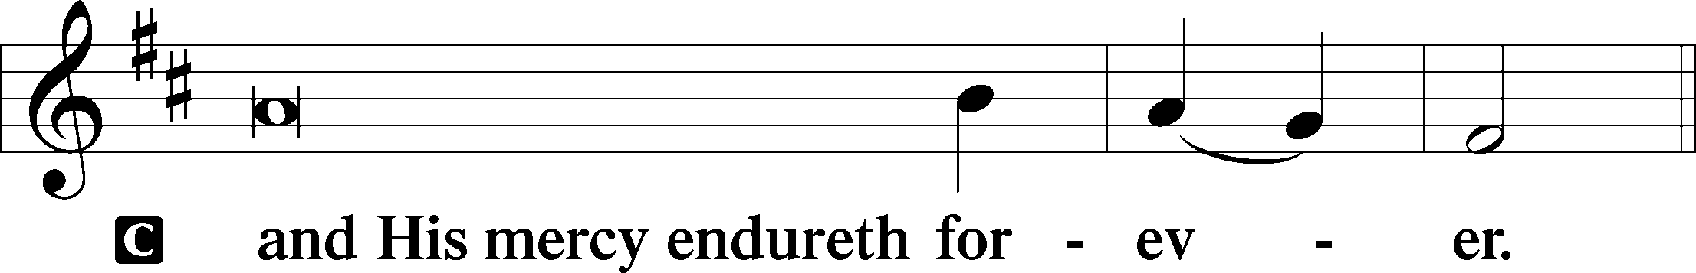

A Let us pray.
We give thanks to You, almighty God, that You have refreshed us through this salutary gift, and we implore You that of Your mercy You would strengthen us through the same in faith toward You and in fervent love toward one another; through Jesus Christ, Your Son, our Lord, who lives and reigns with You and the Holy Spirit, one God, now and forever.

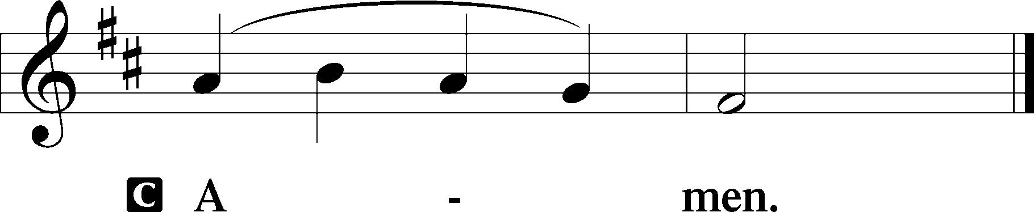

P The Lord be with you.

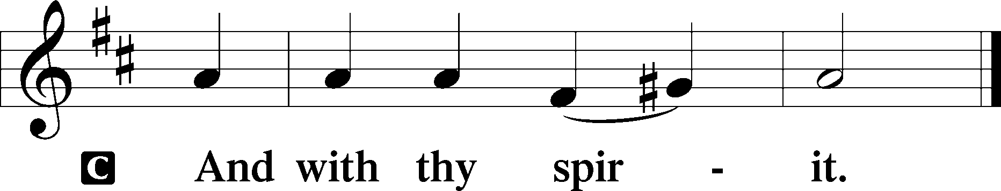
Benedicamus LSB 202
A Bless we the Lord.

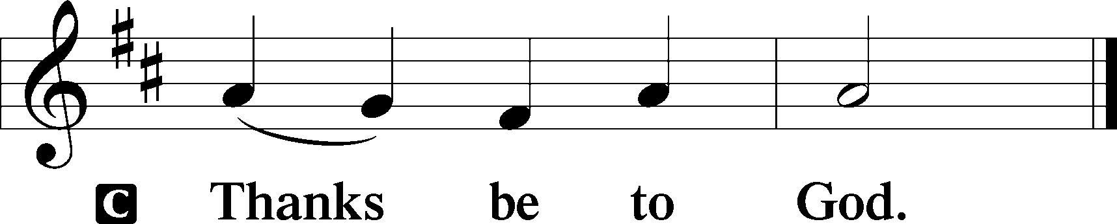

Benediction LSB 202
P The Lord bless you and keep you.
The Lord make His face shine upon you and be gracious unto you.
The Lord lift up His countenance upon you and T give you peace.
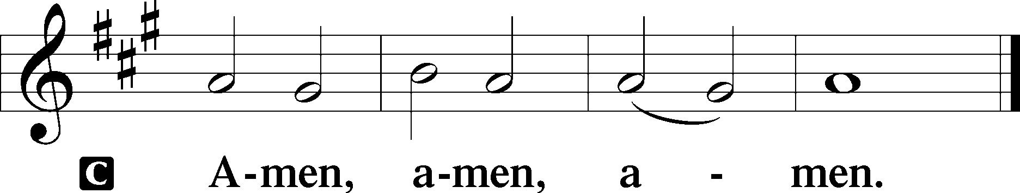

851 Lord of Glory, You Have Bought Us
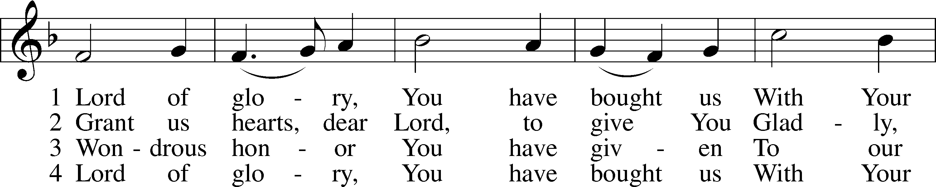
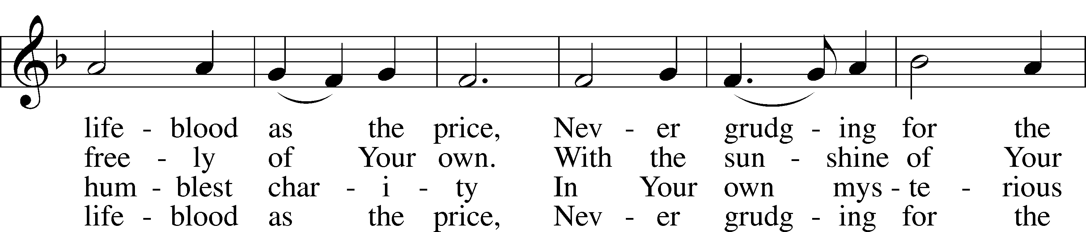
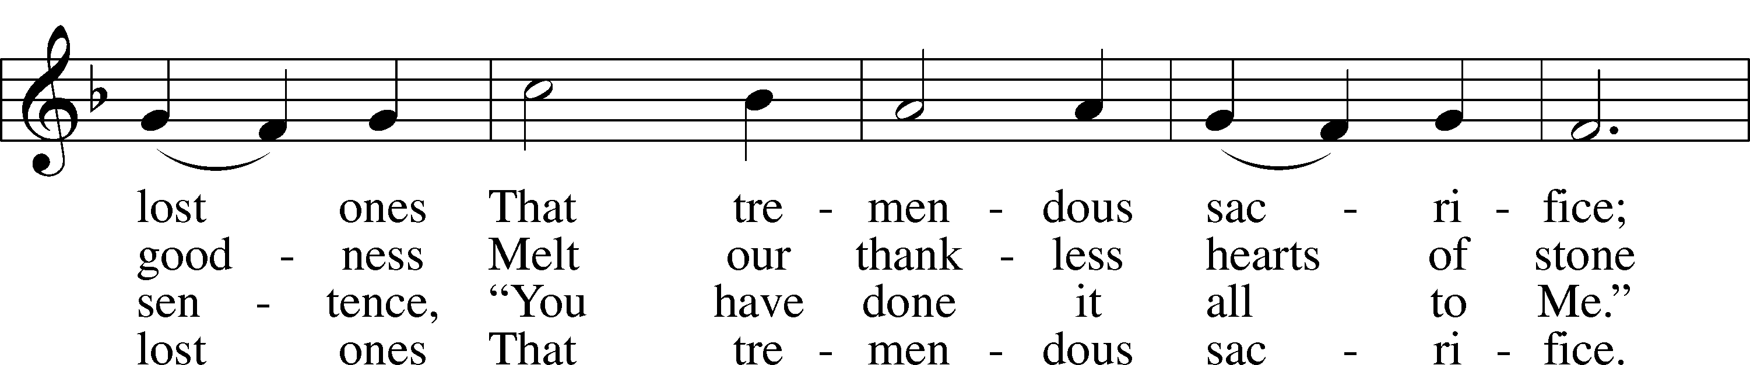
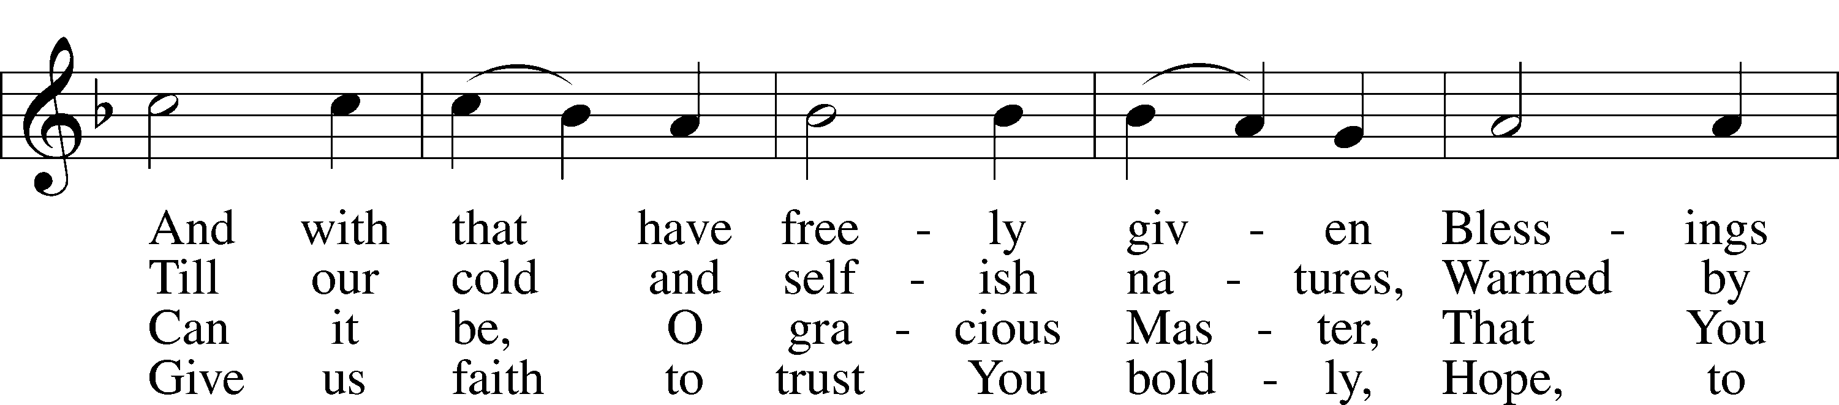
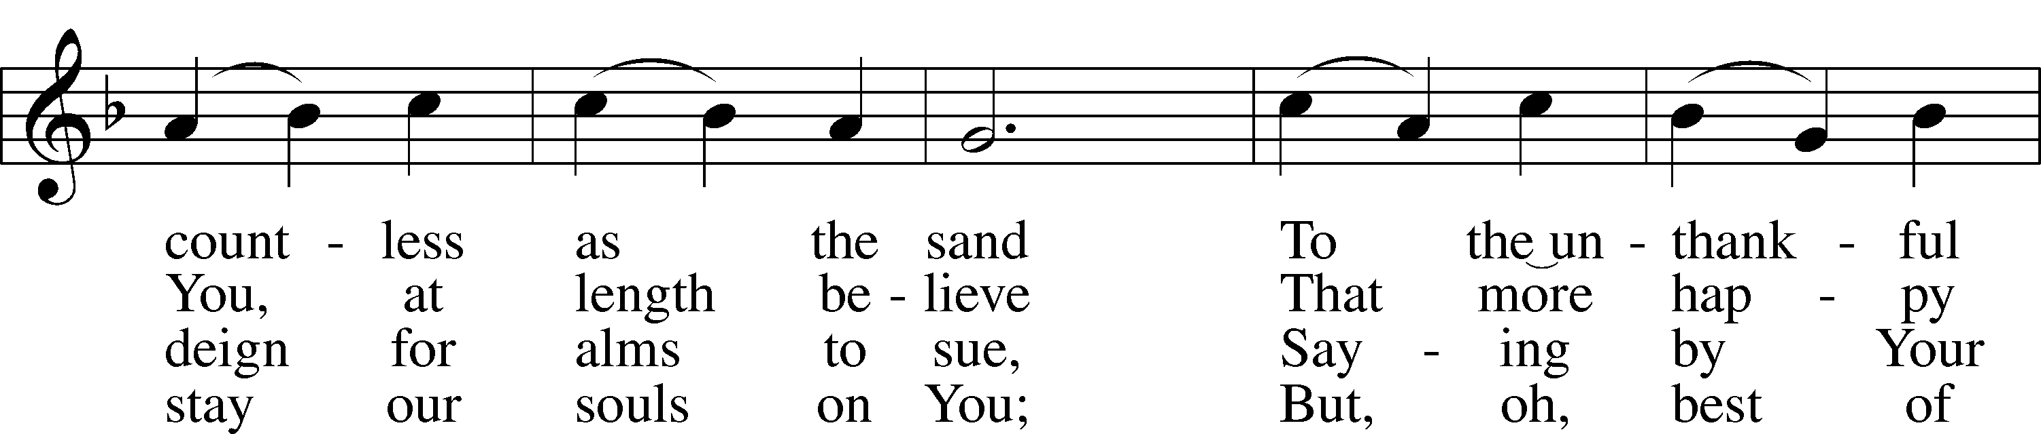
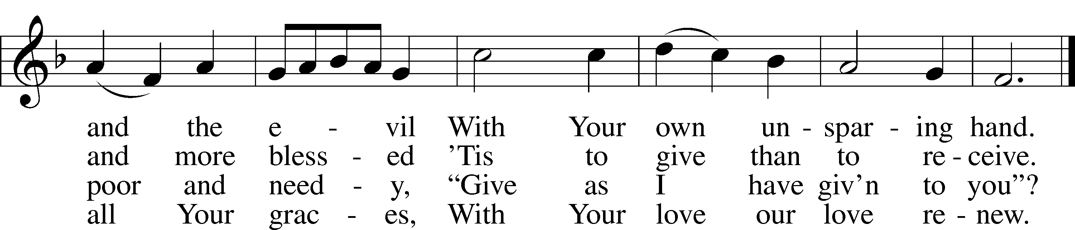
Text: Eliza S. Alderson, 1818–89, alt.
Tune: Rowland H. Prichard, 1811–87
Text and tune: Public domain

Acknowledgments
Divine Service, Setting Three from Lutheran Service Book
Unless otherwise indicated, Scripture quotations are from the ESV® Bible (The Holy Bible, English Standard Version®), copyright © 2001 by Crossway, a publishing ministry of Good News Publishers. Used by permission. All rights reserved.
Created by Lutheran Service Builder © 2023 Concordia Publishing House.

