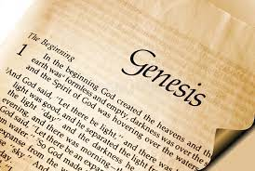
Genesis 21: The Birth of Isaac
Adult Bible Class 2023

Read Genesis 21:1-7
Why did Abraham and Sarah name their son Isaac? (The name “Isaac” means “he laughs.”)

How many years had it been since God first appeared to Abraham and told him that he would be a great nation? (See Genesis 12:4)

Read Genesis 21:8-21
Why was Sarah concerned about Hagar’s son Ishmael? Why do you think that God approved of Sarah’s demand to cast them out?

In what way(s) is the account of Hagar in Genesis 21 like what happened in Genesis 16?

The events of Genesis 21 are historical fact, yet St. Paul writes that we can also understand them allegorically. Read Galatians 4:21-31. How does Paul interpret the two women (Hagar and Sarah) in Galatians? Where is our place in the allegory of these two women?

