The Day of Pentecost
May 28, 2023

913 O Holy Spirit, Enter In
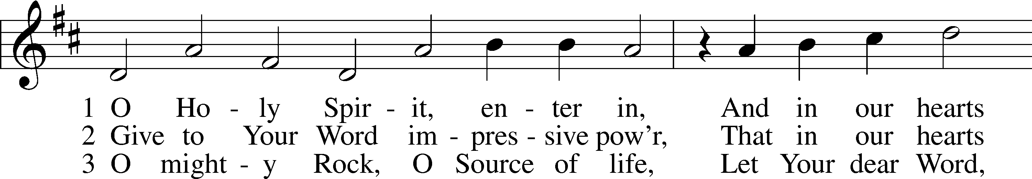
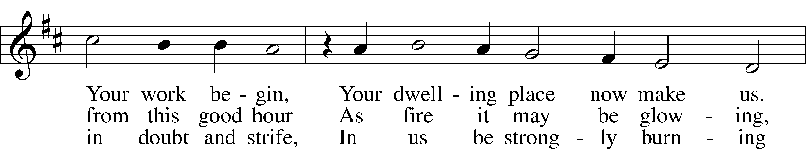
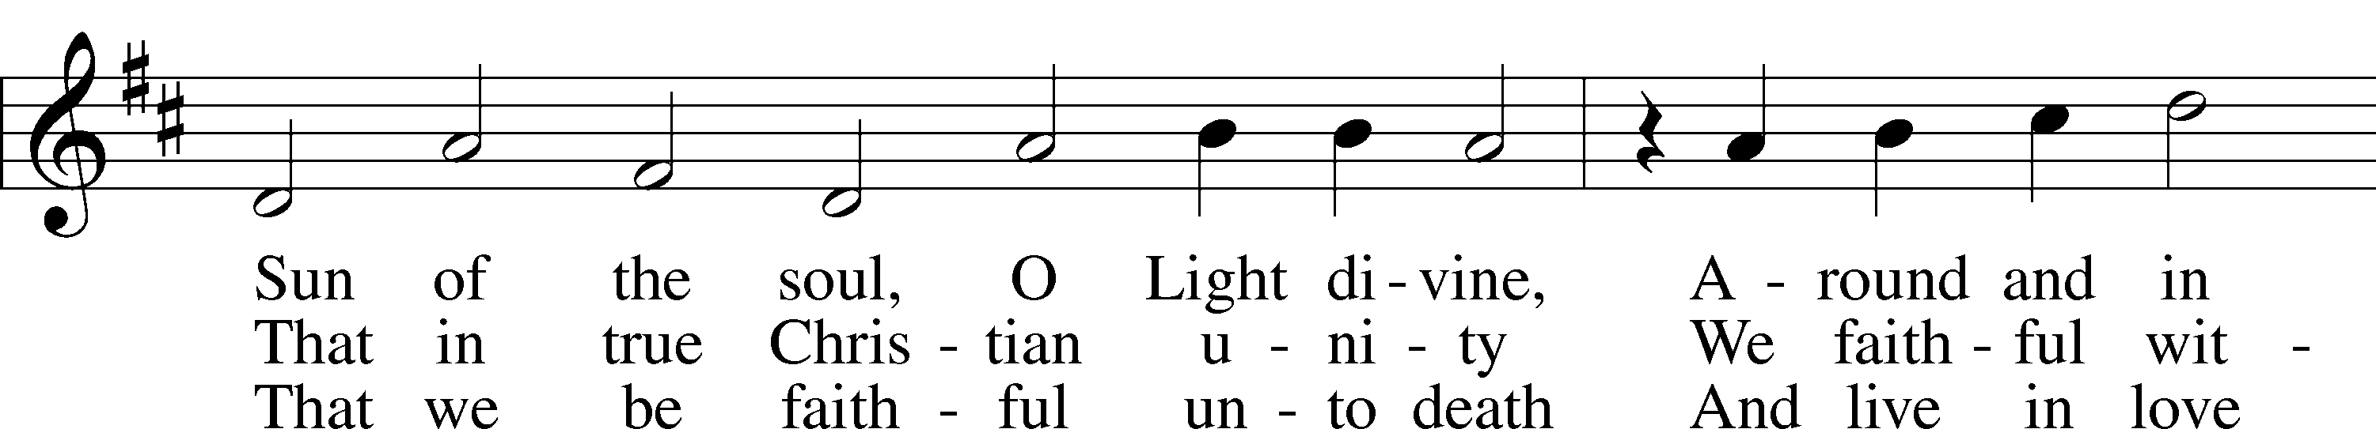
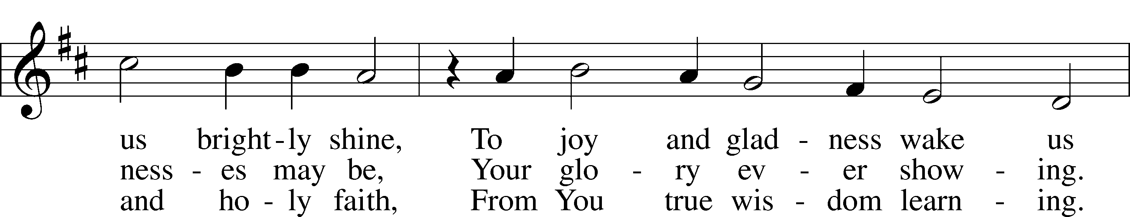
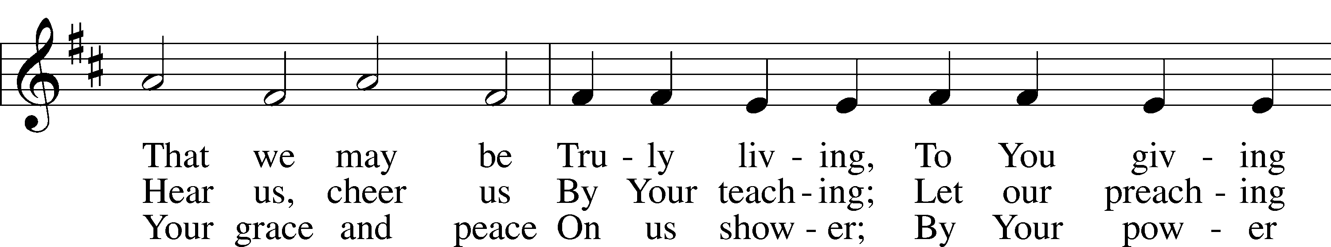
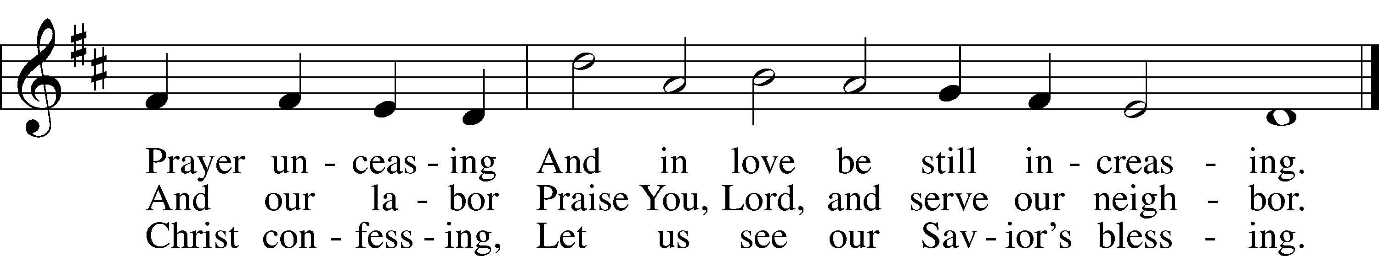
Text: Michael Schirmer, 1606–73, adapt.; (sts. 1, 3): tr. Catherine Winkworth, 1827–78, alt.; (st. 2): tr. The Lutheran Hymnal, 1941, alt.
Tune: Philipp Nicolai, 1556–1608
Text and tune: Public domain
P In the name of the Father and of the T Son and of the Holy Spirit.
C Amen.

P If we say we have no sin, we deceive ourselves, and the truth is not in us.
C But if we confess our sins, God, who is faithful and just, will forgive our sins and cleanse us from all unrighteousness.

P Let us then confess our sins to God our Father.
C Most merciful God, we confess that we are by nature sinful and unclean. We have sinned against You in thought, word, and deed, by what we have done and by what we have left undone. We have not loved You with our whole heart; we have not loved our neighbors as ourselves. We justly deserve Your present and eternal punishment. For the sake of Your Son, Jesus Christ, have mercy on us. Forgive us, renew us, and lead us, so that we may delight in Your will and walk in Your ways to the glory of Your holy name. Amen.

P Almighty God in His mercy has given His Son to die for you and for His sake forgives you all your sins. As a called and ordained servant of Christ, and by His authority, I therefore forgive you all your sins in the name of the Father and of the T Son and of the Holy Spirit.
C Amen.

Service of the Word

Introit Psalm 104:24, 27–28, 30; antiphon: Liturgical Text
Come, Holy Spirit, fill the hearts of the faithful,
and kindle in them the fire of your love. Alleluia.
O Lord, how manifold are your works! In wisdom have you made them all;
the earth is full of your creatures.
These all look to you,
to give them their food in due season.
When you give it to them, they gather it up;
when you open your hand, they are filled with good things.
When you send forth your Spirit, they are created,
and you renew the face of the ground.
Glory be to the Father and to the Son
and to the Holy Spirit;
as it was in the beginning,
is now, and will be forever. Amen.
Come, Holy Spirit, fill the hearts of the faithful,
and kindle in them the fire of your love. Alleluia.

Kyrie LSB 152
A In peace let us pray to the Lord.
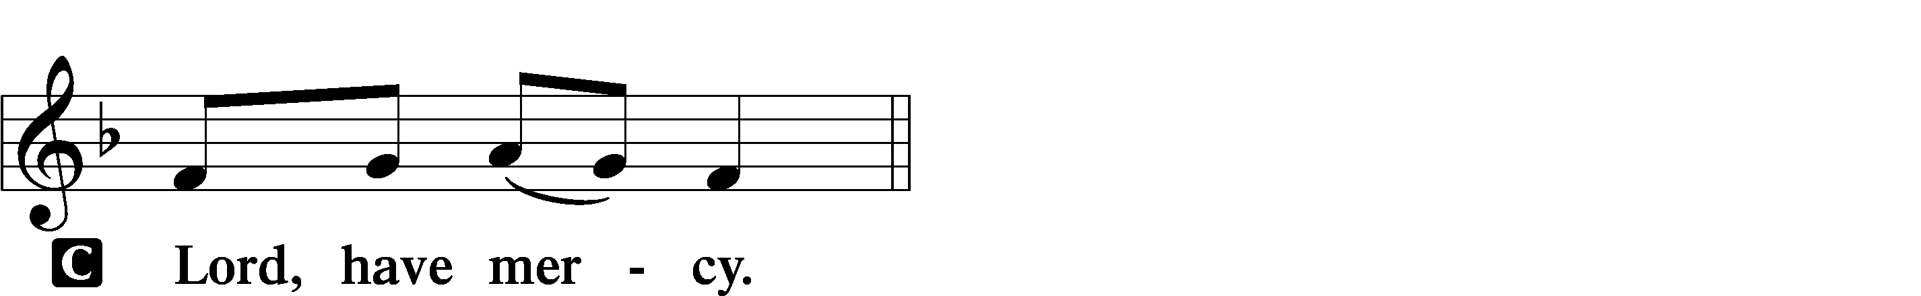

A For the peace from above and for our salvation let us pray to the Lord.
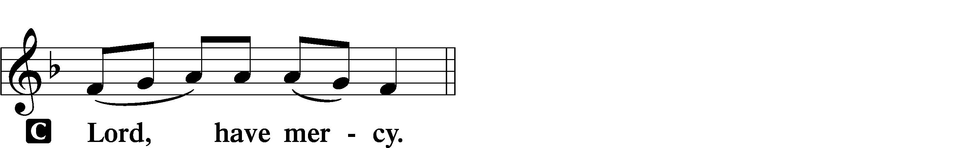

A For the peace of the whole world, for the well-being of the Church of God, and for the unity of all let us pray to the Lord.
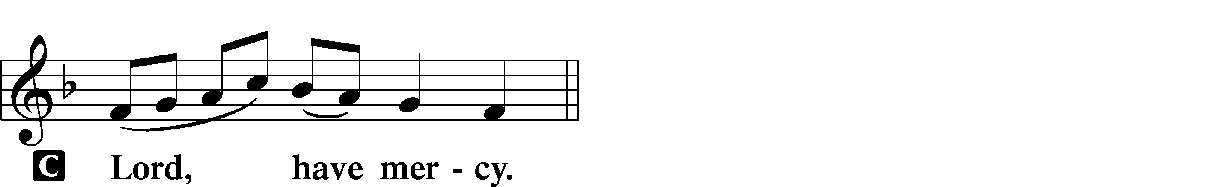

A For this holy house and for all who offer here their worship and praise let us pray to the Lord.
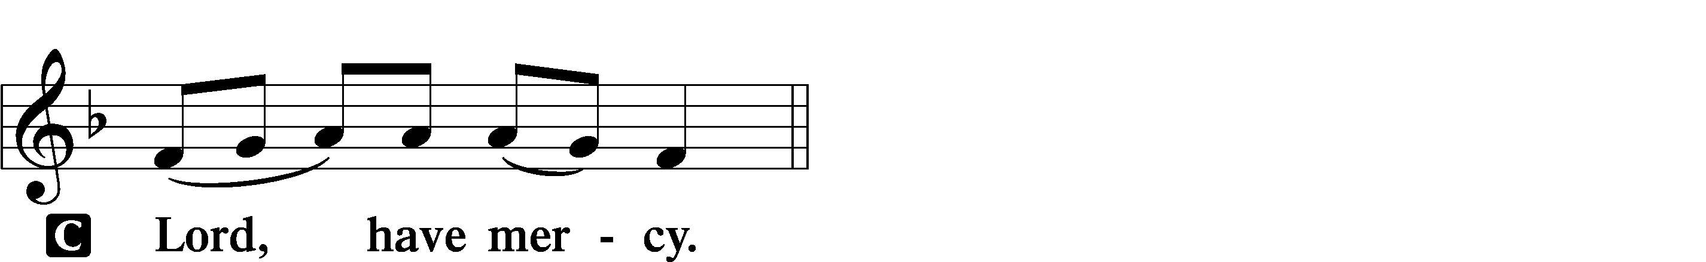

A Help, save, comfort, and defend us, gracious Lord.

Salutation and Collect of the Day
P The Lord be with you.
C And also with you.

P Let us pray.
O God, on this day You once taught the hearts of Your faithful people by sending them the light of Your Holy Spirit. Grant us in our day by the same Spirit to have a right understanding in all things and evermore to rejoice in His holy consolation; through Jesus Christ, Your Son, our Lord, who lives and reigns with You and the Holy Spirit, one God, now and forever.

C Amen.

Old Testament Reading Numbers 11:24–30
24Moses went out and told the people the words of the Lord. And he gathered seventy men of the elders of the people and placed them around the tent. 25Then the Lord came down in the cloud and spoke to him, and took some of the Spirit that was on him and put it on the seventy elders. And as soon as the Spirit rested on them, they prophesied. But they did not continue doing it.
26Now two men remained in the camp, one named Eldad, and the other named Medad, and the Spirit rested on them. They were among those registered, but they had not gone out to the tent, and so they prophesied in the camp. 27And a young man ran and told Moses, “Eldad and Medad are prophesying in the camp.” 28And Joshua the son of Nun, the assistant of Moses from his youth, said, “My lord Moses, stop them.” 29But Moses said to him, “Are you jealous for my sake? Would that all the Lord’s people were prophets, that the Lord would put his Spirit on them!” 30And Moses and the elders of Israel returned to the camp.

A This is the Word of the Lord.
C Thanks be to God.

Second Reading Acts 2:1–21
1When the day of Pentecost arrived, they were all together in one place. 2And suddenly there came from heaven a sound like a mighty rushing wind, and it filled the entire house where they were sitting. 3And divided tongues as of fire appeared to them and rested on each one of them. 4And they were all filled with the Holy Spirit and began to speak in other tongues as the Spirit gave them utterance.
5Now there were dwelling in Jerusalem Jews, devout men from every nation under heaven. 6And at this sound the multitude came together, and they were bewildered, because each one was hearing them speak in his own language. 7And they were amazed and astonished, saying, “Are not all these who are speaking Galileans? 8And how is it that we hear, each of us in his own native language? 9Parthians and Medes and Elamites and residents of Mesopotamia, Judea and Cappadocia, Pontus and Asia, 10Phrygia and Pamphylia, Egypt and the parts of Libya belonging to Cyrene, and visitors from Rome, 11both Jews and proselytes, Cretans and Arabians—we hear them telling in our own tongues the mighty works of God.” 12And all were amazed and perplexed, saying to one another, “What does this mean?” 13But others mocking said, “They are filled with new wine.”
14But Peter, standing with the eleven, lifted up his voice and addressed them, “Men of Judea and all who dwell in Jerusalem, let this be known to you, and give ear to my words. 15For these men are not drunk, as you suppose, since it is only the third hour of the day. 16But this is what was uttered through the prophet Joel:
17“‘And in the last days it shall be, God declares,
that I will pour out my Spirit on all flesh,
and your sons and your daughters shall prophesy,
and your young men shall see visions,
and your old men shall dream dreams;
18even on my male servants and female servants
in those days I will pour out my Spirit, and they shall prophesy.
19And I will show wonders in the heavens above
and signs on the earth below,
blood, and fire, and vapor of smoke;
20the sun shall be turned to darkness
and the moon to blood,
before the day of the Lord comes, the great and magnificent day.
21And it shall come to pass that everyone who calls upon the name of the Lord shall be saved.’”

A This is the Word of the Lord.
C Thanks be to God.

Alleluia and Verse LSB 156
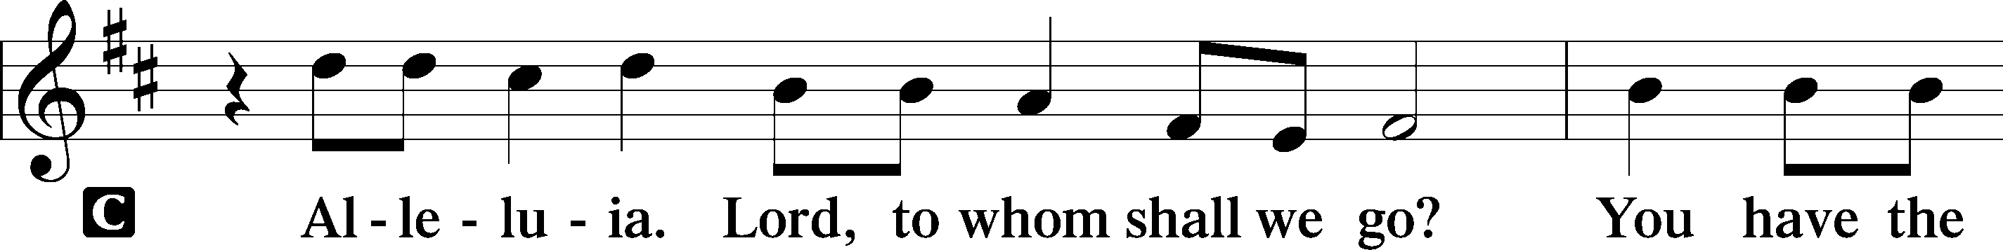
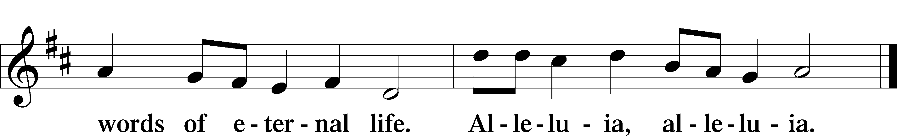

Holy Gospel John 7:37–39
P The Holy Gospel according to St. John, the seventh chapter.
C Glory to You, O Lord.

37On the last day of the feast, the great day, Jesus stood up and cried out, “If anyone thirsts, let him come to me and drink. 38Whoever believes in me, as the Scripture has said, ‘Out of his heart will flow rivers of living water.’” 39Now this he said about the Spirit, whom those who believed in him were to receive, for as yet the Spirit had not been given, because Jesus was not yet glorified.

P This is the Gospel of the Lord.
C Praise to You, O Christ.

Apostles’ Creed
C I believe in God, the Father Almighty, maker of heaven and earth.

And in Jesus Christ, His only Son, our Lord, who was conceived by the Holy Spirit, born of the virgin Mary, suffered under Pontius Pilate, was crucified, died and was buried. He descended into hell. The third day He rose again from the dead. He ascended into heaven and sits at the right hand of God the Father Almighty. From thence He will come to judge the living and the dead.

I believe in the Holy Spirit, the holy Christian Church, the communion of saints, the forgiveness of sins, the resurrection of the body, and the life T everlasting. Amen.

496 Holy Spirit, Light Divine
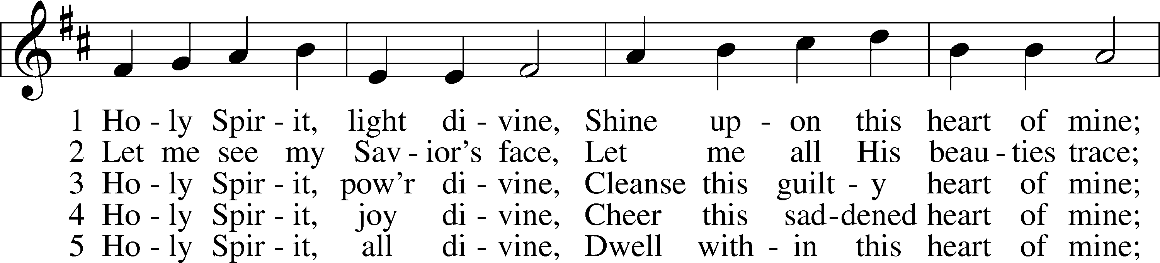
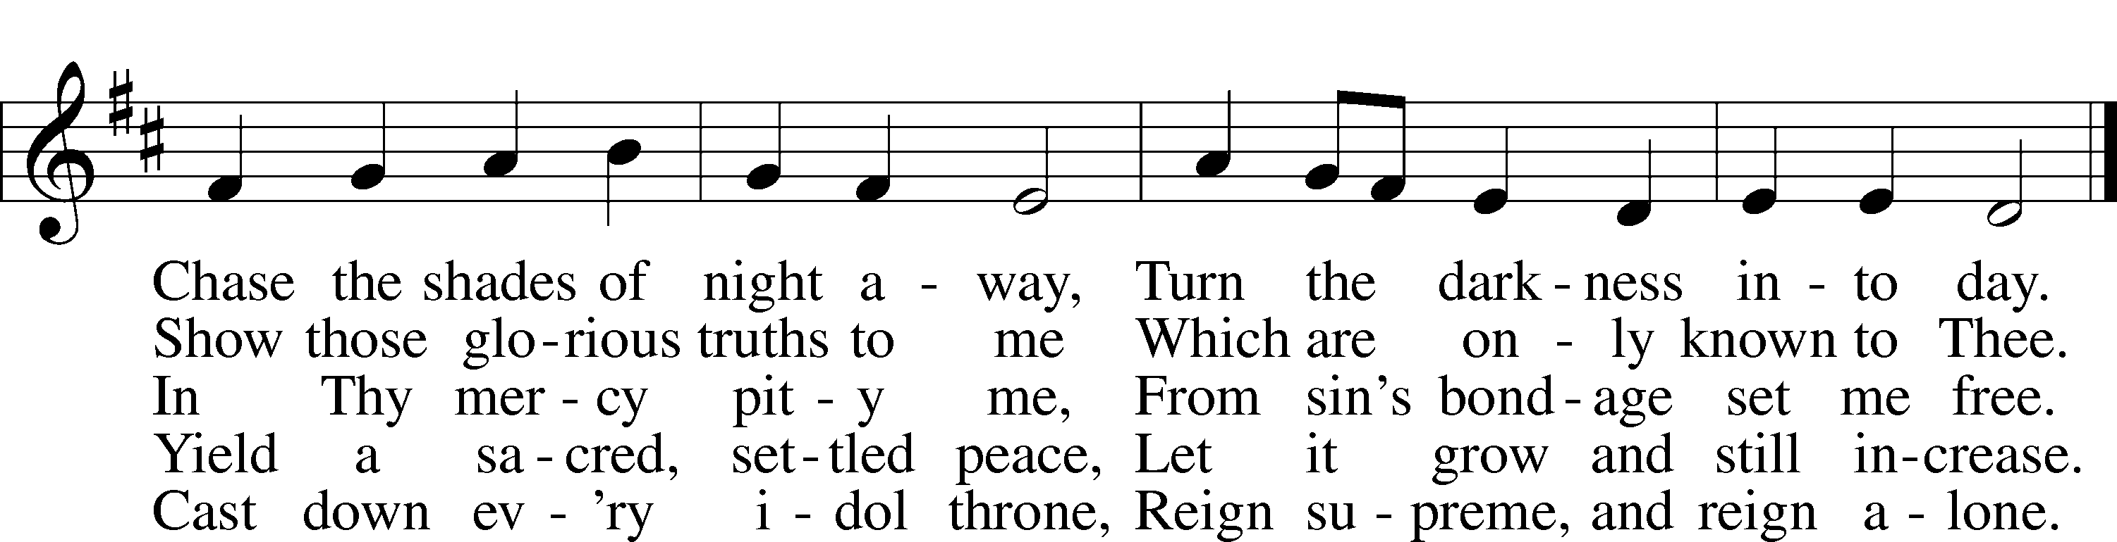
Text: Andrew Reed, 1787–1862, alt. Tune: Orlando Gibbons, 1583–1625 Text and tune: Public domain
Sermon: “The Gifts That Flow From Christ” John 7:37-39

Offering

Offertory LSB 159
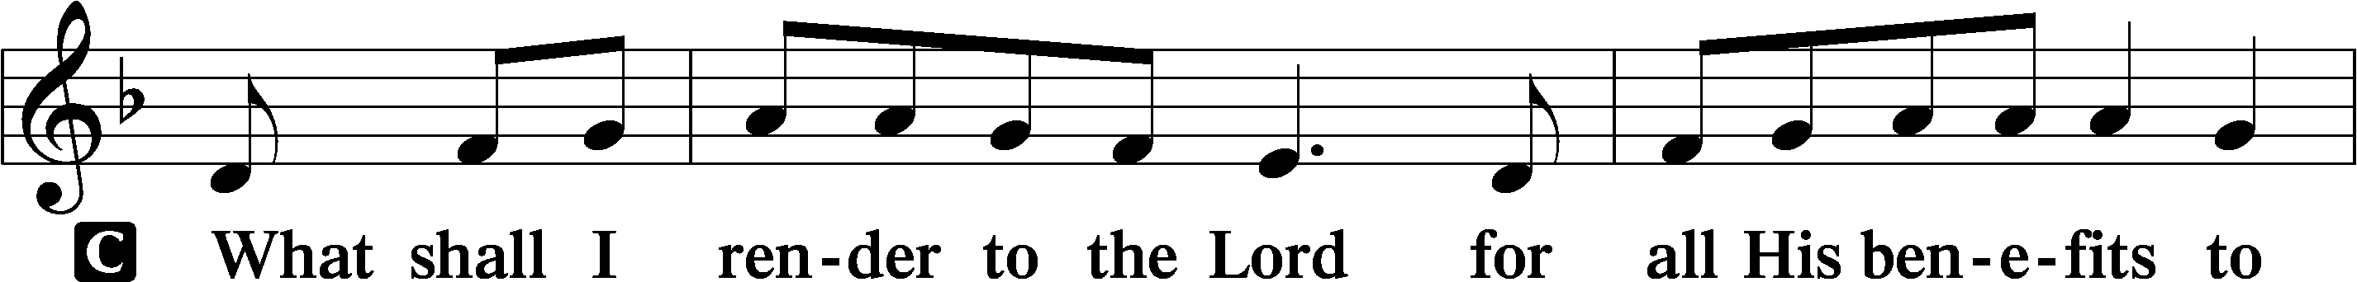
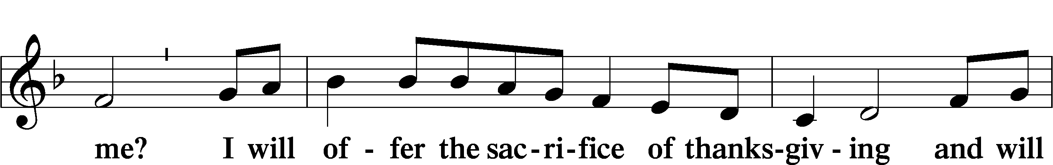
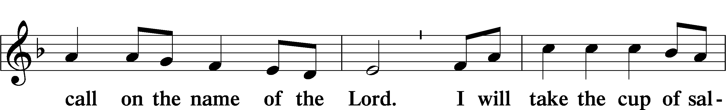
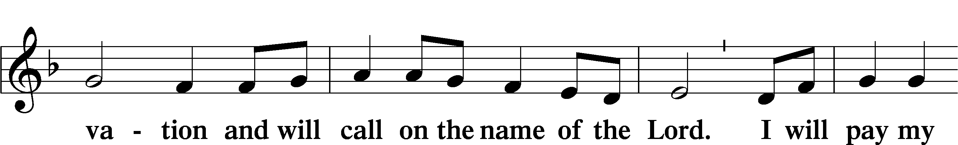
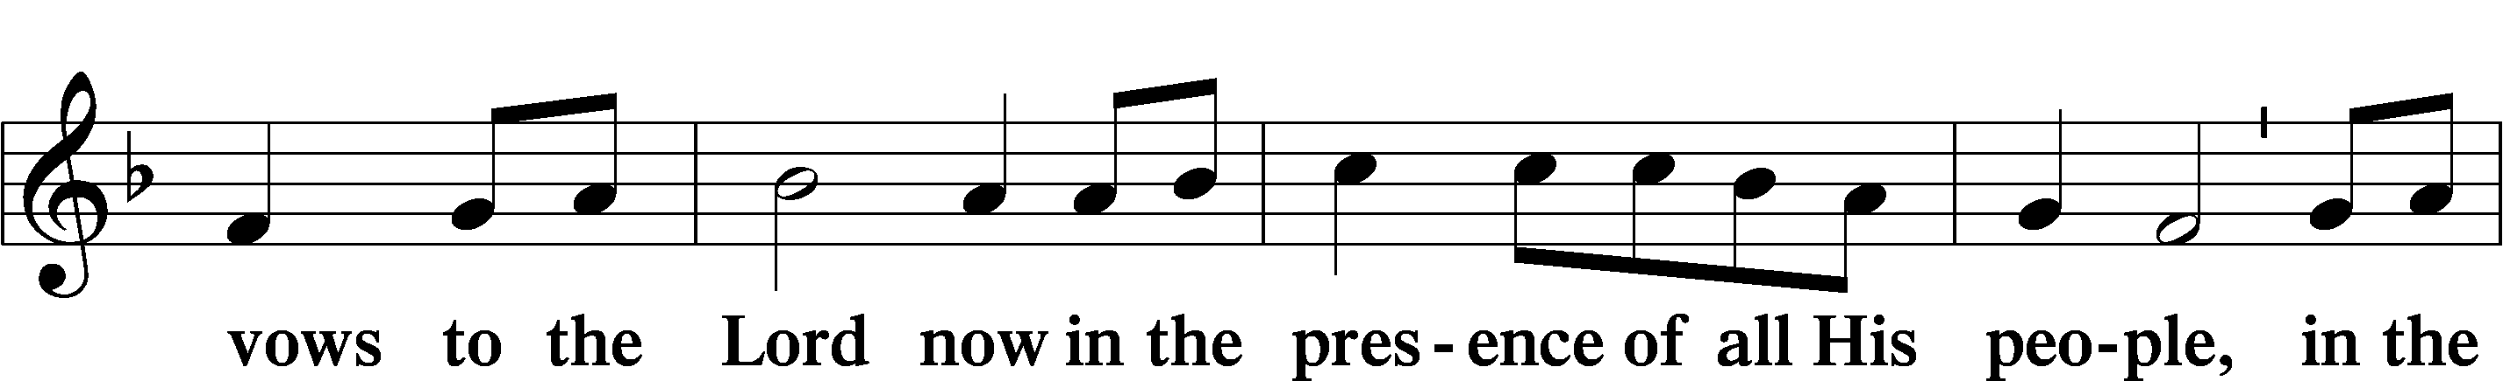
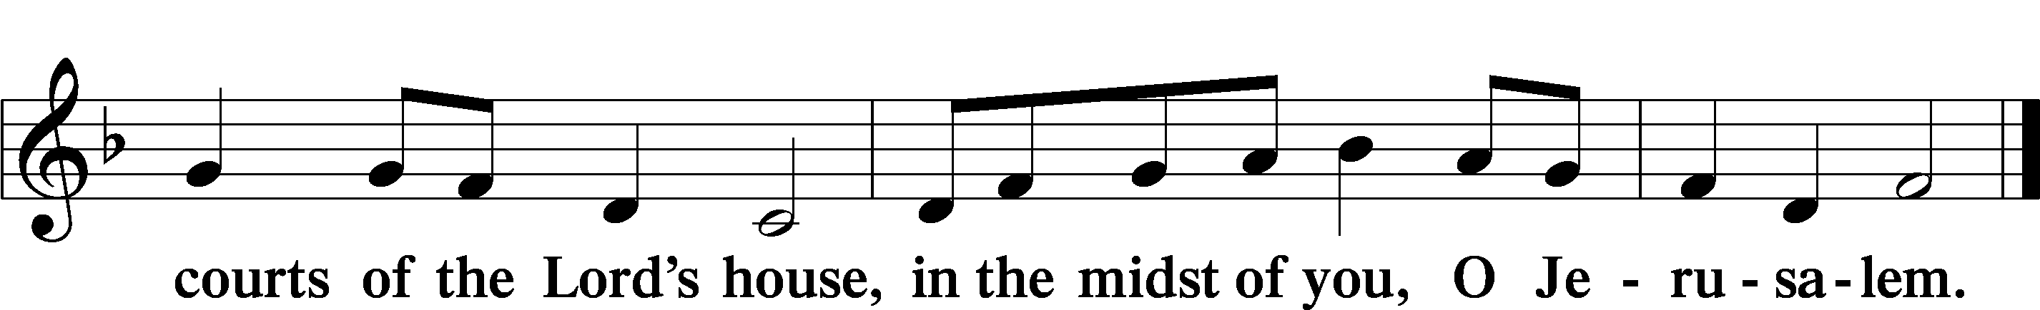

Prayer of the Church

Lord’s Prayer
C Our Father who art in heaven, hallowed be Thy name, Thy kingdom come, Thy will be done on earth as it is in heaven; give us this day our daily bread; and forgive us our trespasses as we forgive those who trespass against us; and lead us not into temptation, but deliver us from evil. For Thine is the kingdom and the power and the glory forever and ever. Amen.

Benediction LSB 166
P The Lord bless you and keep you.
The Lord make His face shine on you and be gracious to you.
The Lord look upon you with favor and T give you peace.

501 Come Down, O Love Divine
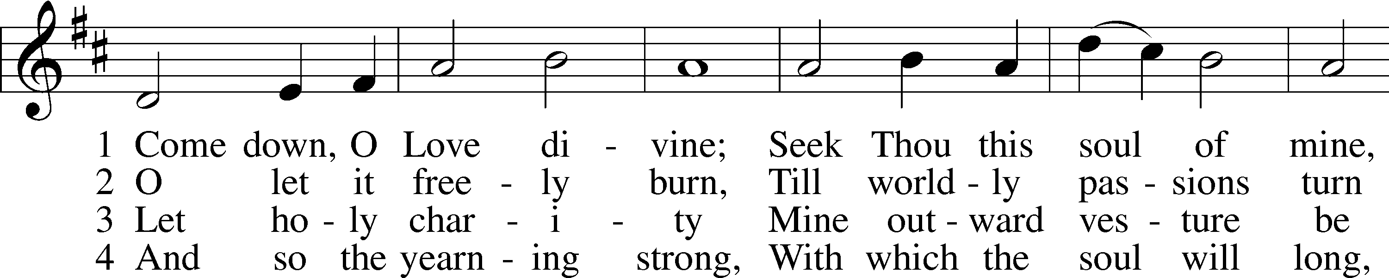
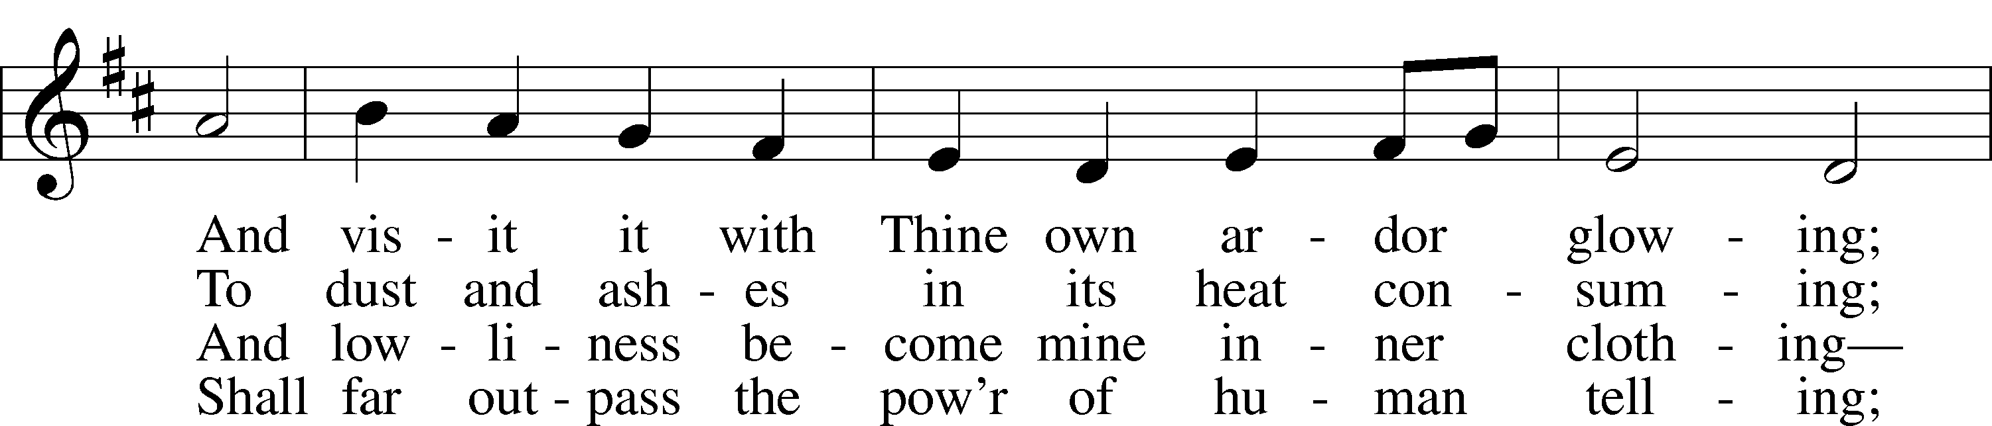
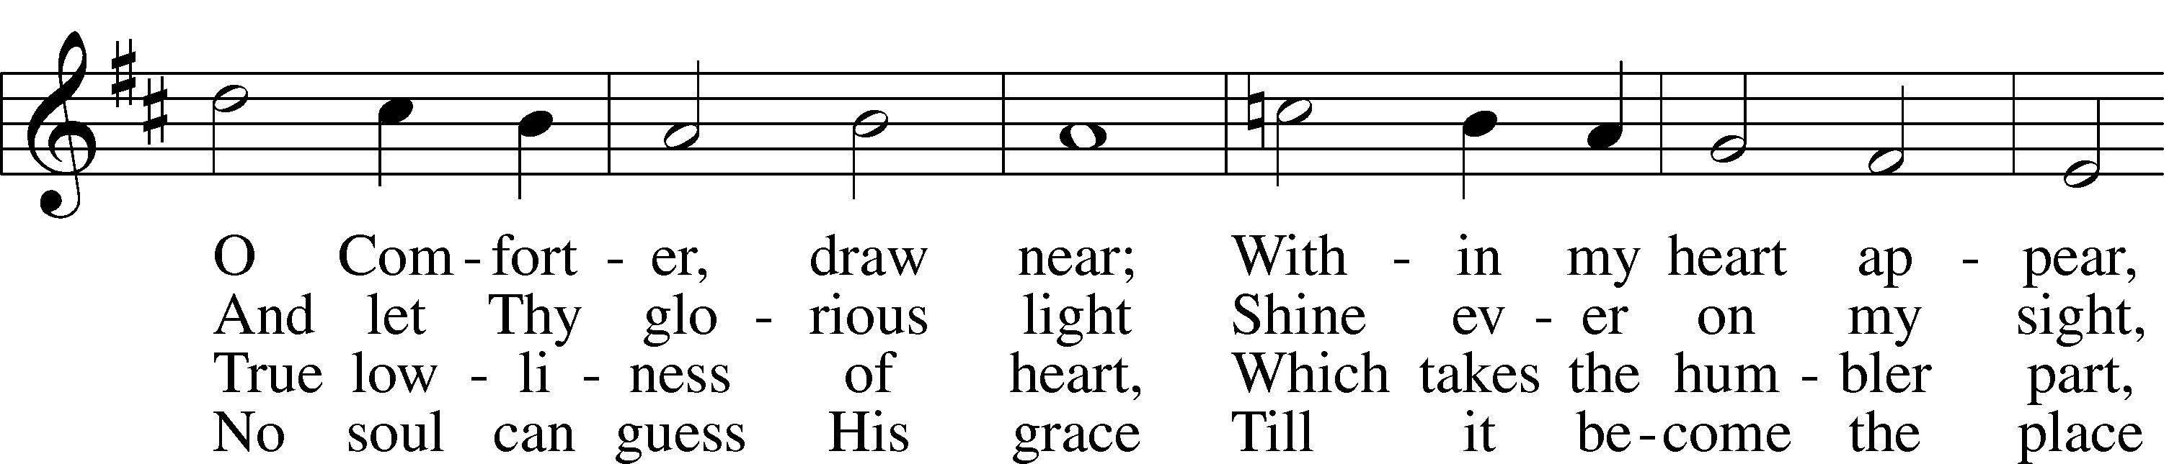
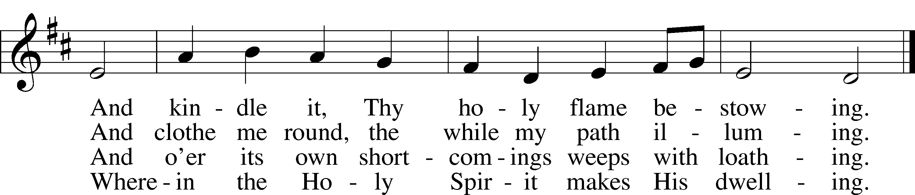
Text: Bianco da Siena, c. 1350–1434; tr. Richard F. Littledale, 1833–90
Tune: Ralph Vaughan Williams, 1872–1958 Text and tune: Public domain

Acknowledgments
Divine Service, Setting One from Lutheran Service Book
Unless otherwise indicated, Scripture quotations are from the ESV® Bible (The Holy Bible, English Standard Version®), copyright © 2001 by Crossway, a publishing ministry of Good News Publishers. Used by permission. All rights reserved. Created by Lutheran Service Builder © 2023 Concordia Publishing House.

