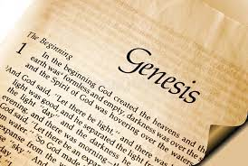
Genesis 27: Isaac Blesses Jacob
Adult Bible Class 2023

Read Genesis 27:1-13
What do Isaac’s words in the first four verses suggest about his relationship to his son Esau? (See Genesis 25:28)

Here we begin to see a plot forming against Isaac and Esau. Who is the “mastermind” behind the deceitful scheme? What was the purpose of this scheme?

Did the end justify the means? Why or why not?

Read Genesis 27:14-25
What does Jacob do when Isaac suspects that something isn’t right? (verse 20). Which of the Ten Commandments does Jacob break here? What does it mean for us to keep this Commandment?

Isaac blessed his son despite his uncertainty. Did he have to act so carelessly? What could he have done differently to possibly change the outcome of the blessing? (Isaac unknowingly fulfills God’s Word and blesses Jacob despite his desire to bless Esau.)

Read Genesis 27:26-40
In what way is Isaac’s blessing a fulfillment of God’s Word in Genesis 25:23?

What’s the tragic irony of Esau referring to himself as the “firstborn?” (See Genesis 25:29-34)

Read Hebrews 12:15-17. What can we learn from impulsive Esau in this passage?

Read Genesis 27:41-46
We talked earlier about how favoritism within households leads to a multitude of problems. How did Isaac and Rebekah’s favoritism toward their sons cause problems for their family?

Where do we see Jesus in Genesis 27? (See Galatians 3:13)

