The Third Sunday of Easter
April 14, 2024

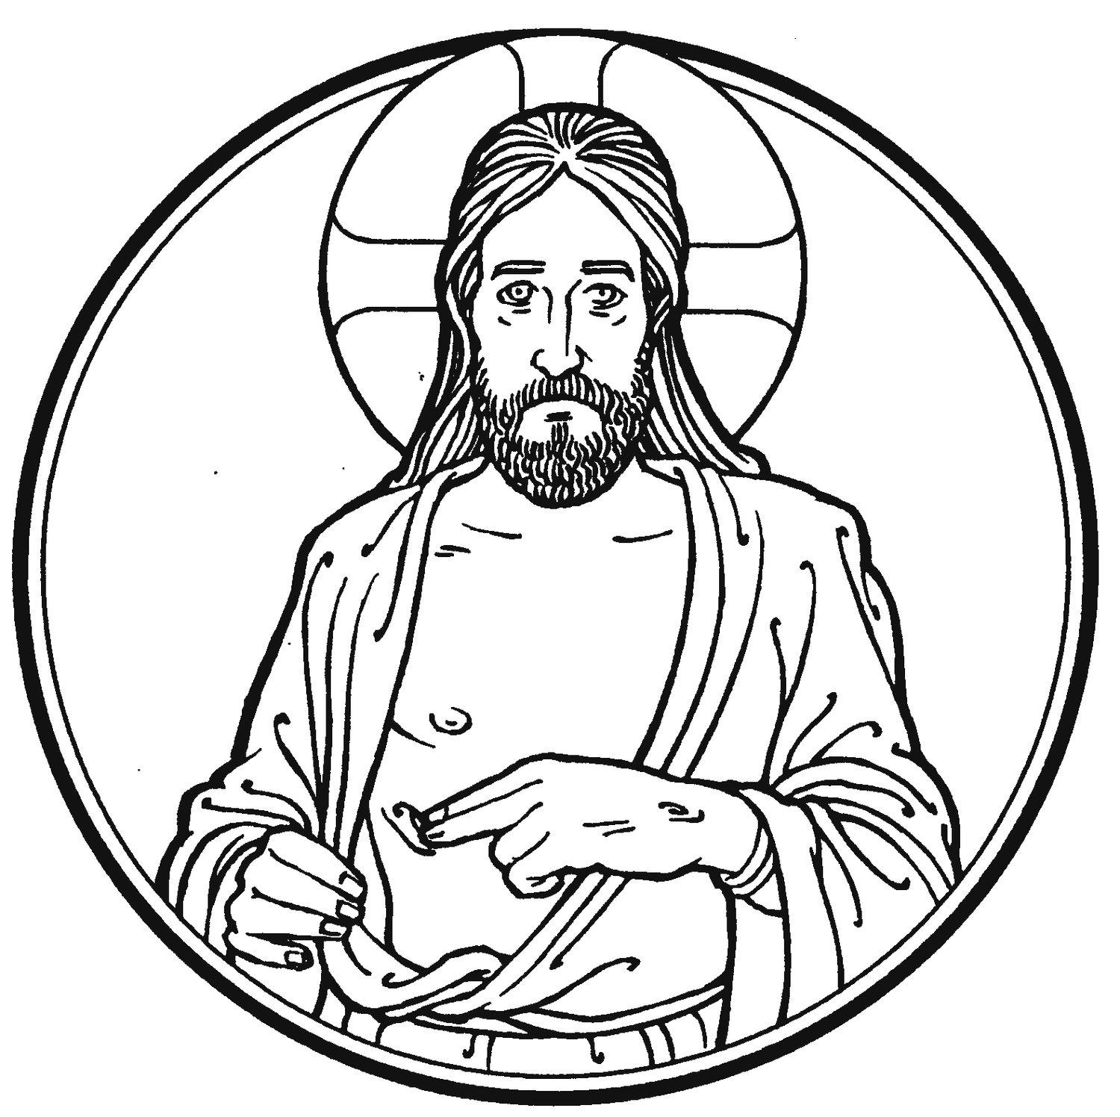

“Thus it is written, that the Christ should suffer and on the third day rise from the dead”

Peace Lutheran Church + 1451 Ebenezer Rd + Cincinnati, OH 45233
www.peacechurchlink.com + 513-941-5177
605 Father Welcomes
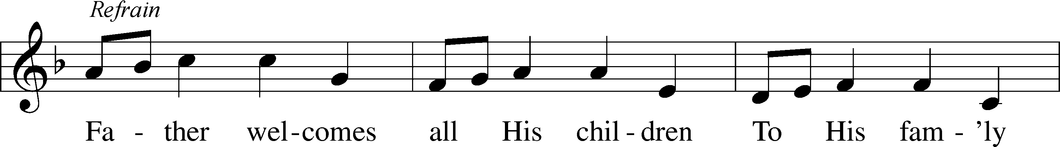
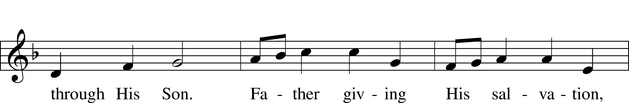
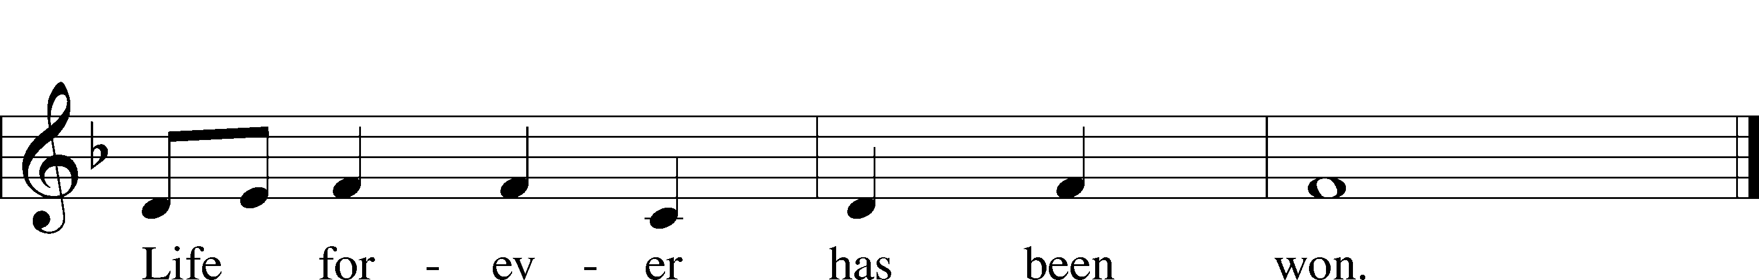
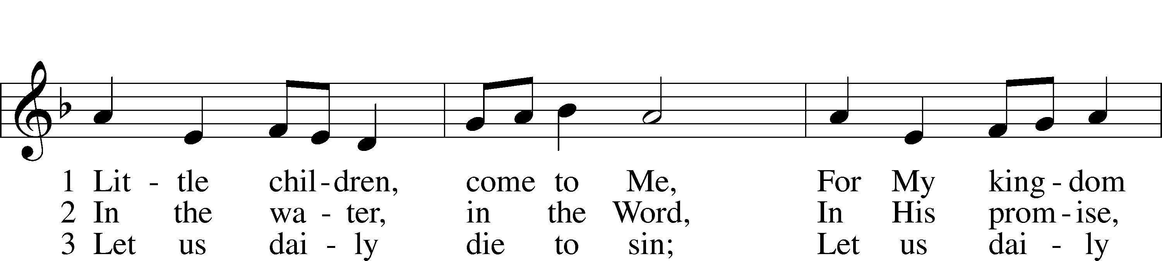
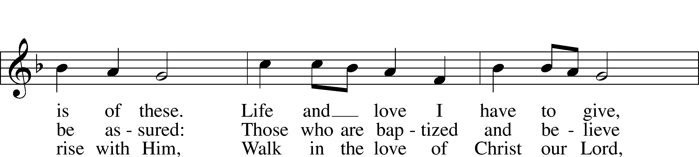
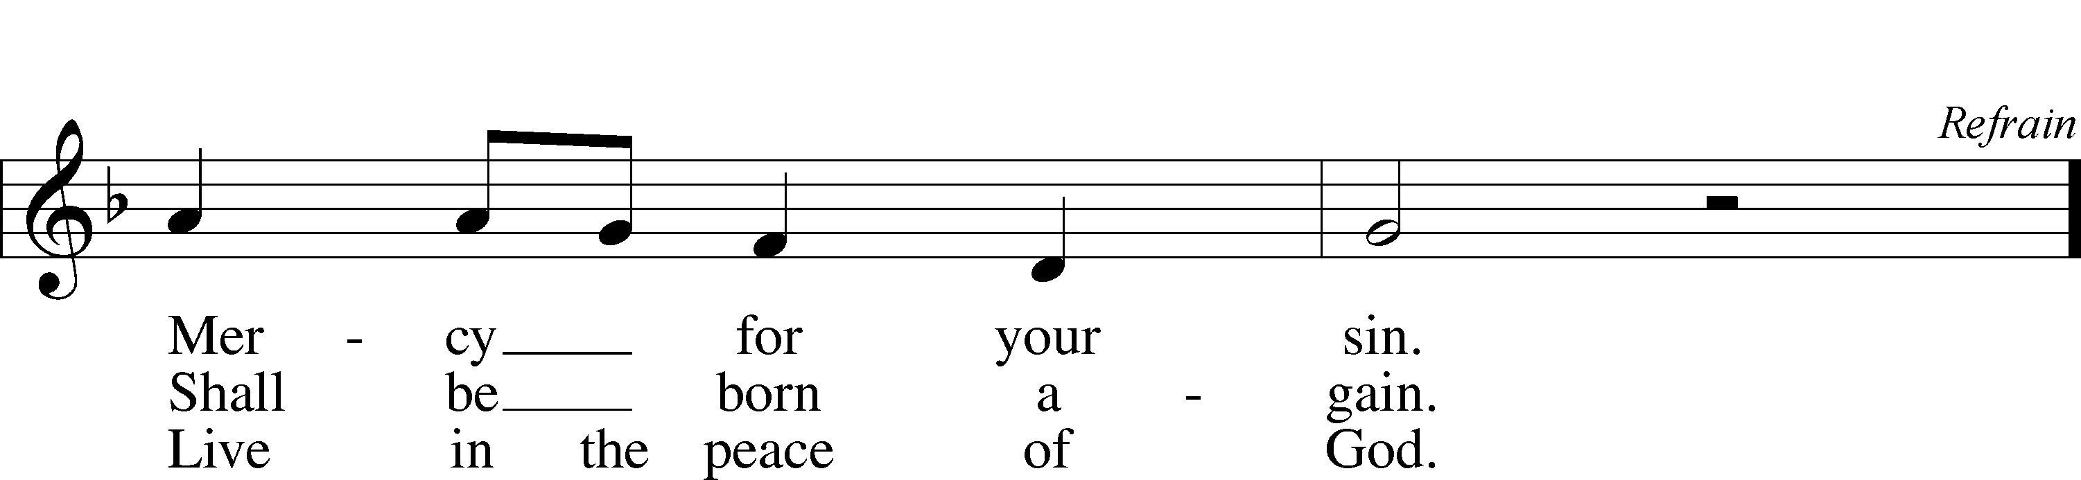
Text and tune: Robin Mann, 1949
Text and tune: © 1986 Kevin Mayhew Ltd. Used by permission: LSB Hymn License no. 110004388

Confession and Absolution

Stand

The sign of the cross may be made by all in remembrance of their Baptism.

P In the name of the Father and of the T Son and of the Holy Spirit.
C Amen.

P Our help is in the name of the Lord,
C who made heaven and earth.

P If You, O Lord, kept a record of sins, O Lord, who could stand?
C But with You there is forgiveness; therefore You are feared.

P Since we are gathered to hear God’s Word and call upon Him in prayer and praise, let us first consider our unworthiness and confess before God and one another that we have sinned in thought, word, and deed, and that we cannot free ourselves from our sinful condition. Together as His people let us take refuge in the infinite mercy of God, our heavenly Father, seeking His grace for the sake of Christ, and saying: God, be merciful to me, a sinner.

C Almighty God, have mercy upon us, forgive us our sins, and lead us to everlasting life. Amen.

P Almighty God in His mercy has given His Son to die for you and for His sake forgives you all your sins. As a called and ordained servant of Christ, and by His authority, I therefore forgive you all your sins in the name of the Father and of the T Son and of the Holy Spirit.
C Amen.

Service of the Word

Introit Psalm 30:1–5; antiphon: Psalm 16:11b
In your presence there is fullness of joy;
at your right hand are pleasures forevermore.
I will extol you, O Lord, for you have drawn me up
and have not let my foes rejoice over me.
O Lord my God, I cried to you for help,
and you have healed me.
O Lord, you have brought up my soul from Sheol;
you restored me to life from among those who go down to the pit.
Sing praises to the Lord, O you his saints,
and give thanks to his holy name.
For his anger is but for a moment, and his favor is for a lifetime.
Weeping may tarry for the night, but joy comes with the morning.
Glory be to the Father and to the Son
and to the Holy Spirit;
as it was in the beginning,
is now, and will be forever. Amen.
In your presence there is fullness of joy;
at your right hand are pleasures forevermore.

Kyrie LSB 204
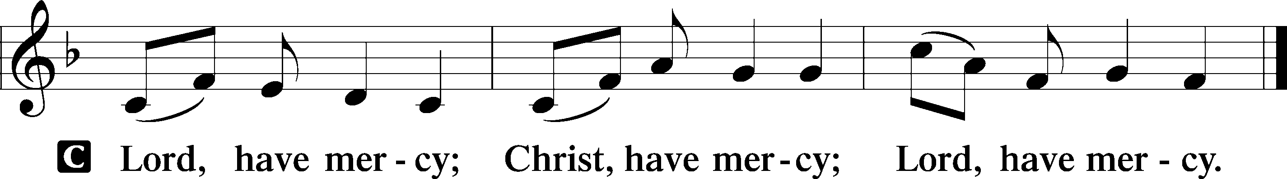

Gloria in Excelsis LSB 204
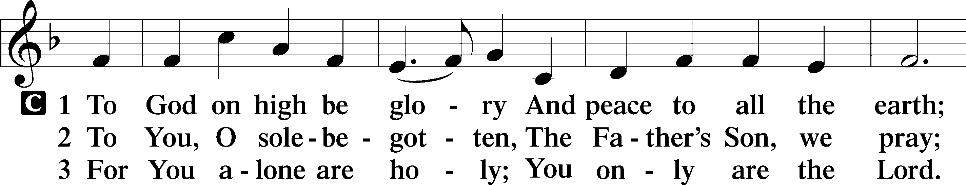
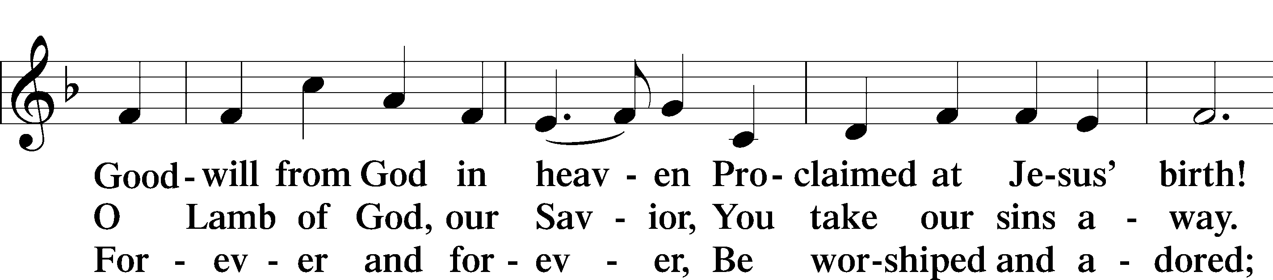
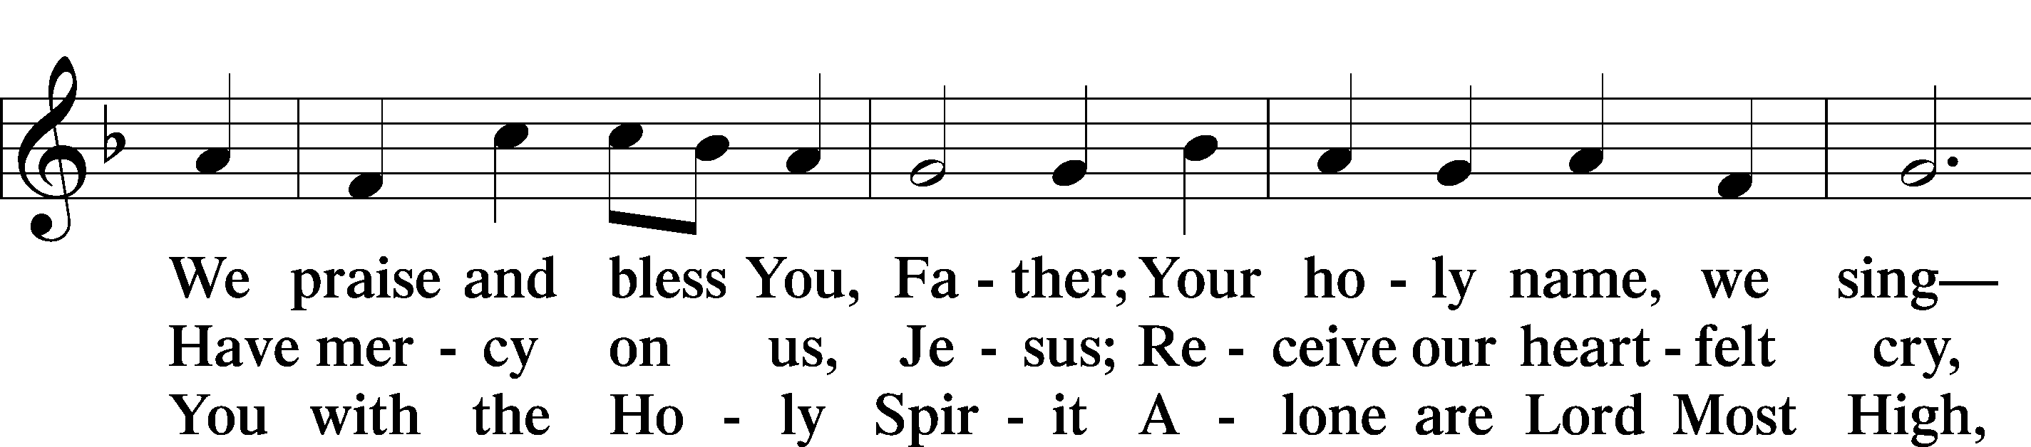
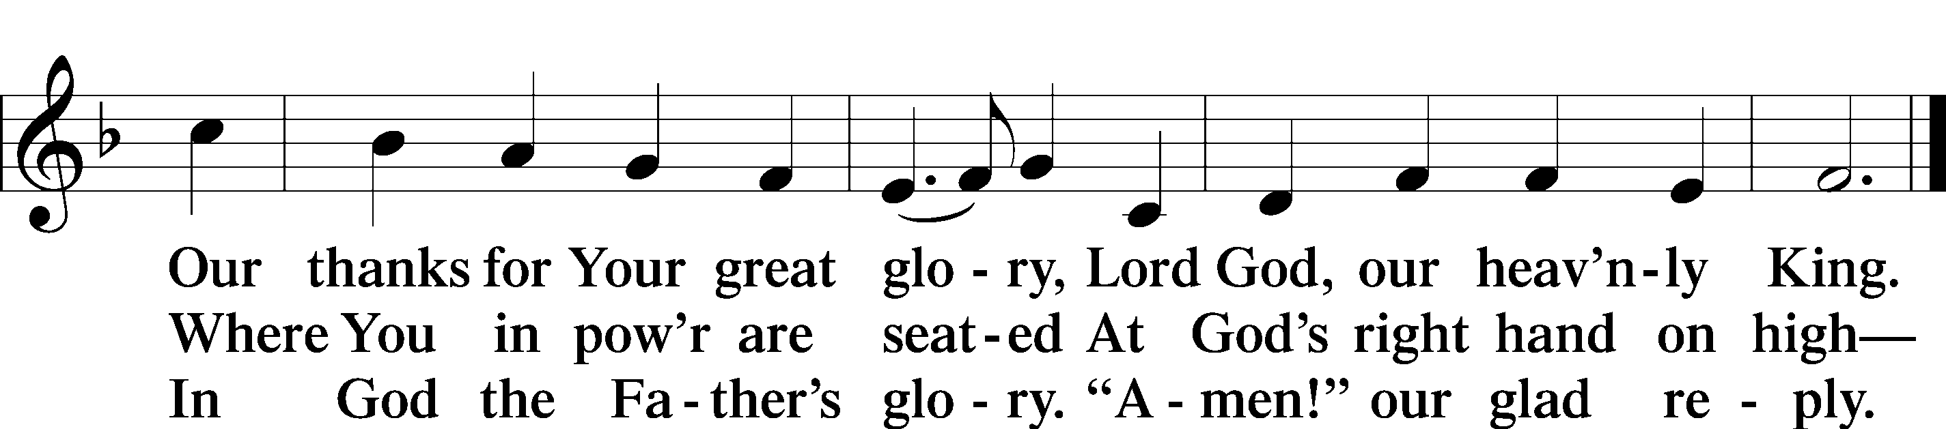
Text: Stephen P. Starke

Salutation and Collect of the Day
P The Lord be with you.
C And also with you.

P Let us pray.
O God, through the humiliation of Your Son You raised up the fallen world. Grant to Your faithful people, rescued from the peril of everlasting death, perpetual gladness and eternal joys; through Jesus Christ, our Lord, who lives and reigns with You and the Holy Spirit, one God, now and forever.

C Amen.

Sit

First Reading Acts 3:11–21
11While [the lame man who was now healed] clung to Peter and John, all the people ran together to them in the portico called Solomon’s, astounded. 12And when Peter saw it he addressed the people: “Men of Israel, why do you wonder at this, or why do you stare at us, as though by our own power or piety we have made him walk? 13The God of Abraham, the God of Isaac, and the God of Jacob, the God of our fathers, glorified his servant Jesus, whom you delivered over and denied in the presence of Pilate, when he had decided to release him. 14But you denied the Holy and Righteous One, and asked for a murderer to be granted to you, 15and you killed the Author of life, whom God raised from the dead. To this we are witnesses. 16And his name—by faith in his name—has made this man strong whom you see and know, and the faith that is through Jesus has given the man this perfect health in the presence of you all.
17“And now, brothers, I know that you acted in ignorance, as did also your rulers. 18But what God foretold by the mouth of all the prophets, that his Christ would suffer, he thus fulfilled. 19Repent therefore, and turn again, that your sins may be blotted out, 20that times of refreshing may come from the presence of the Lord, and that he may send the Christ appointed for you, Jesus, 21whom heaven must receive until the time for restoring all the things about which God spoke by the mouth of his holy prophets long ago.”

A This is the Word of the Lord.
C Thanks be to God.

Epistle 1 John 3:1–7
1See what kind of love the Father has given to us, that we should be called children of God; and so we are. The reason why the world does not know us is that it did not know him. 2Beloved, we are God’s children now, and what we will be has not yet appeared; but we know that when he appears we shall be like him, because we shall see him as he is. 3And everyone who thus hopes in him purifies himself as he is pure.
4Everyone who makes a practice of sinning also practices lawlessness; sin is lawlessness. 5You know that he appeared to take away sins, and in him there is no sin. 6No one who abides in him keeps on sinning; no one who keeps on sinning has either seen him or known him. 7Little children, let no one deceive you. Whoever practices righteousness is righteous, as he is righteous.

A This is the Word of the Lord.
C Thanks be to God.

Trusting You for All (Cornell) Choir

Stand

Holy Gospel Luke 24:36–49
P The Holy Gospel according to St. Luke, the twenty-fourth chapter.
C Glory to You, O Lord.

36As they were talking about these things, Jesus himself stood among them, and said to them, “Peace to you!” 37But they were startled and frightened and thought they saw a spirit. 38And he said to them, “Why are you troubled, and why do doubts arise in your hearts? 39See my hands and my feet, that it is I myself. Touch me, and see. For a spirit does not have flesh and bones as you see that I have.” 40And when he had said this, he showed them his hands and his feet. 41And while they still disbelieved for joy and were marveling, he said to them, “Have you anything here to eat?” 42They gave him a piece of broiled fish, 43and he took it and ate before them.
44Then he said to them, “These are my words that I spoke to you while I was still with you, that everything written about me in the Law of Moses and the Prophets and the Psalms must be fulfilled.” 45Then he opened their minds to understand the Scriptures, 46and said to them, “Thus it is written, that the Christ should suffer and on the third day rise from the dead, 47and that repentance and forgiveness of sins should be proclaimed in his name to all nations, beginning from Jerusalem. 48You are witnesses of these things. 49And behold, I am sending the promise of my Father upon you. But stay in the city until you are clothed with power from on high.”

P This is the Gospel of the Lord.
C Praise to You, O Christ.

Apostles’ Creed
C I believe in God, the Father Almighty, maker of heaven and earth.

And in Jesus Christ, His only Son, our Lord, who was conceived by the Holy Spirit, born of the virgin Mary, suffered under Pontius Pilate, was crucified, died and was buried. He descended into hell. The third day He rose again from the dead. He ascended into heaven and sits at the right hand of God the Father Almighty. From thence He will come to judge the living and the dead.

I believe in the Holy Spirit, the holy Christian Church, the communion of saints, the forgiveness of sins, the resurrection of the body, and the life T everlasting. Amen.

Sit

484 Make Songs of Joy
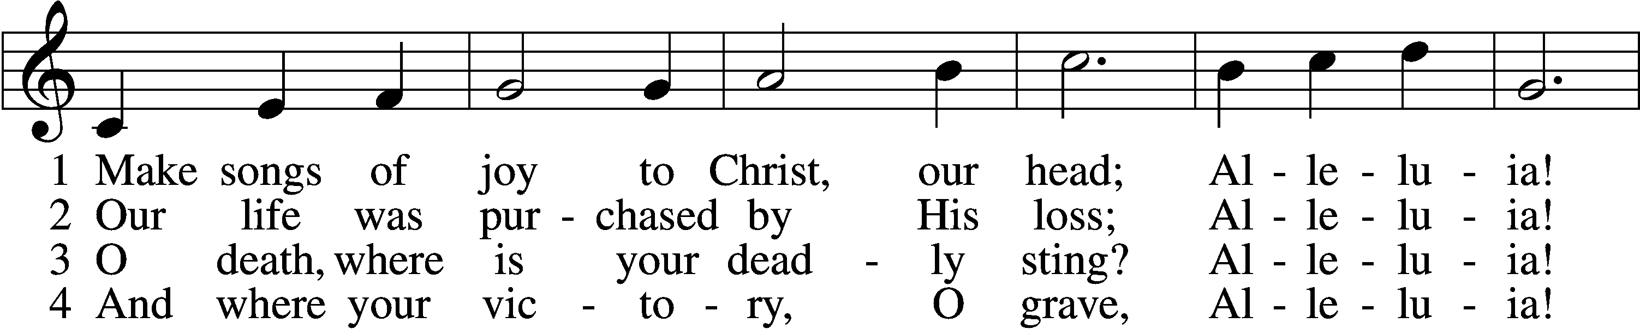
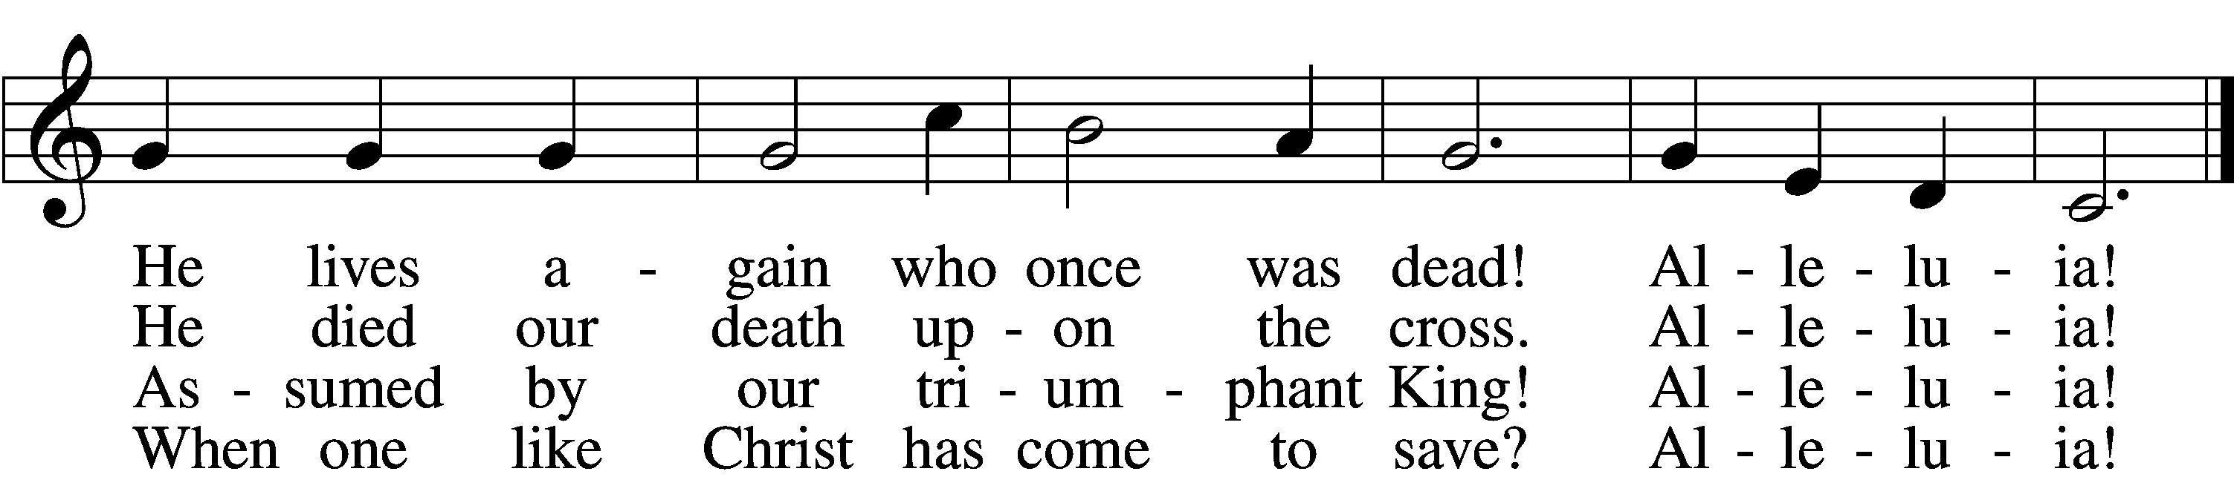

5 Behold, the tyrants, one and all,
Alleluia!
Before our mighty Savior fall!
Alleluia!
D 6 For this be praised the Son who rose,
Alleluia!
The Father, and the Holy Ghost!
Alleluia!

Text: Juraj Tranovský, 1591–1637; tr. Jaroslav J. Vajda, 1919–2008
Tune: Velká Partitúra, 1936, ed. Juraj Chorvát
Text: © 1978 Lutheran Book of Worship. Used by permission: LSB Hymn License no. 110004388
Tune: Public domain

Sermon: “Jesus Opens Our Minds” Luke 24:36-49

Offering

Stand

Prayer of the Church

Lord’s Prayer
C Our Father who art in heaven, hallowed be Thy name, Thy kingdom come, Thy will be done on earth as it is in heaven; give us this day our daily bread; and forgive us our trespasses as we forgive those who trespass against us; and lead us not into temptation, but deliver us from evil. For Thine is the kingdom and the power and the glory forever and ever. Amen.

Benedicamus LSB 212
A Let us bless the Lord.
C Thanks be to God.

Benediction
P The Lord bless you and keep you.
The Lord make His face shine on you and be gracious to you.
The Lord look upon you with favor and T give you peace.
C Amen.

483 With High Delight Let Us Unite
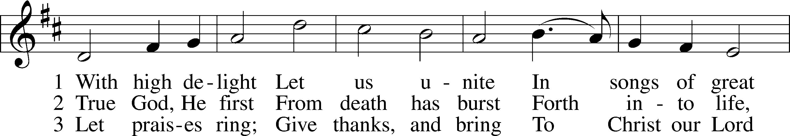
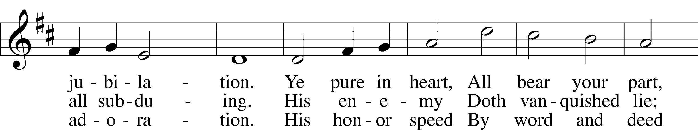
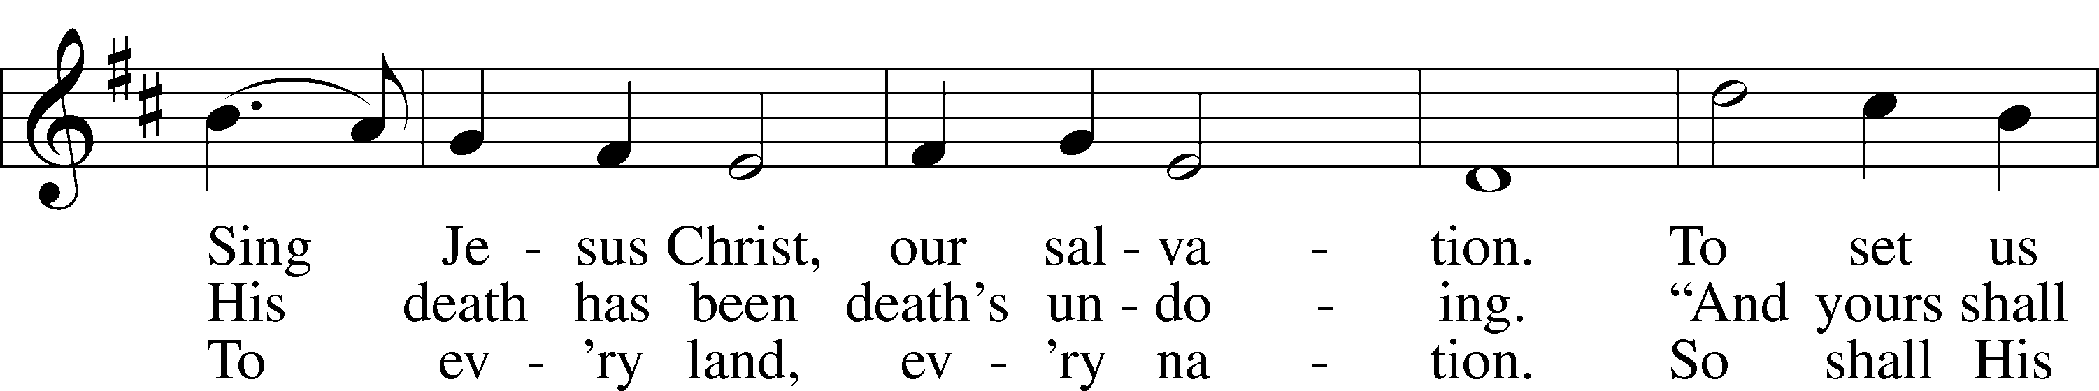
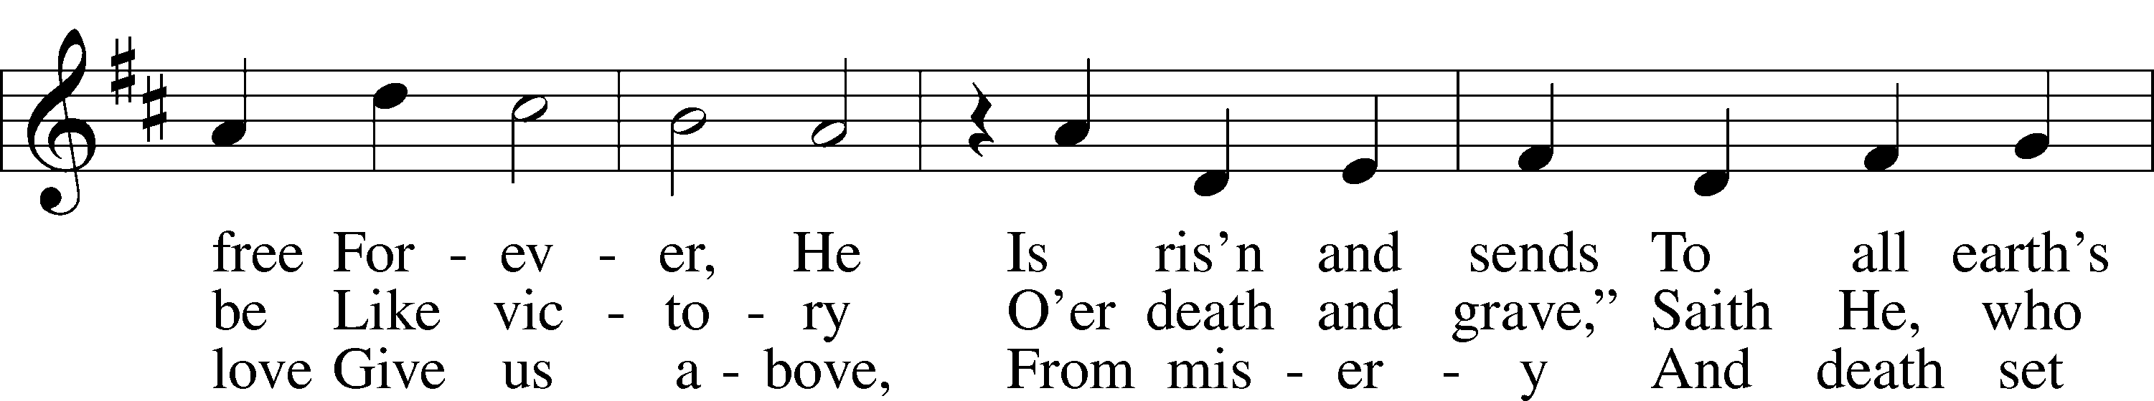
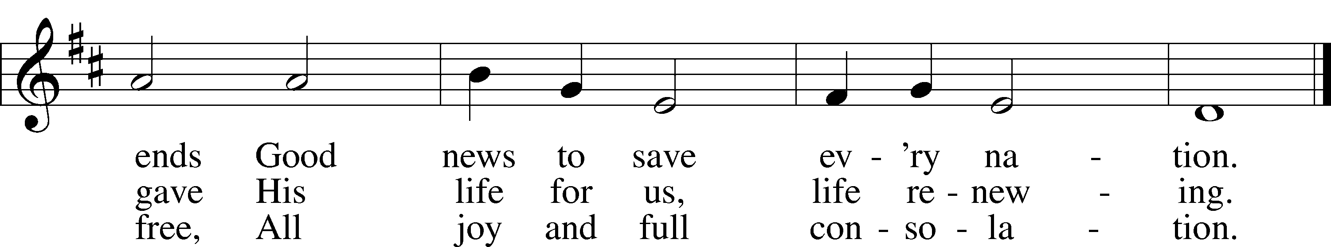
Text: Georg Vetter, 1536–99; tr. Martin H. Franzmann, 1907–76
Tune: Cinquante Pseaumes, 1543, Geneva
Text: © 1969 Concordia Publishing House. Used by permission: LSB Hymn License no. 110004388
Tune: Public domain

Acknowledgments
Divine Service, Setting Four from Lutheran Service Book
Unless otherwise indicated, Scripture quotations are from the ESV® Bible (The Holy Bible, English Standard Version®), copyright © 2001 by Crossway, a publishing ministry of Good News Publishers. Used by permission. All rights reserved.
Created by Lutheran Service Builder © 2024 Concordia Publishing House.

