The Fifth Sunday of Easter
April 28, 2024

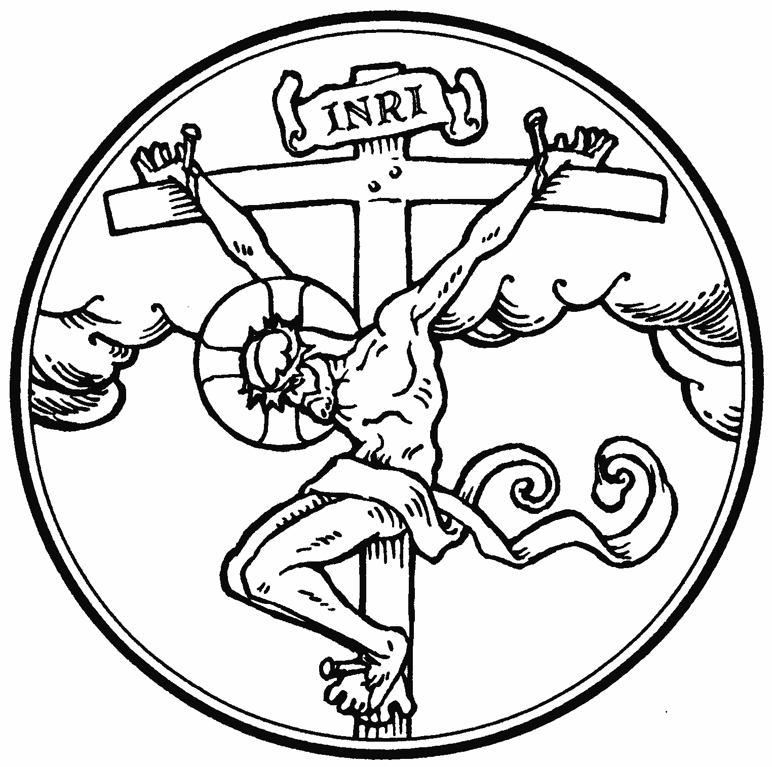

“In this is love, not that we have loved God but that he loved us and sent his Son to be the propitiation for our sins”

Peace Lutheran Church + 1451 Ebenezer Rd + Cincinnati, OH 45233
www.peacechurchlink.com + 513-941-5177
601 All Who Believe and Are Baptized
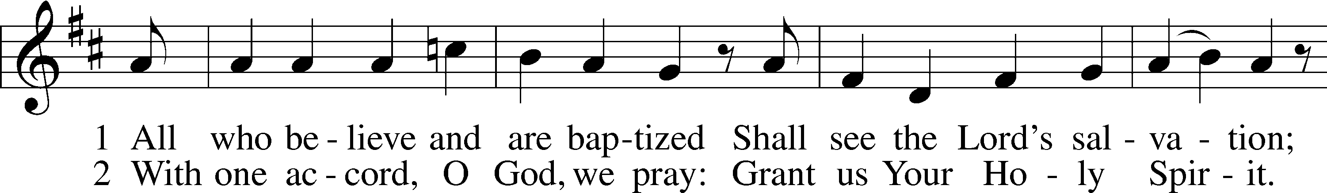
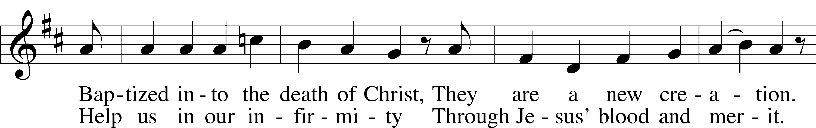
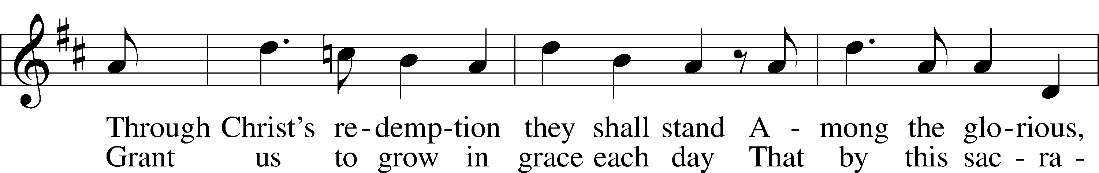
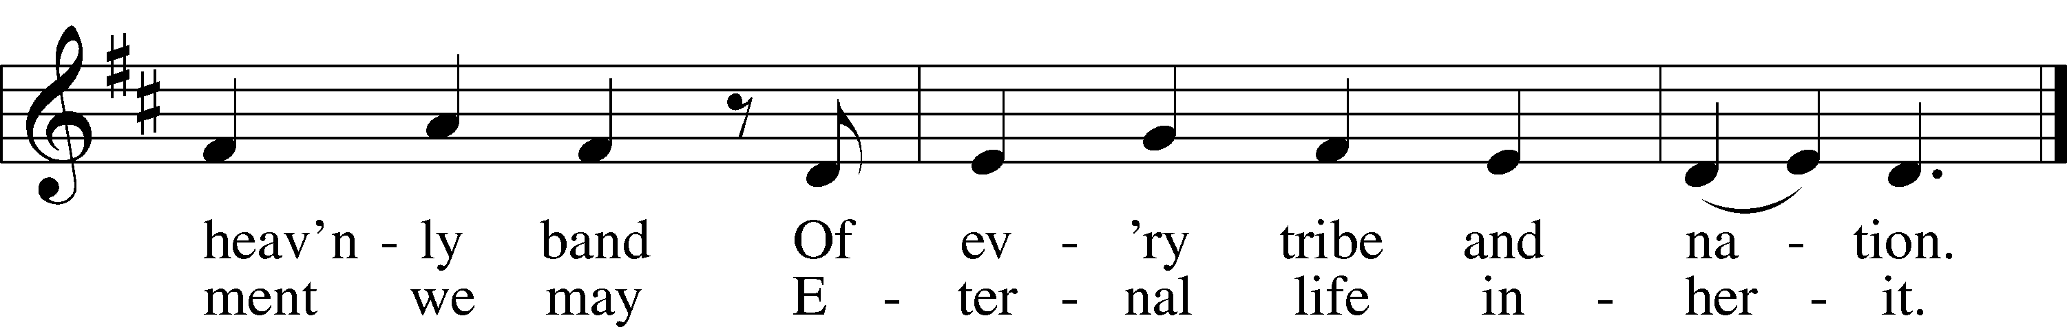
Text: Thomas Hansen Kingo, 1634–1703; tr. George A. T. Rygh, 1860–1942, alt.
Tune: Etlich Cristlich lider, 1524, Wittenberg
Text and tune: Public domain

Confession and Absolution

Stand

The sign of the cross may be made by all in remembrance of their Baptism.

P In the name of the Father and of the T Son and of the Holy Spirit.
C Amen.

P Our help is in the name of the Lord,
C who made heaven and earth.

P If You, O Lord, kept a record of sins, O Lord, who could stand?
C But with You there is forgiveness; therefore You are feared.
P Since we are gathered to hear God’s Word and call upon Him in prayer and praise, let us first consider our unworthiness and confess before God and one another that we have sinned in thought, word, and deed, and that we cannot free ourselves from our sinful condition. Together as His people let us take refuge in the infinite mercy of God, our heavenly Father, seeking His grace for the sake of Christ, and saying: God, be merciful to me, a sinner.

C Almighty God, have mercy upon us, forgive us our sins, and lead us to everlasting life. Amen.

P Almighty God in His mercy has given His Son to die for you and for His sake forgives you all your sins. As a called and ordained servant of Christ, and by His authority, I therefore forgive you all your sins in the name of the Father and of the T Son and of the Holy Spirit.
C Amen.

Service of the Word

Introit Psalm 145:1–2, 8, 10, 21; antiphon: John 16:16
A little while, and you will see me no longer;
and again a little while, and you will see me.
I will extol you, my God and King,
and bless your name forever and ever.
Every day I will bless you
and praise your name forever and ever.
The Lord is gracious and merciful,
slow to anger and abounding in steadfast love.
All your works shall give thanks to you, O Lord,
and all your saints shall bless you!
My mouth will speak the praise of the Lord,
and let all flesh bless his holy name forever and ever.
Glory be to the Father and to the Son
and to the Holy Spirit;
as it was in the beginning,
is now, and will be forever. Amen.
A little while, and you will see me no longer;
and again a little while, and you will see me.
Kyrie LSB 204
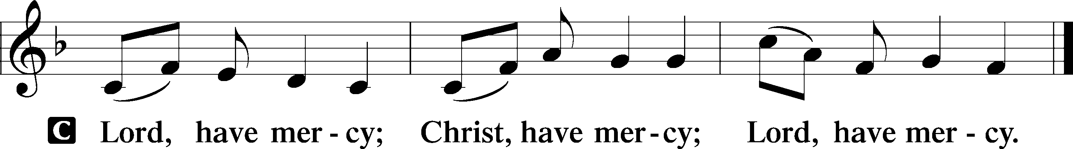

Gloria in Excelsis LSB 204
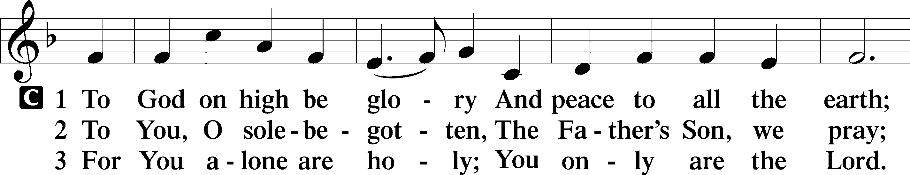
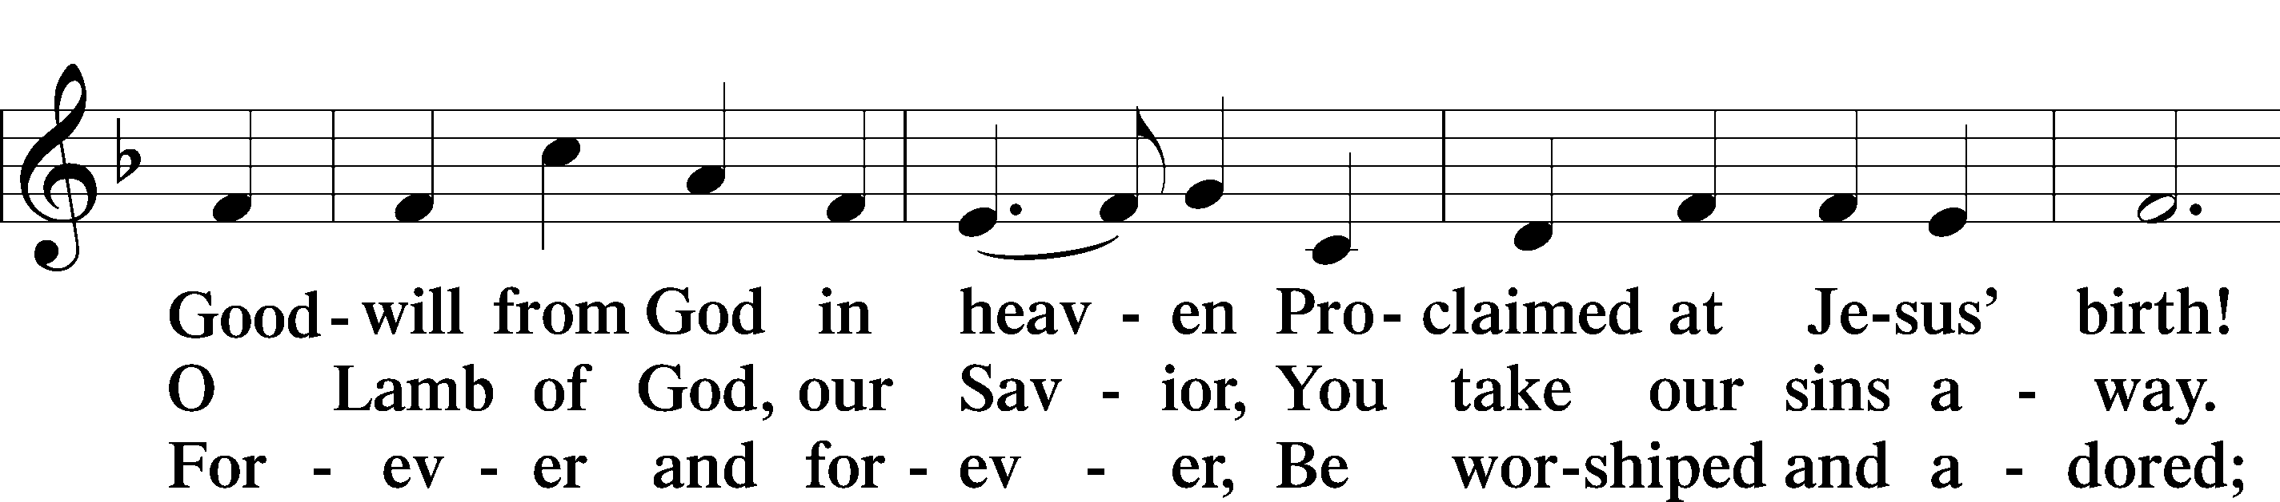
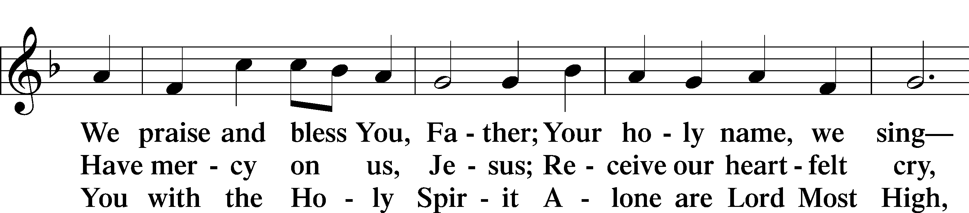
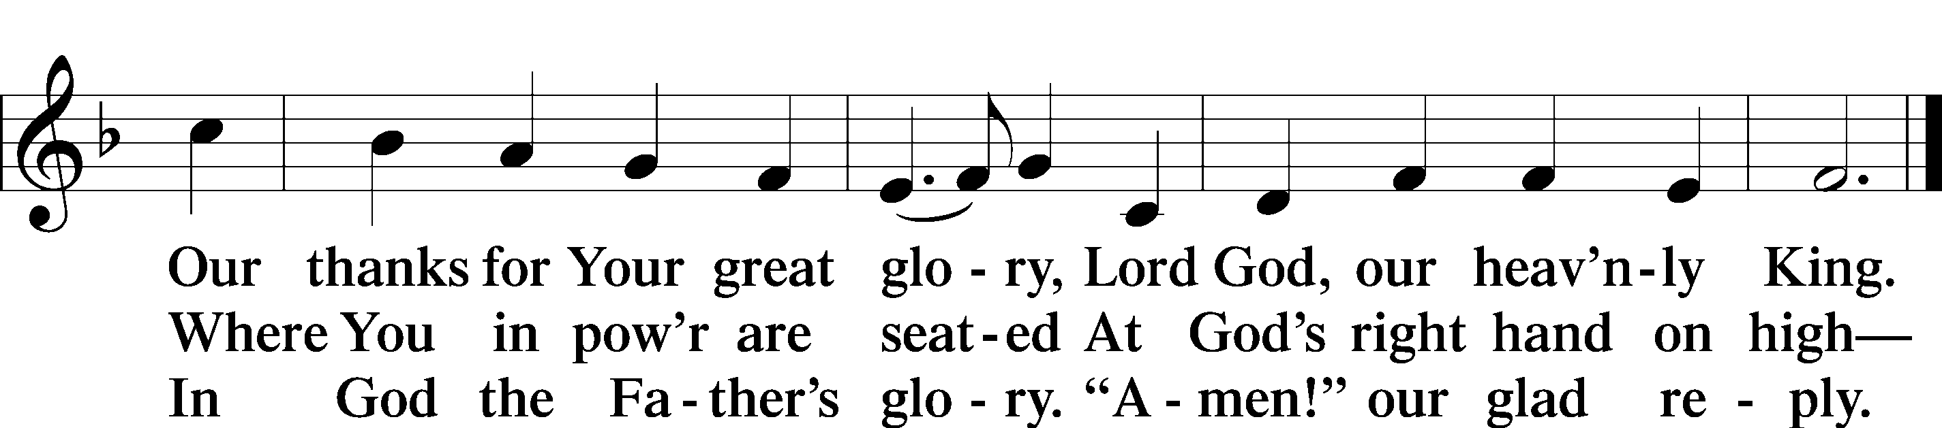
Text: Stephen P. Starke

Salutation and Collect of the Day
P The Lord be with you.
C And also with you.

P Let us pray.
O God, You make the minds of Your faithful to be of one will. Grant that we may love what You have commanded and desire what You promise, that among the many changes of this world our hearts may be fixed where true joys are found; through Jesus Christ, Your Son, our Lord, who lives and reigns with You and the Holy Spirit, one God, now and forever.
C Amen.

Sit

First Reading Acts 8:26–40
26An angel of the Lord said to Philip, “Rise and go toward the south to the road that goes down from Jerusalem to Gaza.” This is a desert place. 27And he rose and went. And there was an Ethiopian, a eunuch, a court official of Candace, queen of the Ethiopians, who was in charge of all her treasure. He had come to Jerusalem to worship 28and was returning, seated in his chariot, and he was reading the prophet Isaiah. 29And the Spirit said to Philip, “Go over and join this chariot.” 30So Philip ran to him and heard him reading Isaiah the prophet and asked, “Do you understand what you are reading?” 31And he said, “How can I, unless someone guides me?” And he invited Philip to come up and sit with him. 32Now the passage of the Scripture that he was reading was this:
“Like a sheep he was led to the slaughter
and like a lamb before its shearer is silent,
so he opens not his mouth.
33In his humiliation justice was denied him.
Who can describe his generation?
For his life is taken away from the earth.”
34And the eunuch said to Philip, “About whom, I ask you, does the prophet say this, about himself or about someone else?” 35Then Philip opened his mouth, and beginning with this Scripture he told him the good news about Jesus. 36And as they were going along the road they came to some water, and the eunuch said, “See, here is water! What prevents me from being baptized?” 38And he commanded the chariot to stop, and they both went down into the water, Philip and the eunuch, and he baptized him. 39And when they came up out of the water, the Spirit of the Lord carried Philip away, and the eunuch saw him no more, and went on his way rejoicing. 40But Philip found himself at Azotus, and as he passed through he preached the gospel to all the towns until he came to Caesarea.
A This is the Word of the Lord.
C Thanks be to God.

Epistle 1 John 4:1–11
1Beloved, do not believe every spirit, but test the spirits to see whether they are from God, for many false prophets have gone out into the world. 2By this you know the Spirit of God: every spirit that confesses that Jesus Christ has come in the flesh is from God, 3and every spirit that does not confess Jesus is not from God. This is the spirit of the antichrist, which you heard was coming and now is in the world already. 4Little children, you are from God and have overcome them, for he who is in you is greater than he who is in the world. 5They are from the world; therefore they speak from the world, and the world listens to them. 6We are from God. Whoever knows God listens to us; whoever is not from God does not listen to us. By this we know the Spirit of truth and the spirit of error.
7Beloved, let us love one another, for love is from God, and whoever loves has been born of God and knows God. 8Anyone who does not love does not know God, because God is love. 9In this the love of God was made manifest among us, that God sent his only Son into the world, so that we might live through him. 10In this is love, not that we have loved God but that he loved us and sent his Son to be the propitiation for our sins. 11Beloved, if God so loved us, we also ought to love one another.

A This is the Word of the Lord.
C Thanks be to God.

I Am the Vine (Pote) Choir

Stand

Holy Gospel John 15:1–8
P The Holy Gospel according to St. John, the fifteenth chapter.
C Glory to You, O Lord.

1[Jesus said:] “I am the true vine, and my Father is the vinedresser. 2Every branch of mine that does not bear fruit he takes away, and every branch that does bear fruit he prunes, that it may bear more fruit. 3Already you are clean because of the word that I have spoken to you. 4Abide in me, and I in you. As the branch cannot bear fruit by itself, unless it abides in the vine, neither can you, unless you abide in me. 5I am the vine; you are the branches. Whoever abides in me and I in him, he it is that bears much fruit, for apart from me you can do nothing. 6If anyone does not abide in me he is thrown away like a branch and withers; and the branches are gathered, thrown into the fire, and burned. 7If you abide in me, and my words abide in you, ask whatever you wish, and it will be done for you. 8By this my Father is glorified, that you bear much fruit and so prove to be my disciples.”

P This is the Gospel of the Lord.
C Praise to You, O Christ.

Apostles’ Creed
C I believe in God, the Father Almighty, maker of heaven and earth.

And in Jesus Christ, His only Son, our Lord, who was conceived by the Holy Spirit, born of the virgin Mary, suffered under Pontius Pilate, was crucified, died and was buried. He descended into hell. The third day He rose again from the dead. He ascended into heaven and sits at the right hand of God the Father Almighty. From thence He will come to judge the living and the dead.

I believe in the Holy Spirit, the holy Christian Church, the communion of saints, the forgiveness of sins, the resurrection of the body, and the life T everlasting. Amen.

Sit

706 Love in Christ Is Strong and Living
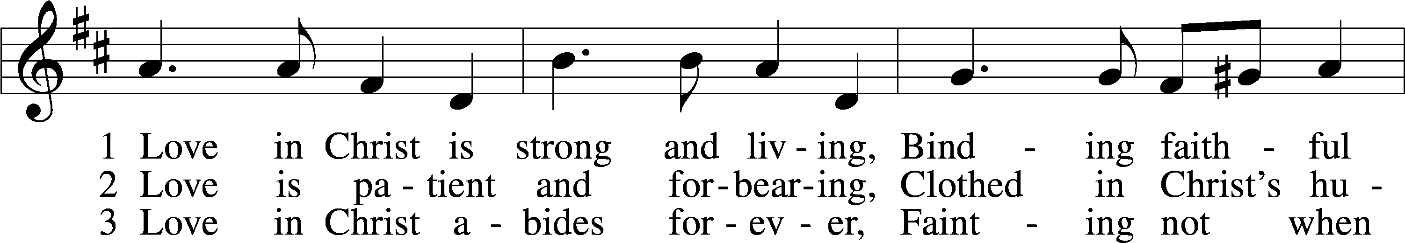
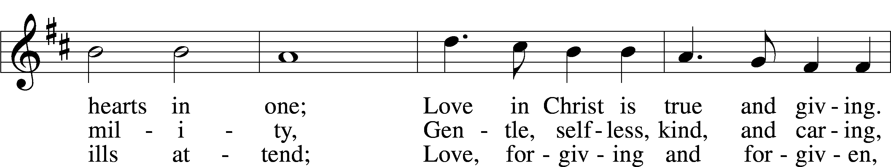
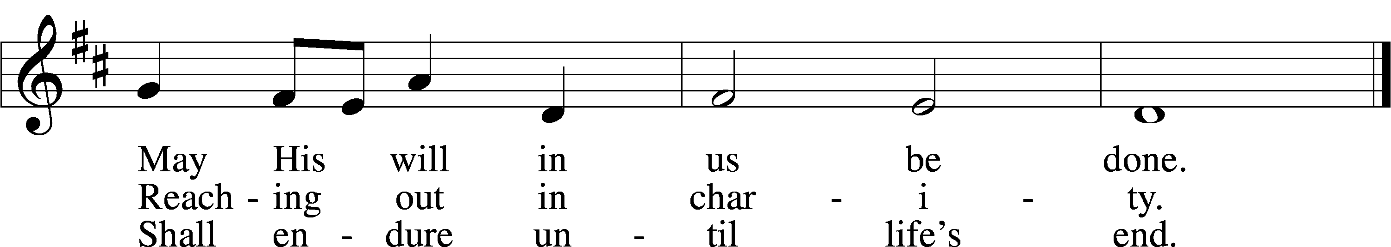
Text: Dorothy R. Schultz, 1934
Tune: Ralph C. Schultz, 1932
Text and tune: © 1979 Concordia Publishing House. Used by permission: LSB Hymn License no. 110004388

Sermon: “What is Love?” 1 John 4:1-11

Offering

Stand

Prayer of the Church

Lord’s Prayer
C Our Father who art in heaven, hallowed be Thy name, Thy kingdom come, Thy will be done on earth as it is in heaven; give us this day our daily bread; and forgive us our trespasses as we forgive those who trespass against us; and lead us not into temptation, but deliver us from evil. For Thine is the kingdom and the power and the glory forever and ever. Amen.

Benedicamus LSB 212
A Let us bless the Lord.
C Thanks be to God.

Benediction
P The Lord bless you and keep you.
The Lord make His face shine on you and be gracious to you.
The Lord look upon you with favor and T give you peace.
C Amen.

465 Now All the Vault of Heaven Resounds
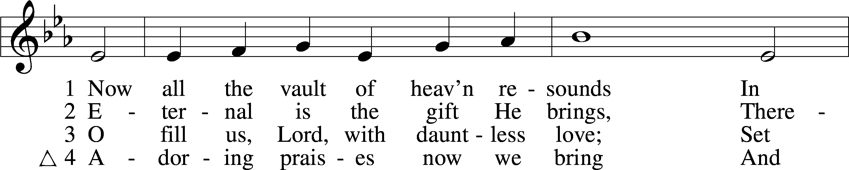
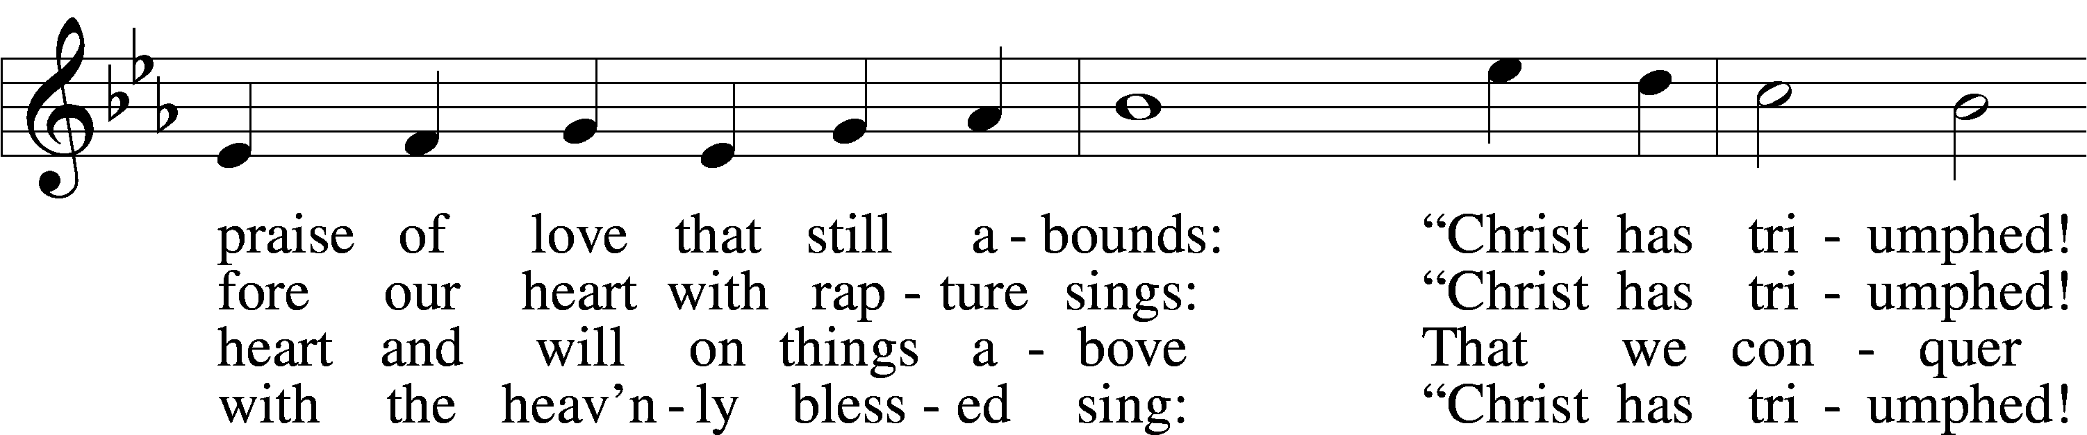
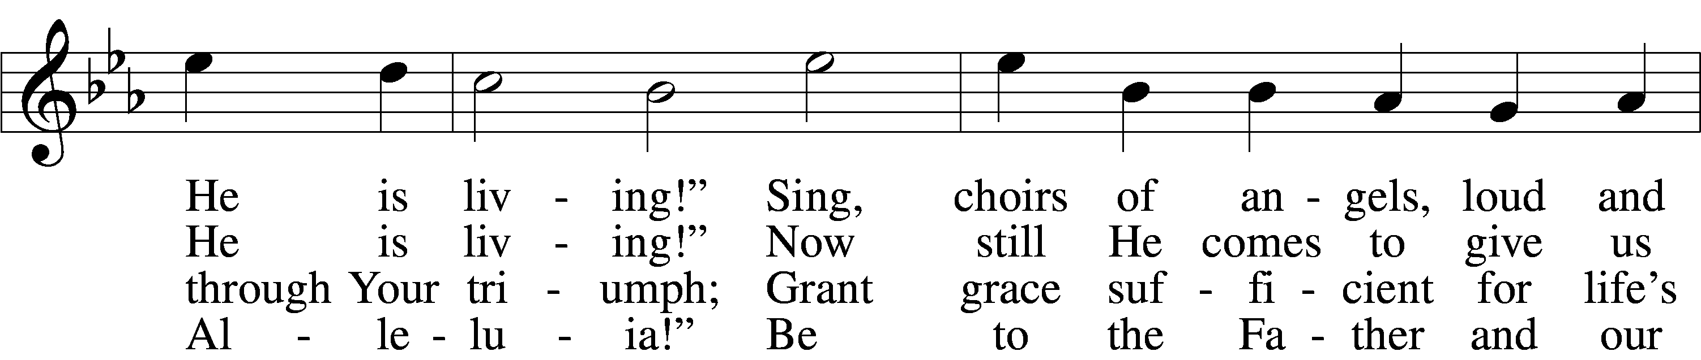
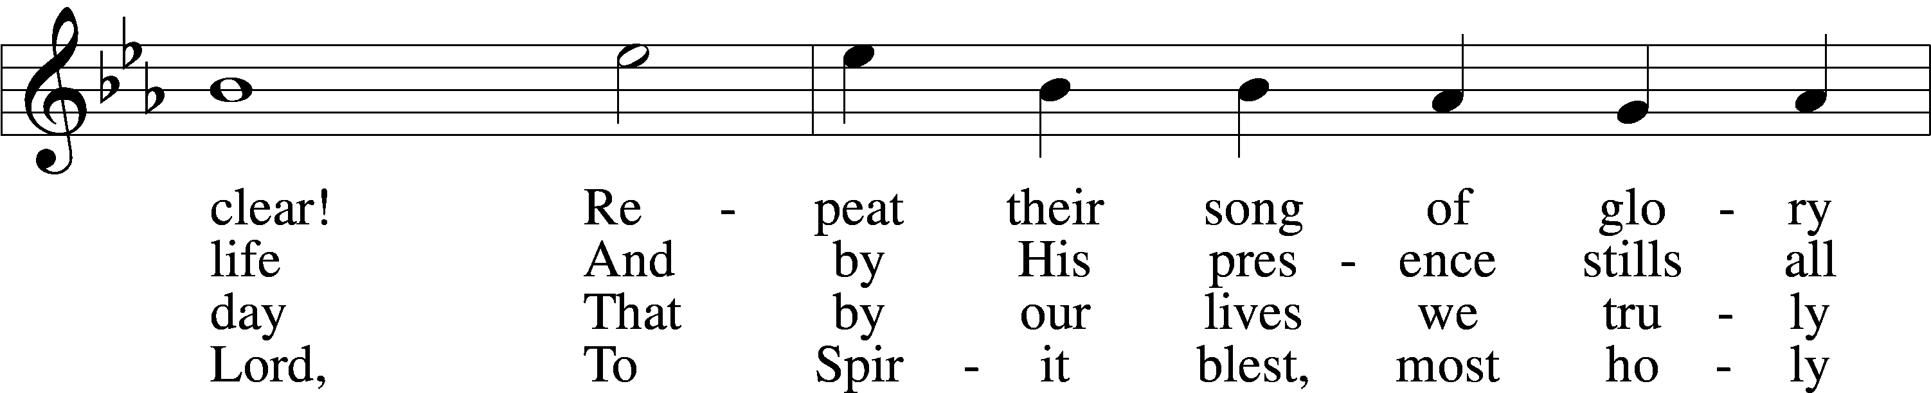
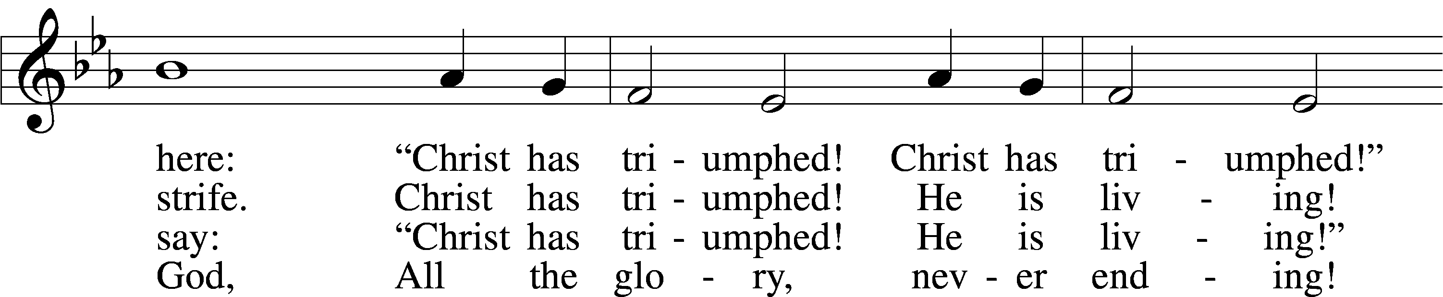
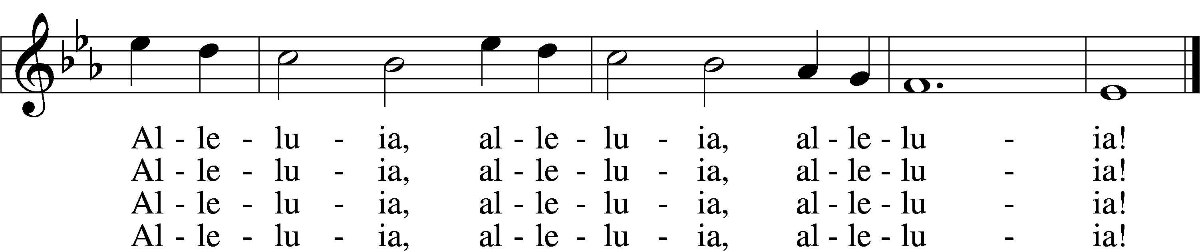
Text: Paul Z. Strodach, 1876–1947, alt.
Tune: Geistliche Kirchengesäng, 1623, Köln
Text: © 1958 Augsburg Publishing House. Used by permission: LSB Hymn License no. 110004388
Tune: Public domain

Acknowledgments
Divine Service, Setting Four from Lutheran Service Book
Unless otherwise indicated, Scripture quotations are from the ESV® Bible (The Holy Bible, English Standard Version®), copyright © 2001 by Crossway, a publishing ministry of Good News Publishers. Used by permission. All rights reserved.
Created by Lutheran Service Builder © 2024 Concordia Publishing House.

