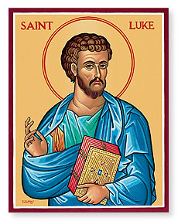
Luke 1
Sunday Bible Class 2024
Background
Who wrote Luke?

When was it written?

What’s the purpose of the book?

Dedication to Theophilus + Luke 1:1-4
Luke writes that “many have undertaken to compile a narrative of the things that have been accomplished among us…” (v.1) What ‘things’ is Luke talking about? What does this verse also suggest?

Who is Theophilus? (v.3) What does his name mean?

Birth of John the Baptist Foretold + Luke 1:5-25
What does John having the Holy Spirit from the womb suggest about infants? (see Luke 1:41, 44)

Why didn’t Zechariah believe Gabriel’s words? (Keep this in mind when we get to the next section)

Birth of Jesus Foretold + Luke 1:26-38
Why does Luke mention that Joseph is “of the house of David?” (v.27; see 2 Sam 7:1-17)

How does Mary’s response to Gabriel’s visit differ from Zechariah’s?

What is the significance of the word “overshadow?” (v.35; see TLSB note p.1706)

Mary Visits Elizabeth + Luke 1:39-45
How could Elizabeth possibly have known that Mary’s child was her ‘Lord?’ (i.e., Jesus)?

The Magnificat + Luke 1:46-56
Which of the major themes in Luke’s Gospel appears in Mary’s song?

In what way(s) does this theme apply to God? (See 2 Cor 8:9)

The Birth of John the Baptist + Luke 1:57-66
What was the significance of circumcising John on the 8th day?

The Benedictus + Luke 1:67-80
In what way(s) has God “visited and redeemed His people?” (v.68)

What is the significance of the wilderness? Why might John be out there until he begins preaching and baptizing in the Jordan River?

