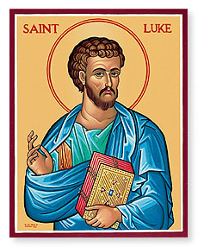
Luke 3
Sunday Bible Class 2024

John the Baptist Prepares the Way + Luke 3:1-9
What details about John the Baptist indicate that he’s a prophet like those in the Old Testament? (Hint: look in verse 2)

What are the similarities and differences between John’s baptism and Christian baptism instituted by Christ? (See also verses 16-17)

What does the phrase “brood of vipers” suggest about the crowds? What is the “wrath to come” which John speaks of here?

John the Baptist Prepares the Way (cont.) + Luke 3:10-17
John exhorts the people to be generous with their possessions and honest in their occupations. These are signs of genuine repentance. What actions can we take to likewise demonstrate genuine repentance?

What does it mean that Christ will baptize with “the Holy Spirit and fire?”

John The Baptist Prepares the Way (cont.) + Luke 3:18-22
Why did Herod (Antipas) lock up John in prison? What did Herod’s actions reveal about his repentance (or lack thereof)?

What detail in the account of Jesus’ baptism is unique to Luke’s Gospel?

The Genealogy of Jesus Christ + Luke 3:23-38
Why does Luke present Jesus’ genealogy here in chapter 3? (Note: Matthew puts Jesus’ genealogy at the beginning of his Gospel)

Why are there so many differences between Luke’s genealogy and Matthew’s genealogy? (See TLSB note on verses 23-38, p.1713)

