The Eighth Sunday after Pentecost
July 14, 2024

“He went and beheaded him in the prison and brought his head on a platter and gave it to the girl, and the girl gave it to her mother”

Peace Lutheran Church + 1451 Ebenezer Rd + Cincinnati, OH 45233
www.peacechurchlink.com + 513-941-5177
659 Lord of Our Life
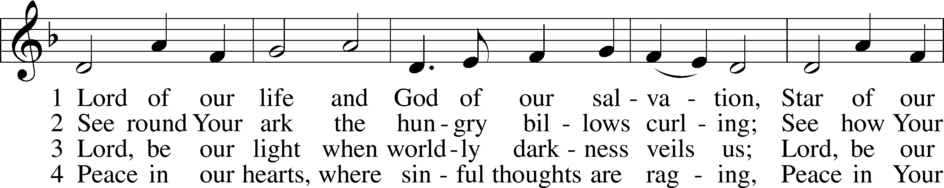
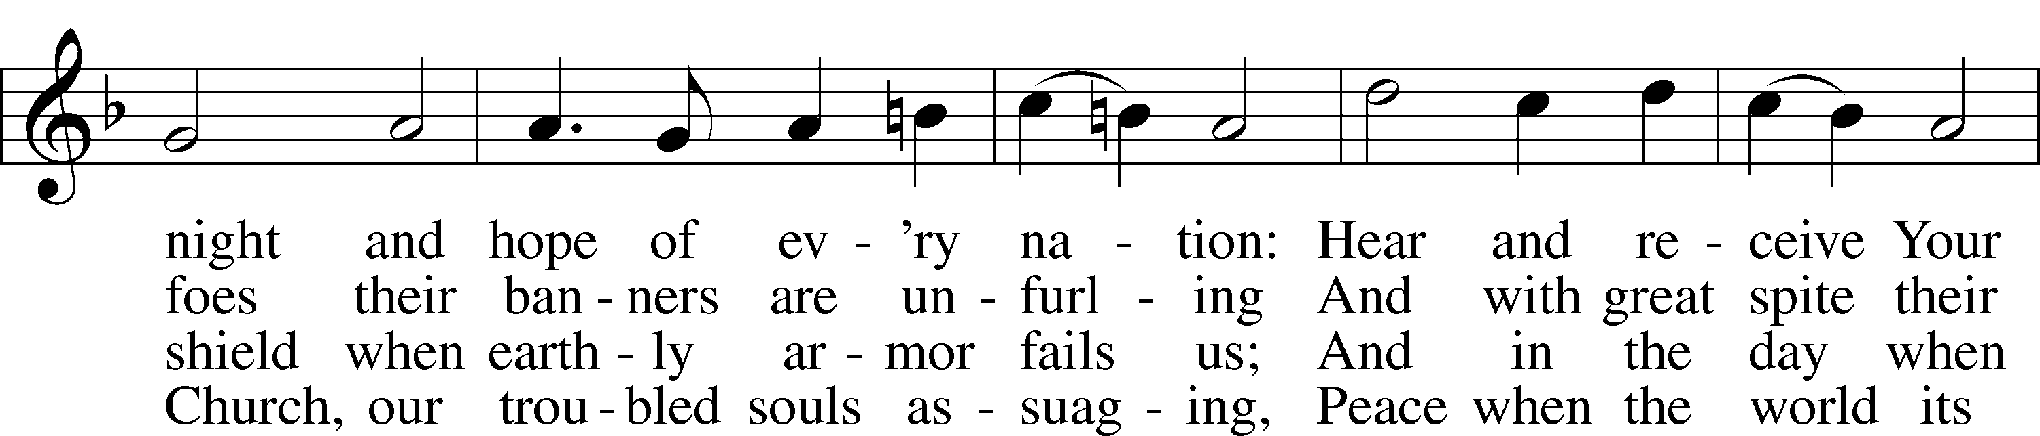
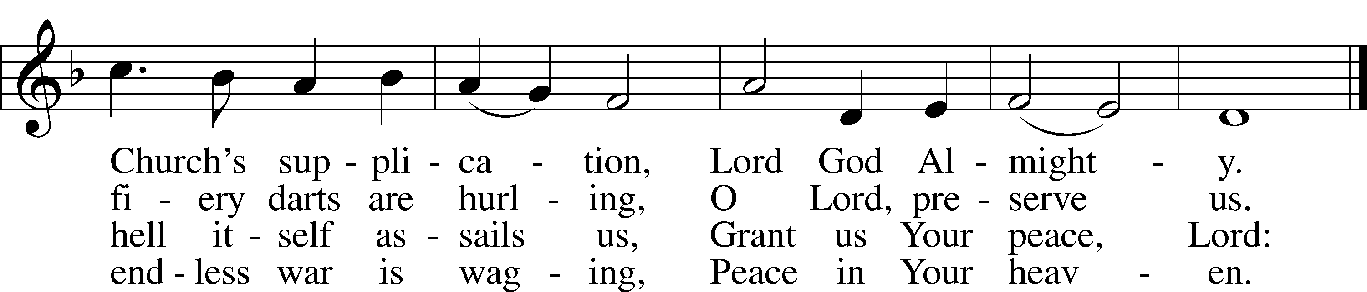
Text: Matthäus Apelles von Löwenstern, 1594–1648; tr. Philip Pusey, 1799–1855, alt.
Tune: Antiphoner, 1746, Poitiers
Text and tune: Public domain

Confession and Absolution

Stand

The sign of the cross may be made by all in remembrance of their Baptism.

P In the name of the Father and of the T Son and of the Holy Spirit.
C Amen.

P Our help is in the name of the Lord,
C who made heaven and earth.

P If You, O Lord, kept a record of sins, O Lord, who could stand?
C But with You there is forgiveness; therefore You are feared.
P Since we are gathered to hear God’s Word and call upon Him in prayer and praise, let us first consider our unworthiness and confess before God and one another that we have sinned in thought, word, and deed, and that we cannot free ourselves from our sinful condition. Together as His people let us take refuge in the infinite mercy of God, our heavenly Father, seeking His grace for the sake of Christ, and saying: God, be merciful to me, a sinner.

C Almighty God, have mercy upon us, forgive us our sins, and lead us to everlasting life. Amen.

P Almighty God in His mercy has given His Son to die for you and for His sake forgives you all your sins. As a called and ordained servant of Christ, and by His authority, I therefore forgive you all your sins in the name of the Father and of the T Son and of the Holy Spirit.
C Amen.

Service of the Word

Introit Psalm 143:1–2, 8a; antiphon: v. 11
For your name’s sake, O Lord, preserve my life!
In your righteousness bring my soul out of trouble!
Hear my prayer, O Lord; give ear to my pleas for mercy!
In your faithfulness answer me, in your righteousness!
Enter not into judgment with your servant,
for no one living is righteous before you.
Let me hear in the morning of your steadfast love,
for in you I trust.
Glory be to the Father and to the Son
and to the Holy Spirit;
as it was in the beginning,
is now, and will be forever. Amen.
For your name’s sake, O Lord, preserve my life!
In your righteousness bring my soul out of trouble!

Kyrie LSB 204
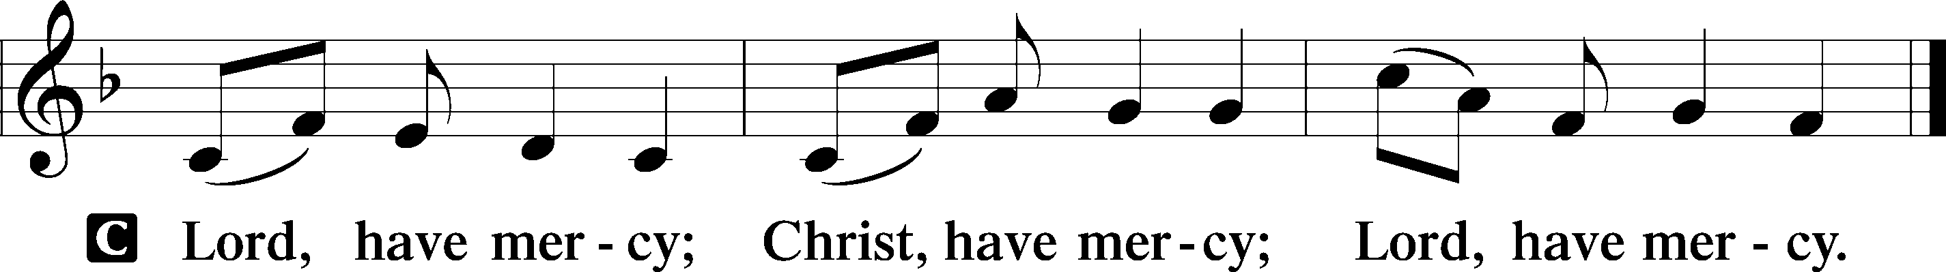

Gloria in Excelsis LSB 204
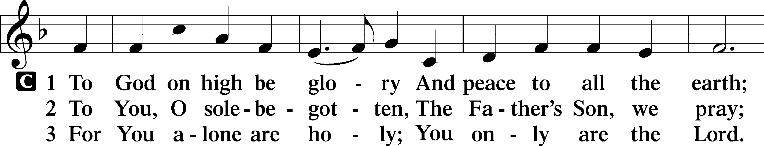
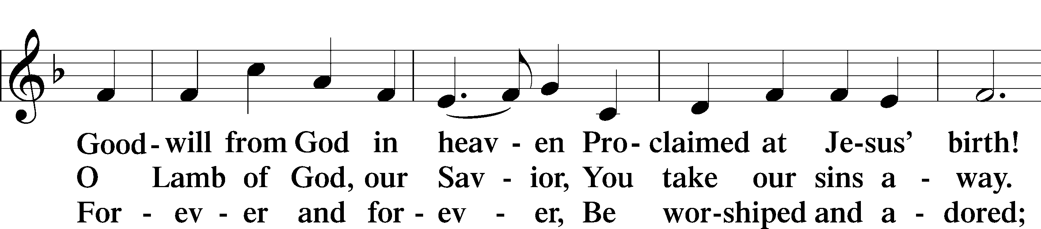
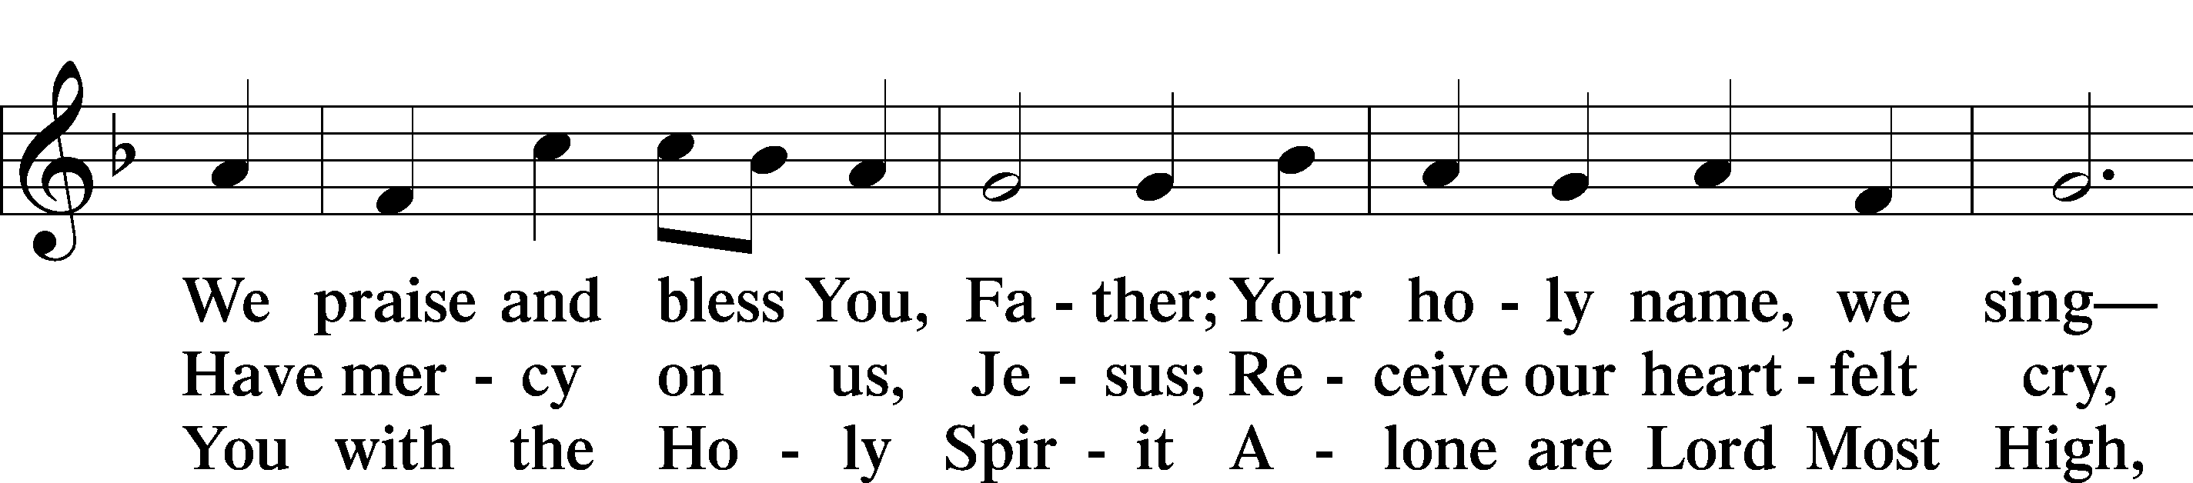
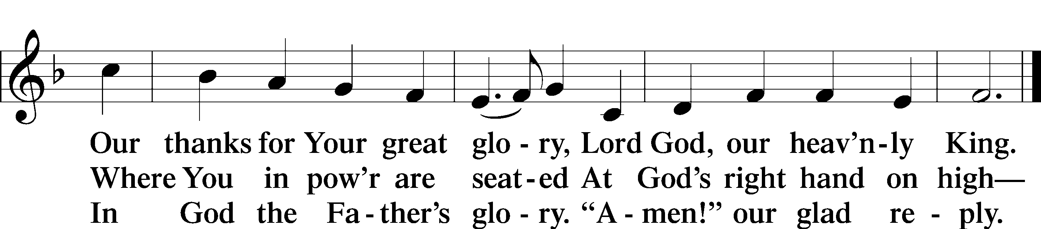
Text: Stephen P. Starke

Salutation and Collect of the Day
P The Lord be with you.
C And also with you.

P Let us pray.
O Lord, You granted Your prophets strength to resist the temptations of the devil and courage to proclaim repentance. Give us pure hearts and minds to follow Your Son faithfully even into suffering and death; through the same Jesus Christ, our Lord, who lives and reigns with You and the Holy Spirit, one God, now and forever.

C Amen.

Sit

Old Testament Reading Amos 7:7–15
7This is what [the Lord God] showed me: behold, the Lord was standing beside a wall built with a plumb line, with a plumb line in his hand. 8And the Lord said to me, “Amos, what do you see?” And I said, “A plumb line.” Then the Lord said,
“Behold, I am setting a plumb line
in the midst of my people Israel;
I will never again pass by them;
9the high places of Isaac shall be made desolate,
and the sanctuaries of Israel shall be laid waste,
and I will rise against the house of Jeroboam with the sword.”
10Then Amaziah the priest of Bethel sent to Jeroboam king of Israel, saying, “Amos has conspired against you in the midst of the house of Israel. The land is not able to bear all his words. 11For thus Amos has said,
“‘Jeroboam shall die by the sword,
and Israel must go into exile
away from his land.’”
12And Amaziah said to Amos, “O seer, go, flee away to the land of Judah, and eat bread there, and prophesy there, 13but never again prophesy at Bethel, for it is the king’s sanctuary, and it is a temple of the kingdom.”
14Then Amos answered and said to Amaziah, “I was no prophet, nor a prophet’s son, but I was a herdsman and a dresser of sycamore figs. 15But the Lord took me from following the flock, and the Lord said to me, ‘Go, prophesy to my people Israel.’”

A This is the Word of the Lord.
C Thanks be to God.
Epistle Ephesians 1:3–14
3Blessed be the God and Father of our Lord Jesus Christ, who has blessed us in Christ with every spiritual blessing in the heavenly places, 4even as he chose us in him before the foundation of the world, that we should be holy and blameless before him. In love 5he predestined us for adoption as sons through Jesus Christ, according to the purpose of his will, 6to the praise of his glorious grace, with which he has blessed us in the Beloved. 7In him we have redemption through his blood, the forgiveness of our trespasses, according to the riches of his grace, 8which he lavished upon us, in all wisdom and insight 9making known to us the mystery of his will, according to his purpose, which he set forth in Christ 10as a plan for the fullness of time, to unite all things in him, things in heaven and things on earth.
11In him we have obtained an inheritance, having been predestined according to the purpose of him who works all things according to the counsel of his will, 12so that we who were the first to hope in Christ might be to the praise of his glory. 13In him you also, when you heard the word of truth, the gospel of your salvation, and believed in him, were sealed with the promised Holy Spirit, 14who is the guarantee of our inheritance until we acquire possession of it, to the praise of his glory.

A This is the Word of the Lord.
C Thanks be to God.

Stand

Alleluia and Verse

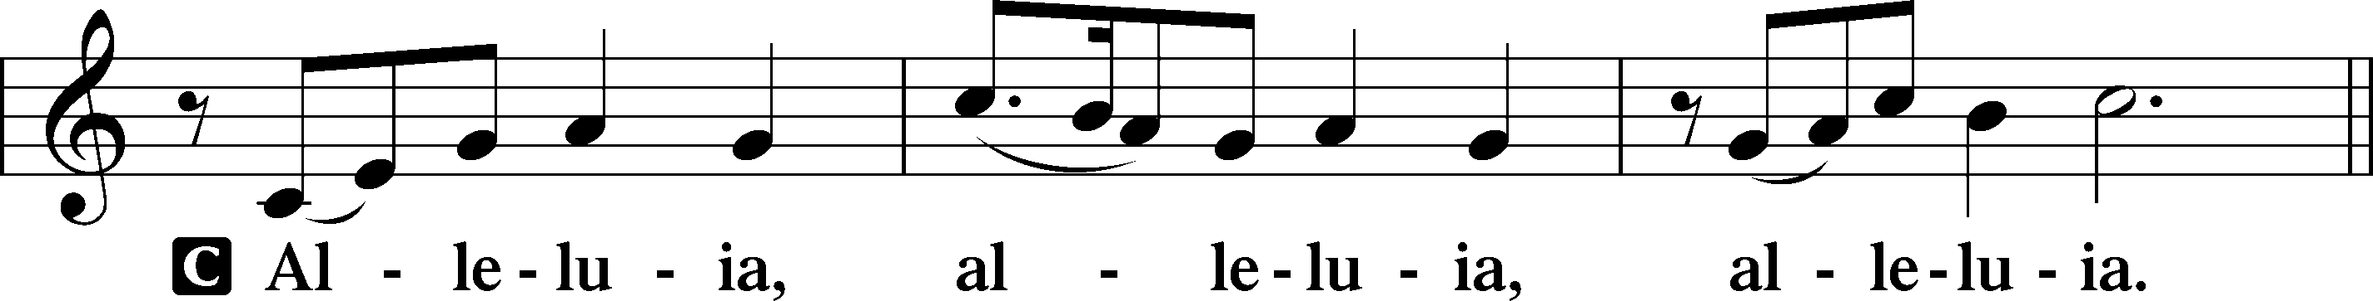
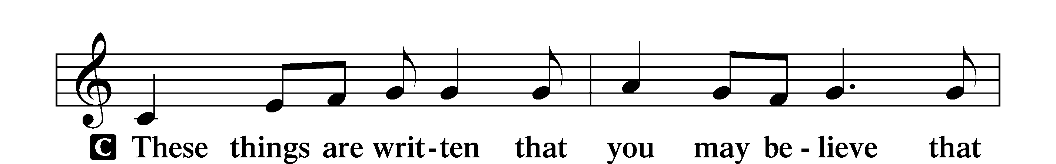
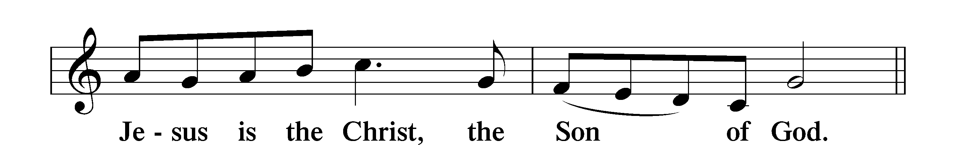
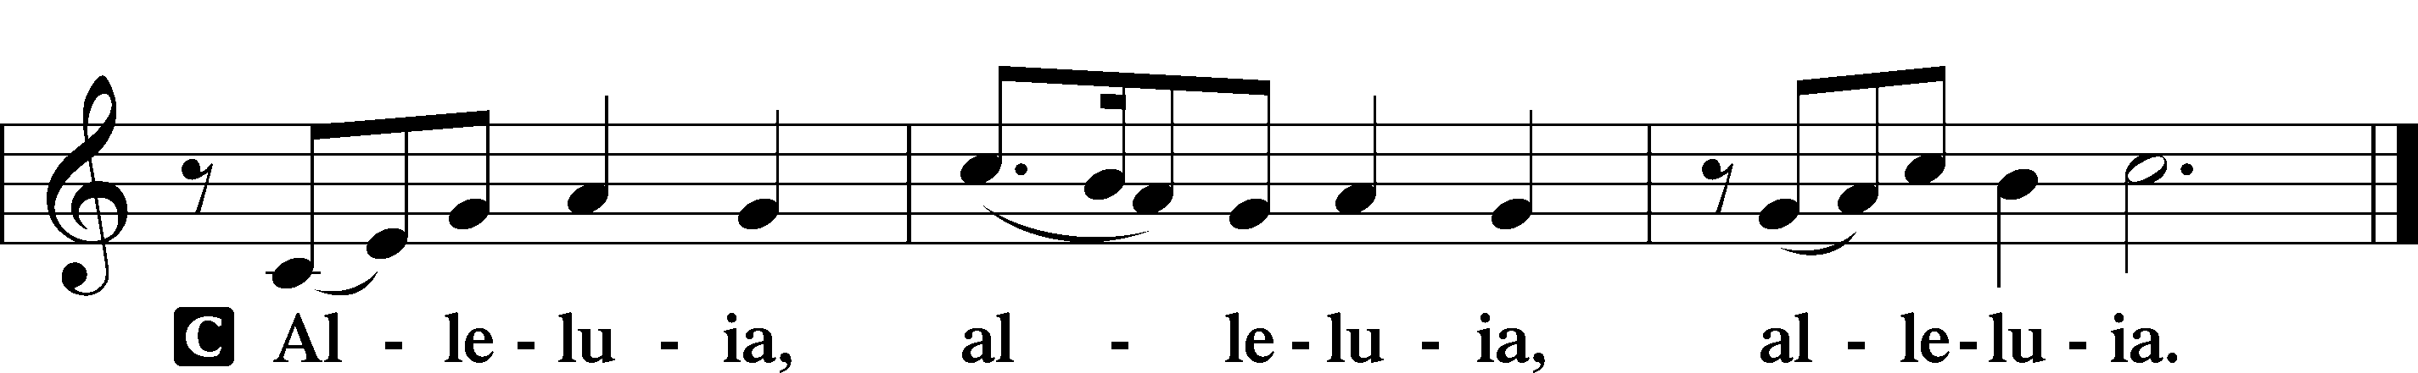

Holy Gospel Mark 6:14–29
P The Holy Gospel according to St. Mark, the sixth chapter.
C Glory to You, O Lord.

14King Herod heard of it, for Jesus’ name had become known. Some said, “John the Baptist has been raised from the dead. That is why these miraculous powers are at work in him.” 15But others said, “He is Elijah.” And others said, “He is a prophet, like one of the prophets of old.” 16But when Herod heard of it, he said, “John, whom I beheaded, has been raised.” 17For it was Herod who had sent and seized John and bound him in prison for the sake of Herodias, his brother Philip’s wife, because he had married her. 18For John had been saying to Herod, “It is not lawful for you to have your brother’s wife.” 19And Herodias had a grudge against him and wanted to put him to death. But she could not, 20for Herod feared John, knowing that he was a righteous and holy man, and he kept him safe. When he heard him, he was greatly perplexed, and yet he heard him gladly.
21But an opportunity came when Herod on his birthday gave a banquet for his nobles and military commanders and the leading men of Galilee. 22For when Herodias’s daughter came in and danced, she pleased Herod and his guests. And the king said to the girl, “Ask me for whatever you wish, and I will give it to you.” 23And he vowed to her, “Whatever you ask me, I will give you, up to half of my kingdom.” 24And she went out and said to her mother, “For what should I ask?” And she said, “The head of John the Baptist.” 25And she came in immediately with haste to the king and asked, saying, “I want you to give me at once the head of John the Baptist on a platter.” 26And the king was exceedingly sorry, but because of his oaths and his guests he did not want to break his word to her. 27And immediately the king sent an executioner with orders to bring John’s head. He went and beheaded him in the prison 28and brought his head on a platter and gave it to the girl, and the girl gave it to her mother. 29When his disciples heard of it, they came and took his body and laid it in a tomb.

P This is the Gospel of the Lord.
C Praise to You, O Christ.

Apostles’ Creed
C I believe in God, the Father Almighty, maker of heaven and earth.

And in Jesus Christ, His only Son, our Lord, who was conceived by the Holy Spirit, born of the virgin Mary, suffered under Pontius Pilate, was crucified, died and was buried. He descended into hell. The third day He rose again from the dead. He ascended into heaven and sits at the right hand of God the Father Almighty. From thence He will come to judge the living and the dead.

I believe in the Holy Spirit, the holy Christian Church, the communion of saints, the forgiveness of sins, the resurrection of the body, and the life T everlasting. Amen.

Sit

713 From God Can Nothing Move Me sts. 1–5
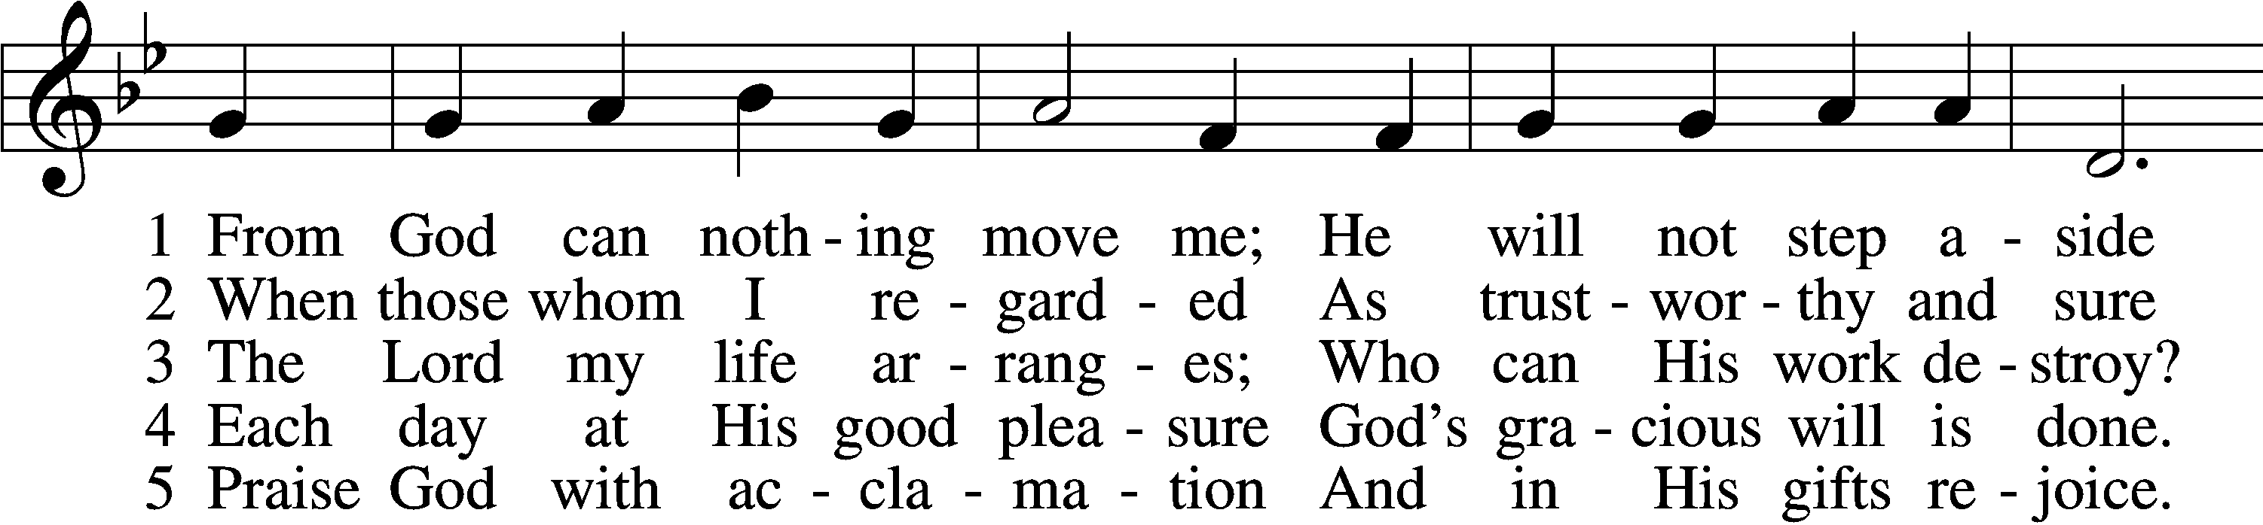
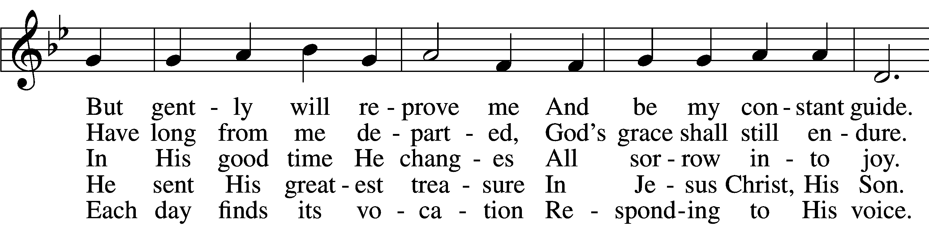
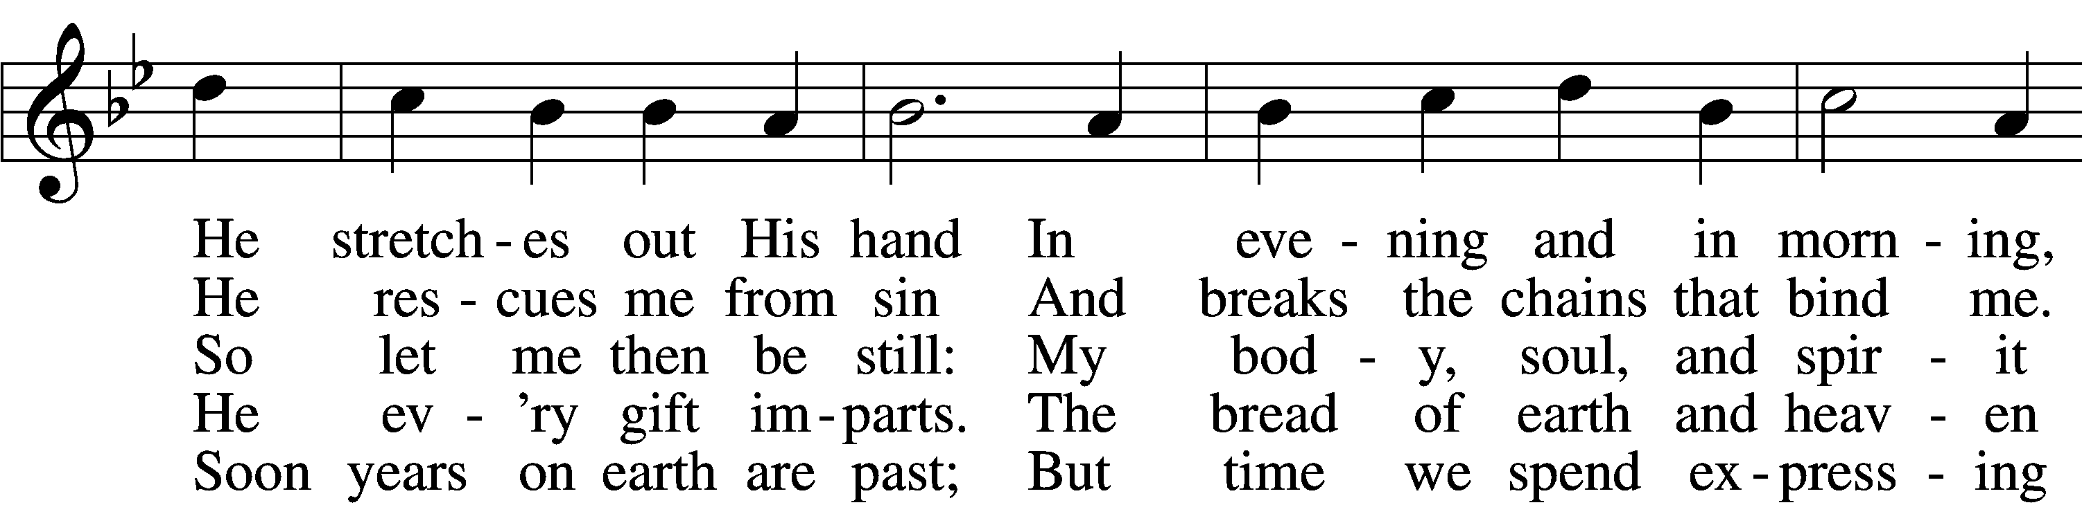
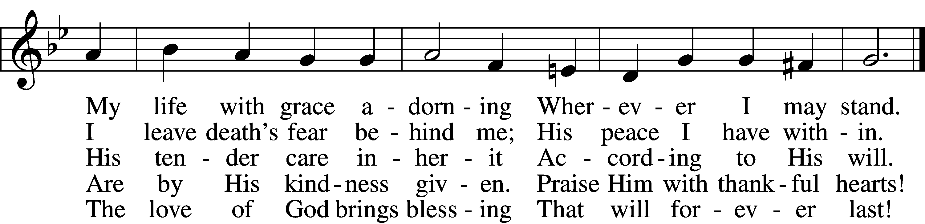
Text: Ludwig Helmbold, 1532–98; (sts. 1–2): tr. Gerald Thorson, 1921–2001, alt.; (st. 3): tr. Lutheran Service Book, 2006; (sts. 4–5): tr. Gregory J. Wismar, 1946
Tune: Recueil de plusieurs chansons, 1557, Lyons, alt.
Text (sts. 1–2): © 1978 Lutheran Book of Worship; (sts. 3–5): © 2006 Concordia Publishing House. Used by permission: LSB Hymn License no. 110004388
Tune: Public domain

Sermon: “God’s Word Can’t Be Stopped!” Mark 6:14-29

Offering

Stand

Prayer of the Church

Lord’s Prayer
C Our Father who art in heaven, hallowed be Thy name, Thy kingdom come, Thy will be done on earth as it is in heaven; give us this day our daily bread; and forgive us our trespasses as we forgive those who trespass against us; and lead us not into temptation, but deliver us from evil. For Thine is the kingdom and the power and the glory forever and ever. Amen.

Benedicamus LSB 212
A Let us bless the Lord.
C Thanks be to God.

Benediction
P The Lord bless you and keep you.
The Lord make His face shine on you and be gracious to you.
The Lord look upon you with favor and T give you peace.
C Amen.

585 Lord Jesus Christ, with Us Abide
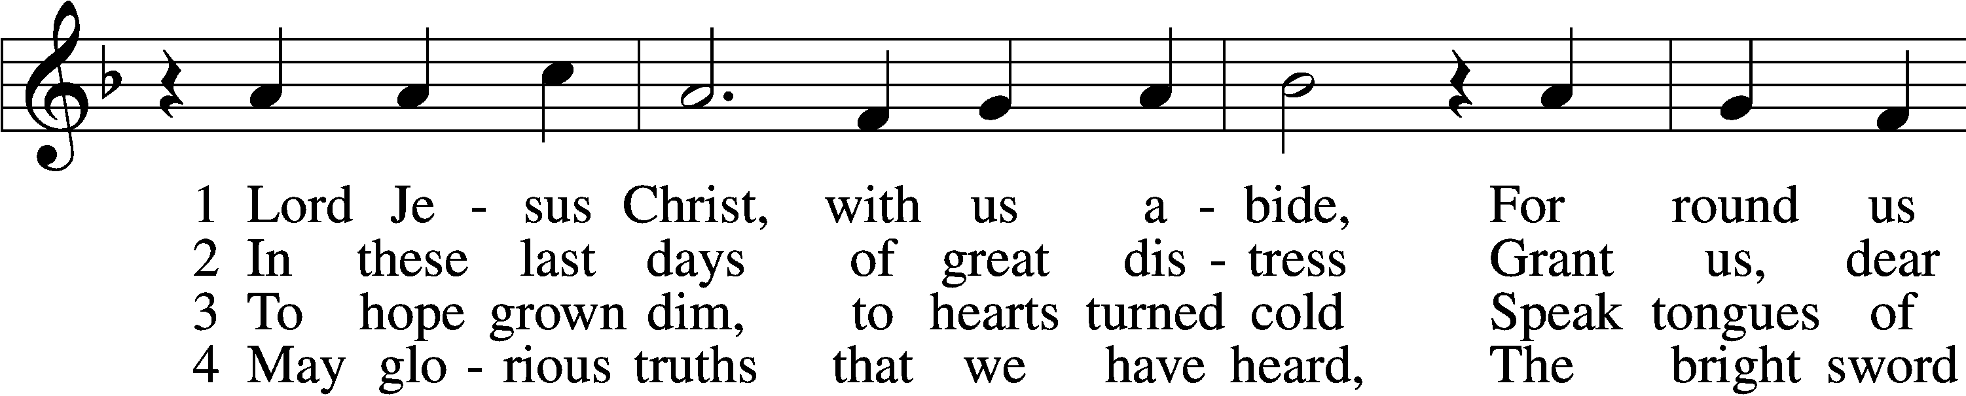
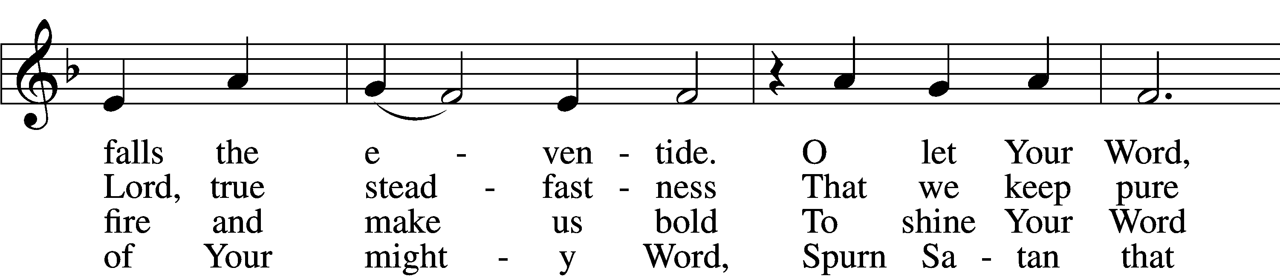
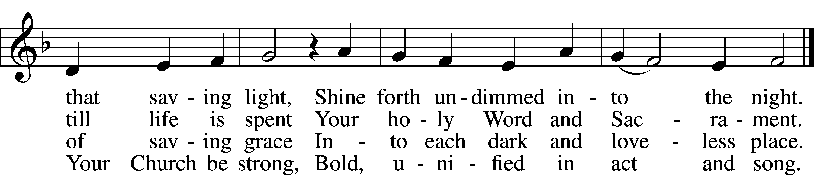

5 Restrain, O Lord, the human pride
That seeks to thrust Your truth aside
Or with some man-made thoughts or things
Would dim the words Your Spirit sings.

6 Stay with us, Lord, and keep us true;
Preserve our faith our whole life through—
Your Word alone our heart’s defense,
The Church’s glorious confidence.
Text: tr. F. Samuel Janzow, 1913–2001, alt.; (st. 1): Philipp Melanchthon, 1497–1560; (st. 1): German version Geistliche Psalmen, 1611, Nuremberg; (sts. 2–6): Nicolaus Selnecker, 1532–92
Tune: Geistliche Lieder D. Martini Lutheri, 1589, Leipzig
Text: © 1982 Concordia Publishing House. Used by permission: LSB Hymn License no. 110004388
Tune: Public domain

Acknowledgments
Divine Service, Setting Four from Lutheran Service Book
Unless otherwise indicated, Scripture quotations are from the ESV® Bible (The Holy Bible, English Standard Version®), copyright © 2001 by Crossway, a publishing ministry of Good News Publishers. Used by permission. All rights reserved.
Created by Lutheran Service Builder © 2024 Concordia Publishing House.

