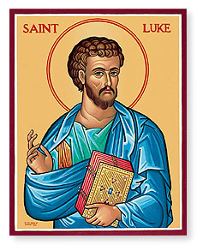
Luke 5
Sunday Bible Class 2024

Jesus Calls the First Disciples + Luke 5:1-11
Why was the crowd “pressing in on [Jesus]?” What did they want from Him?

Jesus tells Simon (Peter) to let their nets down for a catch of fish. Why is this an absurd thing for Peter to do? What do we learn from his response to Jesus? (verse 5)

Why does Peter tell Jesus to “depart from [him]?” What does he perceive about Jesus’ identity? How should we respond when we’re in Christ’s presence?

What is(are) the parallel(s) between catching fish and “catching men?” What’s the huge difference between the two? (Ask Pastor for a hint!)

Jesus Cleanses a Leper + Luke 5:12-16
St. Luke points out that Jesus touched the leper. Why is this detail worth pointing out?

What does the offering in verse 14 foreshadow?

Jesus Heals a Paralytic + Luke 5:17-26
Is there a connection between physical and spiritual things? What does this passage seem to suggest about it?

Which of the two things mentioned here is easier? Why? (see verses 23-24)

Jesus Calls Levi + Luke 5:27-32
Who is Levi? (See Matthew 9:9-13)

Jesus refers to Himself as a physician. If Jesus is the physician, who are we? What kind of sickness is Jesus talking about here?

A Question About Fasting + Luke 5:33-39
Why are Jesus’ disciples’ “eating and drinking?” What does their lack of fasting imply?

When will Jesus (the bridegroom) be taken away from the disciples (the wedding guests)?

What’s the point of Jesus’ parable in verses 36-39?

