**The Second Sunday in Advent**

**December 8, 2024**

“Even now the axe is laid to the root of the trees. Every tree therefore that does not bear good fruit is cut down and thrown into the fire”

**PEACE LUTHERAN CHURCH**

1451 Ebenezer Rd + Cincinnati, OH 45233 + 513-941-5177

[**www.peacechurchlink.com**](http://www.peacechurchlink.com)

**About This Service**

For many centuries the Church has celebrated the season of Advent as the beginning of a new church year and as a time of preparation for Christmas. Advent means “coming” and gives us opportunity to meditate on the Incarnation (the coming of God in human flesh for our salvation) and the Parousia (His coming again, in glory, to judge the world).

The time before the Divine Service begins is a time for meditation and prayer. It’s a time for us to prepare our hearts and minds to hear God’s Word and receive His gifts. Therefore, we ask that you would please remain silent as you enter the sanctuary out of reverence for God and respect for one another.

**Are My Children Welcome?**

In God’s eyes we’re all children. Yes, your little ones are more than welcome! If your child needs a little extra room to “make a joyful noise” you’re welcome to take them out of the sanctuary and into the narthex or the Fellowship Hall.

**How Do I Become a Lutheran Christian?**

If you’re exploring the Lutheran Church, Pastor Shaw would be happy to offer guidance or answer your questions. Our website peacechurchlink.com is also a good resource. When you’re ready, there’s a formal process of reading, study, and prayer that culminates in being received into the Lutheran Church.

**Preservice Music**

“Light One Candle" *Sunday School Children and Congregation*

Light one candle for Hope,  
 One bright candle for Hope!  
He brings Hope to every heart,  
 He comes, He comes!

Light one candle for Peace,  
 One bright candle for Peace!  
He brings Hope to every heart,  
 He comes, He comes!

*The first and second candles on the Advent wreath are lit.*

343 Prepare the Royal Highway

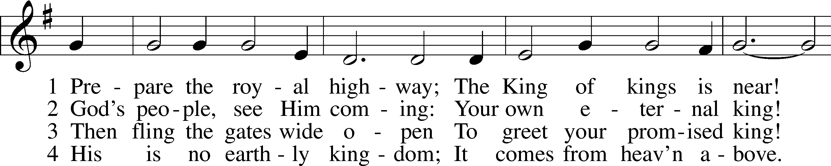

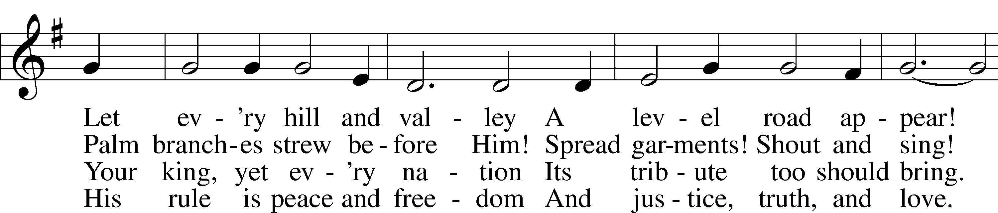

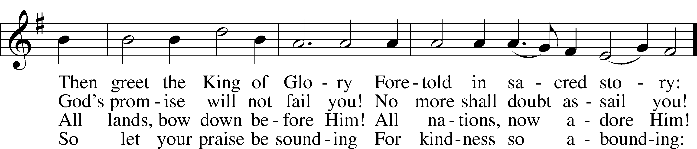

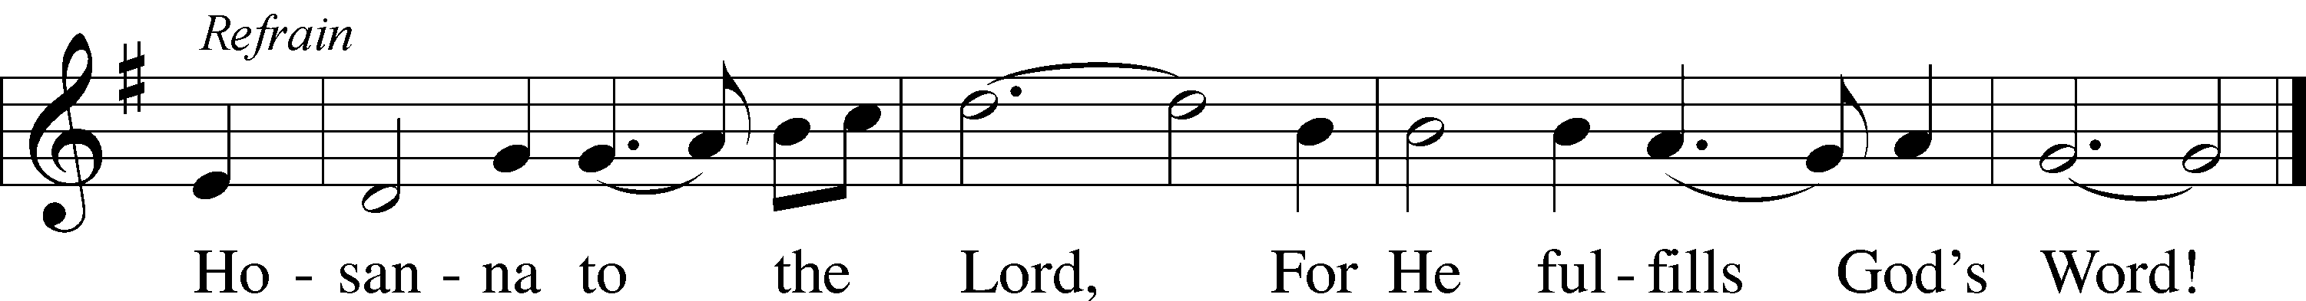

Text: Frans Mikael Franzén, 1772–1847; tr. Lutheran Book of Worship, 1978, alt.  
Tune: Swedish, 17th cent.  
Text: © 1978 Lutheran Book of Worship. Used by permission: LSB Hymn License no. 110004388  
Tune: Public domain

# Confession and Absolution

Stand

The sign of the cross may be made by all in remembrance of their Baptism.

Invocation

P In the name of the Father and of the T Son and of the Holy Spirit.

C **Amen.**

Exhortation LSB 203

P Our help is in the name of the Lord,

C **who made heaven and earth.**

P If You, O Lord, kept a record of sins, O Lord, who could stand?

C **But with You there is forgiveness; therefore You are feared.**

P Since we are gathered to hear God’s Word and call upon Him in prayer and praise, let us first consider our unworthiness and confess before God and one another that we have sinned in thought, word, and deed, and that we cannot free ourselves from our sinful condition. Together as His people let us take refuge in the infinite mercy of God, our heavenly Father, seeking His grace for the sake of Christ, and saying: God, be merciful to me, a sinner.

Confession of Sins LSB 203

C **Almighty God, have mercy upon us, forgive us our sins, and lead us to everlasting life. Amen.**

Absolution LSB 203

P Almighty God in His mercy has given His Son to die for you and for His sake forgives you all your sins. As a called and ordained servant of Christ, and by His authority, I therefore forgive you all your sins in the name of the Father and of the T Son and of the Holy Spirit.

C **Amen.**

# Service of the Word

Introit Psalm 81:8, 10–11, 13; antiphon: Luke 3:4b

The voice of one crying in the wilderness:  
 **“Prepare the way of the Lord, make his paths straight.”**Hear, O my people, while I admonish you!  
 **O Israel, if you would but listen to me!**I am the Lord your God, who brought you up out of the land of Egypt.  
 **Open your mouth wide, and I will fill it.**

But my people did not listen to my voice;  
 **Israel would not submit to me.**Oh, that my people would listen to me,  
 **that Israel would walk in my ways!  
Glory be to the Father and to the Son**  
 **and to the Holy Spirit;**  
**as it was in the beginning,**  
 **is now, and will be forever. Amen.**  
The voice of one crying in the wilderness:  
 **“Prepare the way of the Lord, make his paths straight.”**

Kyrie LSB 204

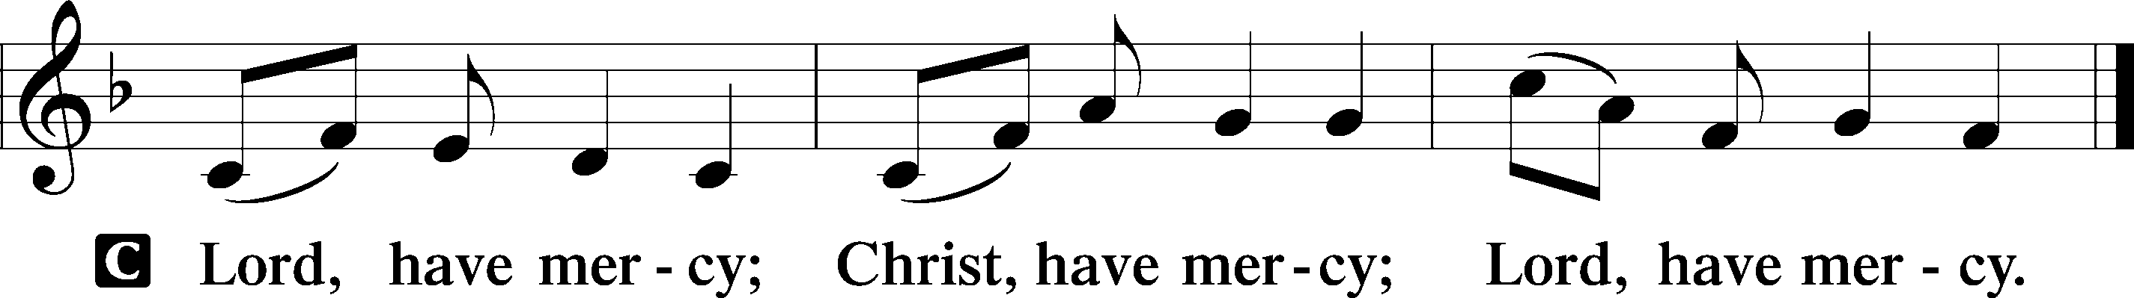

Salutation and Collect of the Day

P The Lord be with you.

C **And also with you.**

P Let us pray.

Stir up our hearts, O Lord, to make ready the way of Your only-begotten Son, that by His coming we may be enabled to serve You with pure minds; through the same Jesus Christ, our Lord, who lives and reigns with You and the Holy Spirit, one God, now and forever.

C **Amen.**

Sit

Old Testament Reading Malachi 3:1–7b

1“Behold, I send my messenger and he will prepare the way before me. And the Lord whom you seek will suddenly come to his temple; and the messenger of the covenant in whom you delight, behold, he is coming, says the Lord of hosts. 2But who can endure the day of his coming, and who can stand when he appears? For he is like a refiner’s fire and like fullers’ soap. 3He will sit as a refiner and purifier of silver, and he will purify the sons of Levi and refine them like gold and silver, and they will bring offerings in righteousness to the Lord. 4Then the offering of Judah and Jerusalem will be pleasing to the Lord as in the days of old and as in former years.

5“Then I will draw near to you for judgment. I will be a swift witness against the sorcerers, against the adulterers, against those who swear falsely, against those who oppress the hired worker in his wages, the widow and the fatherless, against those who thrust aside the sojourner, and do not fear me, says the Lord of hosts.

6“For I the Lord do not change; therefore you, O children of Jacob, are not consumed. 7From the days of your fathers you have turned aside from my statutes and have not kept them.”

A This is the Word of the Lord.

C **Thanks be to God.**

Epistle Philippians 1:2–11

2Grace to you and peace from God our Father and the Lord Jesus Christ.

3I thank my God in all my remembrance of you, 4always in every prayer of mine for you all making my prayer with joy, 5because of your partnership in the gospel from the first day until now. 6And I am sure of this, that he who began a good work in you will bring it to completion at the day of Jesus Christ. 7It is right for me to feel this way about you all, because I hold you in my heart, for you are all partakers with me of grace, both in my imprisonment and in the defense and confirmation of the gospel. 8For God is my witness, how I yearn for you all with the affection of Christ Jesus. 9And it is my prayer that your love may abound more and more, with knowledge and all discernment, 10so that you may approve what is excellent, and so be pure and blameless for the day of Christ, 11filled with the fruit of righteousness that comes through Jesus Christ, to the glory and praise of God.

A This is the Word of the Lord.

C **Thanks be to God.**

Stand

Holy Gospel Luke 3:1–20

P The Holy Gospel according to St. Luke, the third chapter.

C **Glory to You, O Lord.**

1In the fifteenth year of the reign of Tiberius Caesar, Pontius Pilate being governor of Judea, and Herod being tetrarch of Galilee, and his brother Philip tetrarch of the region of Ituraea and Trachonitis, and Lysanias tetrarch of Abilene, 2during the high priesthood of Annas and Caiaphas, the word of God came to John the son of Zechariah in the wilderness. 3And he went into all the region around the Jordan, proclaiming a baptism of repentance for the forgiveness of sins. 4As it is written in the book of the words of Isaiah the prophet,

“The voice of one crying in the wilderness:  
‘Prepare the way of the Lord,  
 make his paths straight.  
5Every valley shall be filled,  
 and every mountain and hill shall be made low,  
and the crooked shall become straight,  
 and the rough places shall become level ways,  
6and all flesh shall see the salvation of God.’”

7He said therefore to the crowds that came out to be baptized by him, “You brood of vipers! Who warned you to flee from the wrath to come? 8Bear fruits in keeping with repentance. And do not begin to say to yourselves, ‘We have Abraham as our father.’ For I tell you, God is able from these stones to raise up children for Abraham. 9Even now the axe is laid to the root of the trees. Every tree therefore that does not bear good fruit is cut down and thrown into the fire.”

10And the crowds asked him, “What then shall we do?” 11And he answered them, “Whoever has two tunics is to share with him who has none, and whoever has food is to do likewise.” 12Tax collectors also came to be baptized and said to him, “Teacher, what shall we do?” 13And he said to them, “Collect no more than you are authorized to do.” 14Soldiers also asked him, “And we, what shall we do?” And he said to them, “Do not extort money from anyone by threats or by false accusation, and be content with your wages.”

15As the people were in expectation, and all were questioning in their hearts concerning John, whether he might be the Christ, 16John answered them all, saying, “I baptize you with water, but he who is mightier than I is coming, the strap of whose sandals I am not worthy to untie. He will baptize you with the Holy Spirit and with fire. 17His winnowing fork is in his hand, to clear his threshing floor and to gather the wheat into his barn, but the chaff he will burn with unquenchable fire.”

18So with many other exhortations he preached good news to the people. 19But Herod the tetrarch, who had been reproved by him for Herodias, his brother’s wife, and for all the evil things that Herod had done, 20added this to them all, that he locked up John in prison.

P This is the Gospel of the Lord.

C **Praise to You, O Christ.**

Apostles’ Creed

C **I believe in God, the Father Almighty, maker of heaven and earth.**

**And in Jesus Christ, His only Son, our Lord, who was conceived by the Holy Spirit, born of the virgin Mary, suffered under Pontius Pilate, was crucified, died and was buried. He descended into hell. The third day He rose again from the dead. He ascended into heaven and sits at the right hand of God the Father Almighty. From thence He will come to judge the living and the dead.**

**I believe in the Holy Spirit, the holy Christian Church, the communion of saints, the forgiveness of sins, the resurrection of the body, and the life** T **everlasting. Amen.**

Sit

344 On Jordan’s Bank the Baptist’s Cry

*Stand for Stanza 5*

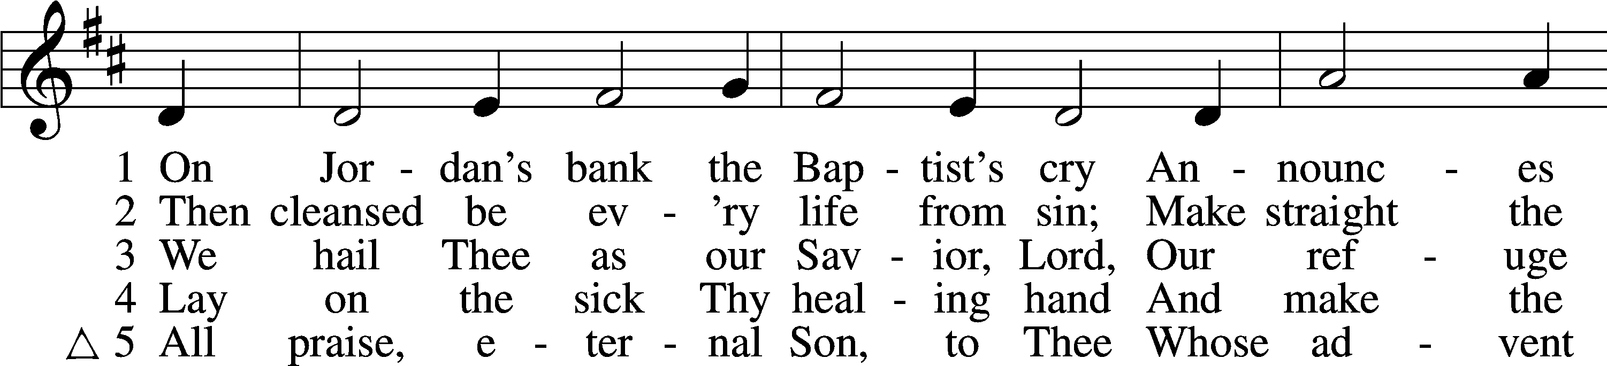

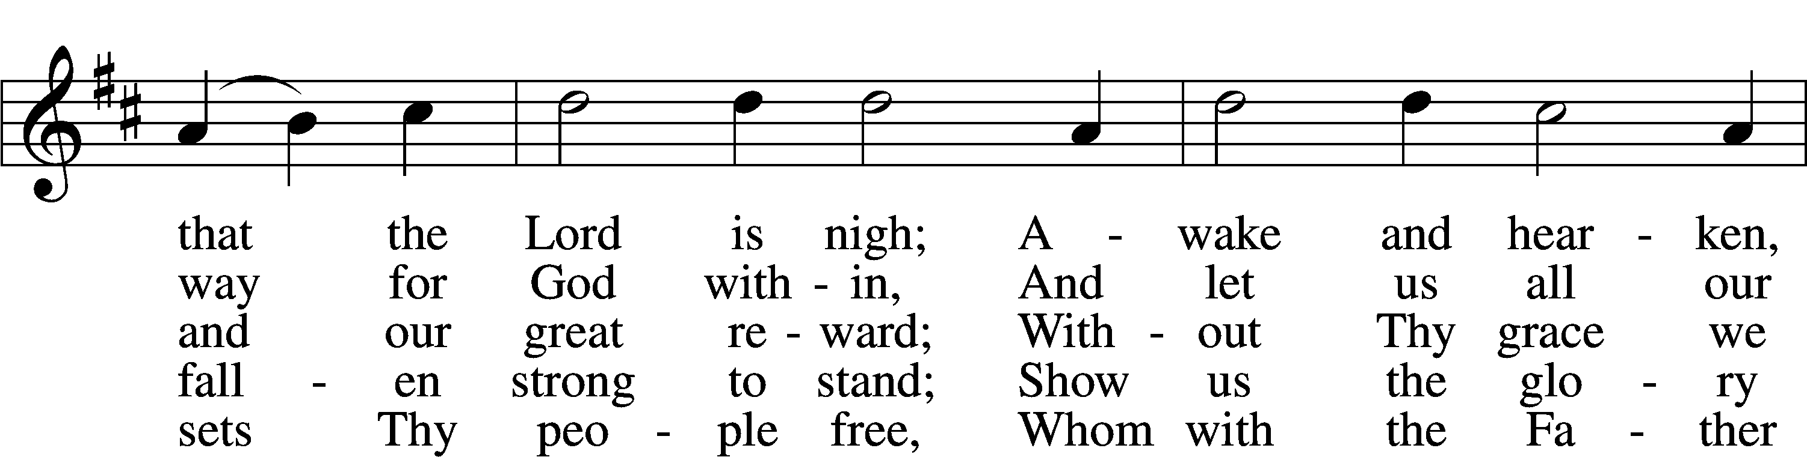

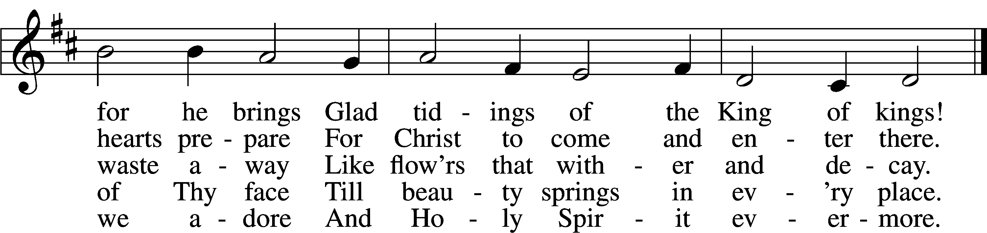

Text: Charles Coffin, 1676–1749; tr. composite  
Tune: adapt. Michael Praetorius, 1571–1621  
Text and tune: Public domain

Sit

Sermon

Offering

Stand

Prayer of the Church

Lord’s Prayer

C **Our Father who art in heaven, hallowed be Thy name, Thy kingdom come, Thy will be done on earth as it is in heaven; give us this day our daily bread; and forgive us our trespasses as we forgive those who trespass against us; and lead us not into temptation, but deliver us from evil. For Thine is the kingdom and the power and the glory forever and ever. Amen.**

Benedicamus LSB 212

A Let us bless the Lord.

C **Thanks be to God.**

Benediction

P The Lord bless you and keep you.

The Lord make His face shine on you and be gracious to you.

The Lord look upon you with favor and T give you peace.

C **Amen.**

349 Hark the Glad Sound

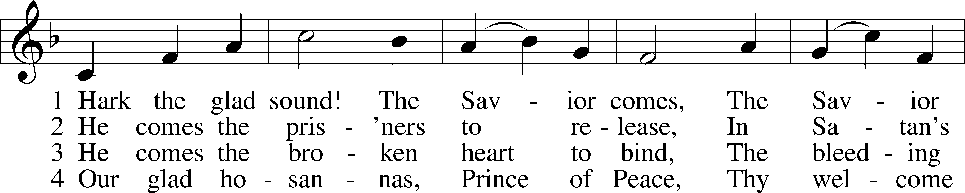

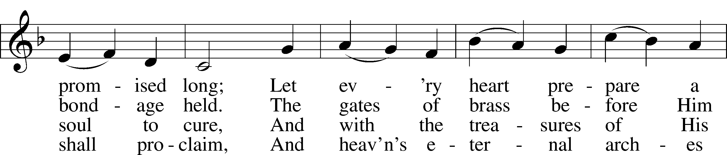

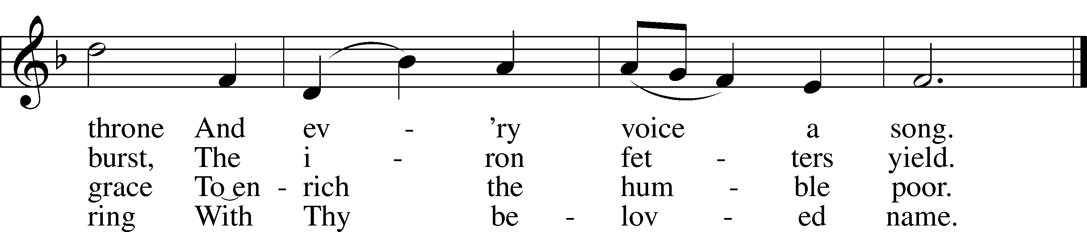

Text: Philip Doddridge, 1702–51 Tune: Thomas Haweis, 1734–1820 Text and tune: Public domain

**Acknowledgments**

Divine Service, Setting Four from Lutheran Service Book Unless otherwise indicated, Scripture quotations are from the ESV® Bible (The Holy Bible, English Standard Version®), copyright © 2001 by Crossway, a publishing ministry of Good News Publishers. Used by permission. All rights reserved. Created by Lutheran Service Builder © 2024 Concordia Publishing House.