**The Twenty-first Sunday after Pentecost**

**October 13, 2024**

“Disheartened by the saying, he went away sorrowful, for he had great possessions”

**PEACE LUTHERAN CHURCH**

1451 Ebenezer Rd + Cincinnati, OH 45233 + 513-941-5177

[**www.peacechurchlink.com**](http://www.peacechurchlink.com)

**About This Service**

The heart of Christianity is not what we do for God but what God has done for us in Christ Jesus. We call our service “Divine Service” because the Divine One, our Lord Jesus, promises to be present with us this very day in His Word and Sacraments to give us clean hearts and renewed spirits. We come in joyful reverence to receive from Him.

The time before the Divine Service begins is a time for meditation and prayer. It’s a time for us to prepare our hearts and minds to hear God’s Word and receive His gifts. Therefore, we ask that you would please remain silent as you enter the sanctuary out of reverence for God and respect for one another.

**Are My Children Welcome?**

In God’s eyes we’re all children. Yes, your little ones are more than welcome! If your child needs a little extra room to “make a joyful noise” you’re welcome to take them out of the sanctuary and into the narthex or the Fellowship Hall.

**How Do I Become a Lutheran Christian?**

If you’re exploring the Lutheran Church, Pastor Shaw would be happy to offer guidance or answer your questions. Our website peacechurchlink.com is also a good resource. When you’re ready, there’s a formal process of reading, study, and prayer that culminates in being received into the Lutheran Church.

555 Salvation unto Us Has Come sts. 1–6

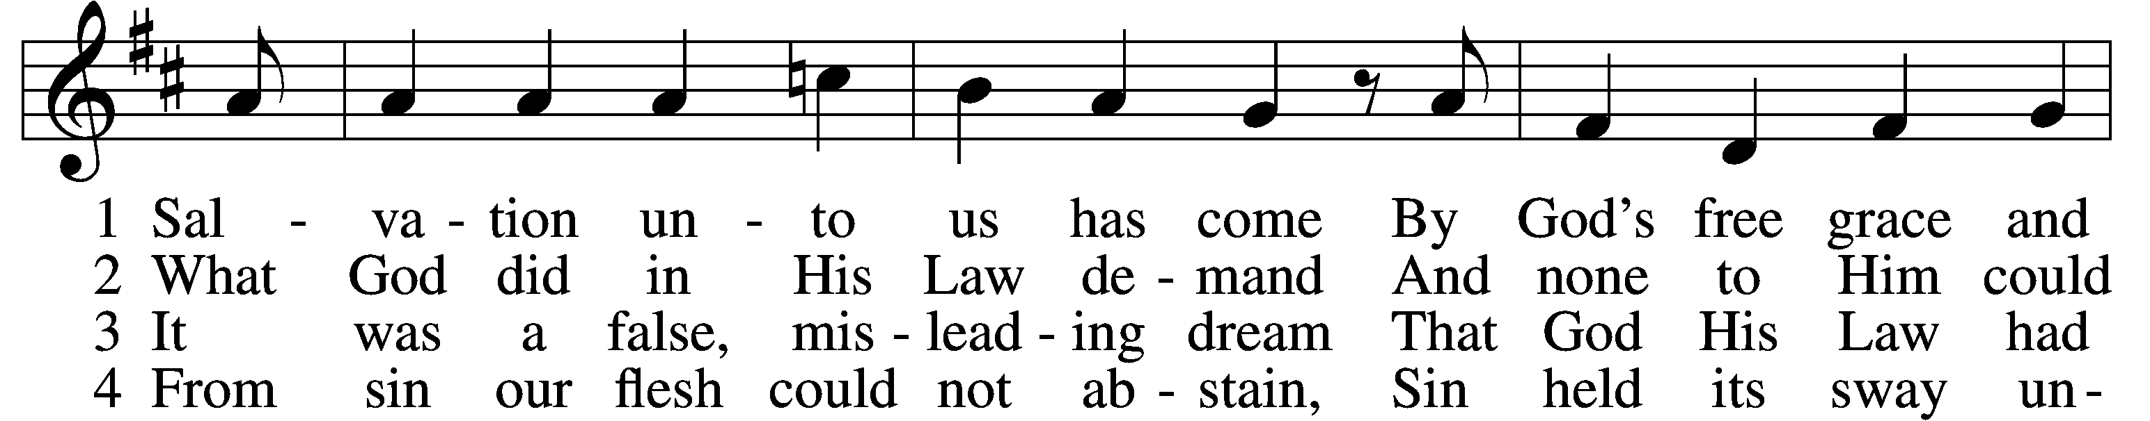

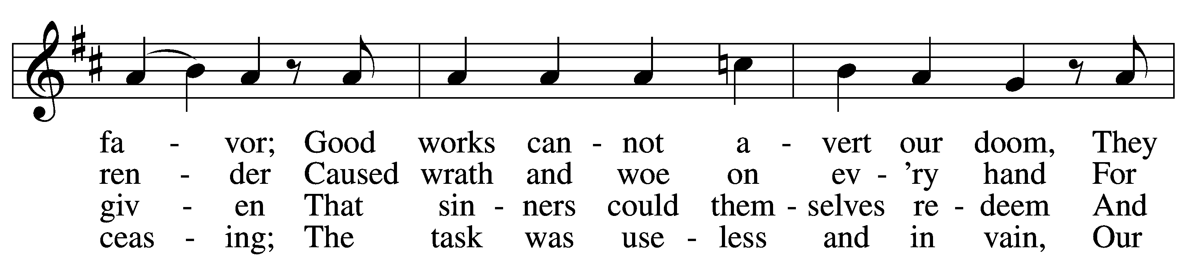

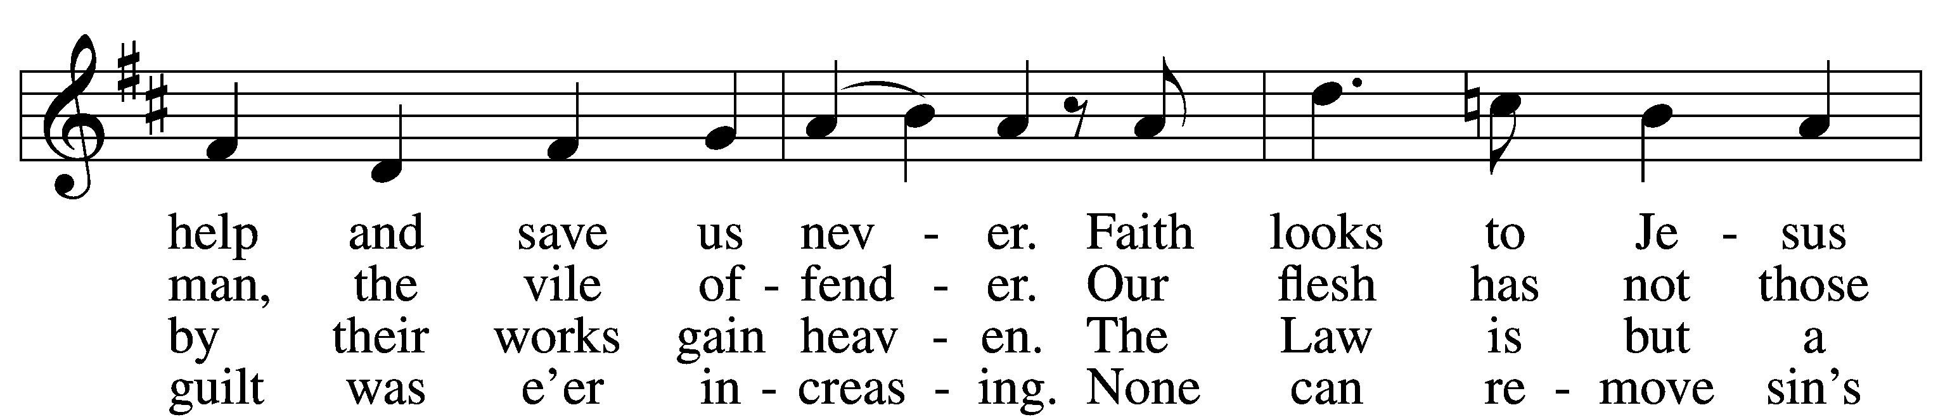

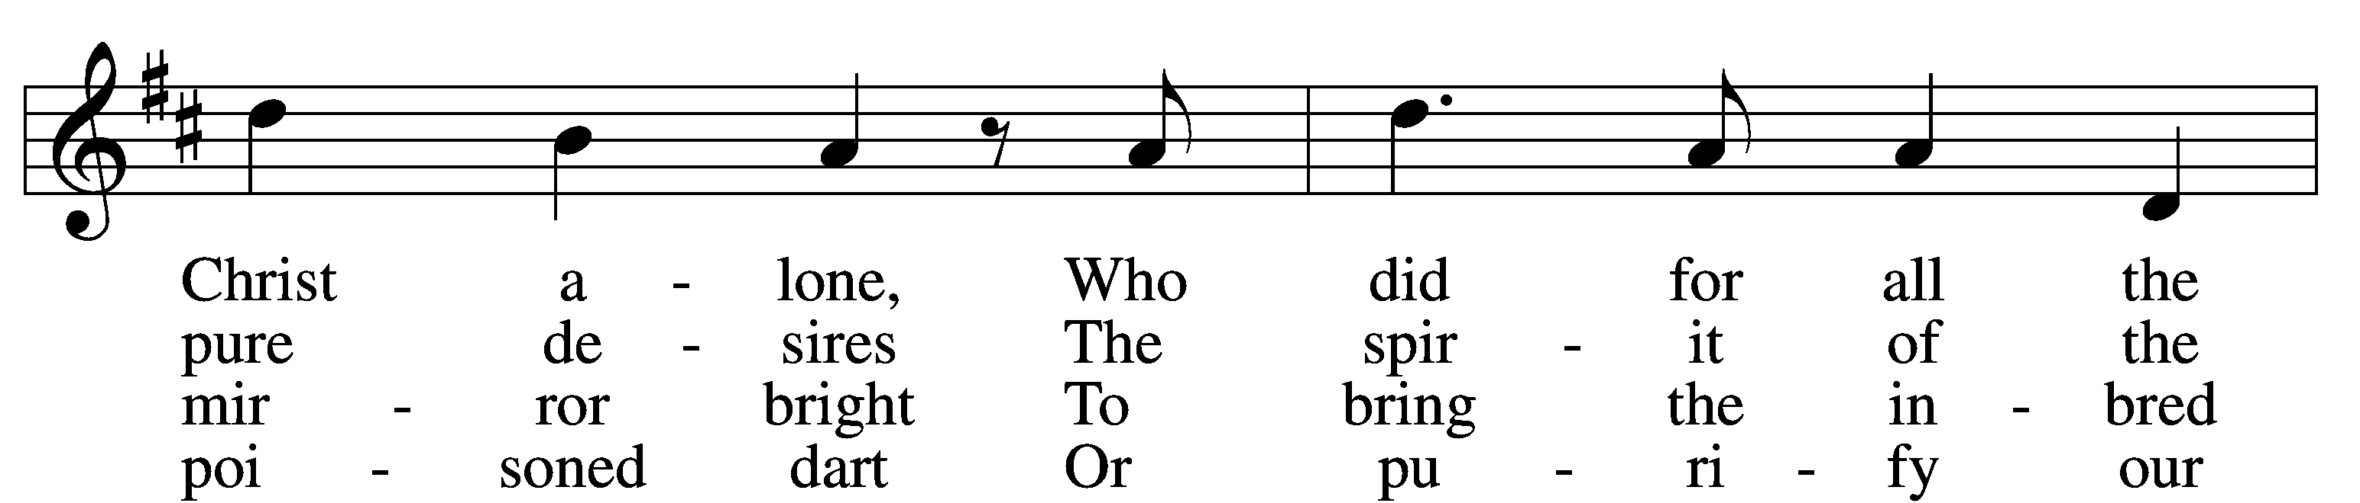

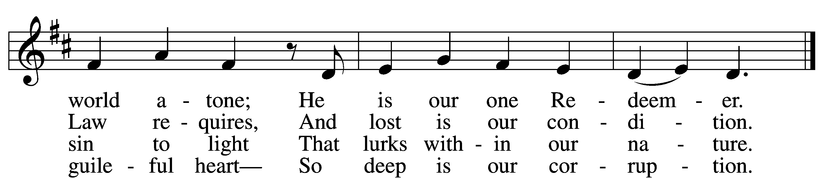

5 Yet as the Law must be fulfilled  
 Or we must die despairing,  
Christ came and has God’s anger stilled,  
 Our human nature sharing.  
He has for us the Law obeyed  
And thus the Father’s vengeance stayed  
 Which over us impended.

6 Since Christ has full atonement made  
 And brought to us salvation,  
Each Christian therefore may be glad  
 And build on this foundation.  
Your grace alone, dear Lord, I plead,  
Your death is now my life indeed,  
 For You have paid my ransom.

Text: Paul Speratus, 1484–1551; tr. The Lutheran Hymnal, 1941, alt. Tune: Etlich Cristlich lider, 1524, Wittenberg Text and tune: Public domain

# Confession and Absolution

Stand

The sign of the cross may be made by all in remembrance of their Baptism.

P In the name of the Father and of the T Son and of the Holy Spirit.

C **Amen.**

P Beloved in the Lord! Let us draw near with a true heart and confess our sins unto God our Father, beseeching Him in the name of our Lord Jesus Christ to grant us forgiveness.

P Our help is in the name of the Lord,

C **who made heaven and earth.**

P I said, I will confess my transgressions unto the Lord,

C **and You forgave the iniquity of my sin.**

Silence for reflection on God’s Word and for self-examination.

P O almighty God, merciful Father,

C **I, a poor, miserable sinner, confess unto You all my sins and iniquities with which I have ever offended You and justly deserved Your temporal and eternal punishment. But I am heartily sorry for them and sincerely repent of them, and I pray You of Your boundless mercy and for the sake of the holy, innocent, bitter sufferings and death of Your beloved Son, Jesus Christ, to be gracious and merciful to me, a poor, sinful being.**

P Upon this your confession, I, by virtue of my office, as a called and ordained servant of the Word, announce the grace of God unto all of you, and in the stead and by the command of my Lord Jesus Christ I forgive you all your sins in the name of the Father and of the T Son and of the Holy Spirit.

C **Amen.**

# Service of the Word

Introit Psalm 112:3–6; antiphon: v. 1

Praise the Lord! Blessèd is the man who fears the Lord,  
 **who greatly delights in his commandments!**Wealth and riches are in his house,  
 **and his righteousness endures forever.**

Light dawns in the darkness for the upright;  
 **he is gracious, merciful, and righteous.**It is well with the man who deals generously and lends;  
 **who conducts his affairs with justice.**For the righteous will never be moved;  
 **he will be remembered forever.**

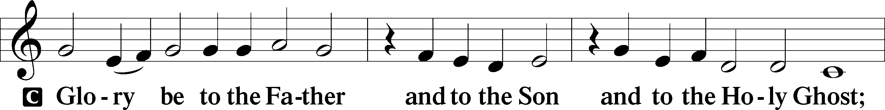

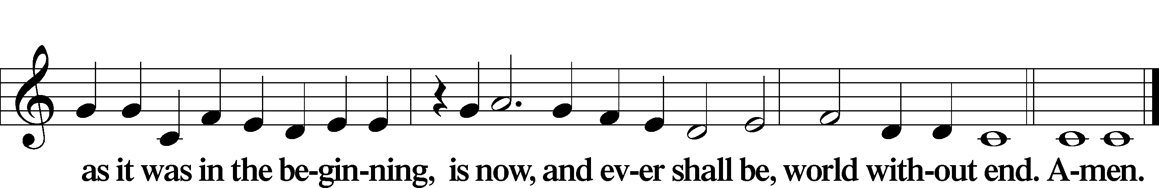

Kyrie LSB 186

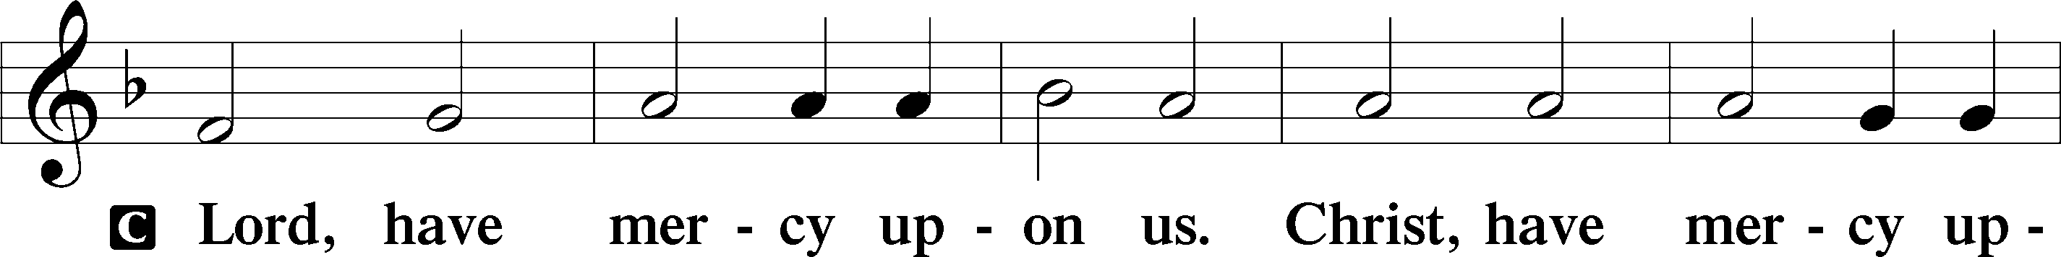

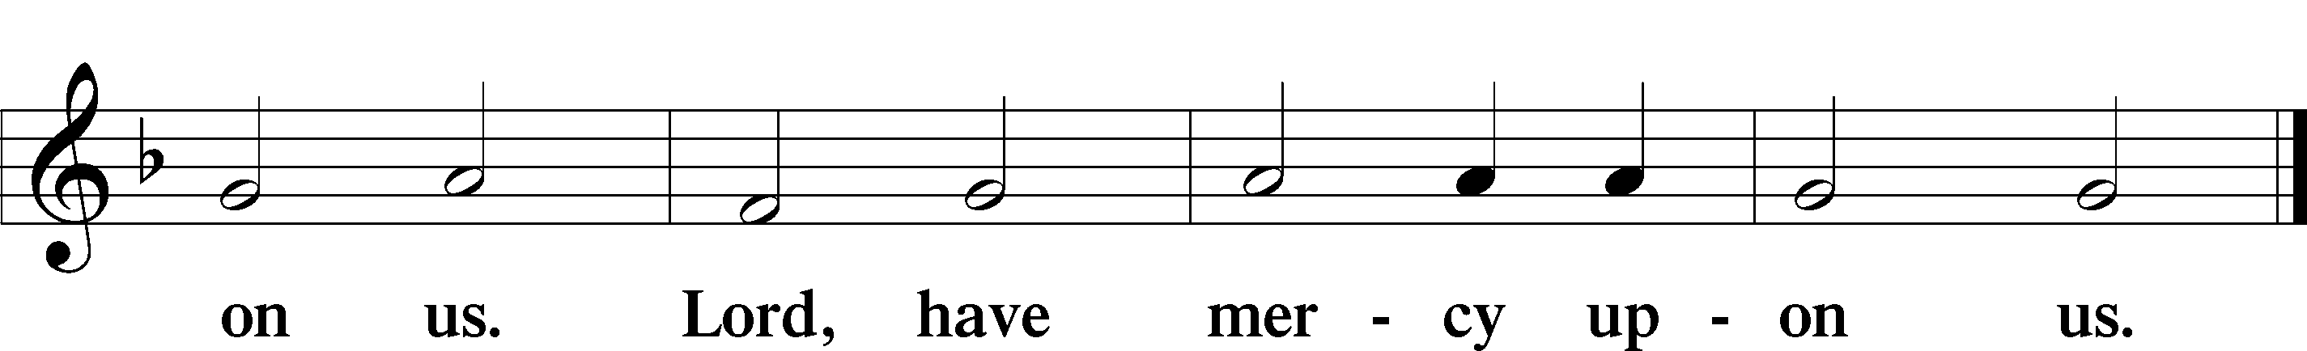

Gloria in Excelsis LSB 187

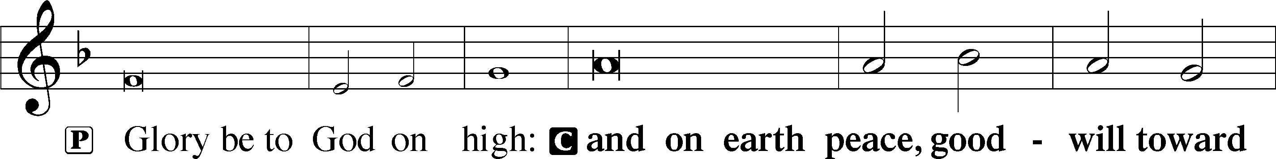

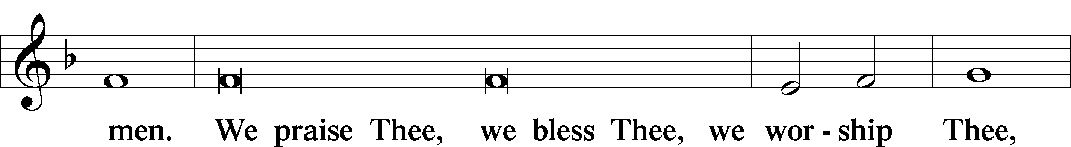

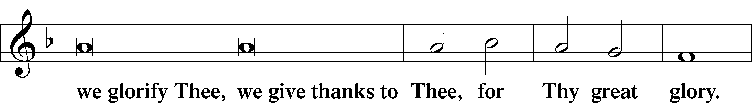

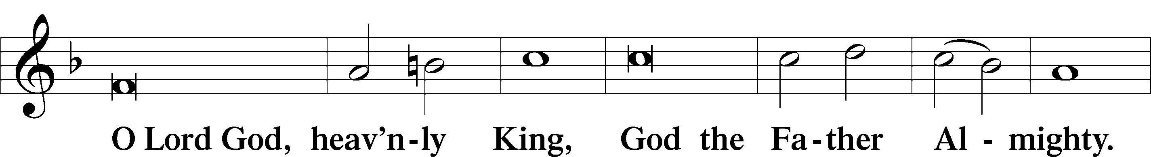

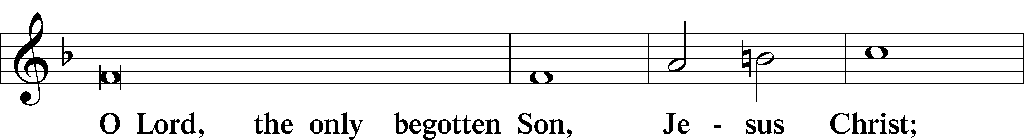

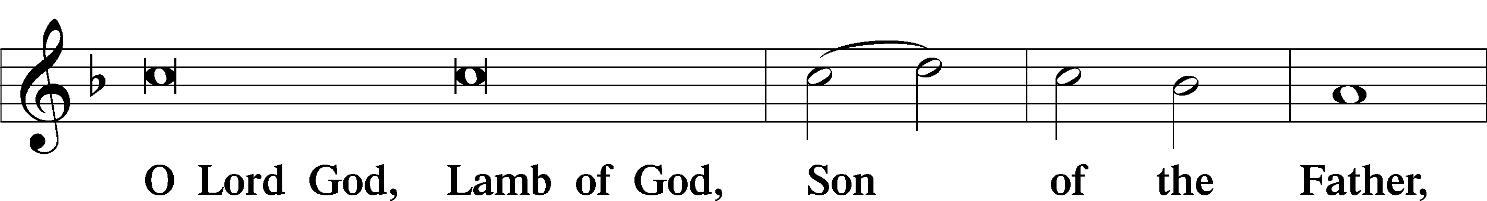

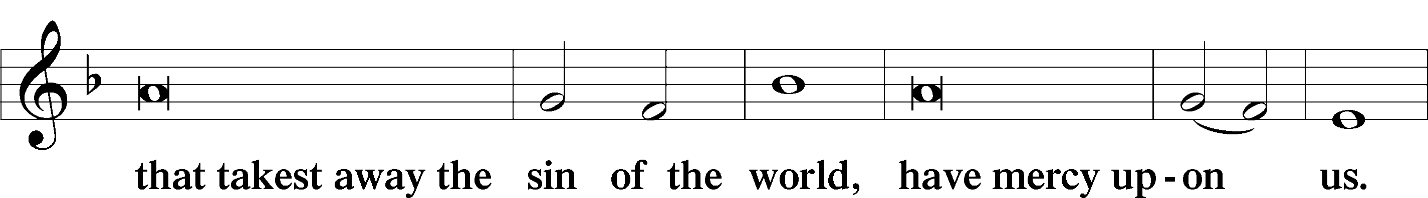

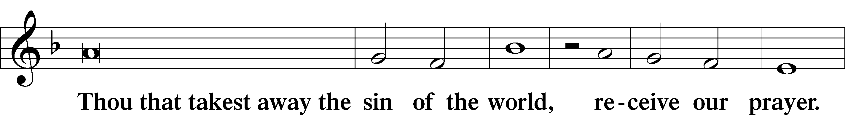

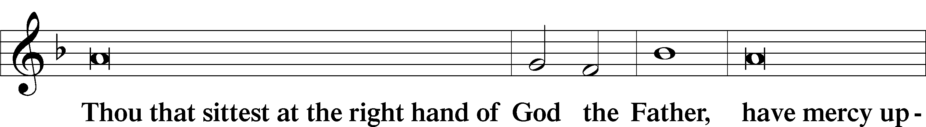

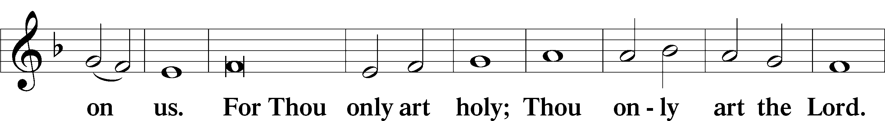

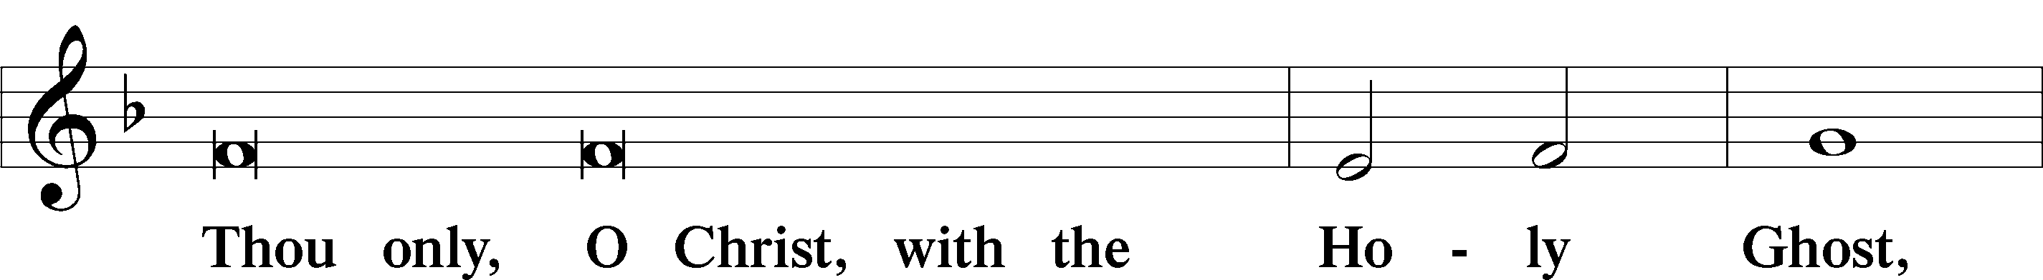

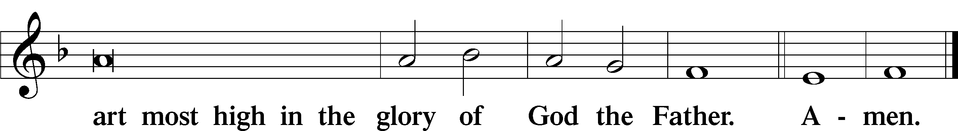

Salutation and Collect of the Day

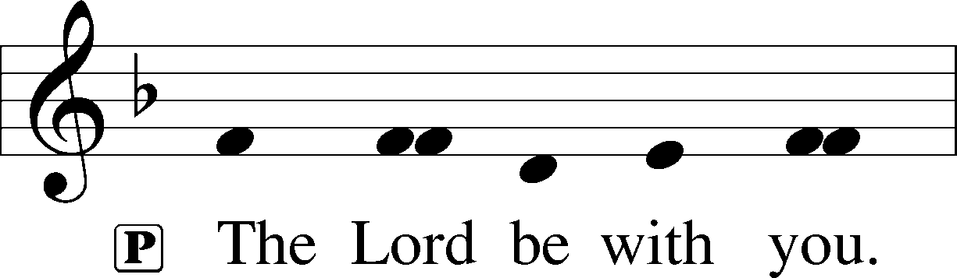

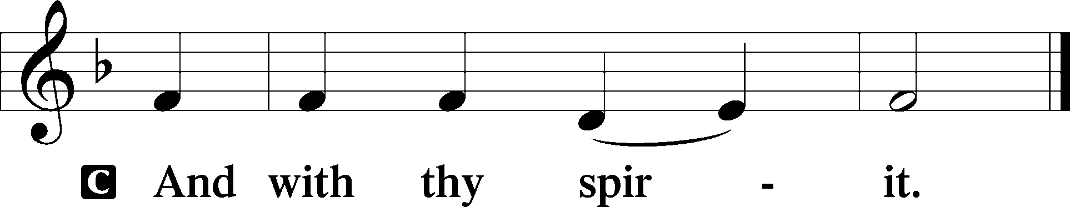

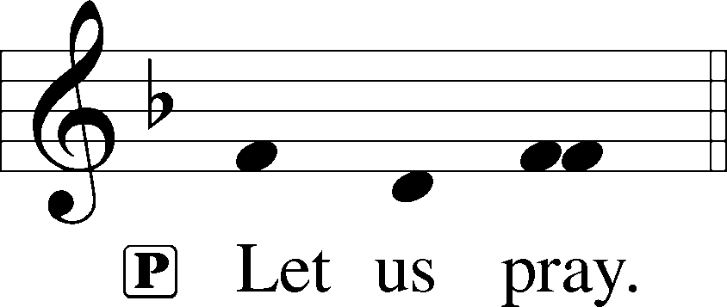

P Lord Jesus Christ, whose grace always precedes and follows us, help us to forsake all trust in earthly gain and to find in You our heavenly treasure; for You live and reign with the Father and the Holy Spirit, one God, now and forever.

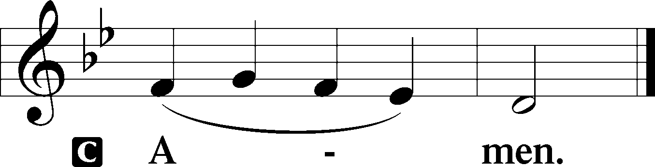

Sit

Old Testament Reading Amos 5:6–7, 10–15

6Seek the Lord and live,  
 lest he break out like fire in the house of Joseph,  
 and it devour, with none to quench it for Bethel,  
7O you who turn justice to wormwood  
 and cast down righteousness to the earth! . . .

10They hate him who reproves in the gate,  
 and they abhor him who speaks the truth.  
11Therefore because you trample on the poor  
 and you exact taxes of grain from him,  
you have built houses of hewn stone,  
 but you shall not dwell in them;  
you have planted pleasant vineyards,  
 but you shall not drink their wine.  
12For I know how many are your transgressions  
 and how great are your sins—  
you who afflict the righteous, who take a bribe,  
 and turn aside the needy in the gate.  
13Therefore he who is prudent will keep silent in such a time,  
 for it is an evil time.  
14Seek good, and not evil,  
 that you may live;  
and so the Lord, the God of hosts, will be with you,  
 as you have said.  
15Hate evil, and love good,  
 and establish justice in the gate;  
it may be that the Lord, the God of hosts,  
 will be gracious to the remnant of Joseph.

A This is the Word of the Lord.

C **Thanks be to God.**

Epistle Hebrews 3:12–19

12Take care, brothers, lest there be in any of you an evil, unbelieving heart, leading you to fall away from the living God. 13But exhort one another every day, as long as it is called “today,” that none of you may be hardened by the deceitfulness of sin. 14For we share in Christ, if indeed we hold our original confidence firm to the end. 15As it is said,

“Today, if you hear his voice,  
do not harden your hearts as in the rebellion.”

16For who were those who heard and yet rebelled? Was it not all those who left Egypt led by Moses? 17And with whom was he provoked for forty years? Was it not with those who sinned, whose bodies fell in the wilderness? 18And to whom did he swear that they would not enter his rest, but to those who were disobedient? 19So we see that they were unable to enter because of unbelief.

A This is the Word of the Lord.

C **Thanks be to God.**

If Ye Love Me (Archer) Choir

Stand

Holy Gospel Mark 10:17–22

P The Holy Gospel according to St. Mark, the tenth chapter.

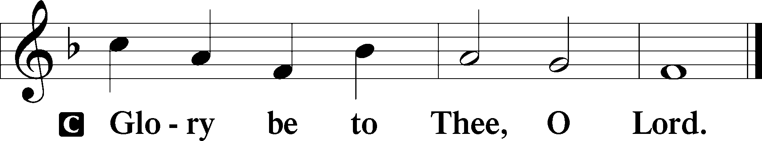

17As [Jesus] was setting out on his journey, a man ran up and knelt before him and asked him, “Good Teacher, what must I do to inherit eternal life?” 18And Jesus said to him, “Why do you call me good? No one is good except God alone. 19You know the commandments: ‘Do not murder, Do not commit adultery, Do not steal, Do not bear false witness, Do not defraud, Honor your father and mother.’” 20And he said to him, “Teacher, all these I have kept from my youth.” 21And Jesus, looking at him, loved him, and said to him, “You lack one thing: go, sell all that you have and give to the poor, and you will have treasure in heaven; and come, follow me.” 22Disheartened by the saying, he went away sorrowful, for he had great possessions.

P This is the Gospel of the Lord.

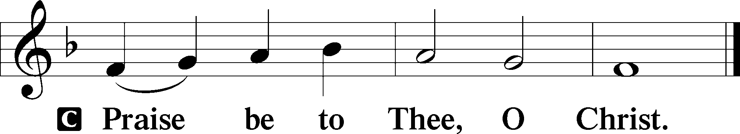

Apostles’ Creed

C **I believe in God, the Father Almighty, maker of heaven and earth.**

**And in Jesus Christ, His only Son, our Lord, who was conceived by the Holy Spirit, born of the virgin Mary, suffered under Pontius Pilate, was crucified, died and was buried. He descended into hell. The third day He rose again from the dead. He ascended into heaven and sits at the right hand of God the Father Almighty. From thence He will come to judge the living and the dead.**

**I believe in the Holy Spirit, the holy Christian Church, the communion of saints, the forgiveness of sins, the resurrection of the body, and the life** T **everlasting. Amen.**

Sit

576 My Hope Is Built on Nothing Less

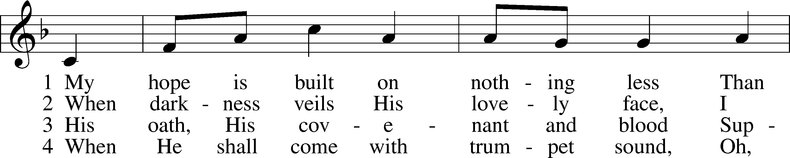

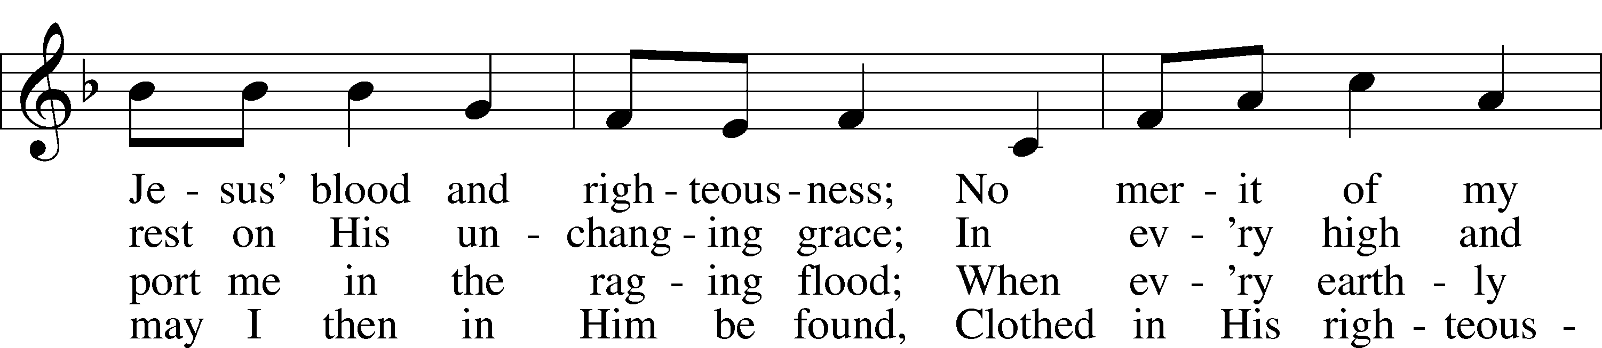

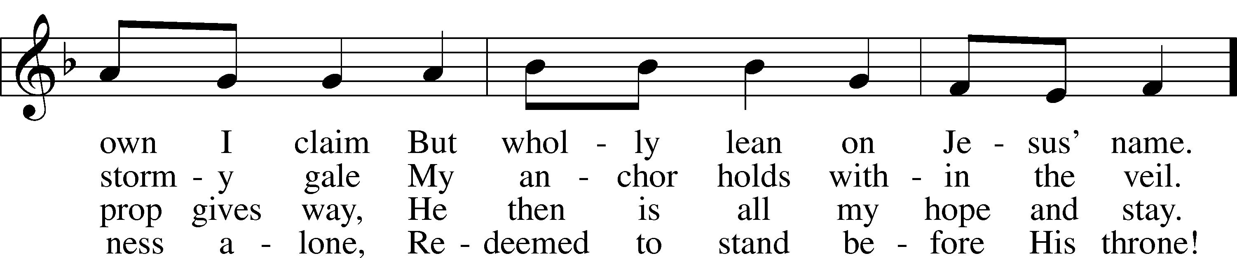

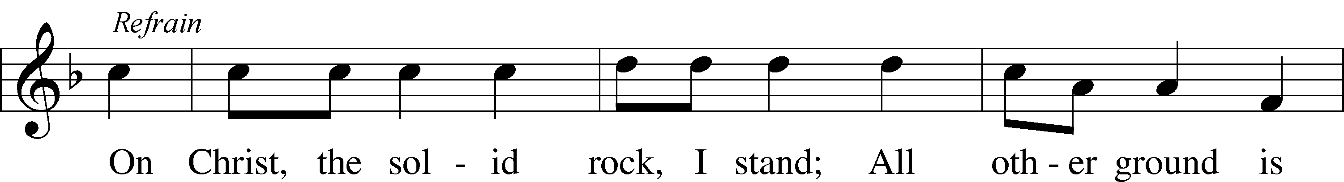

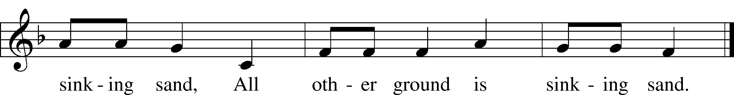

Text: Edward Mote, 1797–1874, alt.  
Tune: William B. Bradbury, 1816–68  
Text and tune: Public domain

Sermon: “What Must I Do?” *Mark 10:17-22*

Offering

Stand

**Offertory** *LSB 192*

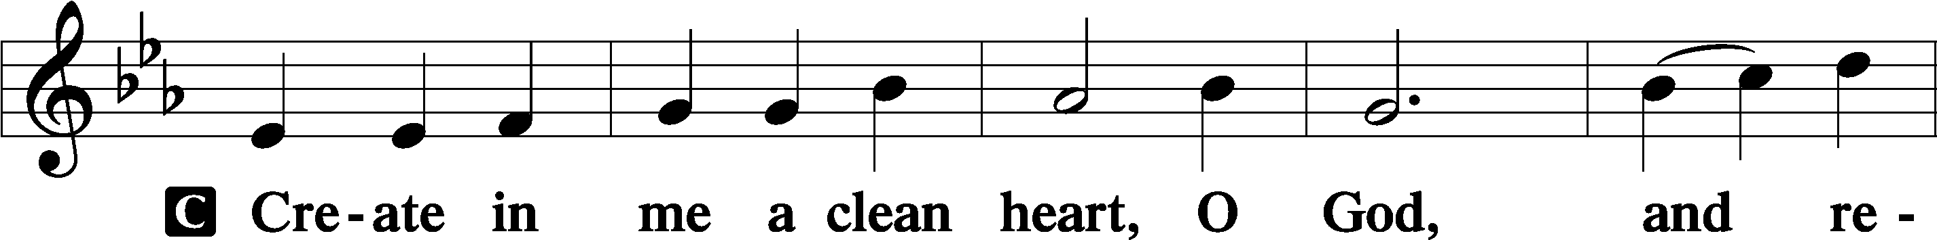

Prayer of the Church

Lord’s Prayer

C  **Our Father who art in heaven, hallowed be Thy name, Thy kingdom come, Thy will be done on earth as it is in heaven; give us this day our daily bread; and forgive us our trespasses as we forgive those who trespass against us; and lead us not into temptation, but deliver us from evil. For Thine is the kingdom and the power and the glory forever and ever. Amen.**

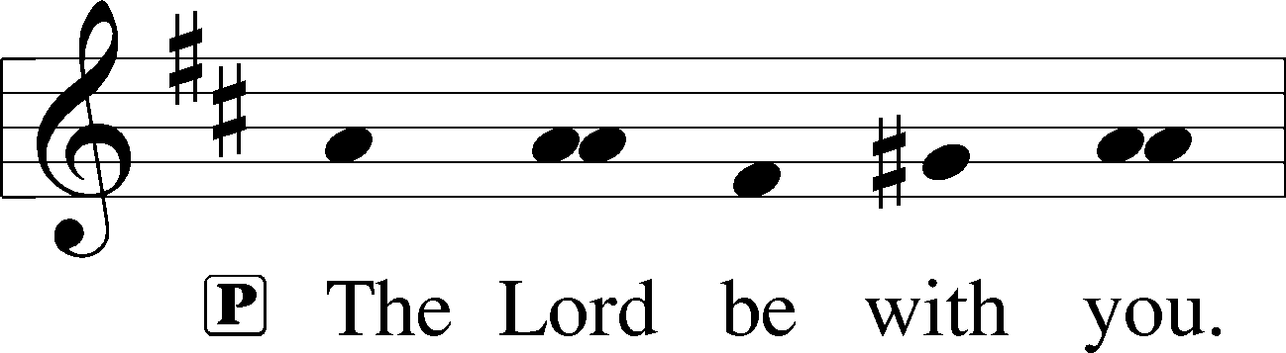

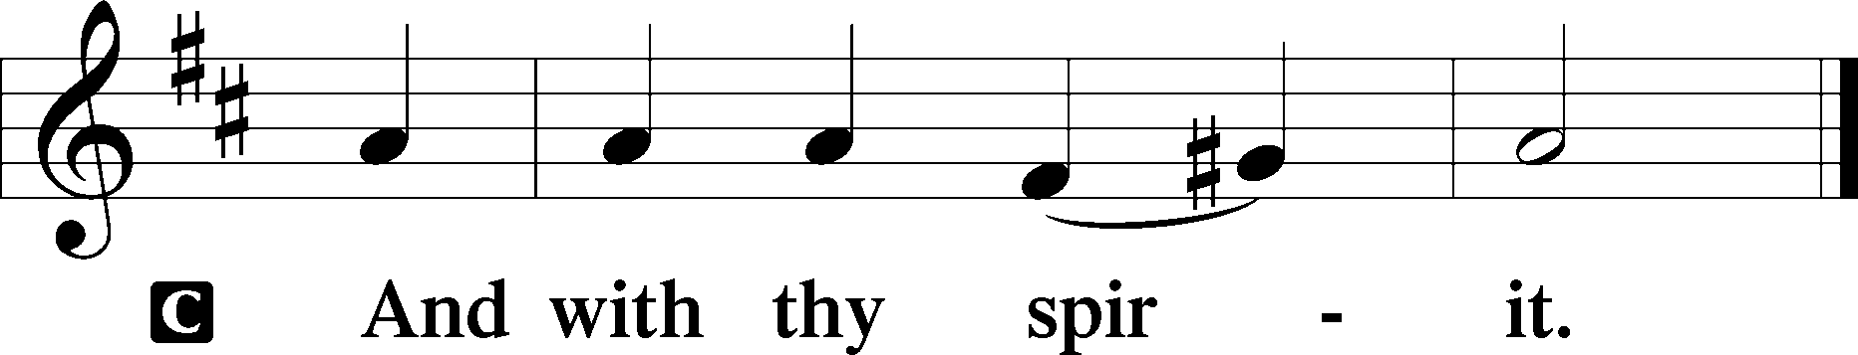

Benedicamus LSB 202

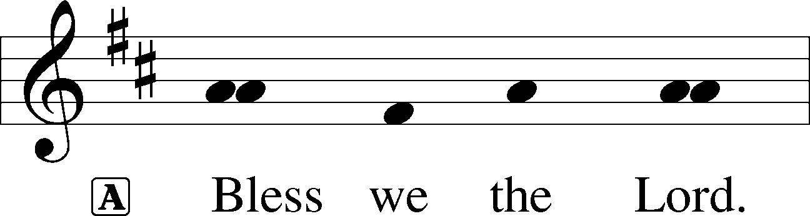

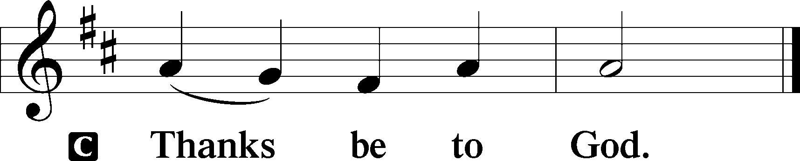

Benediction LSB 202

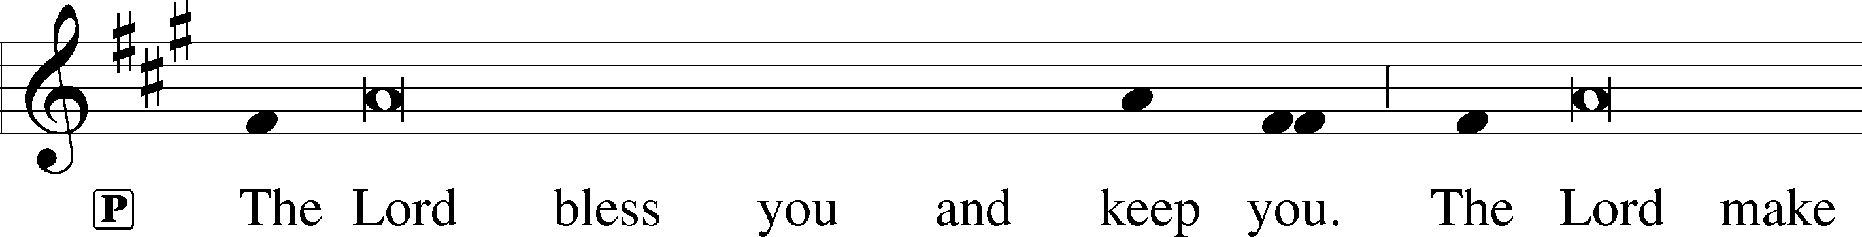

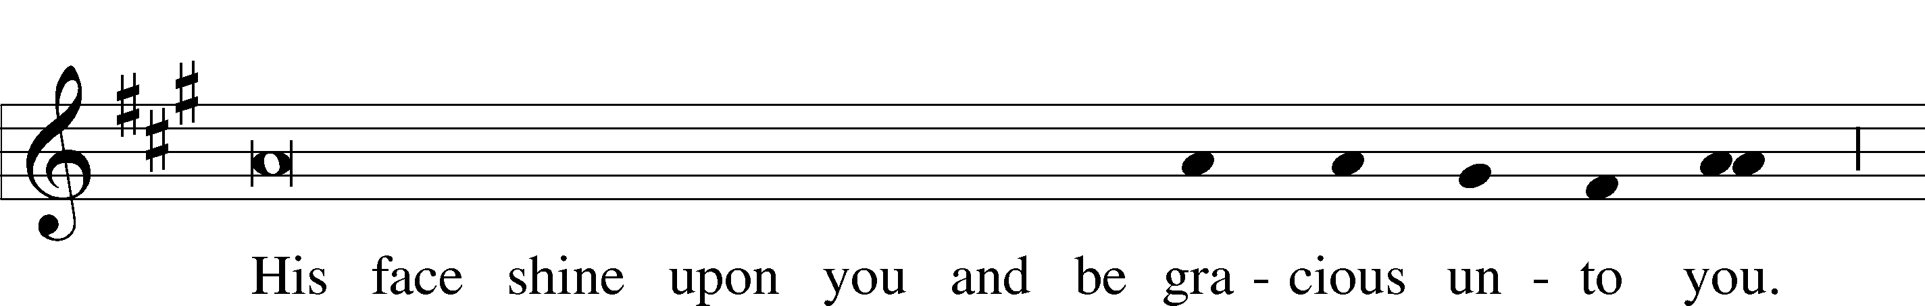

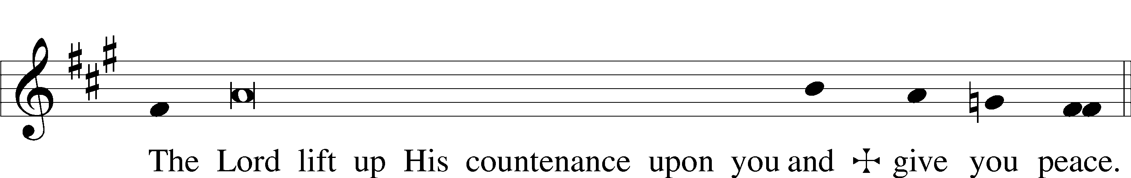

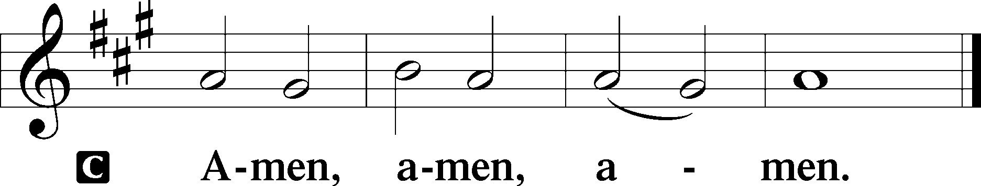

690 Hope of the World

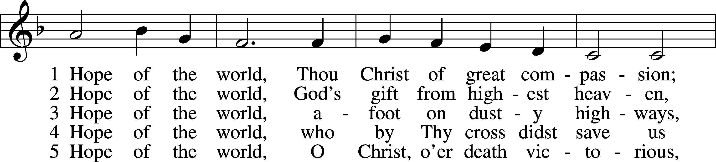

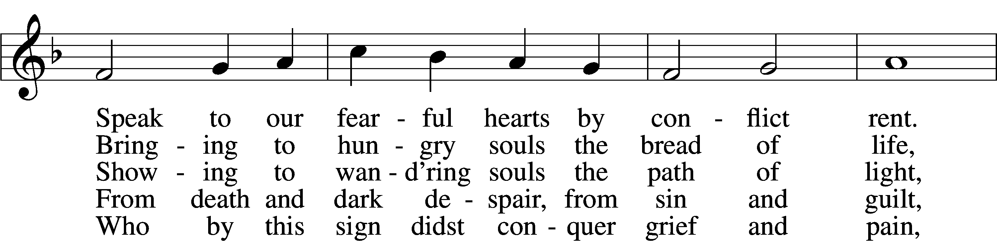

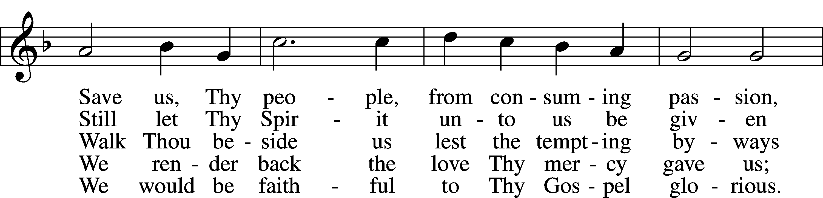

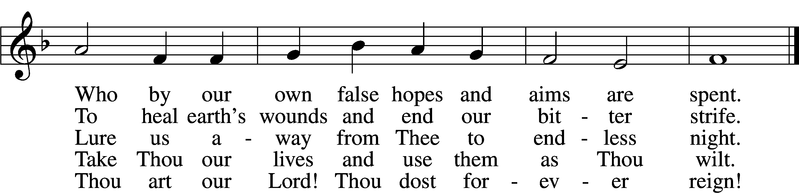

Text: Georgia Harkness, 1891–1974  
Tune: Frances R. Havergal, 1836–79 Text: © 1954, renewed 1982 The Hymn Society, admin. Hope Publishing Co. Used by permission: LSB Hymn License no. 110004388 Tune: Public domain

Acknowledgments

Divine Service, Setting Three from Lutheran Service Book

Unless otherwise indicated, Scripture quotations are from the ESV® Bible (The Holy Bible, English Standard Version®), copyright © 2001 by Crossway, a publishing ministry of Good News Publishers. Used by permission. All rights reserved.

Created by Lutheran Service Builder © 2024 Concordia Publishing House.