**Last Sunday of the Church Year**

**November 24, 2024**

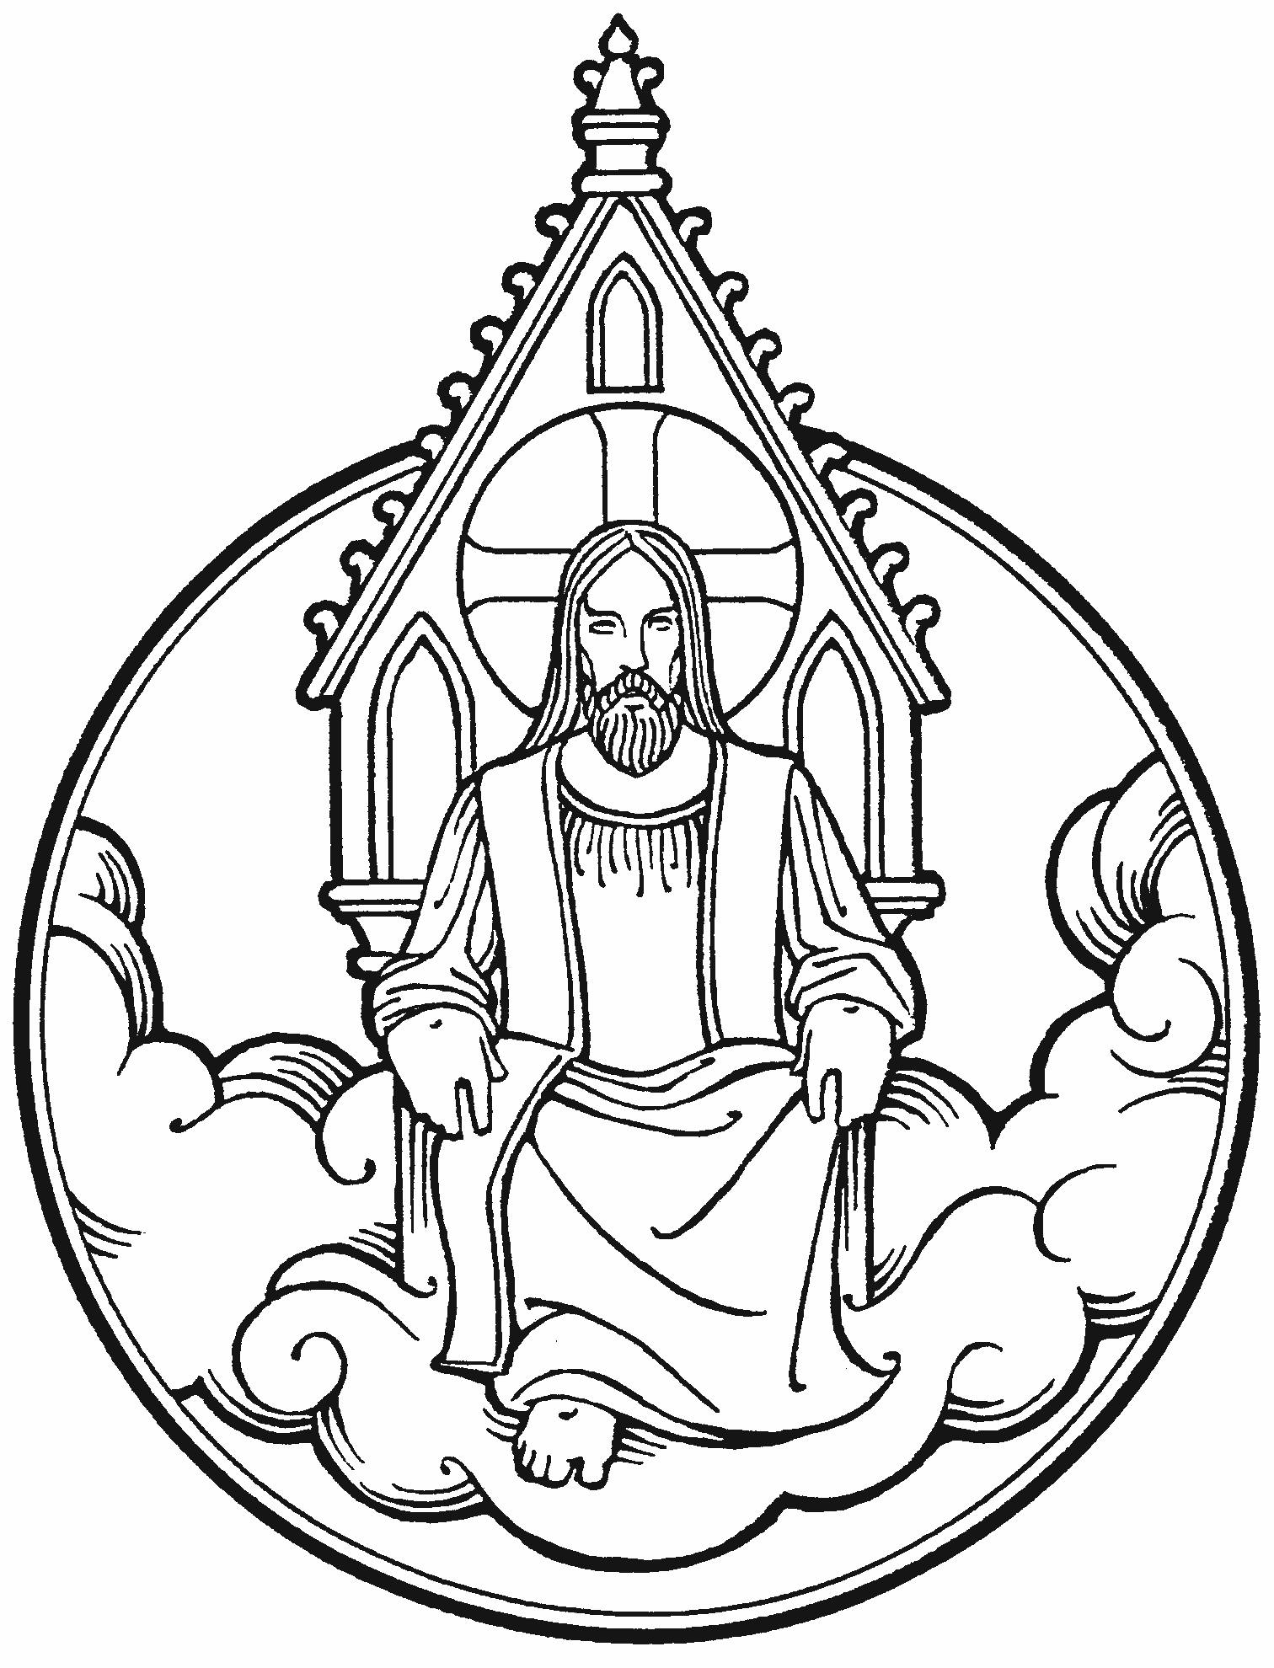

“And then they will see the Son of Man coming in clouds with great power and glory”

**PEACE LUTHERAN CHURCH**

1451 Ebenezer Rd + Cincinnati, OH 45233 + 513-941-5177

[**www.peacechurchlink.com**](http://www.peacechurchlink.com)

**The Last Sunday of the Church Year**

The Last Sunday of the Church Year directs our attention to the end of this age and the judgment of the wicked. We should rise each morning, make the sign of the cross, pray the Lord’s prayer, and live as if this day we will meet our Lord. Indeed, we Christians eagerly await the coming of our good and gracious Judge, the very One who gave His life for us on the cross, the very One who meets us this day at His altar with words of forgiveness. Next Sunday is the first Sunday of a new Church Year and the beginning of the Season of Advent.

The time before the Divine Service begins is a time for meditation and prayer. It’s a time for us to prepare our hearts and minds to hear God’s Word and receive His gifts. Therefore, we ask that you would please remain silent as you enter the sanctuary out of reverence for God and respect for one another.

**Are My Children Welcome?**

In God’s eyes we’re all children. Yes, your little ones are more than welcome! If your child needs a little extra room to “make a joyful noise” you’re welcome to take them out of the sanctuary and into the narthex or the Fellowship Hall.

**How Do I Become a Lutheran Christian?**

If you’re exploring the Lutheran Church, Pastor Shaw would be happy to offer guidance or answer your questions. Our website peacechurchlink.com is also a good resource. When you’re ready, there’s a formal process of reading, study, and prayer that culminates in being received into the Lutheran Church.

578 Thy Strong Word

*Stand for Stanza 6*

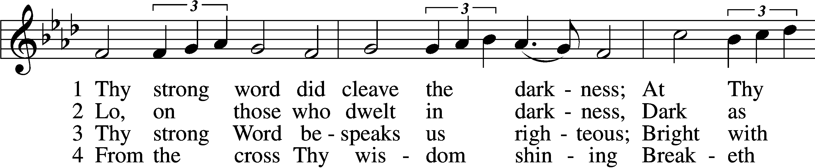

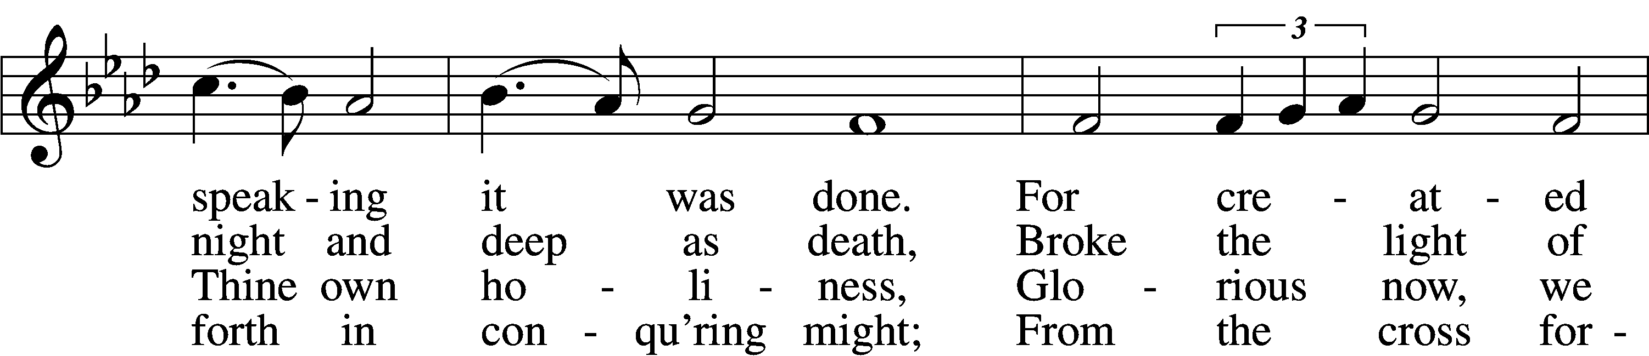

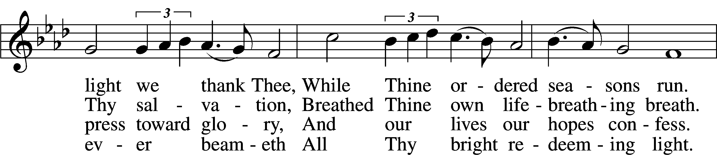

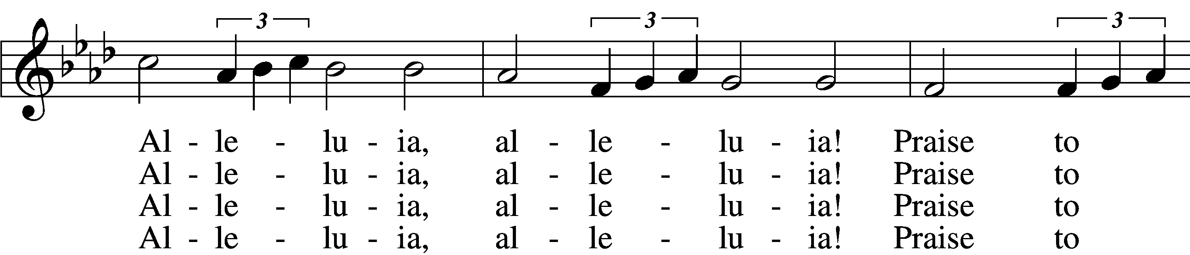

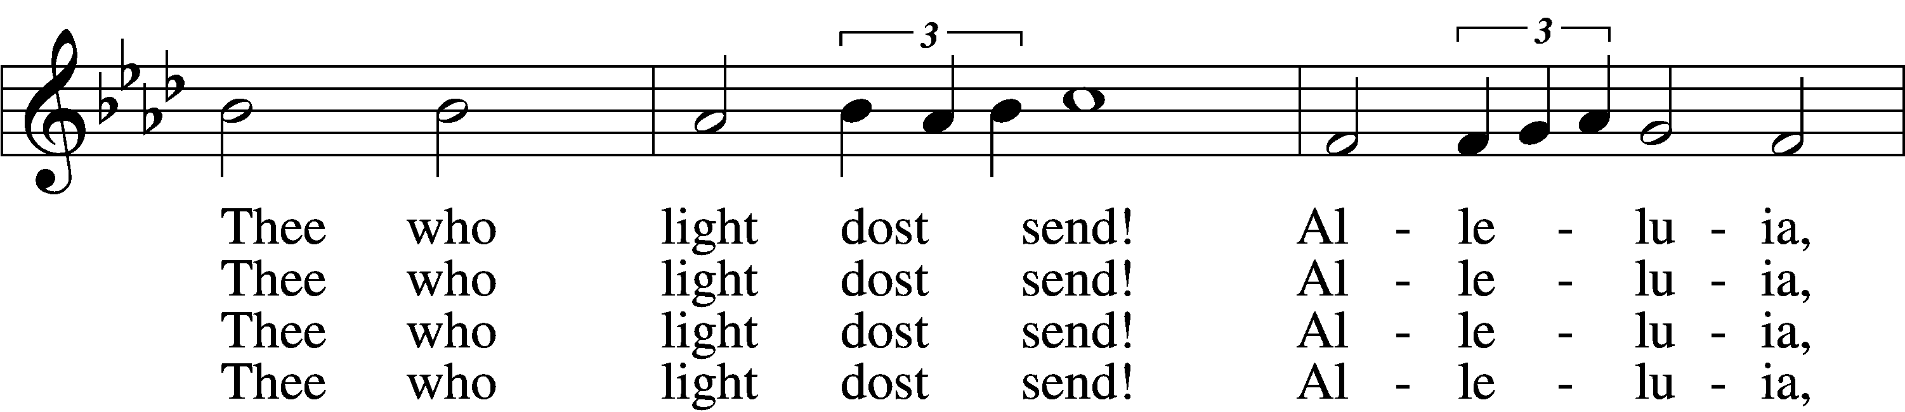

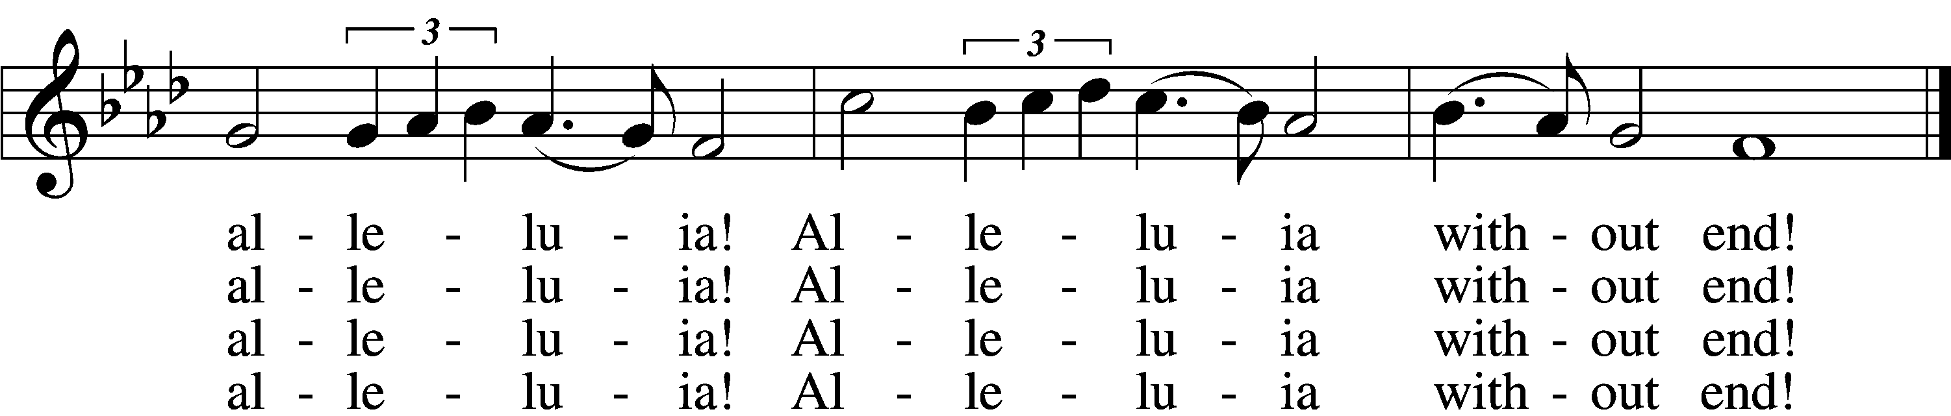

Text: Martin H. Franzmann, 1907–76 Tune: Thomas J. Williams, 1869–1944 Text: © 1969 Concordia Publishing House. Used by permission: LSB Hymn License no. 110004388 Tune: Public domain

# Confession and Absolution

The sign of the cross may be made by all in remembrance of their Baptism.

P In the name of the Father and of the T Son and of the Holy Spirit.

C **Amen.**

P Our help is in the name of the Lord,

C **who made heaven and earth.**

P If You, O Lord, kept a record of sins, O Lord, who could stand?

C **But with You there is forgiveness; therefore You are feared.**

P Since we are gathered to hear God’s Word and call upon Him in prayer and praise, let us first consider our unworthiness and confess before God and one another that we have sinned in thought, word, and deed, and that we cannot free ourselves from our sinful condition. Together as His people let us take refuge in the infinite mercy of God, our heavenly Father, seeking His grace for the sake of Christ, and saying: God, be merciful to me, a sinner.

C **Almighty God, have mercy upon us, forgive us our sins, and lead us to everlasting life. Amen.**

P Almighty God in His mercy has given His Son to die for you and for His sake forgives you all your sins. As a called and ordained servant of Christ, and by His authority, I therefore forgive you all your sins in the name of the Father and of the T Son and of the Holy Spirit.

C **Amen.**

# Service of the Word

Introit Psalm 39:4–5a, 7–8, 12a; antiphon: 2 Peter 3:13b NIV

We are looking forward to a new heaven and a new earth,  
 **the home of righteousness.**O Lord, make me know my end and what is the measure of my days;  
 **let me know how fleeting I am!**  
Behold, you have made my days a few handbreadths,  
 **and my lifetime is as nothing before you.**And now, O Lord, for what do I wait?  
 **My hope is in you.**  
Deliver me from all my transgressions.  
 **Do not make me the scorn of the fool!**Hear my prayer, O Lord, and give ear to my cry;  
 **hold not your peace at my tears!**

**Glory be to the Father and to the Son**  
 **and to the Holy Spirit;**  
**as it was in the beginning,**  
 **is now, and will be forever. Amen.**  
We are looking forward to a new heaven and a new earth,  
 **the home of righteousness.**

Kyrie LSB 204

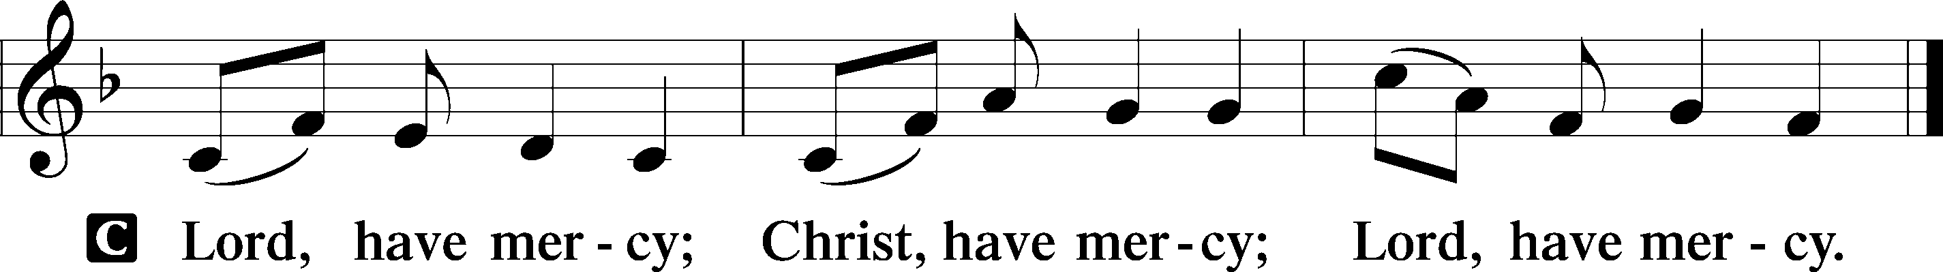

Gloria in Excelsis LSB 204

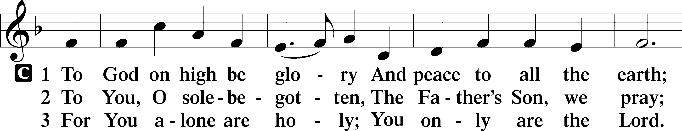

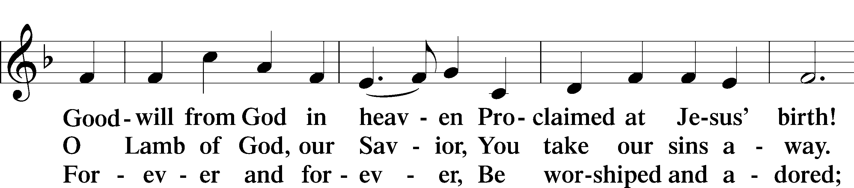

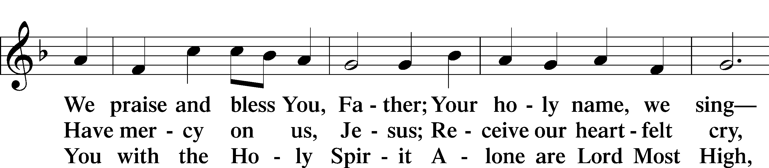

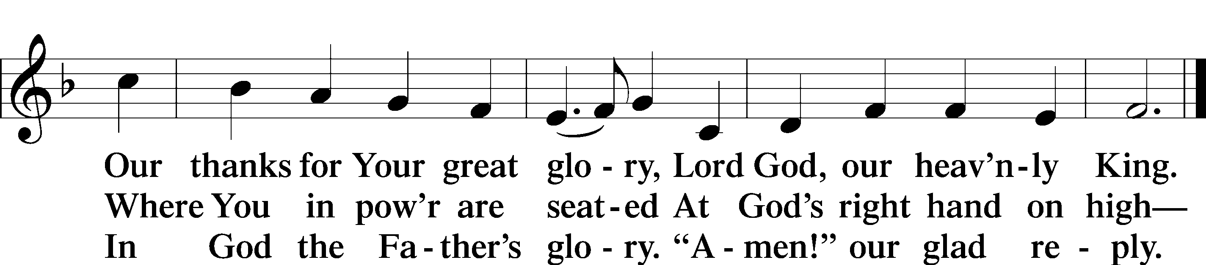

Text: Stephen P. Starke

Salutation and Collect of the Day

P The Lord be with you.

C **And also with you.**

P Let us pray.

Lord Jesus Christ, so govern our hearts and minds by Your Holy Spirit that, ever mindful of Your glorious return, we may persevere in both faith and holiness of living; for You live and reign with the Father and the Holy Spirit, one God, now and forever.

C **Amen.**

Sit

Old Testament Reading Isaiah 51:4–6

4“Give attention to me, my people, and give ear to me, my nation; for a law will go out from me, and I will set my justice for a light to the peoples. 5My righteousness draws near, my salvation has gone out, and my arms will judge the peoples; the coastlands hope for me, and for my arm they wait.

6Lift up your eyes to the heavens, and look at the earth beneath; for the heavens vanish like smoke, the earth will wear out like a garment, and they who dwell in it will die in like manner; but my salvation will be forever, and my righteousness will never be dismayed.”

A This is the Word of the Lord.

C **Thanks be to God.**

Epistle Jude 20–25

20But you, beloved, build yourselves up in your most holy faith; pray in the Holy Spirit; 21keep yourselves in the love of God, waiting for the mercy of our Lord Jesus Christ that leads to eternal life. 22And have mercy on those who doubt; 23save others by snatching them out of the fire; to others show mercy with fear, hating even the garment stained by the flesh.24Now to him who is able to keep you from stumbling and to present you blameless before the presence of his glory with great joy, 25to the only God, our Savior, through Jesus Christ our Lord, be glory, majesty, dominion, and authority, before all time and now and forever. Amen.

A This is the Word of the Lord.

C **Thanks be to God.**

**My Faith Has Found a Resting Place (Marsh)** Choir

Stand

Holy Gospel Mark 13:24–37

P The Holy Gospel according to St. Mark, the thirteenth chapter.

C **Glory to You, O Lord.**

24[Jesus said:] “In those days, after that tribulation, the sun will be darkened, and the moon will not give its light, 25and the stars will be falling from heaven, and the powers in the heavens will be shaken. 26And then they will see the Son of Man coming in clouds with great power and glory. 27And then he will send out the angels and gather his elect from the four winds, from the ends of the earth to the ends of heaven. 28“From the fig tree learn its lesson: as soon as its branch becomes tender and puts out its leaves, you know that summer is near. 29So also, when you see these things taking place, you know that he is near, at the very gates. 30Truly, I say to you, this generation will not pass away until all these things take place. 31Heaven and earth will pass away, but my words will not pass away.

32“But concerning that day or that hour, no one knows, not even the angels in heaven, nor the Son, but only the Father. 33Be on guard, keep awake. For you do not know when the time will come. 34It is like a man going on a journey, when he leaves home and puts his servants in charge, each with his work, and commands the doorkeeper to stay awake. 35Therefore stay awake—for you do not know when the master of the house will come, in the evening, or at midnight, or when the cock crows, or in the morning— 36lest he come suddenly and find you asleep. 37And what I say to you I say to all: Stay awake.”

P This is the Gospel of the Lord.

C **Praise to You, O Christ.**

Apostles’ Creed

C **I believe in God, the Father Almighty, maker of heaven and earth.**

**And in Jesus Christ, His only Son, our Lord, who was conceived by the Holy Spirit, born of the virgin Mary, suffered under Pontius Pilate, was crucified, died and was buried. He descended into hell. The third day He rose again from the dead. He ascended into heaven and sits at the right hand of God the Father Almighty. From thence He will come to judge the living and the dead.**

**I believe in the Holy Spirit, the holy Christian Church, the communion of saints, the forgiveness of sins, the resurrection of the body, and the life** T **everlasting. Amen.**

Sit

**512 At the Name of Jesus** *sts. 1–6*

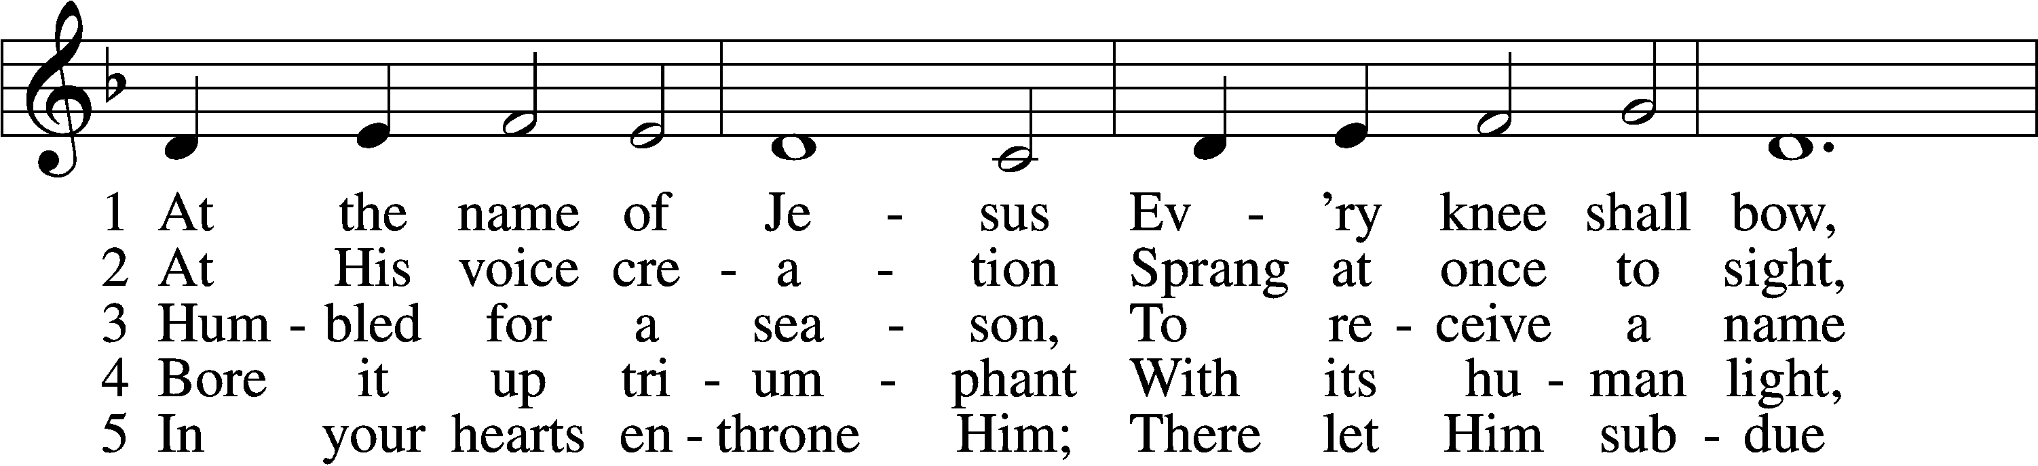

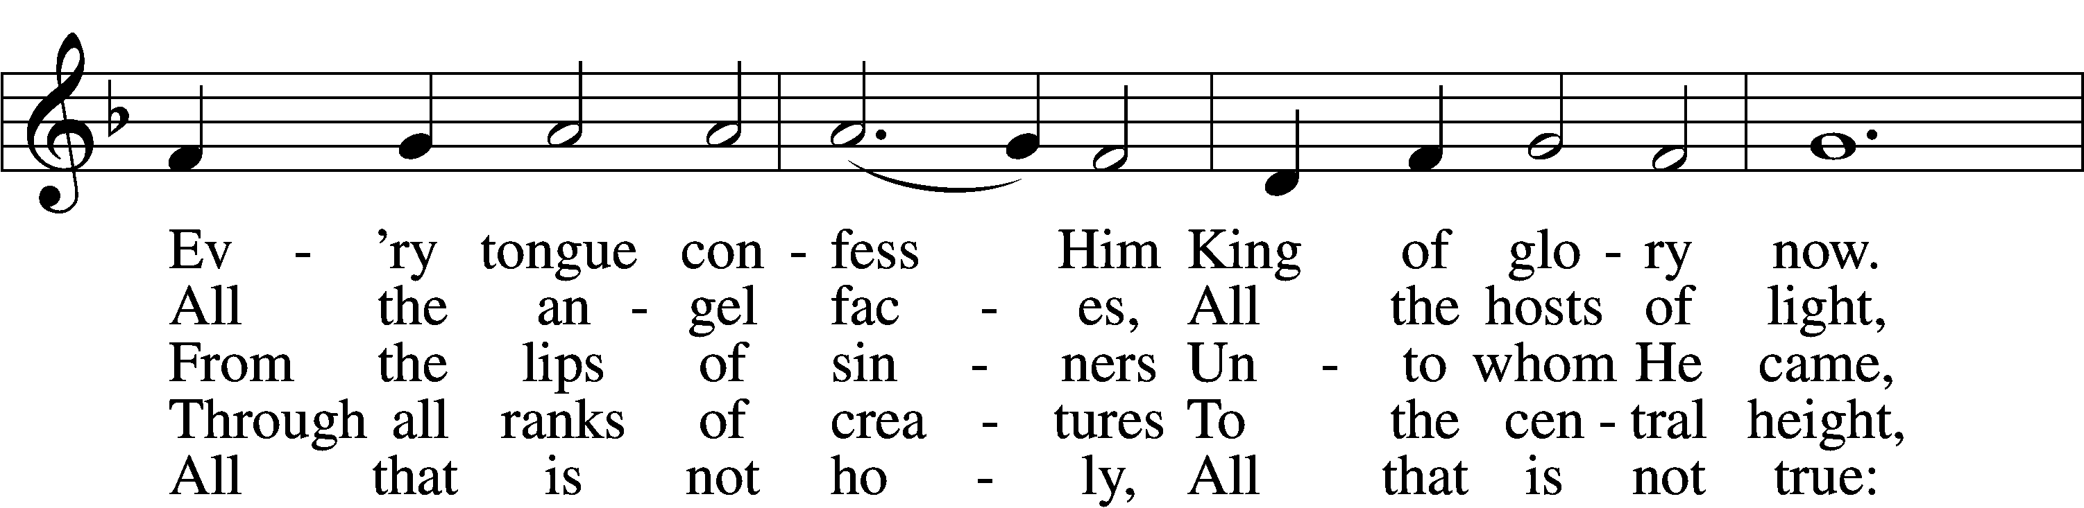

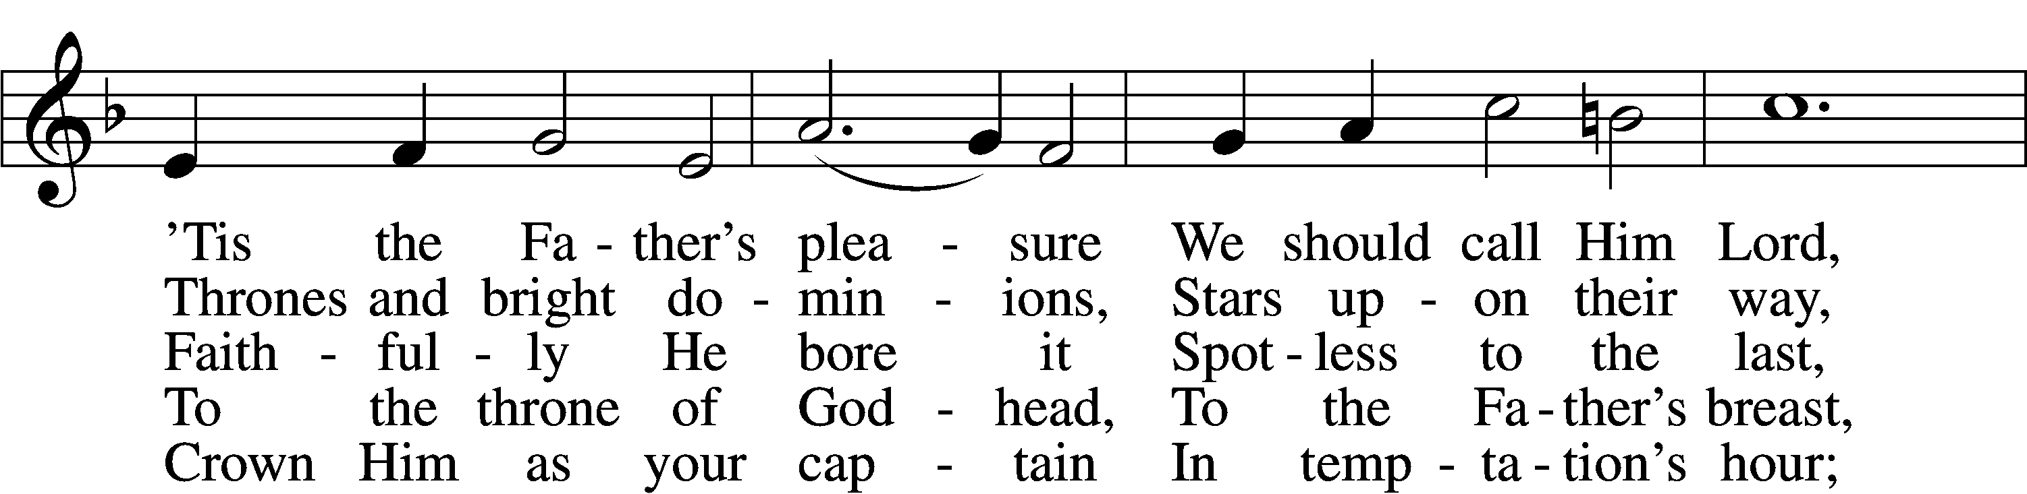

6 Christians, this Lord Jesus  
 Shall return again  
In His Father’s glory,  
 With His angel train;  
For all wreaths of empire  
 Meet upon His brow,  
And our hearts confess Him  
 King of glory now.

Text: Caroline M. Noel, 1817–77, alt. Tune: Ralph Vaughan Williams, 1872–1958 Text and tune: Public domain

Sermon: “You Will See Him Coming” *Mark 13:24-37*

Offering

Stand

Prayer of the Church

Lord’s Prayer

C **Our Father who art in heaven, hallowed be Thy name, Thy kingdom come, Thy will be done on earth as it is in heaven; give us this day our daily bread; and forgive us our trespasses as we forgive those who trespass against us; and lead us not into temptation, but deliver us from evil. For Thine is the kingdom and the power and the glory forever and ever. Amen.**

Benedicamus LSB 212

A Let us bless the Lord.

C **Thanks be to God.**

Benediction

P The Lord bless you and keep you.

The Lord make His face shine on you and be gracious to you.

The Lord look upon you with favor and T give you peace.

C **Amen.**

348 The King Shall Come When Morning Dawns

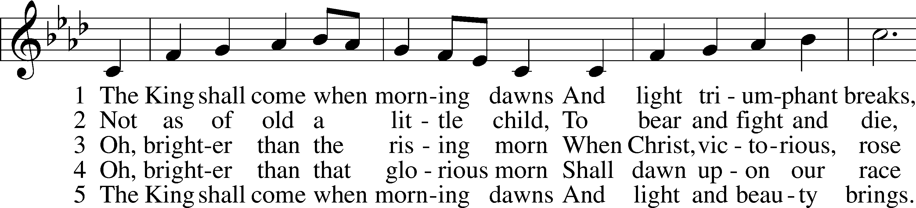

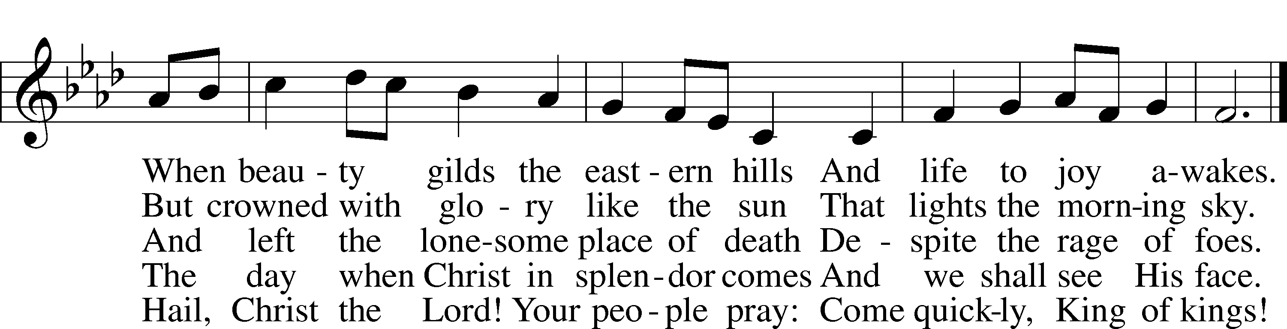

Text: John Brownlie, 1859–1925, alt. Tune: Repository of Sacred Music, Part Second, 1813, Harrisburg, ed. John Wyeth Text and tune: Public domain

Acknowledgments

Divine Service, Setting Four from Lutheran Service Book

Unless otherwise indicated, Scripture quotations are from the ESV® Bible (The Holy Bible, English Standard Version®), copyright © 2001 by Crossway, a publishing ministry of Good News Publishers. Used by permission. All rights reserved.

Created by Lutheran Service Builder © 2024 Concordia Publishing House.