**SEVENTH SUNDAY AFTER**

**THE EPIPHANY**

February 23, 2025 ATD

“Be merciful, even as your Father is merciful”

**PEACE LUTHERAN CHURCH**

1451 Ebenezer Rd + Cincinnati, OH 45233 + 513-941-5177

[**www.peacechurchlink.com**](http://www.peacechurchlink.com)

**About This Service**

The season of Christmas comes to a close with Epiphany (January 6th). The word “Epiphany” comes from the Greek epiphaneia, meaning “manifestation.” The salvation of the Gentiles (not just the Jews) is made manifest in the coming of the Magi to worship Jesus. We are reminded that Jesus comes not only to make atonement for our sins, but also to make all things new. This includes a new human race that is born, not of the flesh, but of God, of water and Spirit, and we are – even now – being formed for all eternity into His Image.

The time before the Divine Service begins is a time for meditation and prayer. It’s a time for us to prepare our hearts and minds to hear God’s Word and receive His gifts. Therefore, we ask that you would please remain silent as you enter the sanctuary out of reverence for God and respect for one another.

**Are My Children Welcome?**

In God’s eyes we’re all children. Yes, your little ones are more than welcome! If your child needs a little extra room to “make a joyful noise” you’re welcome to take them out of the sanctuary and into the narthex or the Fellowship Hall.

**How Do I Become a Lutheran Christian?**

If you’re exploring the Lutheran Church, Pastor Shaw would be happy to offer guidance or answer your questions. Our website peacechurchlink.com is also a good resource. When you’re ready, there’s a formal process of reading, study, and prayer that culminates in being received into the Lutheran Church.

409 HAIL O SOURCE OF EVERY BLESSING

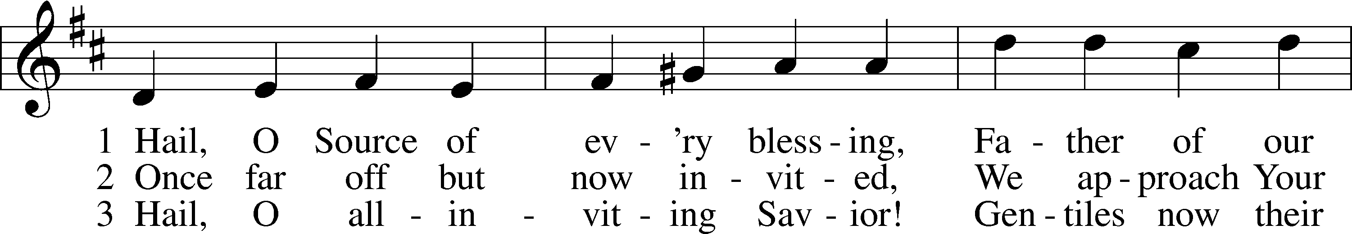

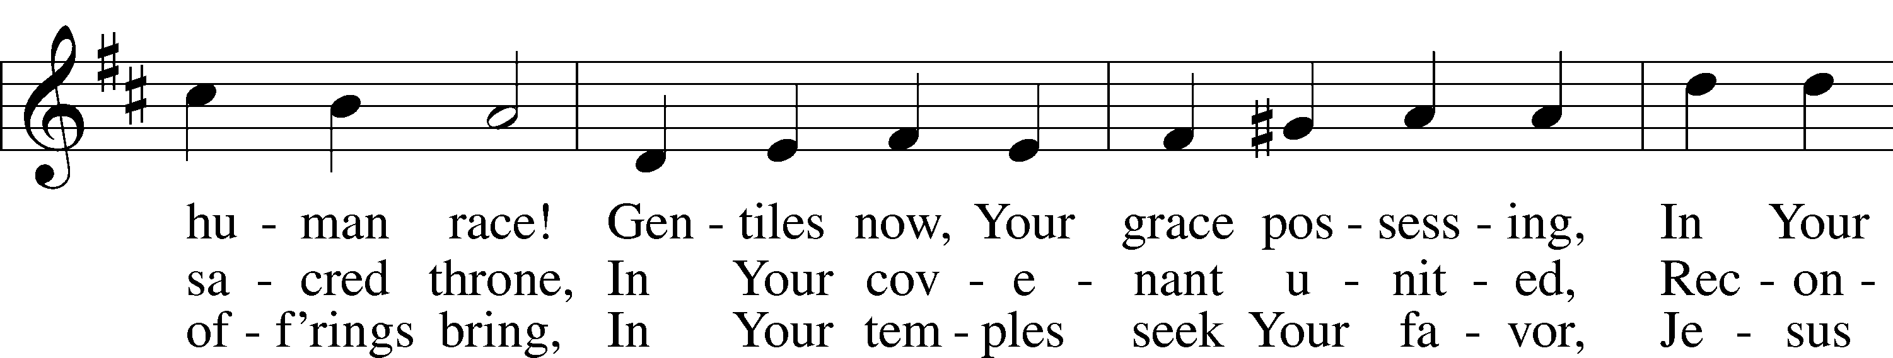

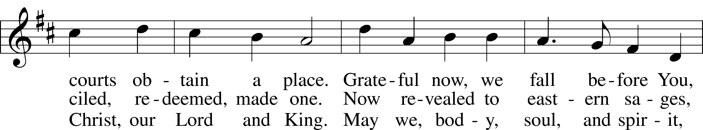

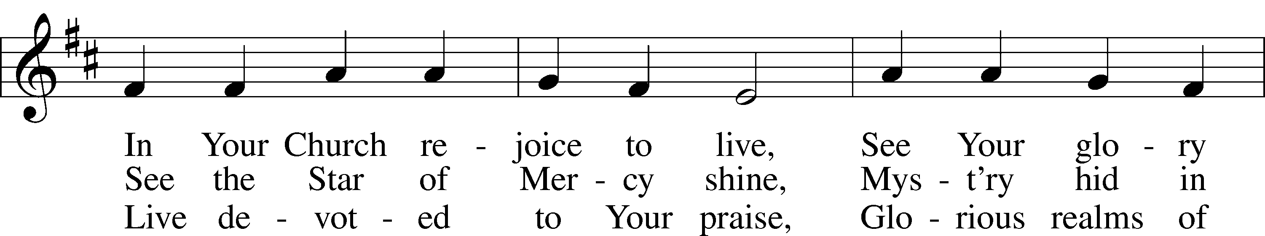

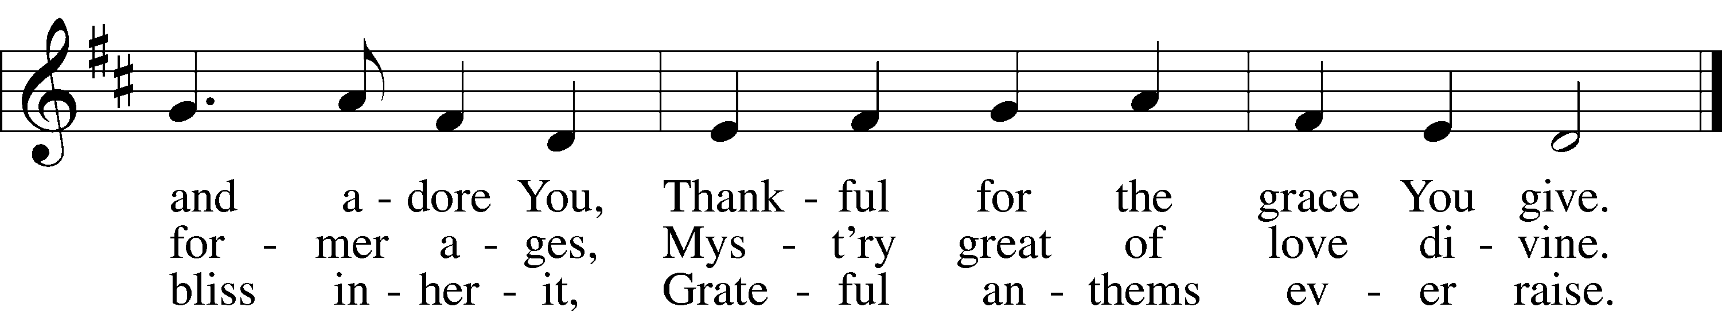

Text: Basil Woodd, 1760–1831, alt.  
Tune: Geist-reiches Gesang-Buch, 1704, Halle, ed. Johann A. Freylinghausen  
Text and tune: Public domain

# CONFESSION AND ABSOLUTION

Stand

The sign of the cross may be made by all in remembrance of their Baptism.

INVOCATION

P In the name of the Father and of the T Son and of the Holy Spirit.

C **Amen.**

EXHORTATION LSB 167

P If we say we have no sin, we deceive ourselves, and the truth is not in us.

C **But if we confess our sins, God, who is faithful and just, will forgive our sins and cleanse us from all unrighteousness.**

Silence for reflection on God’s Word and for self-examination.

CONFESSION OF SINS LSB 167

P Let us then confess our sins to God our Father.

C **Most merciful God, we confess that we are by nature sinful and unclean. We have sinned against You in thought, word, and deed, by what we have done and by what we have left undone. We have not loved You with our whole heart; we have not loved our neighbors as ourselves. We justly deserve Your present and eternal punishment. For the sake of Your Son, Jesus Christ, have mercy on us. Forgive us, renew us, and lead us, so that we may delight in Your will and walk in Your ways to the glory of Your holy name. Amen.**

ABSOLUTION LSB 167

P Almighty God in His mercy has given His Son to die for you and for His sake forgives you all your sins. As a called and ordained servant of Christ, and by His authority, I therefore forgive you all your sins in the name of the Father and of the T Son and of the Holy Spirit.

C **Amen.**

# SERVICE OF THE WORD

INTROIT Psalm 37:1–5; antiphon: vv. 7a, b

Be still before the Lord and wait patiently for him;  
 **fret not yourself over the one who prospers in his way.**Fret not yourself because of evildoers;  
 **be not envious of wrongdoers!**For they will soon fade like the grass  
 **and wither like the green herb.**  
Trust in the Lord, and do good;  
 **dwell in the land and befriend faithfulness.**Delight yourself in the Lord,  
 **and he will give you the desires of your heart.**Commit your way to the Lord;  
 **trust in him, and he will act.  
Glory be to the Father and to the Son**  
 **and to the Holy Spirit;**  
**as it was in the beginning,**  
 **is now, and will be forever. Amen.**  
Be still before the Lord and wait patiently for him;  
 **fret not yourself over the one who prospers in his way.**

KYRIE LSB 168



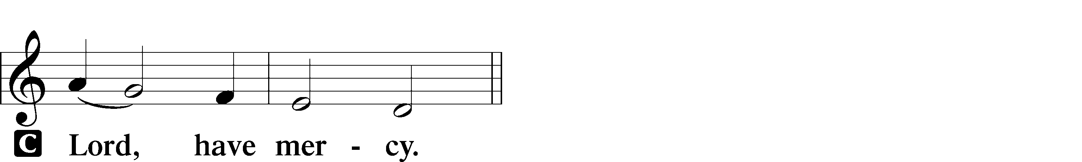

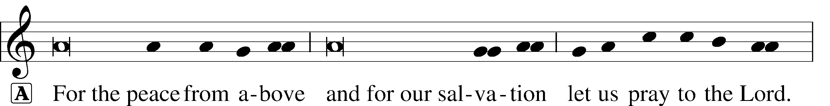

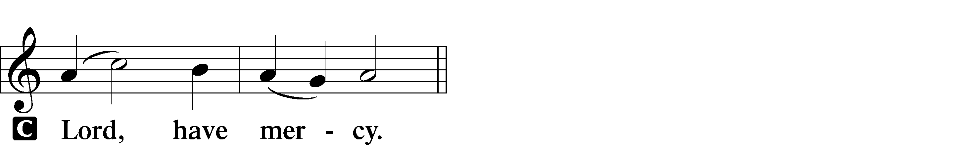

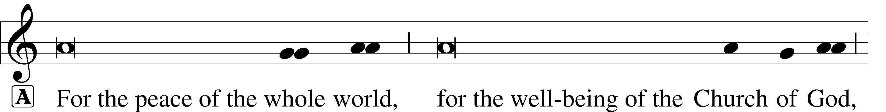



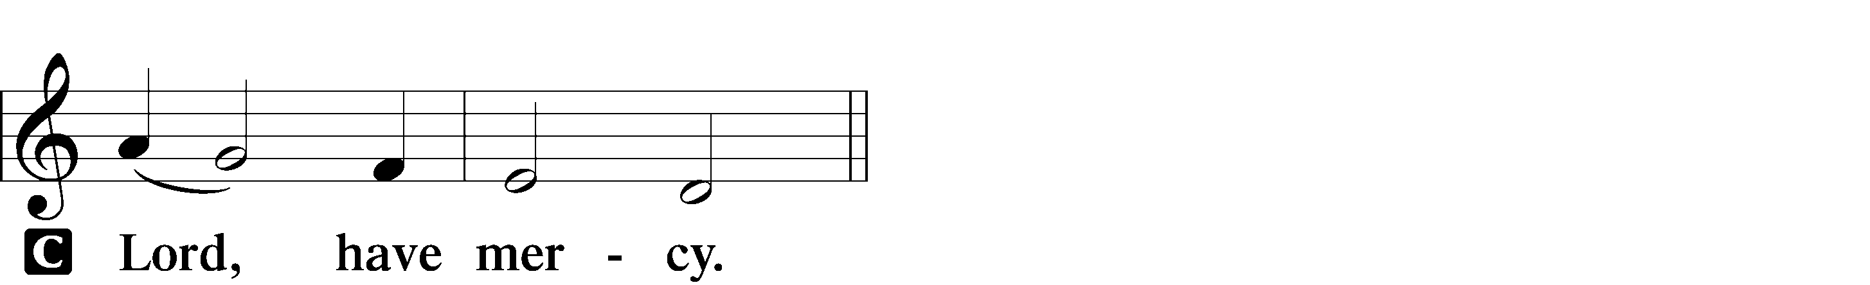

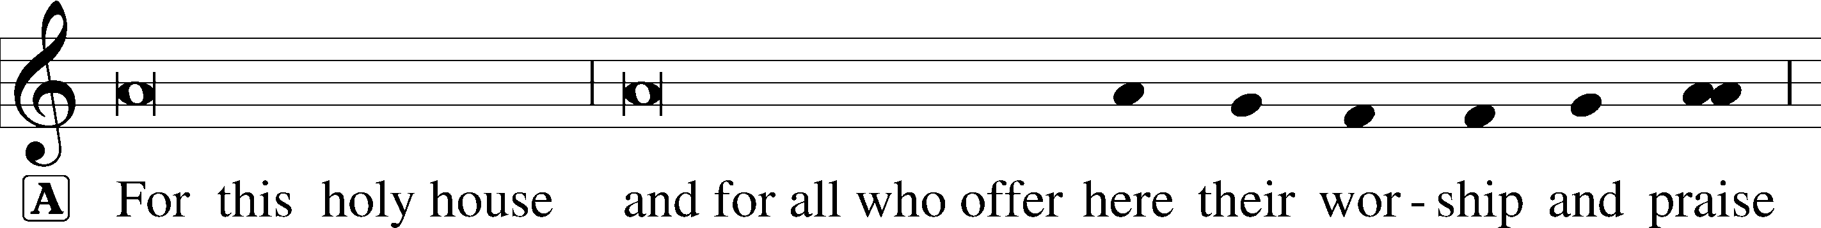



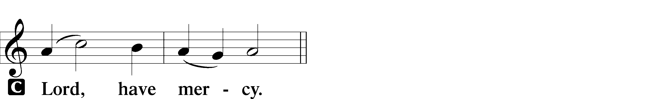





SALUTATION AND COLLECT OF THE DAY

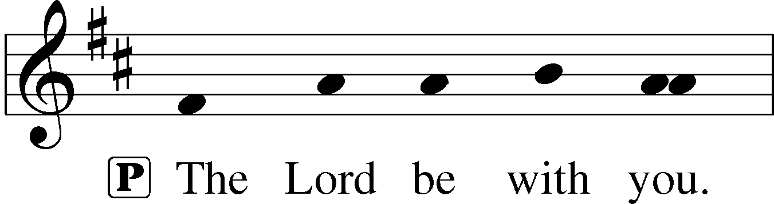

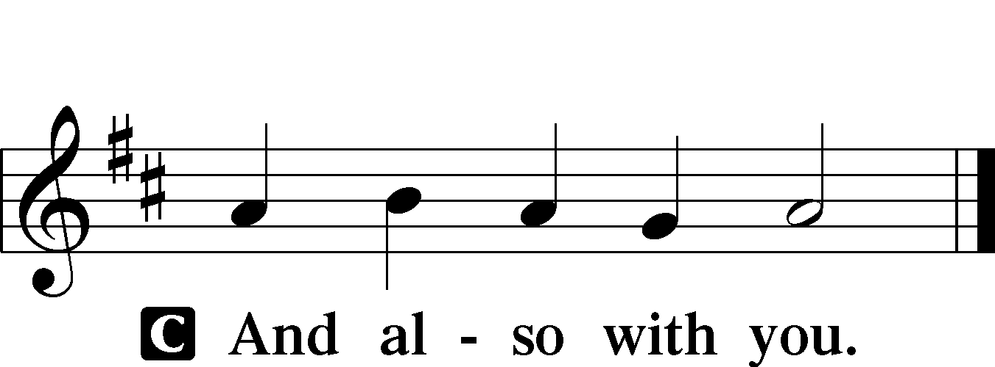

P Let us pray.

O God, the strength of all who put their trust in You, mercifully grant that by Your power we may be defended against all adversity; through Jesus Christ, Your Son, our Lord, who lives and reigns with You and the Holy Spirit, one God, now and forever.

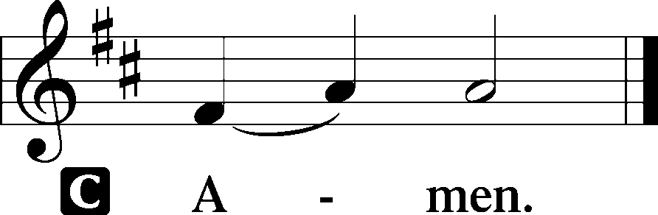

Sit

OLD TESTAMENT READING Genesis 45:3–15

3 Joseph said to his brothers, “I am Joseph! Is my father still alive?” But his brothers could not answer him, for they were dismayed at his presence.

4So Joseph said to his brothers, “Come near to me, please.” And they came near. And he said, “I am your brother, Joseph, whom you sold into Egypt. 5And now do not be distressed or angry with yourselves because you sold me here, for God sent me before you to preserve life. 6For the famine has been in the land these two years, and there are yet five years in which there will be neither plowing nor harvest. 7And God sent me before you to preserve for you a remnant on earth, and to keep alive for you many survivors. 8So it was not you who sent me here, but God. He has made me a father to Pharaoh, and lord of all his house and ruler over all the land of Egypt. 9Hurry and go up to my father and say to him, ‘Thus says your son Joseph, God has made me lord of all Egypt. Come down to me; do not tarry. 10You shall dwell in the land of Goshen, and you shall be near me, you and your children and your children’s children, and your flocks, your herds, and all that you have. 11There I will provide for you, for there are yet five years of famine to come, so that you and your household, and all that you have, do not come to poverty.’ 12And now your eyes see, and the eyes of my brother Benjamin see, that it is my mouth that speaks to you. 13You must tell my father of all my honor in Egypt, and of all that you have seen. Hurry and bring my father down here.” 14Then he fell upon his brother Benjamin’s neck and wept, and Benjamin wept upon his neck. 15And he kissed all his brothers and wept upon them. After that his brothers talked with him.

A This is the Word of the Lord.

C **Thanks be to God.**

EPISTLE 1 Corinthians 15:21–26, 30–42

21For as by a man came death, by a man has come also the resurrection of the dead. 22For as in Adam all die, so also in Christ shall all be made alive. 23But each in his own order: Christ the firstfruits, then at his coming those who belong to Christ. 24Then comes the end, when he delivers the kingdom to God the Father after destroying every rule and every authority and power. 25For he must reign until he has put all his enemies under his feet. 26The last enemy to be destroyed is death…

30Why am I in danger every hour? 31I protest, brothers, by my pride in you, which I have in Christ Jesus our Lord, I die every day! 32What do I gain if, humanly speaking, I fought with beasts at Ephesus? If the dead are not raised, “Let us eat and drink, for tomorrow we die.” 33Do not be deceived: “Bad company ruins good morals.” 34Wake up from your drunken stupor, as is right, and do not go on sinning. For some have no knowledge of God. I say this to your shame.

35But someone will ask, “How are the dead raised? With what kind of body do they come?” 36You foolish person! What you sow does not come to life unless it dies. 37And what you sow is not the body that is to be, but a bare kernel, perhaps of wheat or of some other grain. 38But God gives it a body as he has chosen, and to each kind of seed its own body. 39For not all flesh is the same, but there is one kind for humans, another for animals, another for birds, and another for fish. 40There are heavenly bodies and earthly bodies, but the glory of the heavenly is of one kind, and the glory of the earthly is of another. 41There is one glory of the sun, and another glory of the moon, and another glory of the stars; for star differs from star in glory.

42So is it with the resurrection of the dead. What is sown is perishable; what is raised is imperishable.

A This is the Word of the Lord.

C **Thanks be to God.**

Stand

ALLELUIA AND VERSE LSB 173

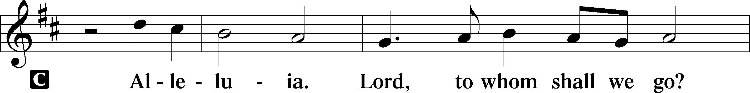

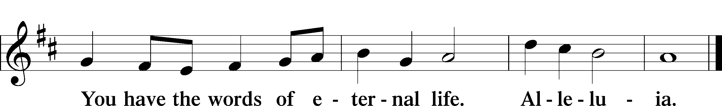

HOLY GOSPEL Luke 6:27–38

P The Holy Gospel according to St. Luke, the sixth chapter.

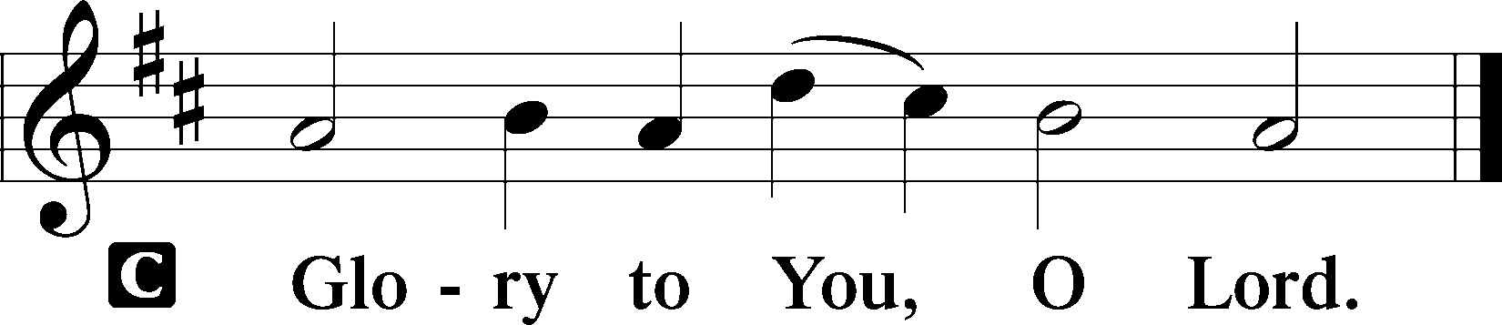

27[Jesus said:] “But I say to you who hear, Love your enemies, do good to those who hate you, 28bless those who curse you, pray for those who abuse you. 29To one who strikes you on the cheek, offer the other also, and from one who takes away your cloak do not withhold your tunic either. 30Give to everyone who begs from you, and from one who takes away your goods do not demand them back. 31And as you wish that others would do to you, do so to them.

32“If you love those who love you, what benefit is that to you? For even sinners love those who love them. 33And if you do good to those who do good to you, what benefit is that to you? For even sinners do the same. 34And if you lend to those from whom you expect to receive, what credit is that to you? Even sinners lend to sinners, to get back the same amount. 35But love your enemies, and do good, and lend, expecting nothing in return, and your reward will be great, and you will be sons of the Most High, for he is kind to the ungrateful and the evil. 36Be merciful, even as your Father is merciful.

37“Judge not, and you will not be judged; condemn not, and you will not be condemned; forgive, and you will be forgiven; 38give, and it will be given to you. Good measure, pressed down, shaken together, running over, will be put into your lap. For with the measure you use it will be measured back to you.”

P This is the Gospel of the Lord.

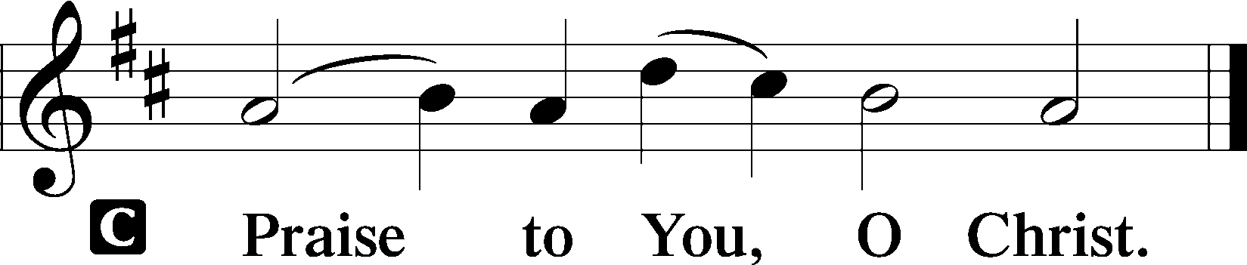

APOSTLES’ CREED

C **I believe in God, the Father Almighty, maker of heaven and earth.**

**And in Jesus Christ, His only Son, our Lord, who was conceived by the Holy Spirit, born of the virgin Mary, suffered under Pontius Pilate, was crucified, died and was buried. He descended into hell. The third day He rose again from the dead. He ascended into heaven and sits at the right hand of God the Father Almighty. From thence He will come to judge the living and the dead.**

**I believe in the Holy Spirit, the holy Christian Church, the communion of saints, the forgiveness of sins, the resurrection of the body, and the life** T **everlasting. Amen.**

Sit

843 “FORGIVE OUR SINS AS WE FORGIVE”

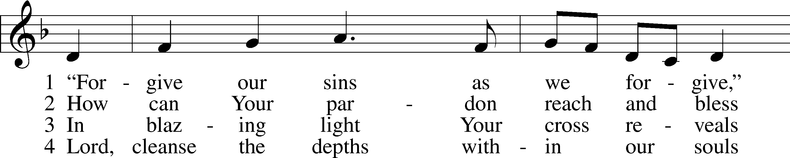

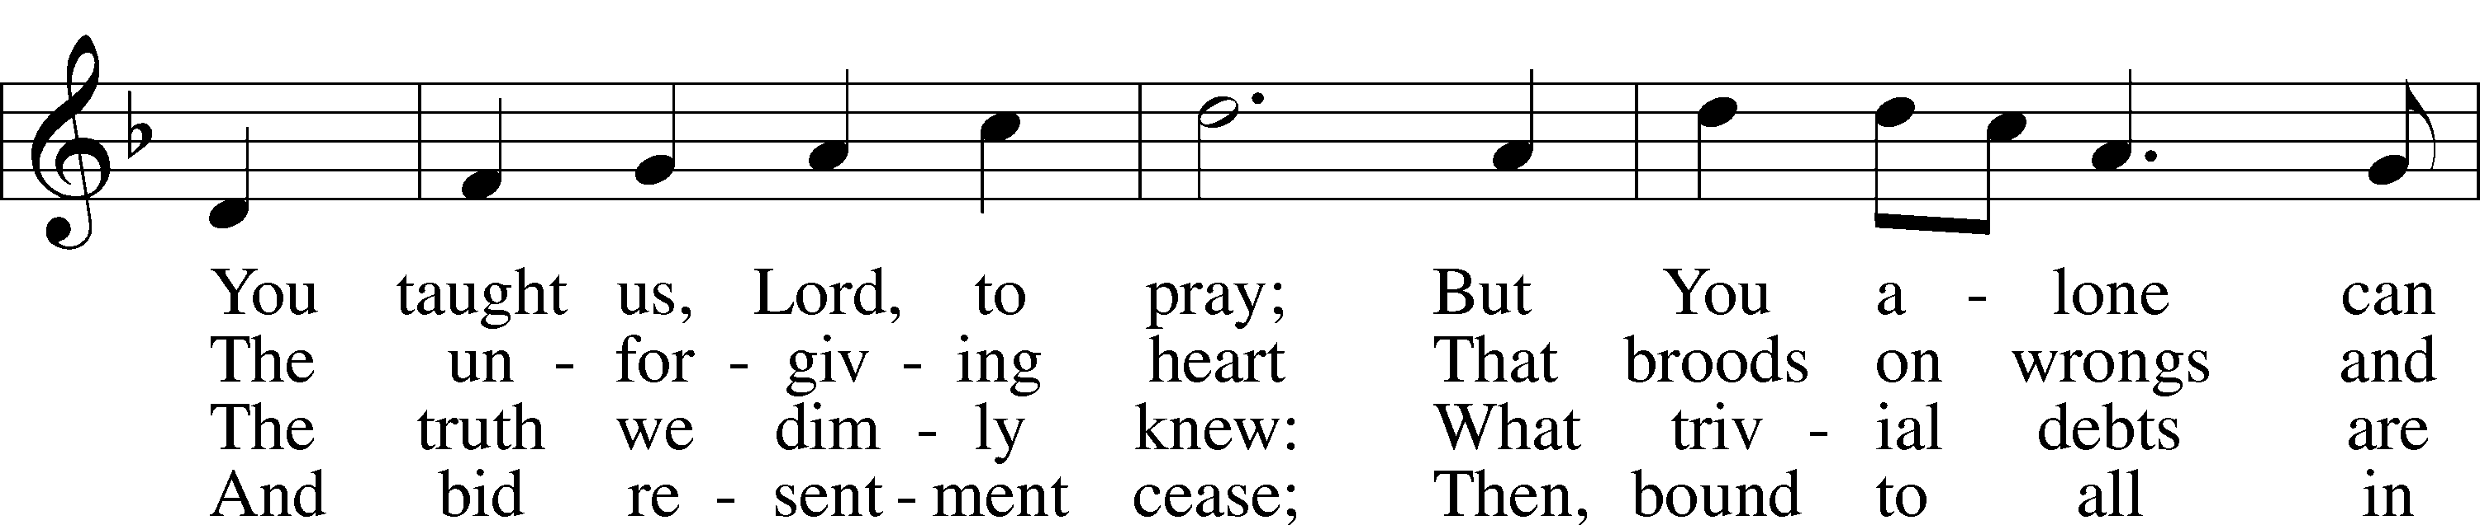

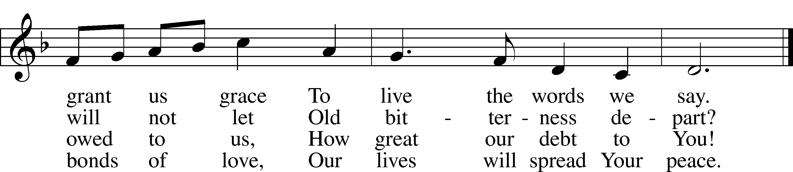

Text: Rosamond E. Herklots, 1905–87, alt. Tune: A Supplement to the Kentucky Harmony, 1820, Harrisonburg Text: © Oxford University Press. Used by permission: LSB Hymn License no. 110004388 Tune: Public domain

SERMON: “BE MERCIFUL” *Luke 6:27-38*

OFFERING

Stand

OFFERTORY LSB 176

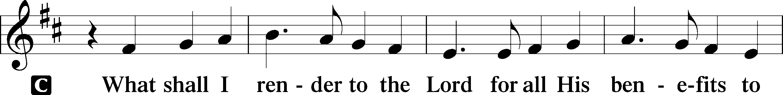

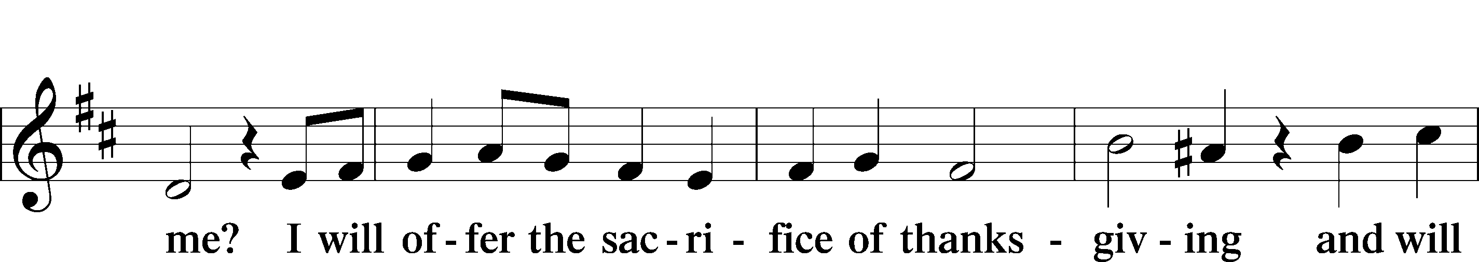

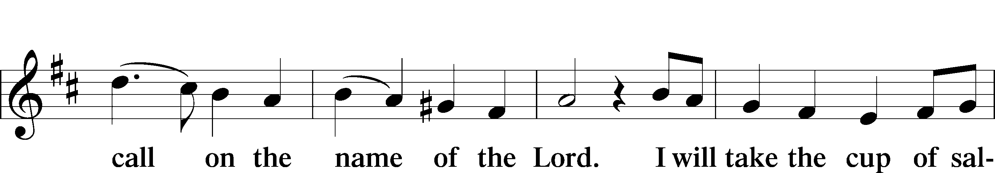

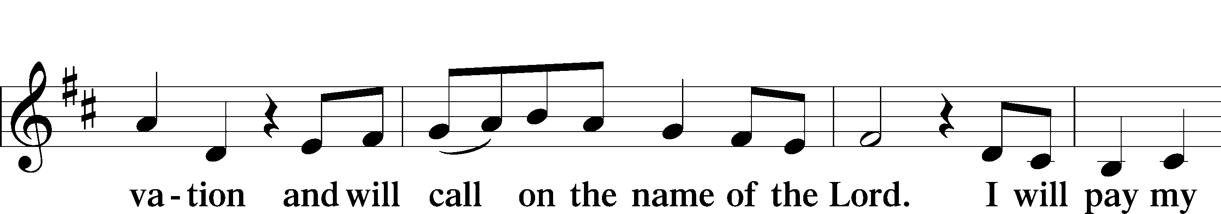

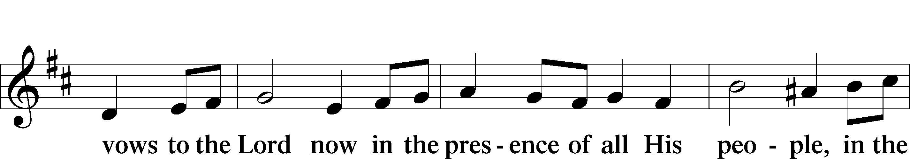

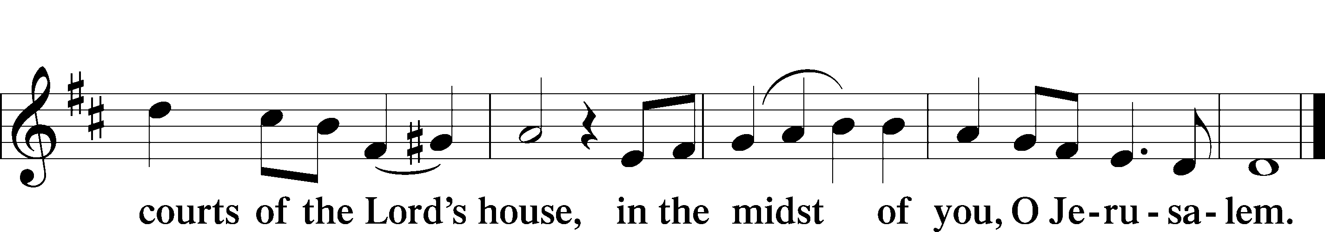

PRAYER OF THE CHURCH

LORD’S PRAYER

C **Our Father who art in heaven, hallowed be Thy name, Thy kingdom come, Thy will be done on earth as it is in heaven; give us this day our daily bread; and forgive us our trespasses as we forgive those who trespass against us; and lead us not into temptation, but deliver us from evil. For Thine is the kingdom and the power and the glory forever and ever. Amen.**

BENEDICTION LSB 183

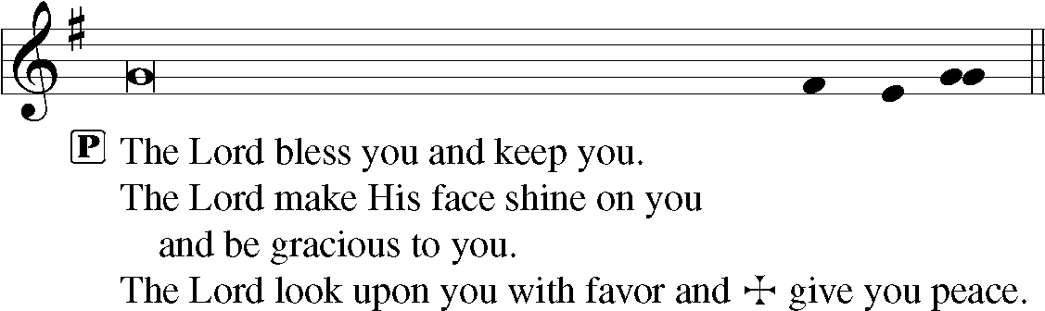

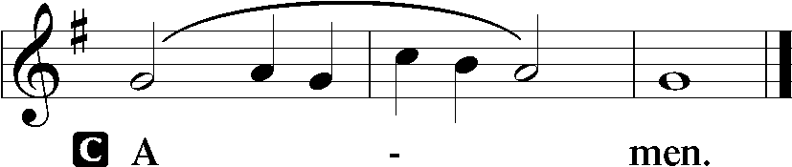

692 PRAISE TO YOU AND ADORATION

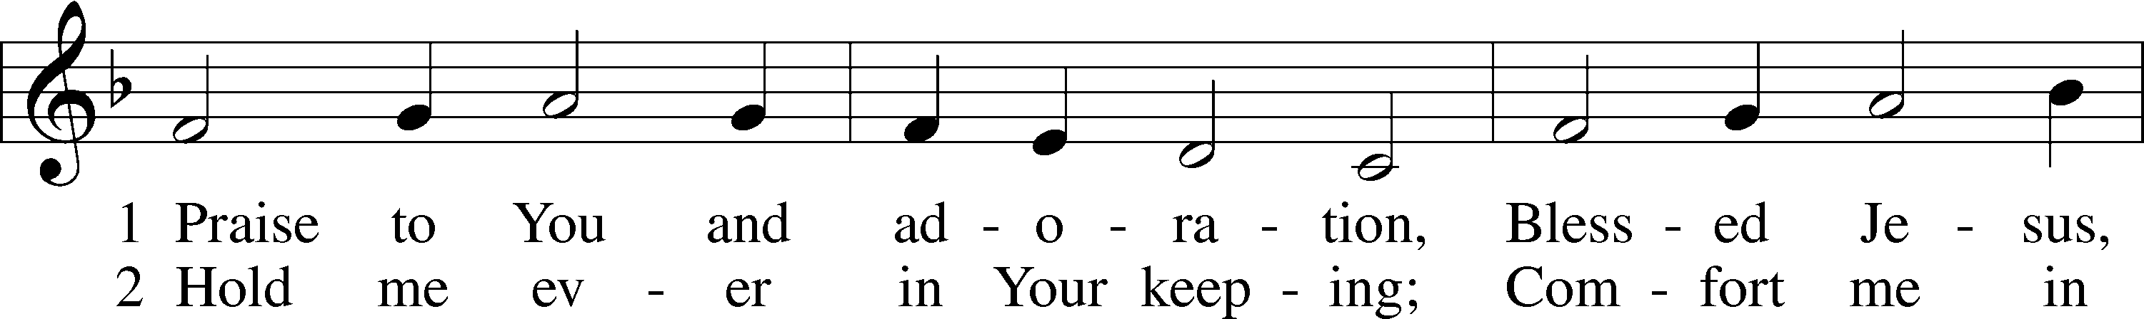

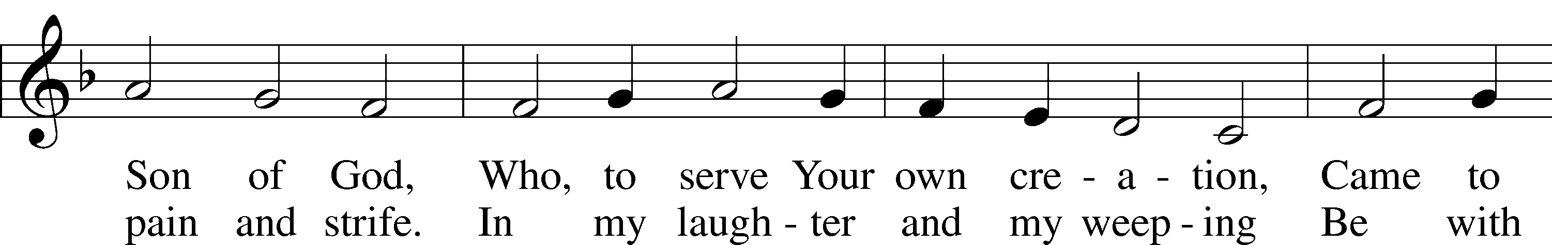

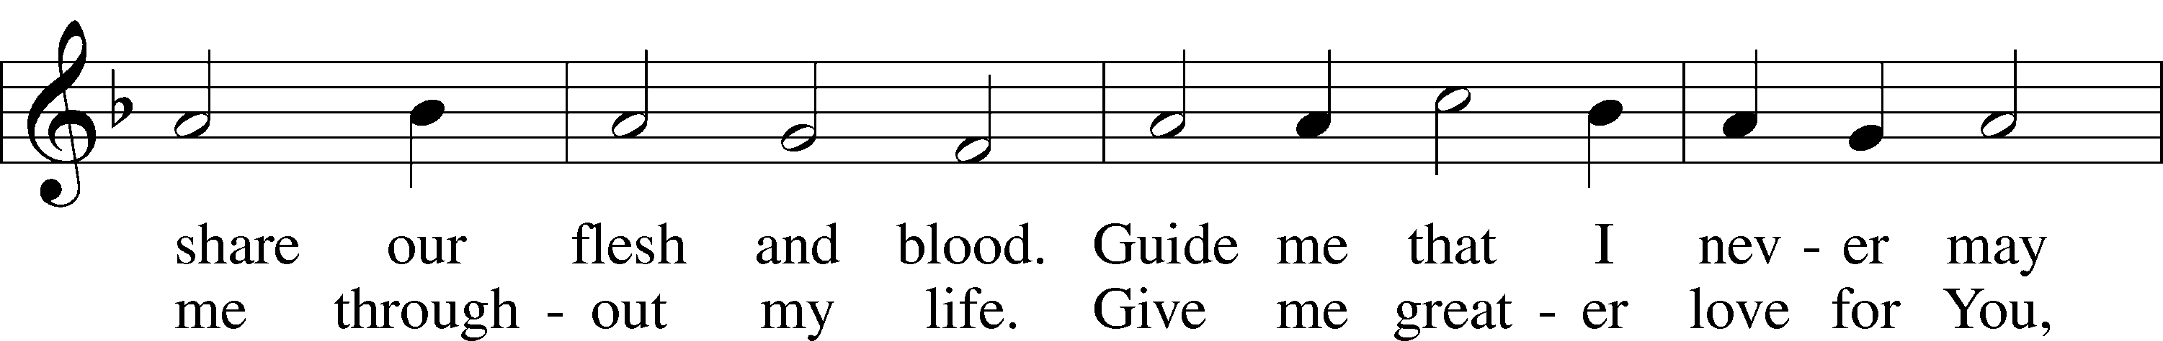

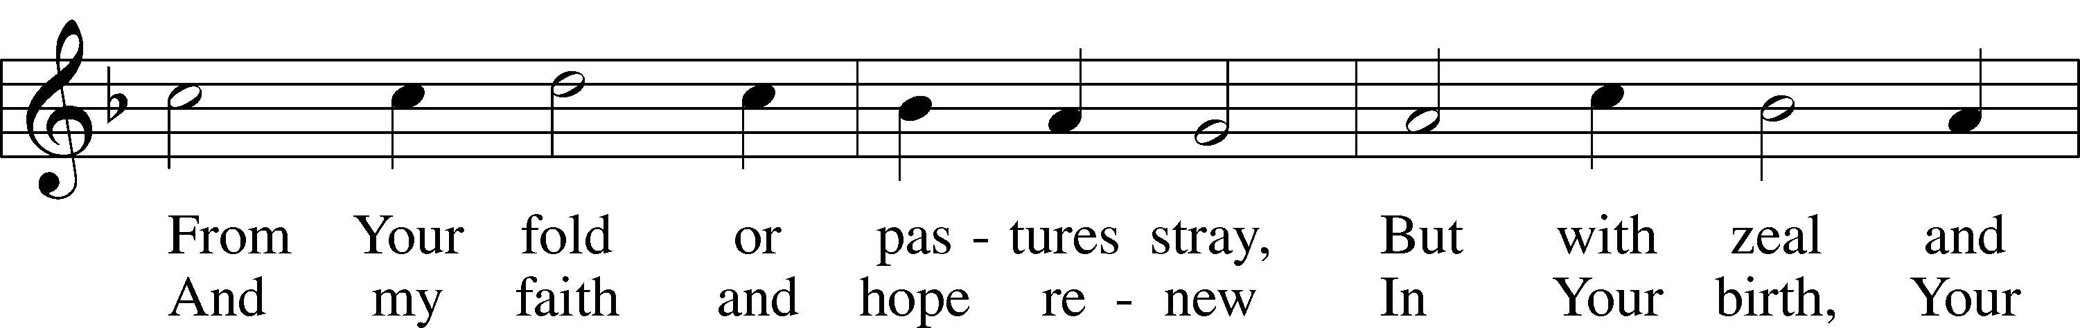

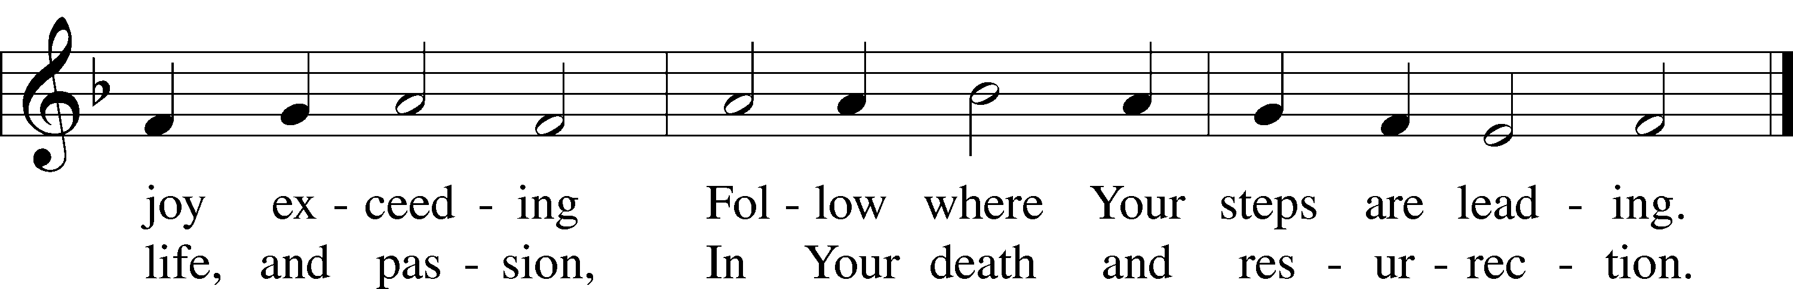

Text: Thomas Hansen Kingo, 1634–1703; (st. 1): tr. Kristen Kvamme, 1866–1938, alt.; (st. 2): tr. Christian Worship, 1993  
Tune: Trente quatre Pseaumes de David, 1551, Geneva, ed. Louis Bourgeois  
Text and tune: Public domain

Acknowledgments

Divine Service, Setting Two from Lutheran Service Book

Unless otherwise indicated, Scripture quotations are from the ESV® Bible (The Holy Bible, English Standard Version®), copyright © 2001 by Crossway, a publishing ministry of Good News Publishers. Used by permission. All rights reserved.

Created by Lutheran Service Builder © 2024 Concordia Publishing House.

**Lent Midweek Services**

Wednesdays in Lent T 7 pm

Meal T 5:45-6:30pm

**“The Lord’s Prayer”**

Ash Wednesday: *“Our Father Who Art In Heaven”*

Midweek 1: *“Hallowed Be Thy Name”*

Midweek 2: *“Thy Kingdom Come”*

Midweek 3: *“Thy Will Be Done…”*

Midweek 4: *“Give Us This Day Our Daily Bread”*

Midweek 5: *“And Forgive Us Our Trespasses…”*

Maundy Thursday: *“And Lead Us Not Into Temptation”*

Good Friday: *“But Deliver Us From Evil”*

Easter Sunday: *“For Thine Is The Kingdom, And The Power, And The Glory, Forever And Ever. Amen.”*

*“The Lord’s Prayer, because it arises from the Lord, is without question the highest, noblest and best. For if He had known a better, the holy faithful school-master that He was, He would have taught us that also. There is on earth no nobler prayer to be found, it is the highest under the sun. It is a wall and bulwark of the Church, a strong weapon for all godly Christians, a prayer above all prayers.” (Martin Luther)*