**Reformation Sunday**

**October 27, 2024**

“For we hold that one is justified by faith apart from works of the law”

**PEACE LUTHERAN CHURCH**

1451 Ebenezer Rd + Cincinnati, OH 45233 + 513-941-5177

[**www.peacechurchlink.com**](http://www.peacechurchlink.com)

**About This Service**

Today we commemorate the Lutheran Reformation, which identified a number of important doctrinal aberrations and abuses in the Western Church. The chief of these doctrinal errors was the teaching that man is justified before God on the basis of his own good works and merits. Contrary to this, the Scriptures teach that we are saved by grace alone, through faith alone, for the sake of Christ alone.

The time before the Divine Service begins is a time for meditation and prayer. It’s a time for us to prepare our hearts and minds to hear God’s Word and receive His gifts. Therefore, we ask that you would please remain silent as you enter the sanctuary out of reverence for God and respect for one another.

**Are My Children Welcome?**

In God’s eyes we’re all children. Yes, your little ones are more than welcome! If your child needs a little extra room to “make a joyful noise” you’re welcome to take them out of the sanctuary and into the narthex or the Fellowship Hall.

**How Do I Become a Lutheran Christian?**

If you’re exploring the Lutheran Church, Pastor Shaw would be happy to offer guidance or answer your questions. Our website peacechurchlink.com is also a good resource. When you’re ready, there’s a formal process of reading, study, and prayer that culminates in being received into the Lutheran Church.

Preservice Music

*Stand*

657 A Mighty Fortress Is Our God sts. 1–4

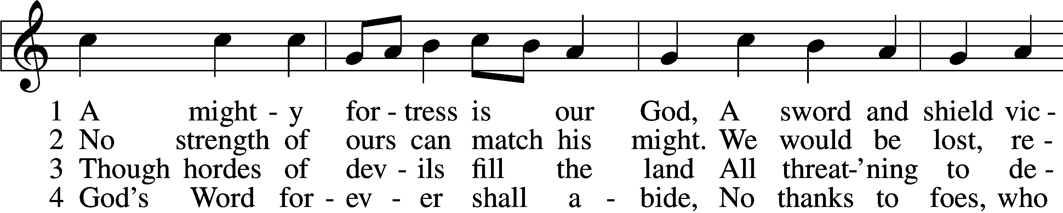

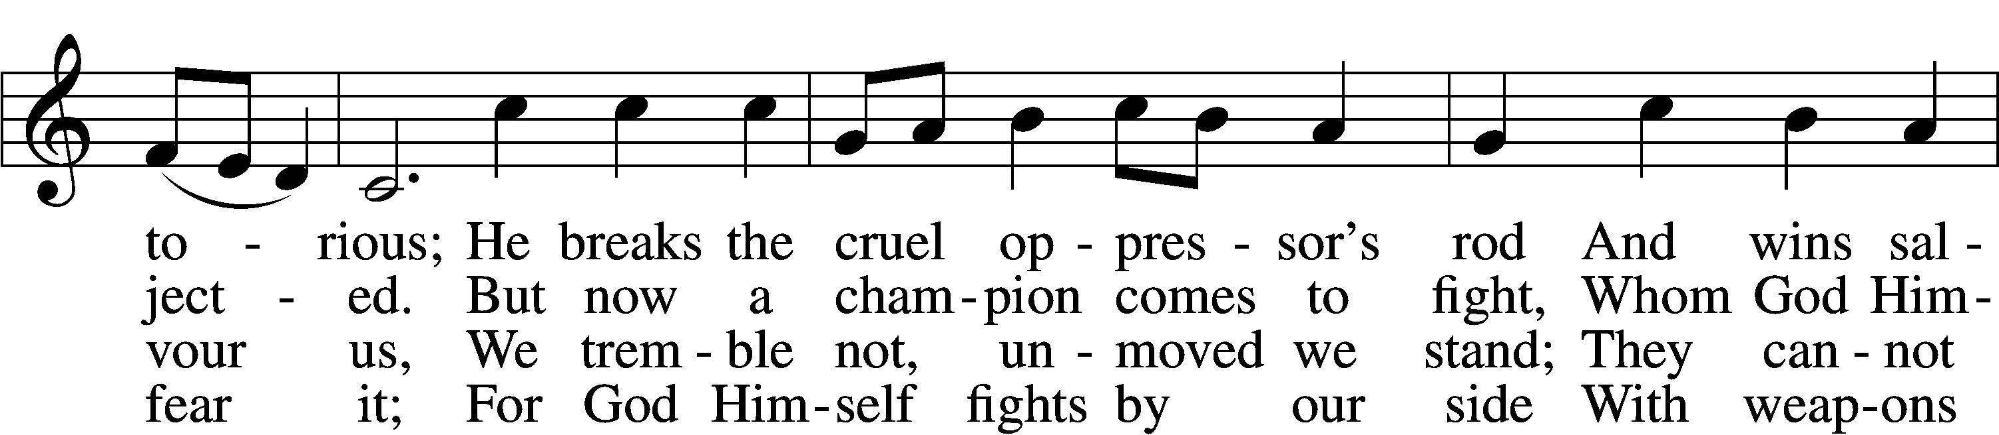

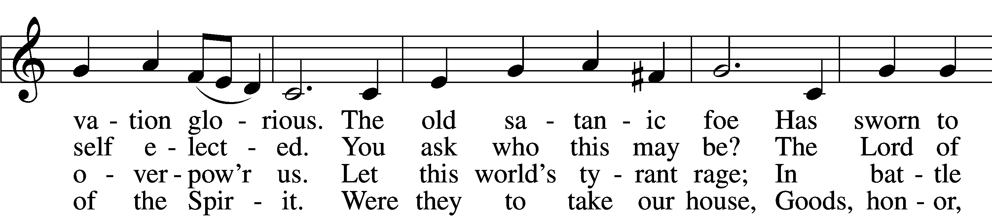

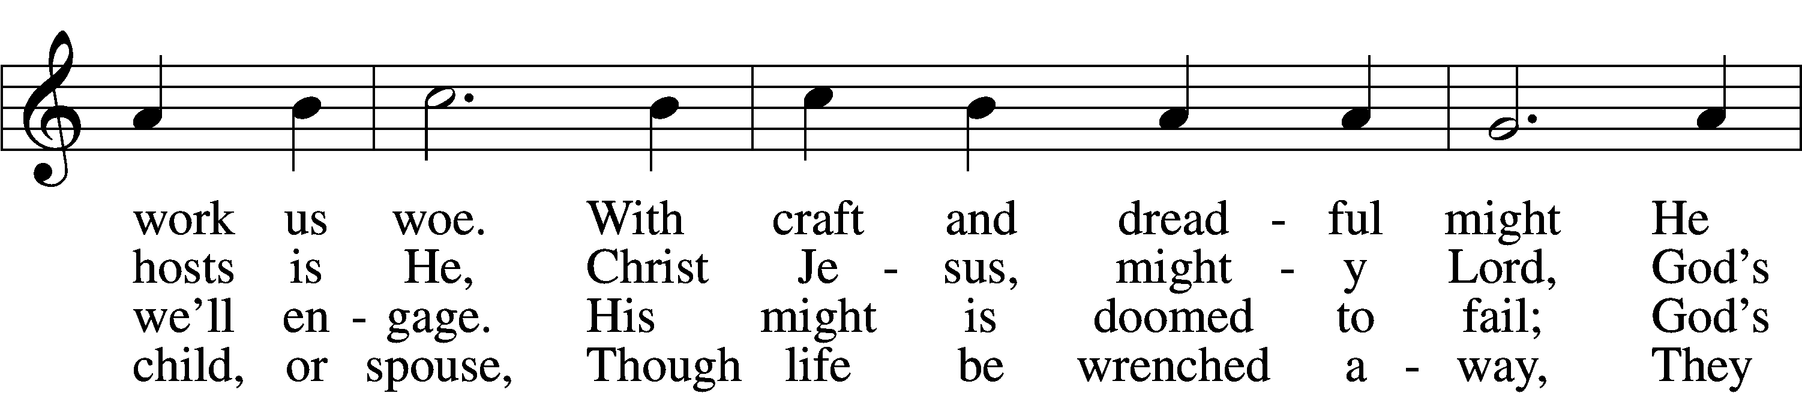

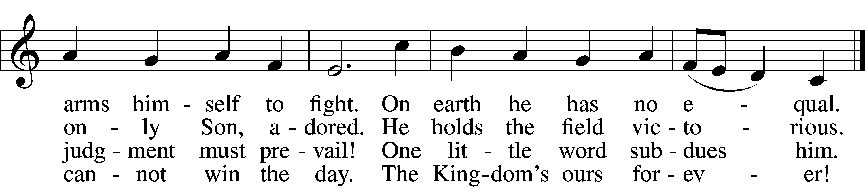

Text: tr. Lutheran Book of Worship, 1978 Text and tune: Martin Luther, 1483–1546 Text: © 1978 Lutheran Book of Worship. Used by permission: LSB Hymn License no. 110004388 Tune: Public domain

Confession and Absolution

The sign of the cross may be made by all in remembrance of their Baptism.

P In the name of the Father and of the T Son and of the Holy Spirit.

C **Amen.**

P Beloved in the Lord! Let us draw near with a true heart and confess our sins unto God our Father, beseeching Him in the name of our Lord Jesus Christ to grant us forgiveness.

P Our help is in the name of the Lord,

C **who made heaven and earth.**

P I said, I will confess my transgressions unto the Lord,

C **and You forgave the iniquity of my sin.**

Silence for reflection on God’s Word and for self-examination.

P O almighty God, merciful Father,

C **I, a poor, miserable sinner, confess unto You all my sins and iniquities with which I have ever offended You and justly deserved Your temporal and eternal punishment. But I am heartily sorry for them and sincerely repent of them, and I pray You of Your boundless mercy and for the sake of the holy, innocent, bitter sufferings and death of Your beloved Son, Jesus Christ, to be gracious and merciful to me, a poor, sinful being.**

P Upon this your confession, I, by virtue of my office, as a called and ordained servant of the Word, announce the grace of God unto all of you, and in the stead and by the command of my Lord Jesus Christ I forgive you all your sins in the name of the Father and of the T Son and of the Holy Spirit.

C **Amen.**

# Service of the Word

Introit Psalm 34:1–2, 11, 22; antiphon: Psalm 119:46

I will speak of your testimonies before kings, [O Lord,]  
 **and shall not be put to shame.**

I will bless the Lord at all times;  
 **his praise shall continually be in my mouth.**  
My soul makes its boast in the Lord;  
 **let the humble hear and be glad.**Come, O children, listen to me;  
 **I will teach you the fear of the Lord.**The Lord redeems the life of his servants;  
 **none of those who take refuge in him will be condemned.**

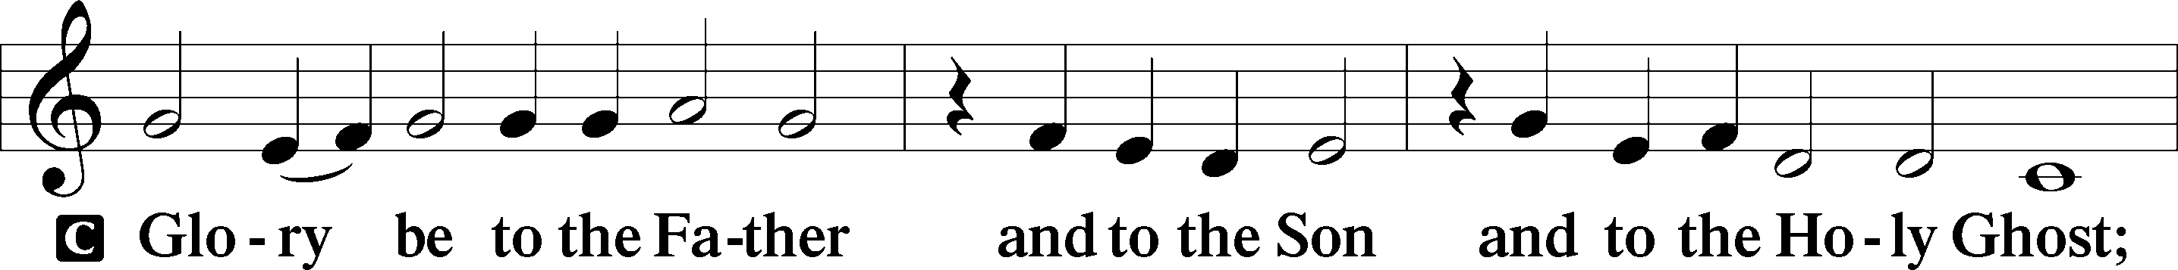

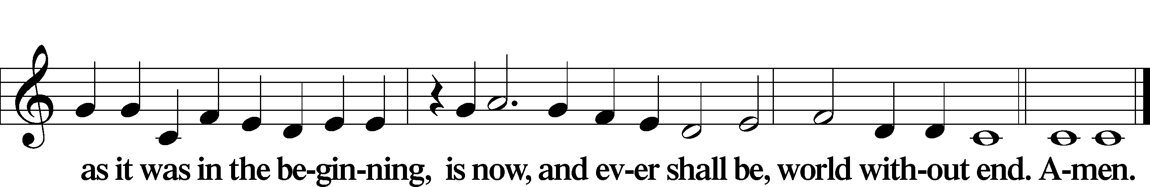

Kyrie LSB 186

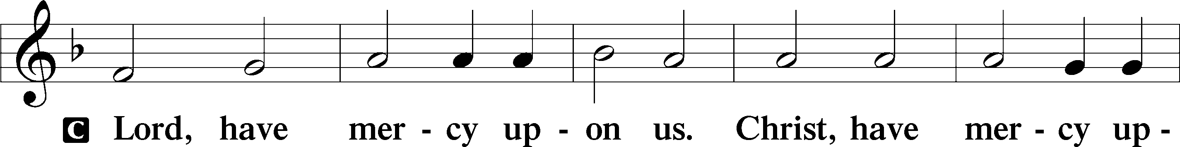

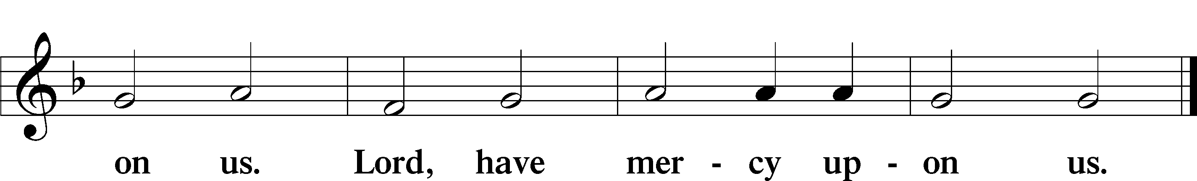

Gloria in Excelsis LSB 187

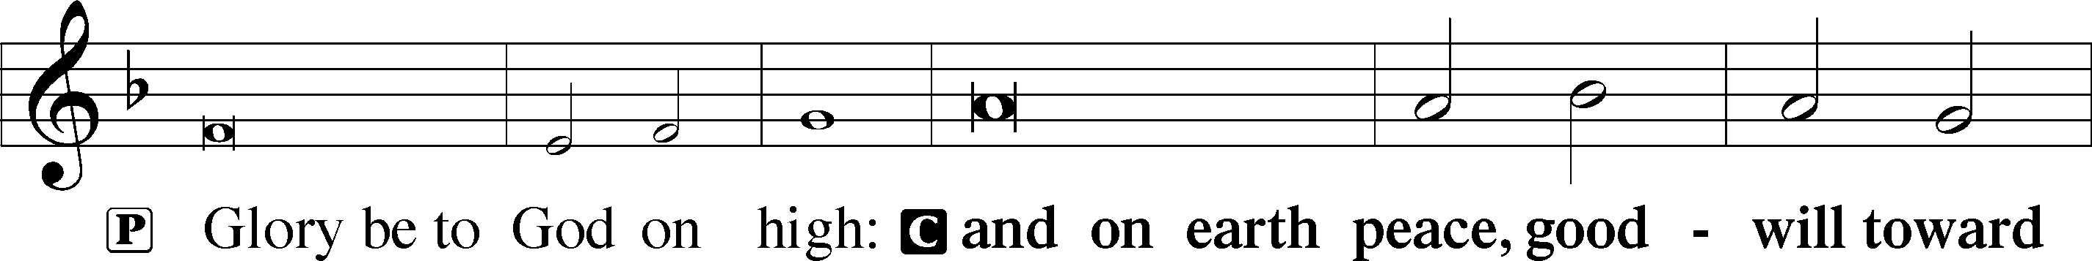

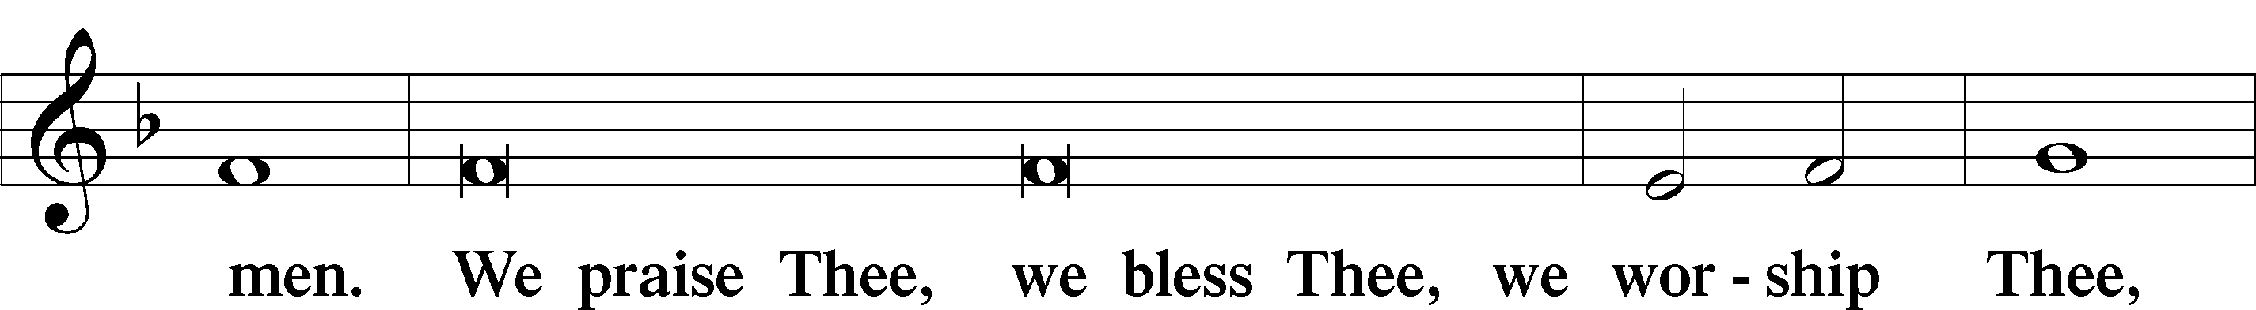

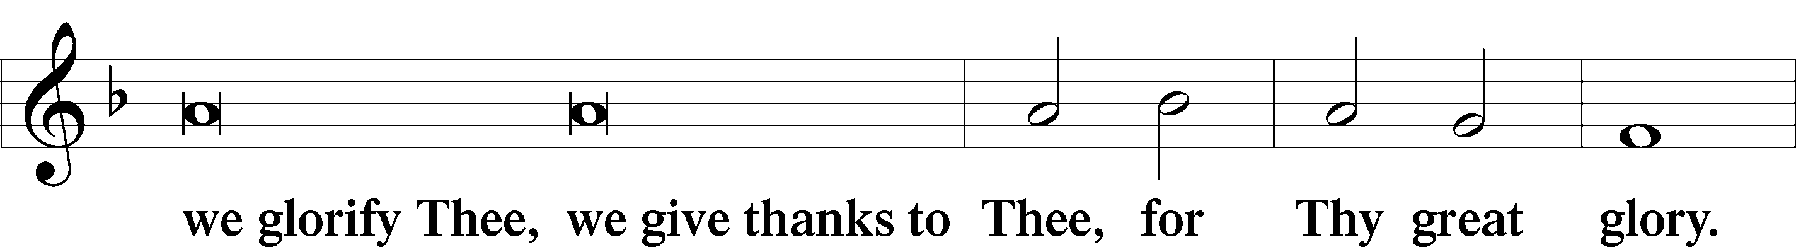

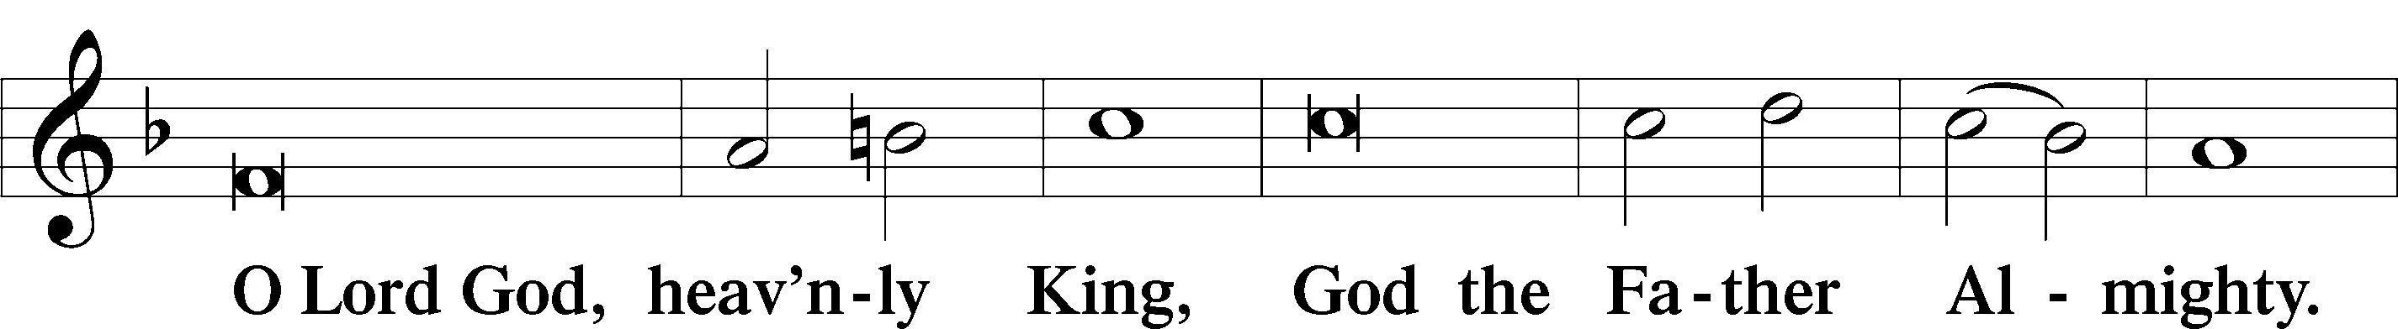

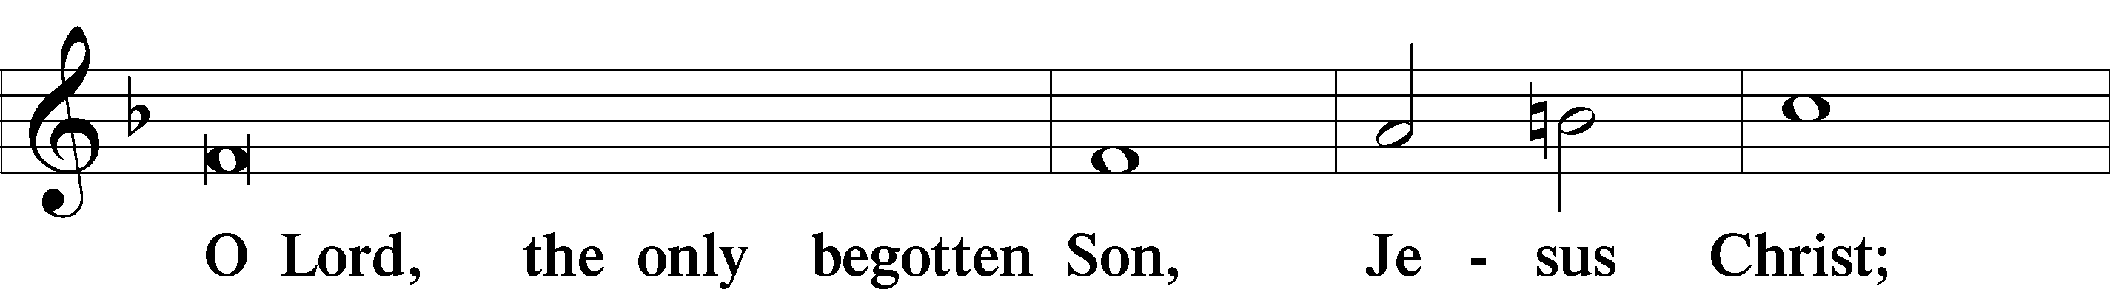

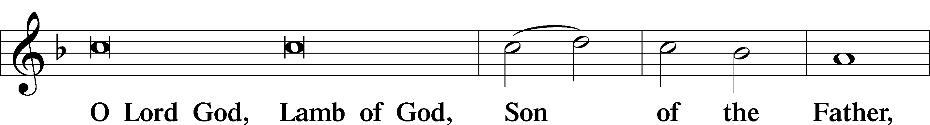

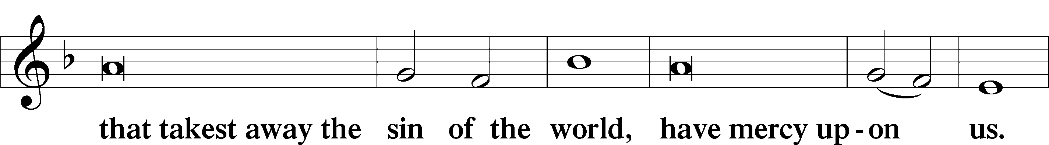

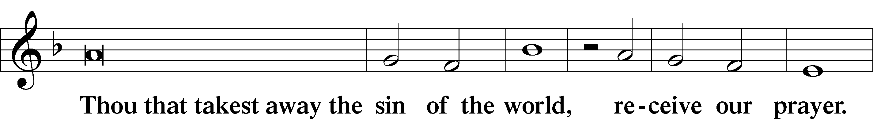

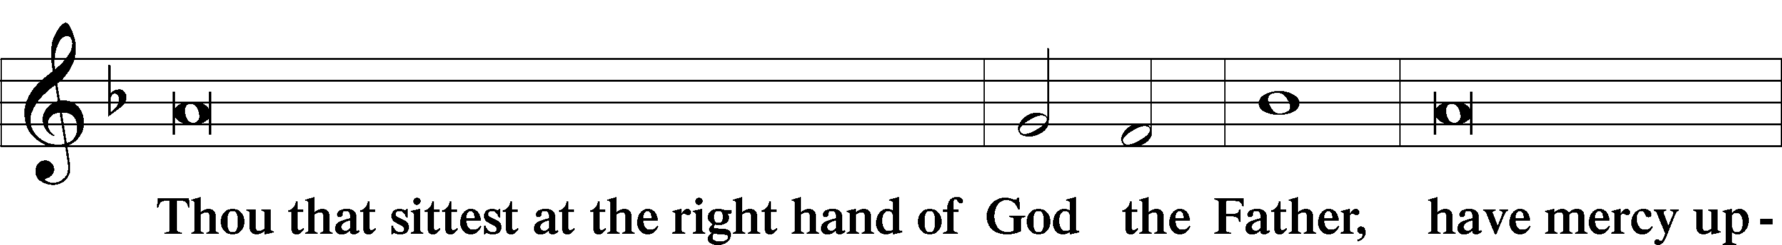

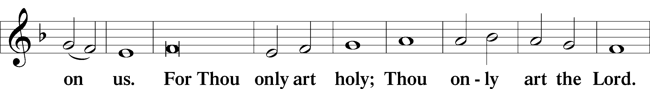

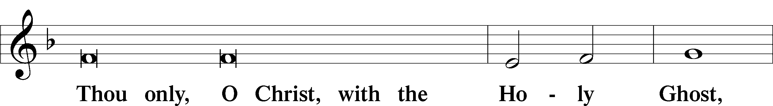

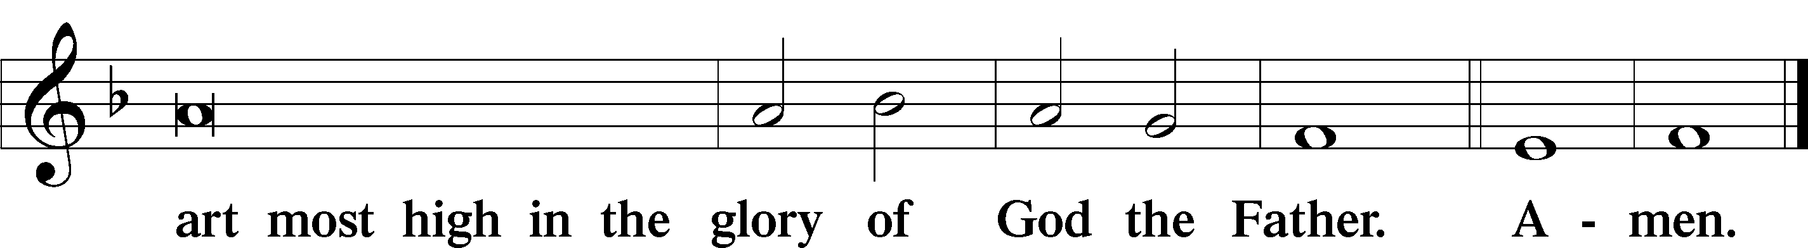

Salutation and Collect of the Day

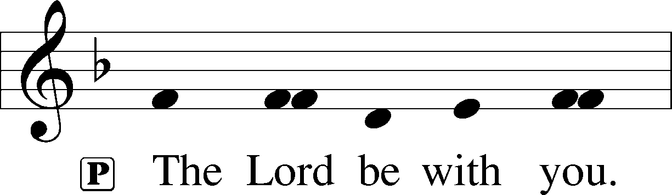

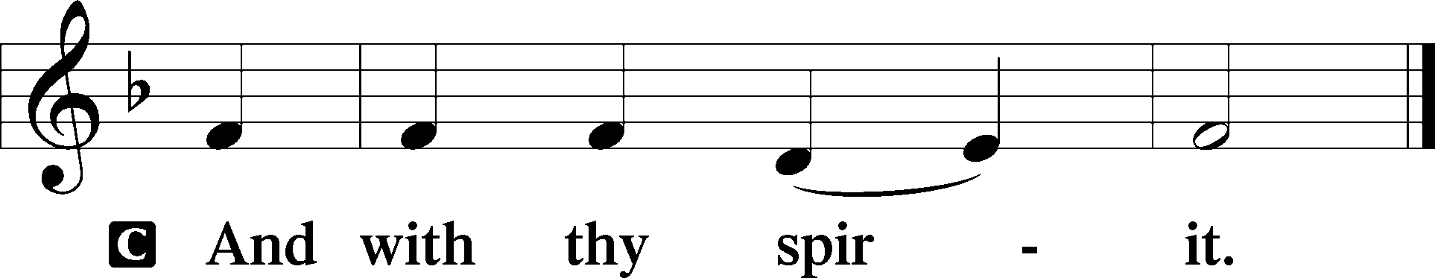

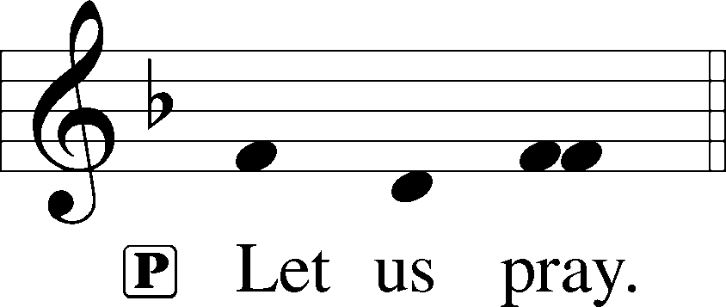

P Almighty and gracious Lord, pour out Your Holy Spirit on Your faithful people. Keep us steadfast in Your grace and truth, protect and deliver us in times of temptation, defend us against all enemies, and grant to Your Church Your saving peace; through Jesus Christ, Your Son, our Lord, who lives and reigns with You and the Holy Spirit, one God, now and forever.

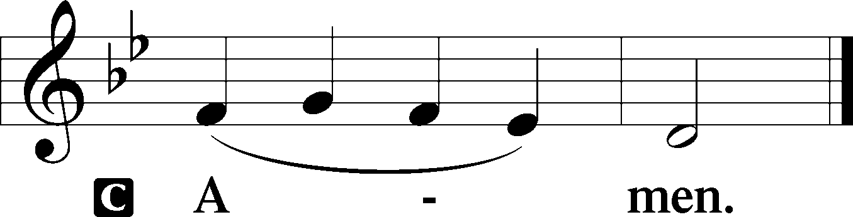

Sit

First Reading Revelation 14:6–7

6Then I saw another angel flying directly overhead, with an eternal gospel to proclaim to those who dwell on earth, to every nation and tribe and language and people. 7And he said with a loud voice, “Fear God and give him glory, because the hour of his judgment has come, and worship him who made heaven and earth, the sea and the springs of water.”

A This is the Word of the Lord.

C **Thanks be to God.**

Epistle Romans 3:19–28

19Now we know that whatever the law says it speaks to those who are under the law, so that every mouth may be stopped, and the whole world may be held accountable to God. 20For by works of the law no human being will be justified in his sight, since through the law comes knowledge of sin.

21But now the righteousness of God has been manifested apart from the law, although the Law and the Prophets bear witness to it— 22the righteousness of God through faith in Jesus Christ for all who believe. For there is no distinction: 23for all have sinned and fall short of the glory of God, 24and are justified by his grace as a gift, through the redemption that is in Christ Jesus, 25whom God put forward as a propitiation by his blood, to be received by faith. This was to show God’s righteousness, because in his divine forbearance he had passed over former sins. 26It was to show his righteousness at the present time, so that he might be just and the justifier of the one who has faith in Jesus.

27Then what becomes of our boasting? It is excluded. By what kind of law? By a law of works? No, but by the law of faith. 28For we hold that one is justified by faith apart from works of the law.

A This is the Word of the Lord.

C **Thanks be to God.**

Give Me A Faith (Bitgood) Choir

Stand

Holy Gospel John 8:31–36

P The Holy Gospel according to St. John, the eighth chapter.

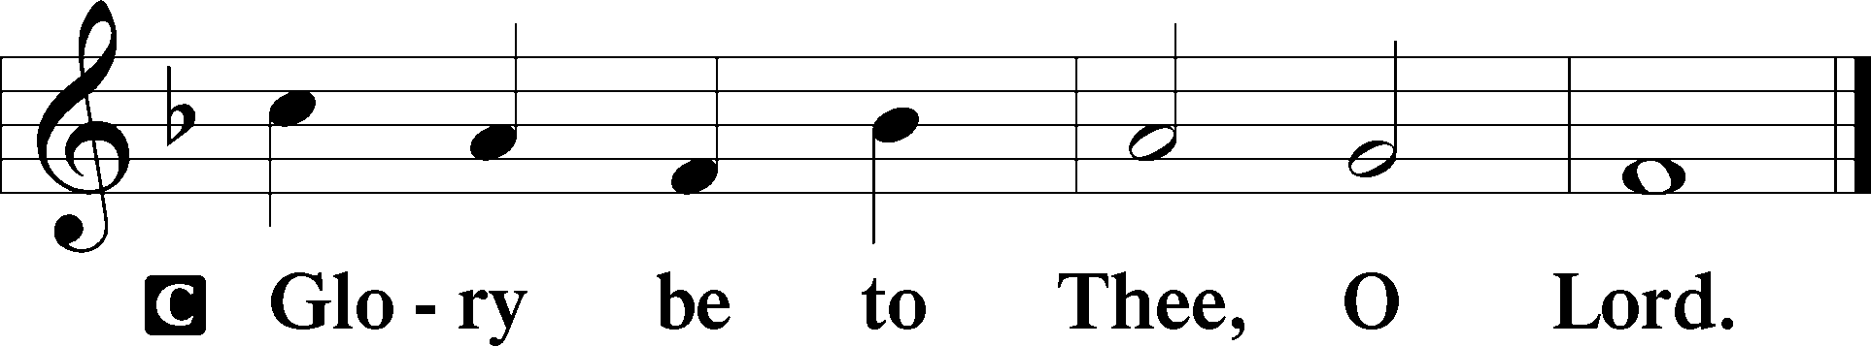

31So Jesus said to the Jews who had believed in him, “If you abide in my word, you are truly my disciples, 32and you will know the truth, and the truth will set you free.” 33They answered him, “We are offspring of Abraham and have never been enslaved to anyone. How is it that you say, ‘You will become free’?”

34Jesus answered them, “Truly, truly, I say to you, everyone who commits sin is a slave to sin. 35The slave does not remain in the house forever; the son remains forever. 36So if the Son sets you free, you will be free indeed.”

P This is the Gospel of the Lord.

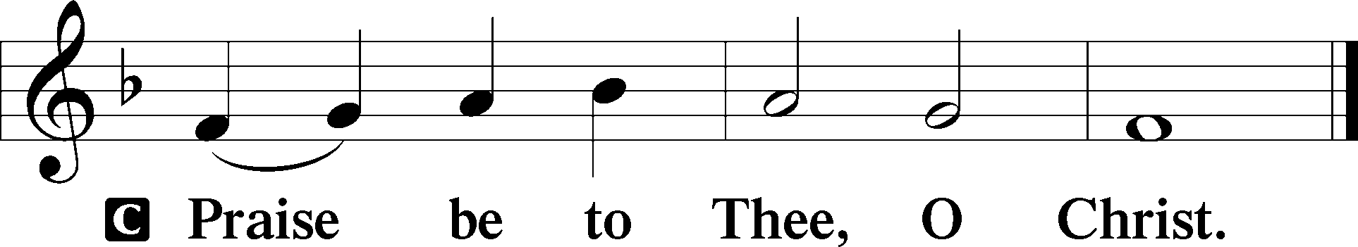

Apostles’ Creed

C **I believe in God, the Father Almighty, maker of heaven and earth.**

**And in Jesus Christ, His only Son, our Lord, who was conceived by the Holy Spirit, born of the virgin Mary, suffered under Pontius Pilate, was crucified, died and was buried. He descended into hell. The third day He rose again from the dead. He ascended into heaven and sits at the right hand of God the Father Almighty. From thence He will come to judge the living and the dead.**

**I believe in the Holy Spirit, the holy Christian Church, the communion of saints, the forgiveness of sins, the resurrection of the body, and the life** T **everlasting. Amen.**

Sit

571 God Loved the World So That He Gave

*Stand for Stanza 6*

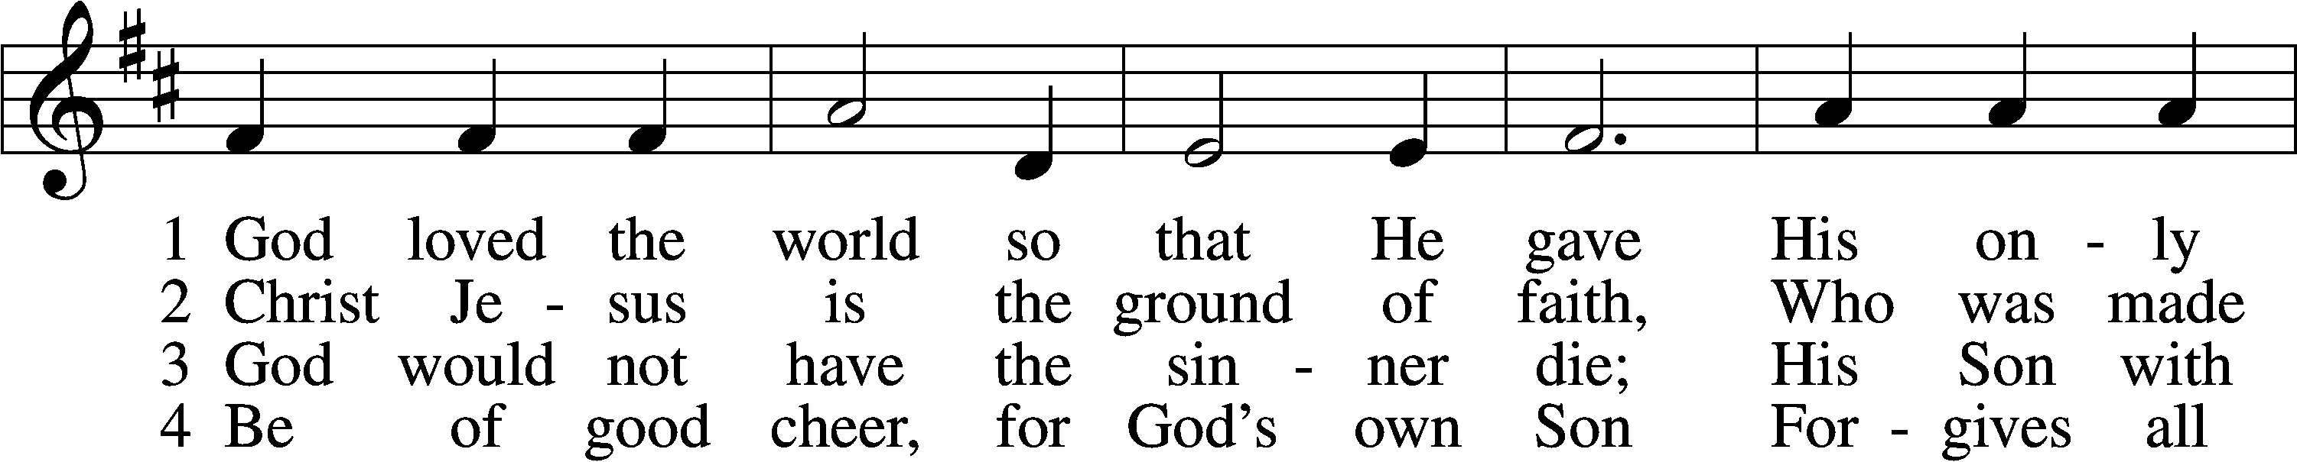

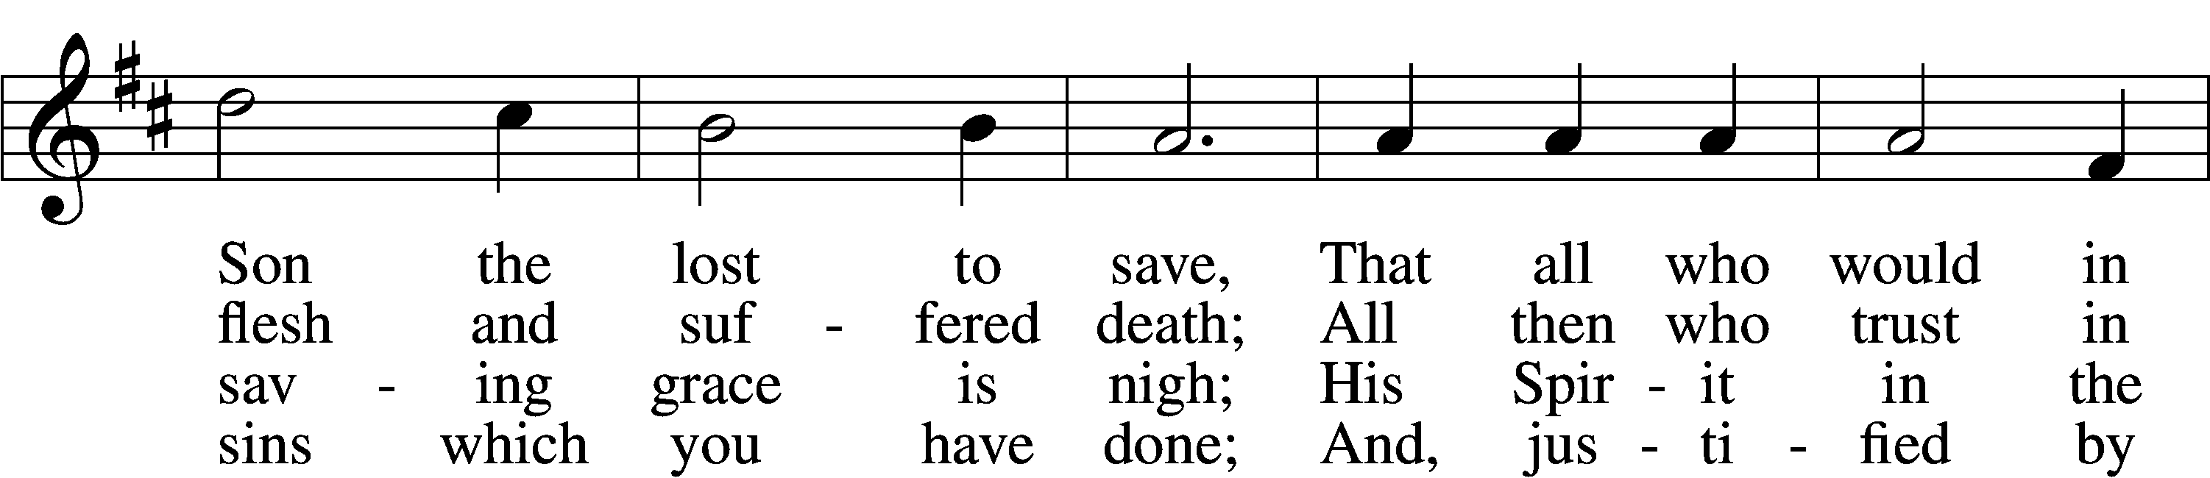

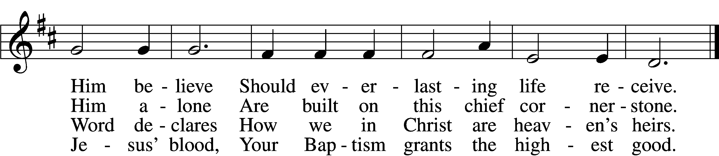

5 If you are sick, if death is near,  
This truth your troubled heart can cheer:  
Christ Jesus saves your soul from death;  
That is the firmest ground of faith.

D 6 Glory to God the Father, Son,  
And Holy Spirit, Three in One!  
To You, O blessèd Trinity,  
Be praise now and eternally!

Text: Heiliges Lippen- und Hertzens-Opffer, c. 1778, Stettin; tr. August Crull, 1845–1923, alt. Tune: George J. Elvey, 1816–93 Text and tune: Public domain

*Sit*

Sermon

Offering

Stand

Offertory LSB 192

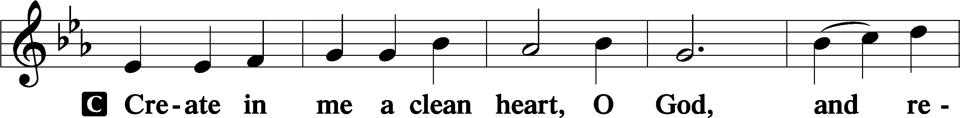

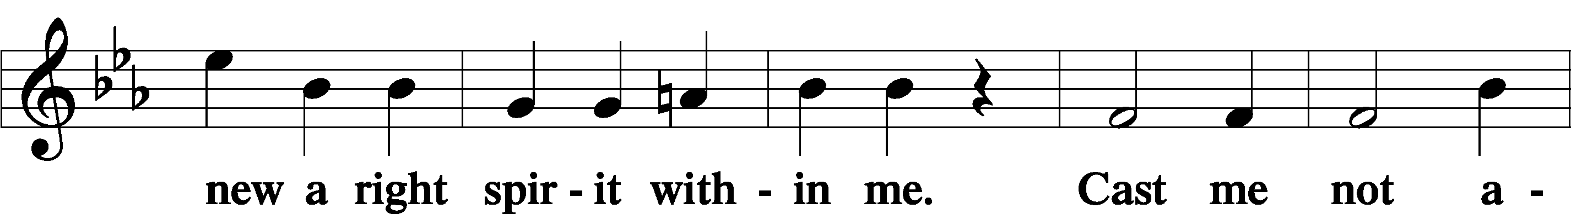

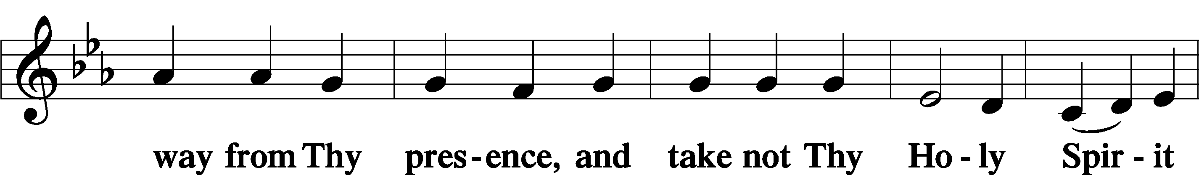

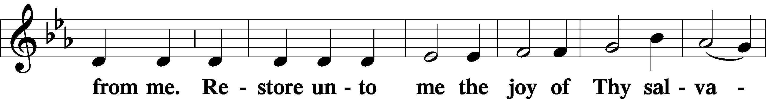

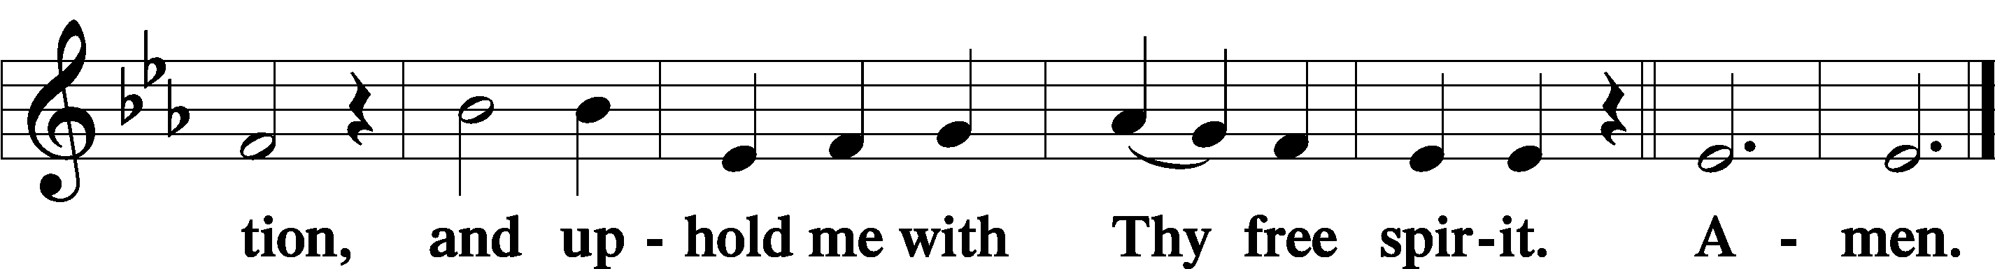

Prayer of the Church

Lord’s Prayer

C **Our Father who art in heaven, hallowed be Thy name, Thy kingdom come, Thy will be done on earth as it is in heaven; give us this day our daily bread; and forgive us our trespasses as we forgive those who trespass against us; and lead us not into temptation, but deliver us from evil. For Thine is the kingdom and the power and the glory forever and ever. Amen.**

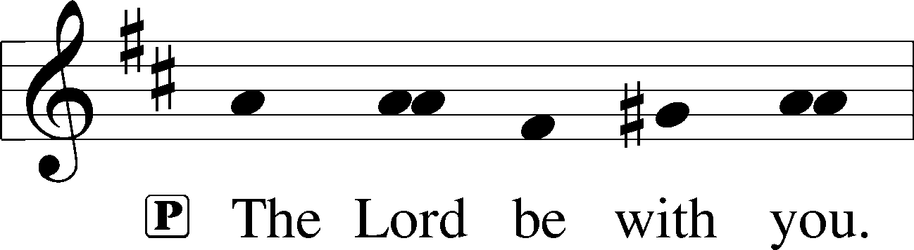

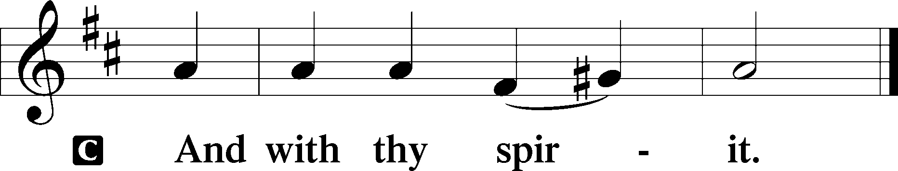

Benedicamus LSB 202

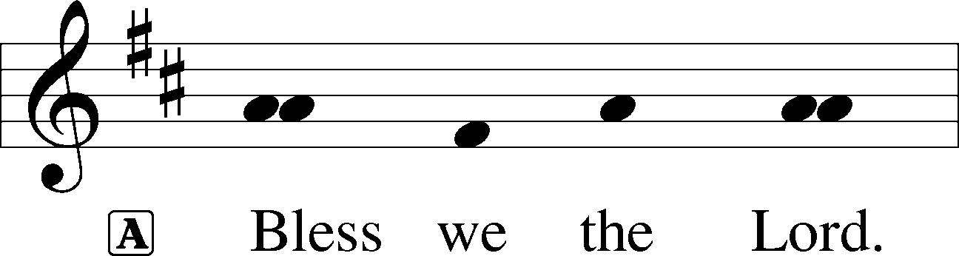

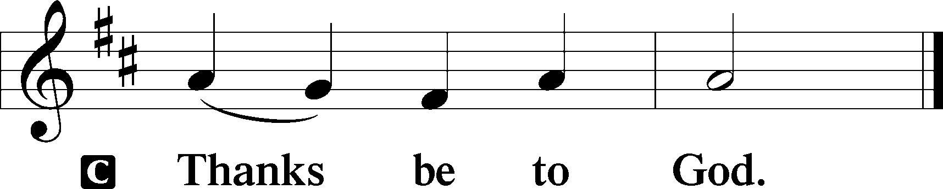

Benediction LSB 202

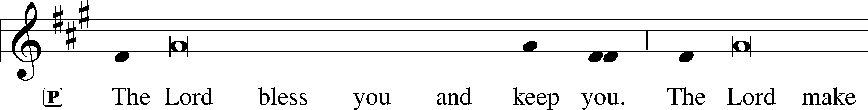

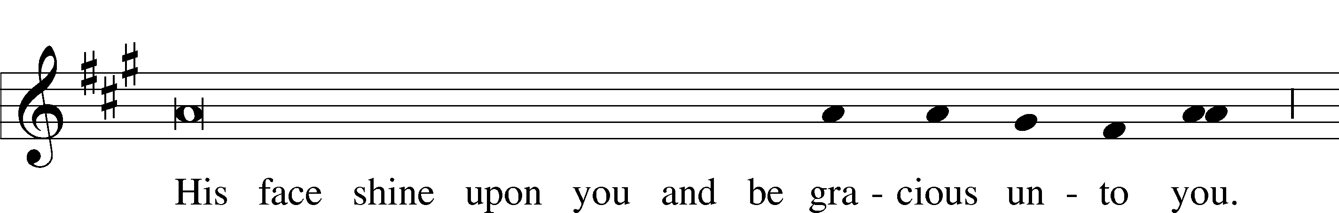

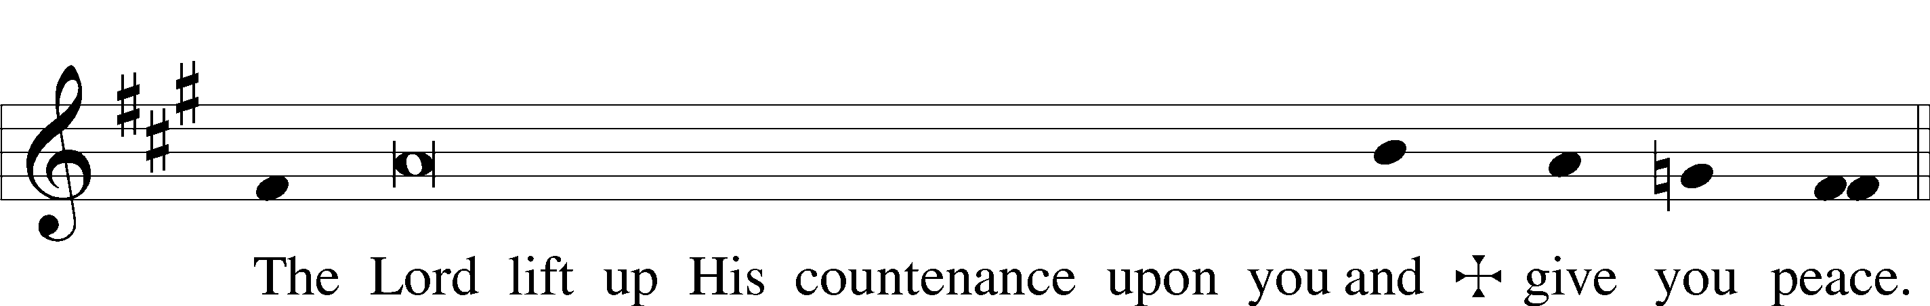

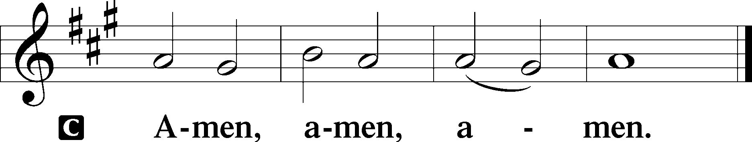

561 The Tree of Life

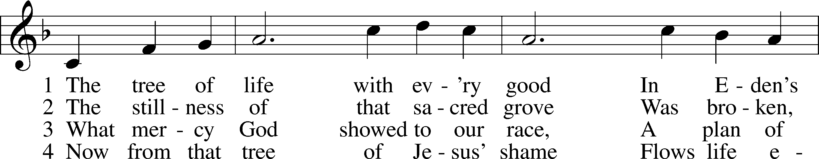

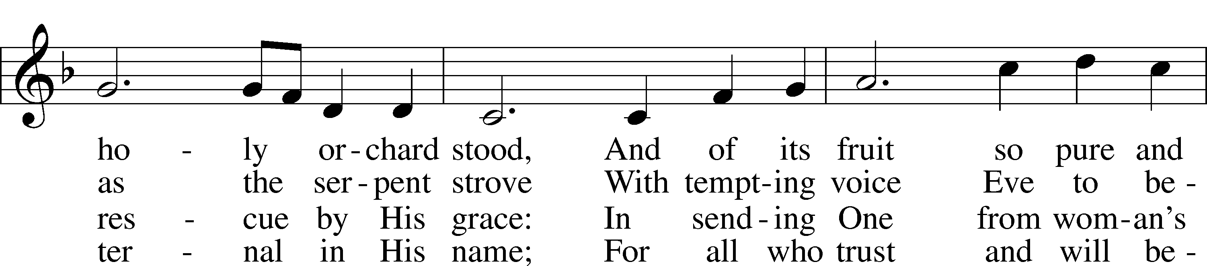

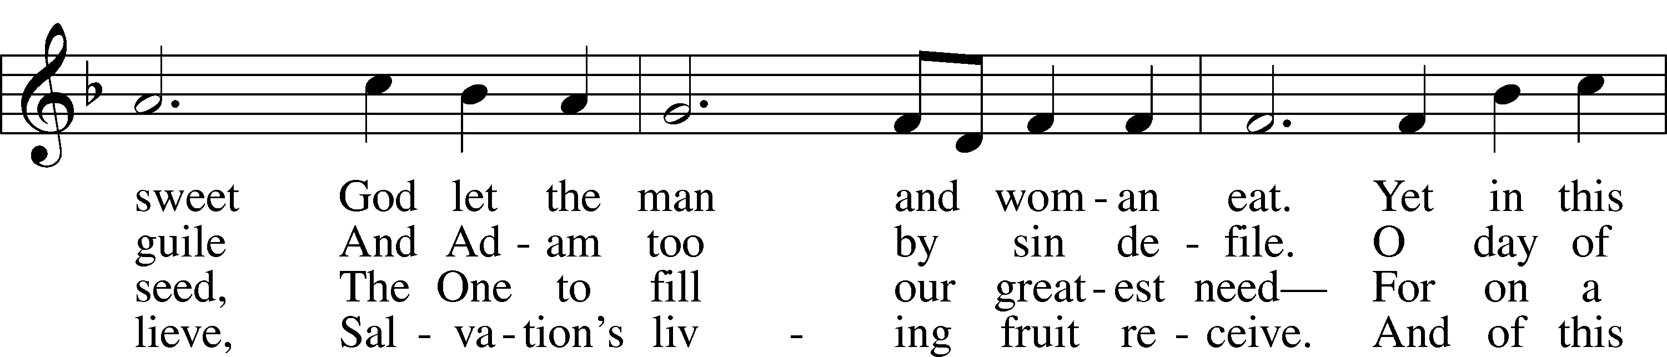

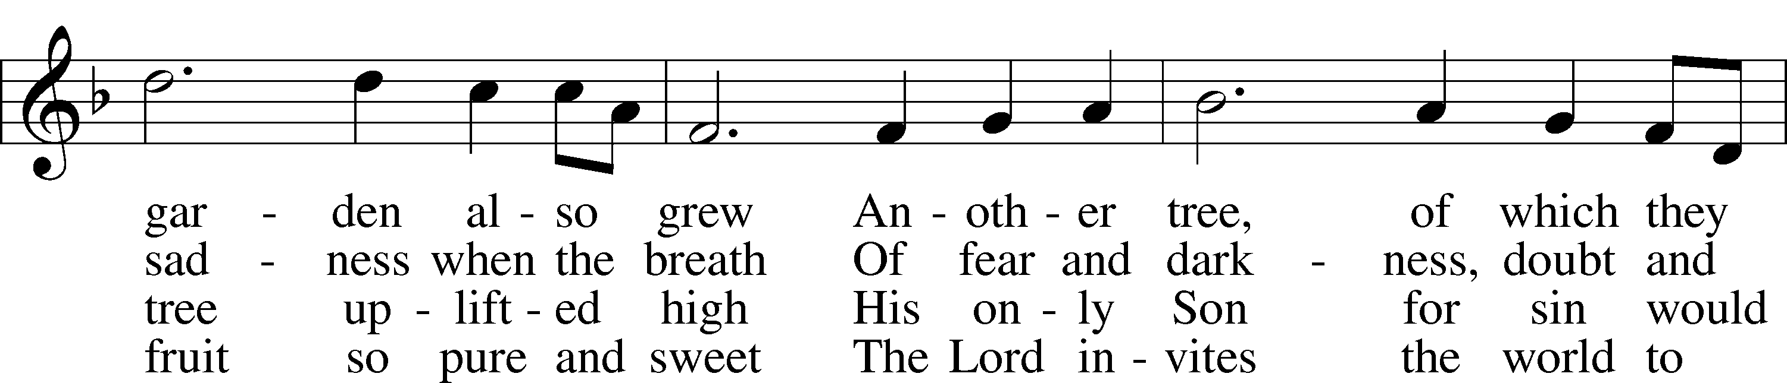

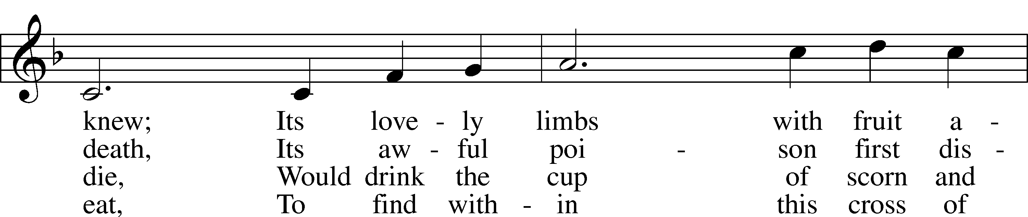

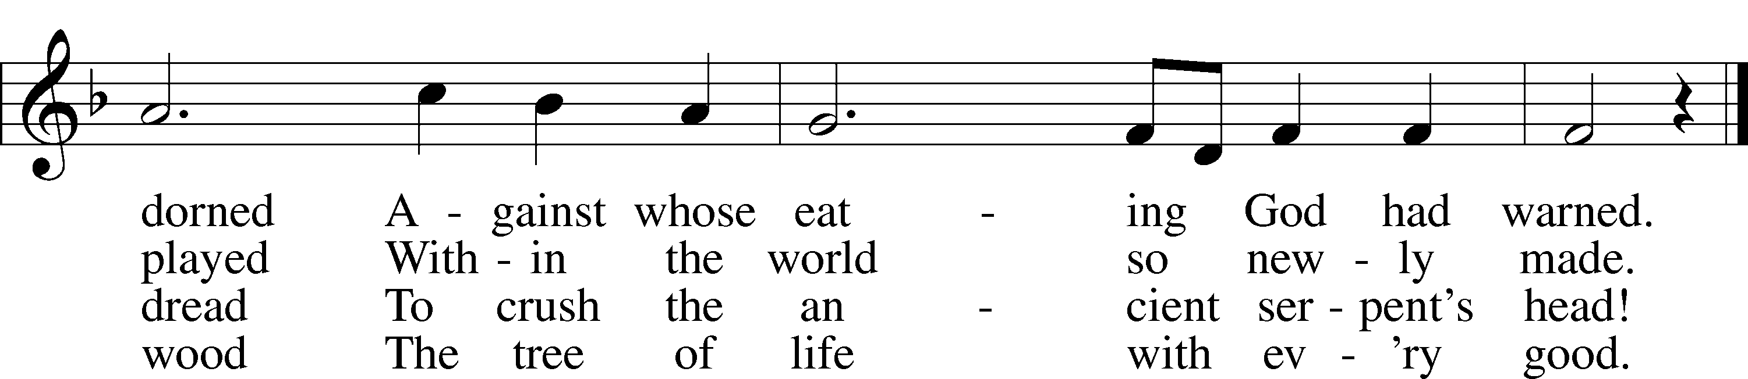

Text: Stephen P. Starke, 1955 Tune: Bruce W. Becker, 1952 Text: © 1993 Stephen P. Starke, admin. Concordia Publishing House. Used by permission: LSB Hymn License no. 110004388 Tune: © 1995 Bruce W. Becker. Used by permission: LSB Hymn License no. 110004388

Benediction Response (Bach) *Choir*

Acknowledgments

Divine Service, Setting Three from Lutheran Service Book

Unless otherwise indicated, Scripture quotations are from the ESV® Bible (The Holy Bible, English Standard Version®), copyright © 2001 by Crossway, a publishing ministry of Good News Publishers. Used by permission. All rights reserved.

Created by Lutheran Service Builder © 2024 Concordia Publishing House.