**The Twentieth Sunday after Pentecost**

**October 6, 2024**

“It is not good that the man should be alone; I will make him a helper fit for him”

**PEACE LUTHERAN CHURCH**

1451 Ebenezer Rd + Cincinnati, OH 45233 + 513-941-5177

[**www.peacechurchlink.com**](http://www.peacechurchlink.com)

**About This Service**

The heart of Christianity is not what we do for God but what God has done for us in Christ Jesus. We call our service “Divine Service” because the Divine One, our Lord Jesus, promises to be present with us this very day in His Word and Sacraments to give us clean hearts and renewed spirits. We come in joyful reverence to receive from Him.

The time before the Divine Service begins is a time for meditation and prayer. It’s a time for us to prepare our hearts and minds to hear God’s Word and receive His gifts. Therefore, we ask that you would please remain silent as you enter the sanctuary out of reverence for God and respect for one another.

**Are My Children Welcome?**

In God’s eyes we’re all children. Yes, your little ones are more than welcome! If your child needs a little extra room to “make a joyful noise” you’re welcome to take them out of the sanctuary and into the narthex or the Fellowship Hall.

**How Do I Become a Lutheran Christian?**

If you’re exploring the Lutheran Church, Pastor Shaw would be happy to offer guidance or answer your questions. Our website peacechurchlink.com is also a good resource. When you’re ready, there’s a formal process of reading, study, and prayer that culminates in being received into the Lutheran Church.

**Can I Take Communion?**

The Lord’s Supper is celebrated at this congregation in the confession and glad confidence that, as our Lord says, He gives into our mouths not only bread and wine but His very body and blood to eat and to drink for the forgiveness of sins and to strengthen our union with Him and with one another. Our Lord invites to His table those who trust His Words, repent of all sins, and set aside any refusal to forgive and love as He forgives and loves us, that they may show forth His death until He comes. Holy Communion is a confession of the faith which is confessed at this altar, any who are not yet instructed, in doubt, or who hold a confession differing from that of this congregation and the Lutheran Church – Missouri Synod, are asked to first speak with the pastor before communing.

793 Praise, My Soul, the King of Heaven

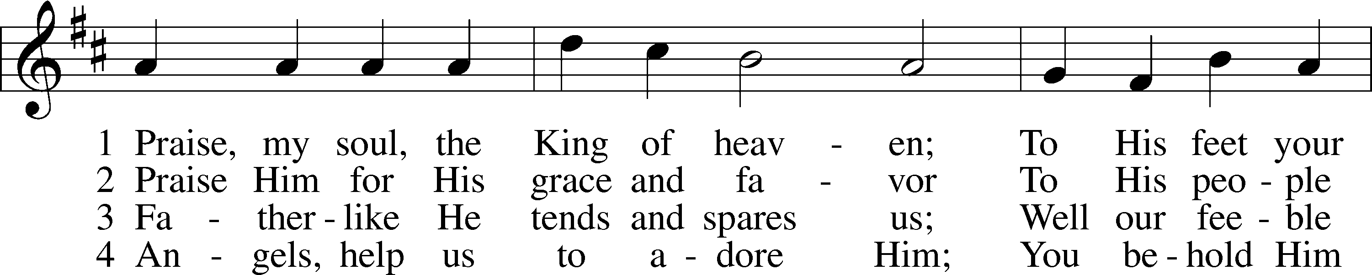

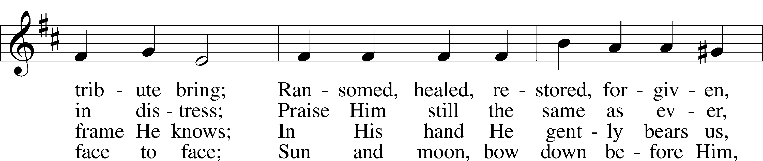

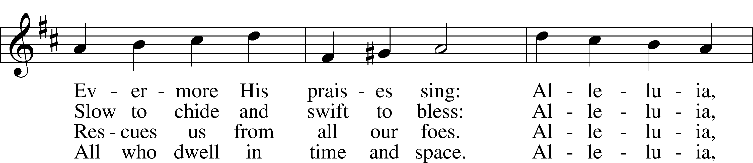

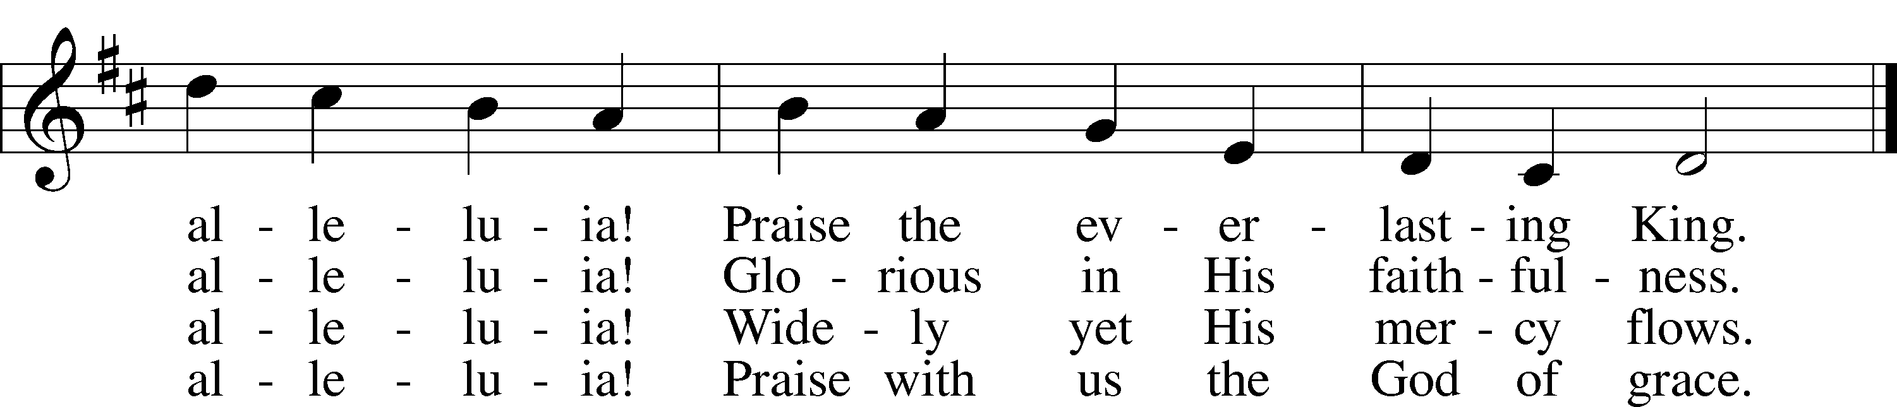

Text: Henry F. Lyte, 1793–1847 Tune: John Goss, 1800–80 Text and tune: Public domain

# Confession and Absolution

Stand

The sign of the cross may be made by all in remembrance of their Baptism.

P In the name of the Father and of the T Son and of the Holy Spirit.

C **Amen.**

P Beloved in the Lord! Let us draw near with a true heart and confess our sins unto God our Father, beseeching Him in the name of our Lord Jesus Christ to grant us forgiveness.

P Our help is in the name of the Lord,

C **who made heaven and earth.**

P I said, I will confess my transgressions unto the Lord,

C **and You forgave the iniquity of my sin.**

Silence for reflection on God’s Word and for self-examination.

P O almighty God, merciful Father,

C **I, a poor, miserable sinner, confess unto You all my sins and iniquities with which I have ever offended You and justly deserved Your temporal and eternal punishment. But I am heartily sorry for them and sincerely repent of them, and I pray You of Your boundless mercy and for the sake of the holy, innocent, bitter sufferings and death of Your beloved Son, Jesus Christ, to be gracious and merciful to me, a poor, sinful being.**

P Upon this your confession, I, by virtue of my office, as a called and ordained servant of the Word, announce the grace of God unto all of you, and in the stead and by the command of my Lord Jesus Christ I forgive you all your sins in the name of the Father and of the T Son and of the Holy Spirit.

C **Amen.**

# Service of the Word

Introit Psalm 127:3–5; antiphon: v. 1a

Unless the Lord builds the house,  
 **those who build it labor in vain.**Behold, children are a heritage from the Lord,  
 **the fruit of the womb a reward.**Like arrows in the hand of a warrior  
 **are the children of one’s youth.**Blessèd is the man who fills his quiver with them!  
 **He shall not be put to shame when he speaks with his enemies in the gate.**

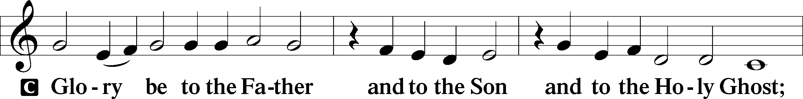

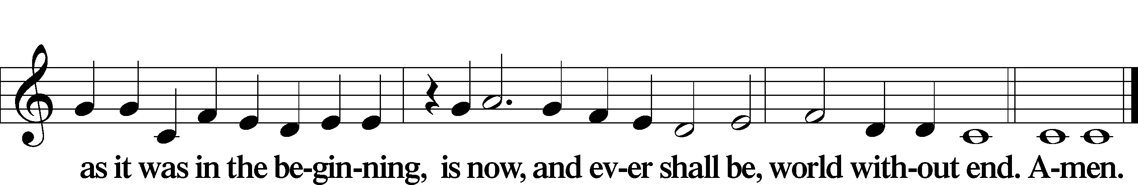

Kyrie LSB 186

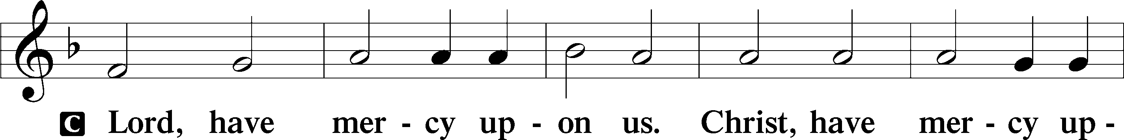

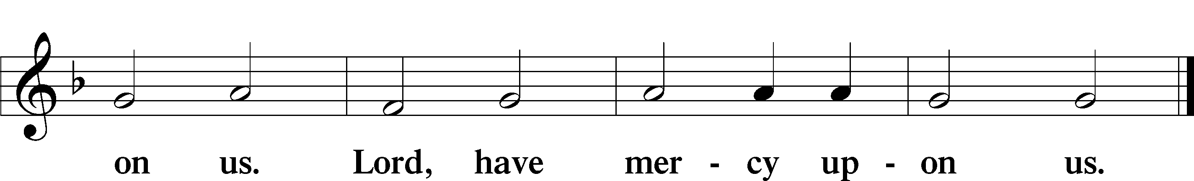

Gloria in Excelsis LSB 187

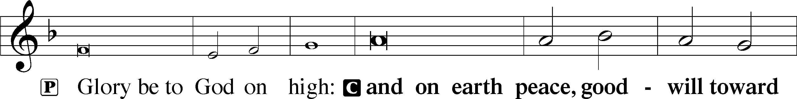

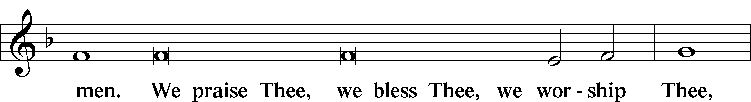

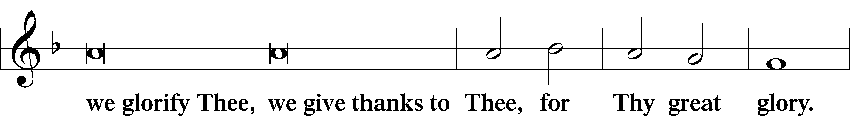

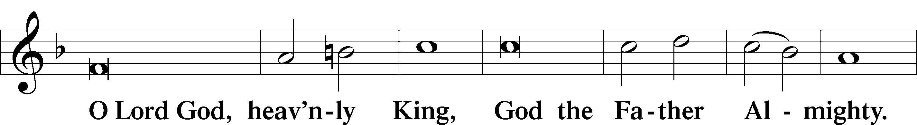

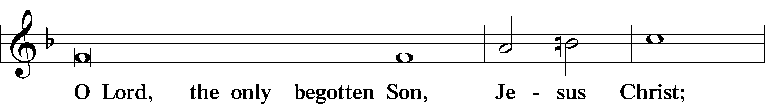

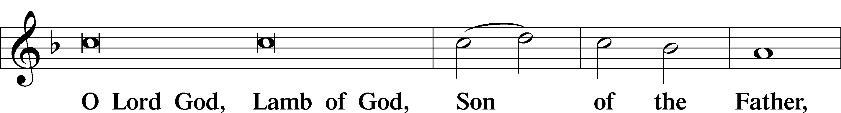

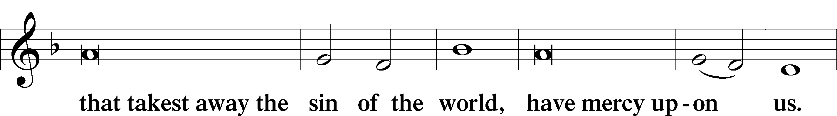

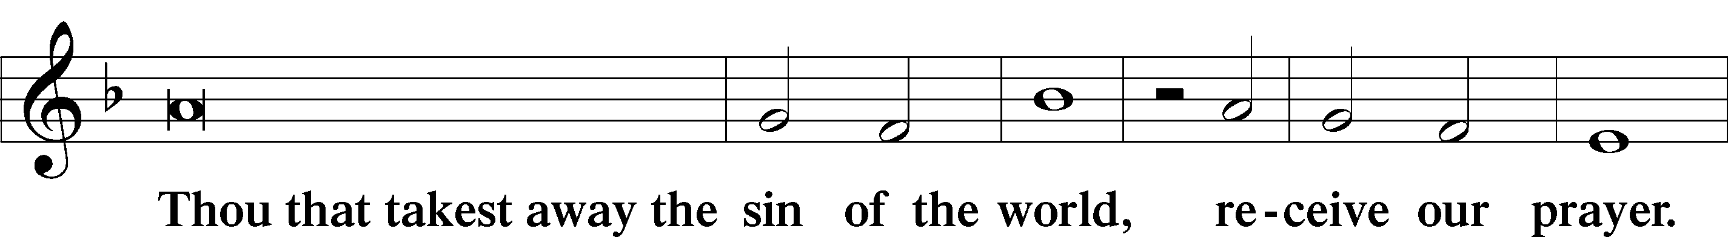

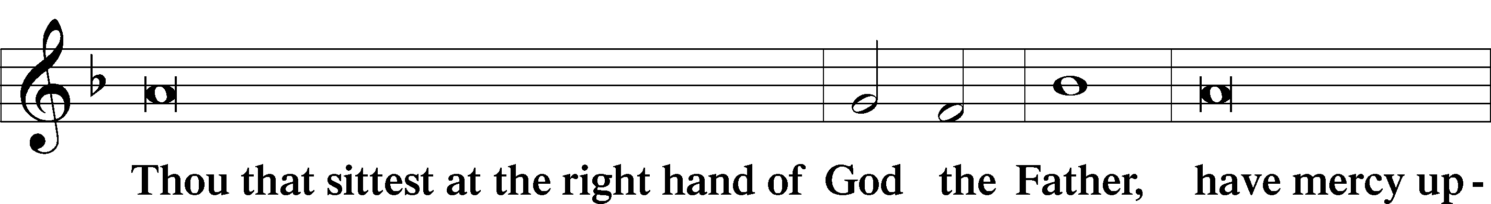

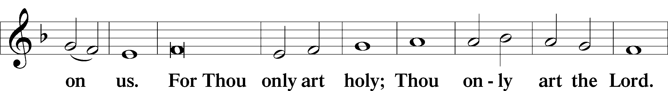

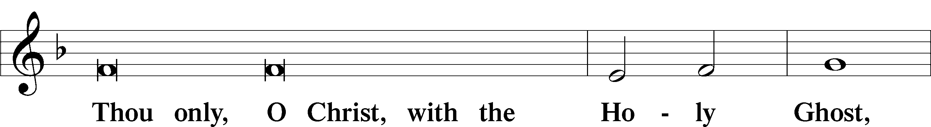

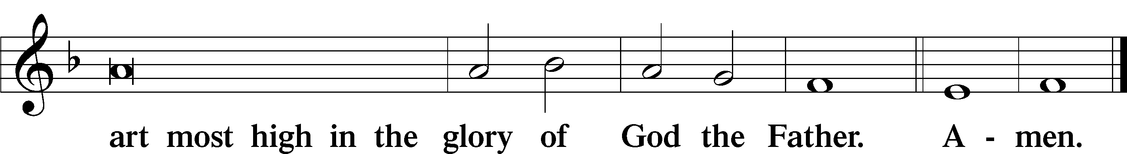

Salutation and Collect of the Day

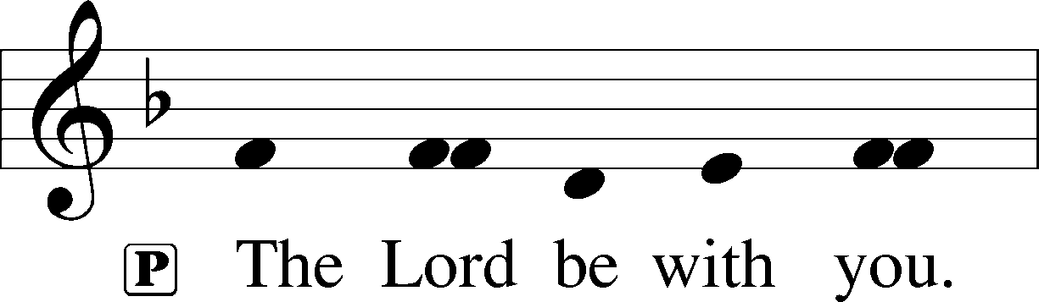

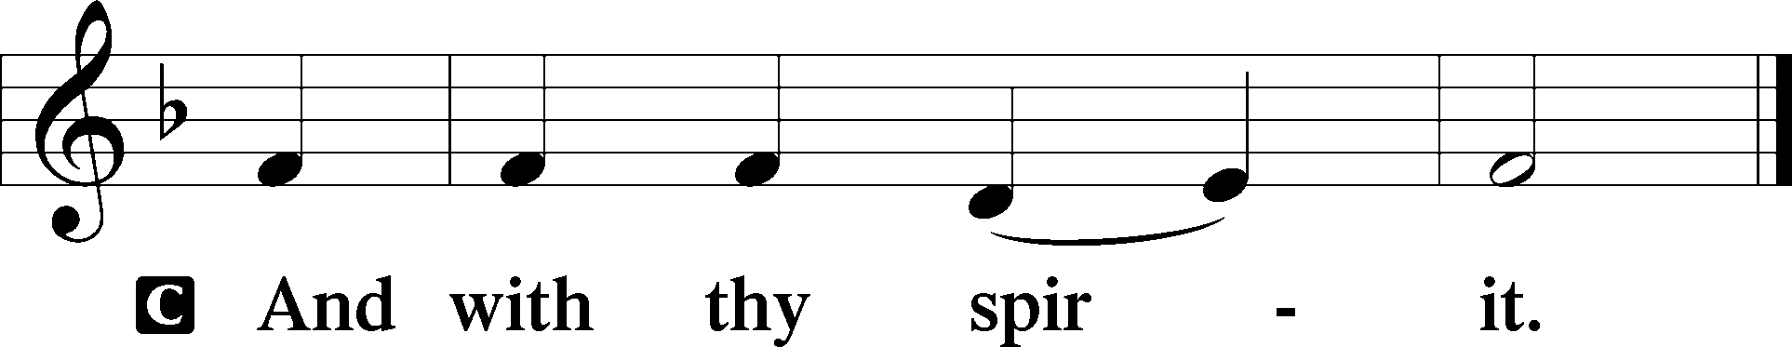

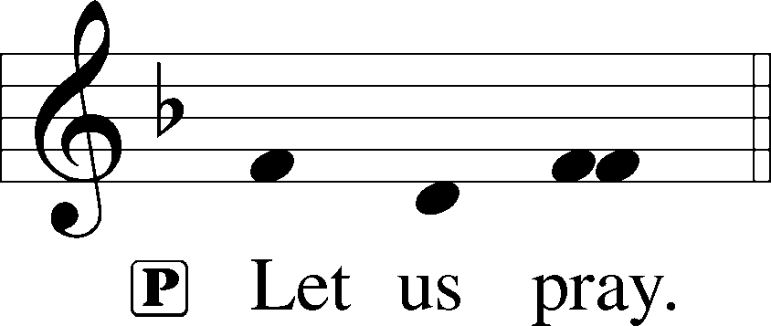

P Merciful Father, Your patience and loving-kindness toward us have no end. Grant that by Your Holy Spirit we may always think and do those things that are pleasing in Your sight; through Jesus Christ, Your Son, our Lord, who lives and reigns with You and the Holy Spirit, one God, now and forever.

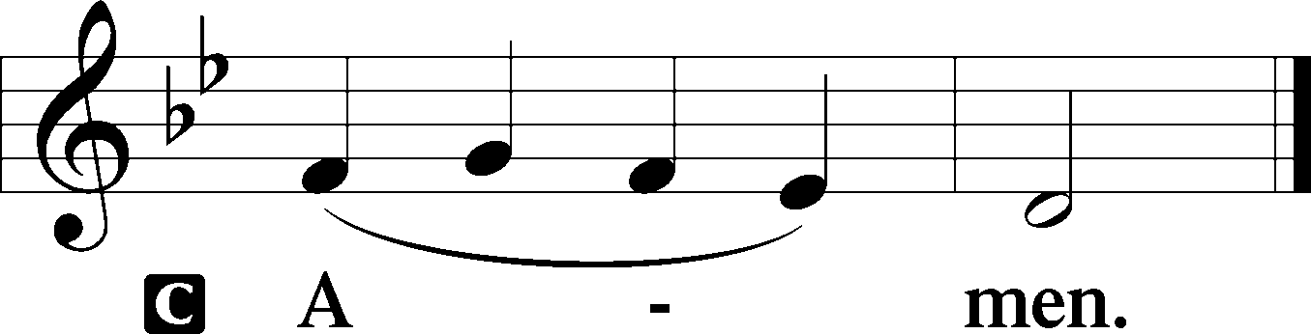

Sit

Old Testament Reading Genesis 2:18–25

18Then the Lord God said, “It is not good that the man should be alone; I will make him a helper fit for him.” 19So out of the ground the Lord God formed every beast of the field and every bird of the heavens and brought them to the man to see what he would call them. And whatever the man called every living creature, that was its name. 20The man gave names to all livestock and to the birds of the heavens and to every beast of the field. But for Adam there was not found a helper fit for him. 21So the Lord God caused a deep sleep to fall upon the man, and while he slept took one of his ribs and closed up its place with flesh. 22And the rib that the Lord God had taken from the man he made into a woman and brought her to the man. 23Then the man said,

“This at last is bone of my bones  
 and flesh of my flesh;  
she shall be called Woman,  
 because she was taken out of Man.”

24Therefore a man shall leave his father and his mother and hold fast to his wife, and they shall become one flesh. 25And the man and his wife were both naked and were not ashamed.

A This is the Word of the Lord.

C **Thanks be to God.**

Epistle Hebrews 2:1–13

1Therefore we must pay much closer attention to what we have heard, lest we drift away from it. 2For since the message declared by angels proved to be reliable and every transgression or disobedience received a just retribution, 3how shall we escape if we neglect such a great salvation? It was declared at first by the Lord, and it was attested to us by those who heard, 4while God also bore witness by signs and wonders and various miracles and by gifts of the Holy Spirit distributed according to his will.

5Now it was not to angels that God subjected the world to come, of which we are speaking. 6It has been testified somewhere,

“What is man, that you are mindful of him,  
 or the son of man, that you care for him?  
7You made him for a little while lower than the angels;  
 you have crowned him with glory and honor,  
 8putting everything in subjection under his feet.”

Now in putting everything in subjection to him, he left nothing outside his control. At present, we do not yet see everything in subjection to him. 9But we see him who for a little while was made lower than the angels, namely Jesus, crowned with glory and honor because of the suffering of death, so that by the grace of God he might taste death for everyone.

10For it was fitting that he, for whom and by whom all things exist, in bringing many sons to glory, should make the founder of their salvation perfect through suffering. 11For he who sanctifies and those who are sanctified all have one origin. That is why he is not ashamed to call them brothers, 12saying,

“I will tell of your name to my brothers;  
 in the midst of the congregation I will sing your praise.”

13And again,

“I will put my trust in him.”

And again,

“Behold, I and the children God has given me.”

A This is the Word of the Lord.

C **Thanks be to God.**

Stand

Alleluia LSB 190

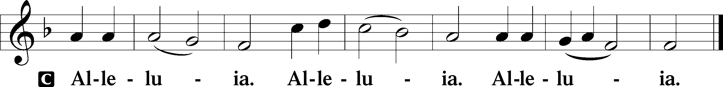

Holy Gospel Mark 10:2–16

P The Holy Gospel according to St. Mark, the tenth chapter.

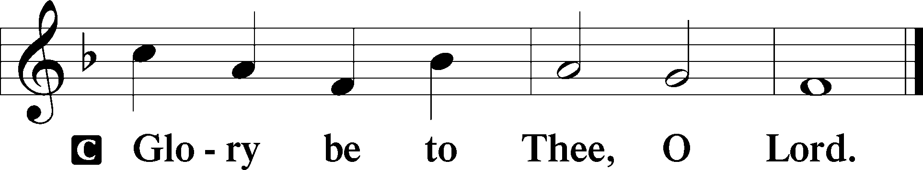

2Pharisees came up and in order to test [Jesus] asked, “Is it lawful for a man to divorce his wife?” 3He answered them, “What did Moses command you?” 4They said, “Moses allowed a man to write a certificate of divorce and to send her away.” 5And Jesus said to them, “Because of your hardness of heart he wrote you this commandment. 6But from the beginning of creation, ‘God made them male and female.’ 7‘Therefore a man shall leave his father and mother and hold fast to his wife, 8and they shall become one flesh.’ So they are no longer two but one flesh. 9What therefore God has joined together, let not man separate.”

10And in the house the disciples asked him again about this matter. 11And he said to them, “Whoever divorces his wife and marries another commits adultery against her, 12and if she divorces her husband and marries another, she commits adultery.”

13And they were bringing children to him that he might touch them, and the disciples rebuked them. 14But when Jesus saw it, he was indignant and said to them, “Let the children come to me; do not hinder them, for to such belongs the kingdom of God. 15Truly, I say to you, whoever does not receive the kingdom of God like a child shall not enter it.” 16And he took them in his arms and blessed them, laying his hands on them.

P This is the Gospel of the Lord.

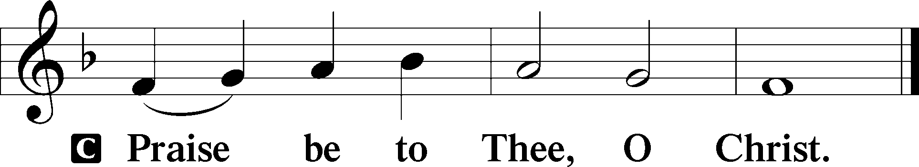

Nicene Creed

C **I believe in one God, the Father Almighty, maker of heaven and earth and of all things visible and invisible.**

**And in one Lord Jesus Christ, the only-begotten Son of God, begotten of His Father before all worlds, God of God, Light of Light, very God of very God, begotten, not made, being of one substance with the Father, by whom all things were made; who for us men and for our salvation came down from heaven and was incarnate by the Holy Spirit of the virgin Mary and was made man; and was crucified also for us under Pontius Pilate. He suffered and was buried. And the third day He rose again according to the Scriptures and ascended into heaven and sits at the right hand of the Father. And He will come again with glory to judge both the living and the dead, whose kingdom will have no end.**

**And I believe in the Holy Spirit, the Lord and giver of life, who proceeds from the Father and the Son, who with the Father and the Son together is worshiped and glorified, who spoke by the prophets. And I believe in one holy Christian and apostolic Church, I acknowledge one Baptism for the remission of sins, and I look for the resurrection of the dead and the life** T **of the world to come. Amen.**

Sit

869 With the Lord Begin Your Task

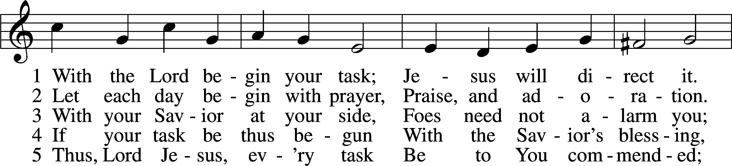

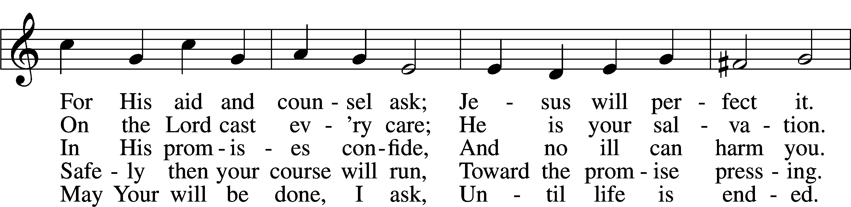

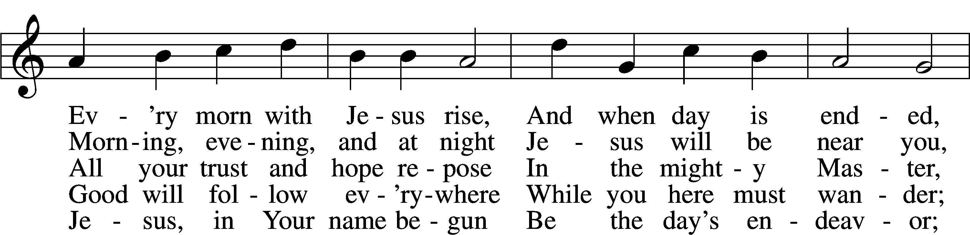

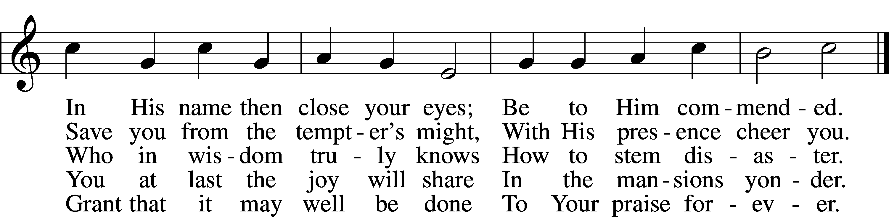

Text: Morgen- und Abend-segen, 1734, Waldenburg; tr. W. Gustave Polack, 1890–1950, alt.  
Tune: Peter Frank, 1616–75  
Text: © 1941 Concordia Publishing House. Used by permission: LSB Hymn License no. 110004388  
Tune: Public domain

Sermon: “God Provides The Helper We Need” *Genesis 2:18-25*

Offering

Stand

Offertory LSB 192

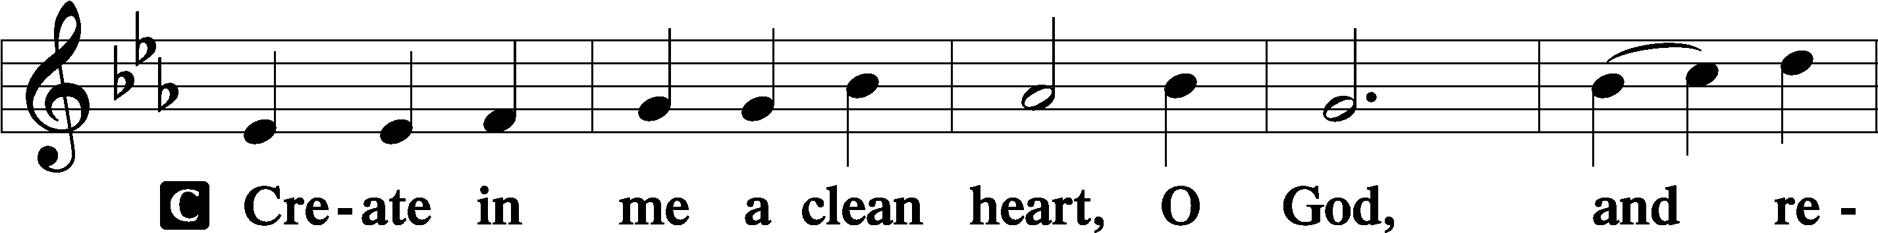

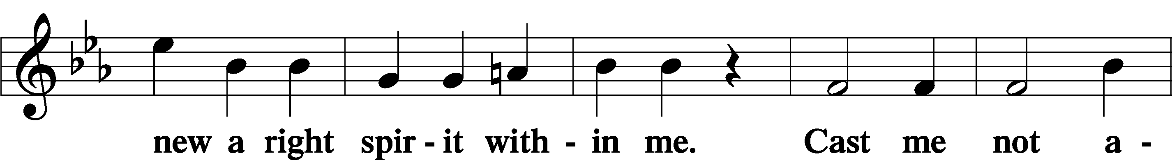

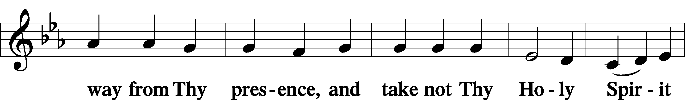

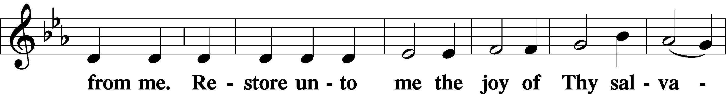

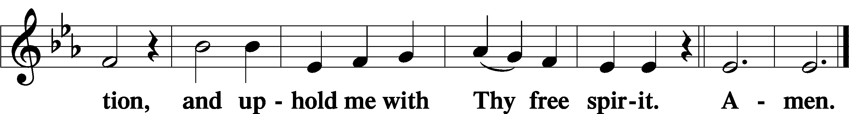

Prayer of the Church

# Service of the Sacrament

Preface LSB 194

P The Lord be with you.

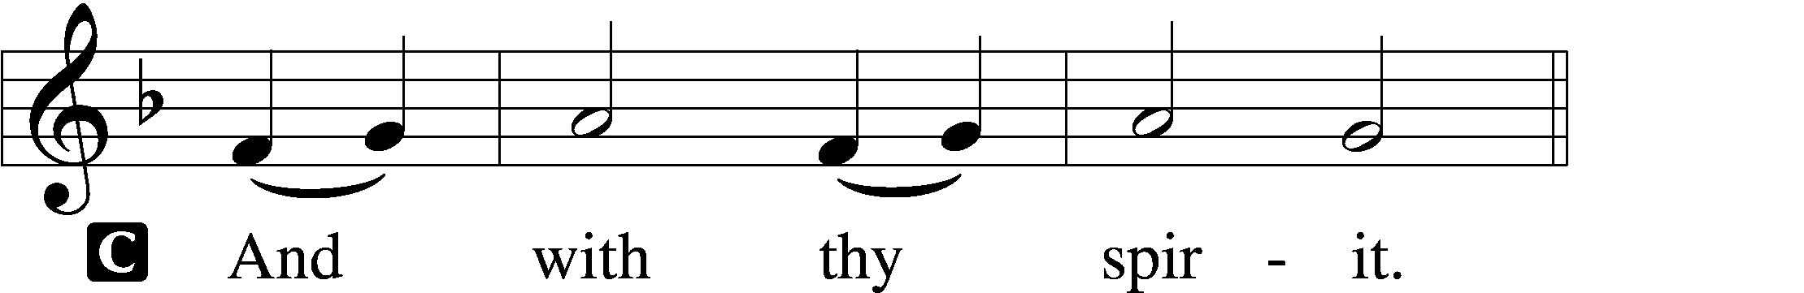

P Lift up your hearts.

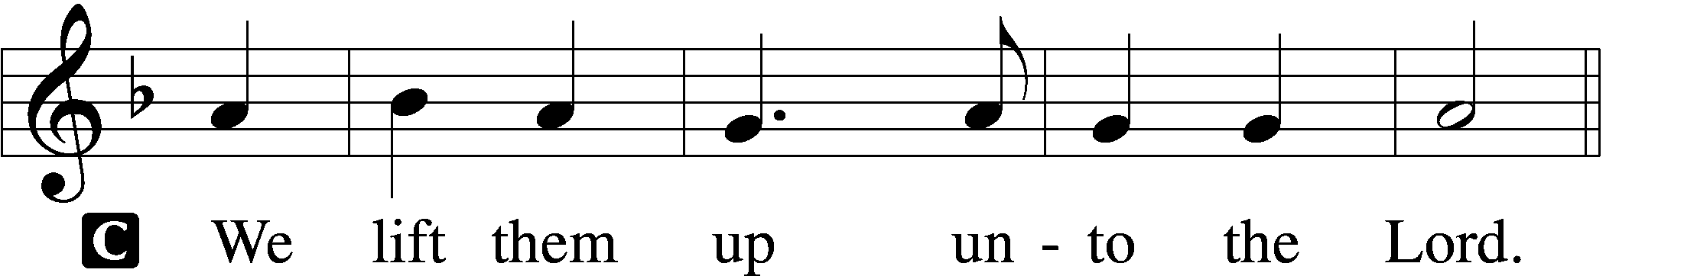

P Let us give thanks unto the Lord, our God.

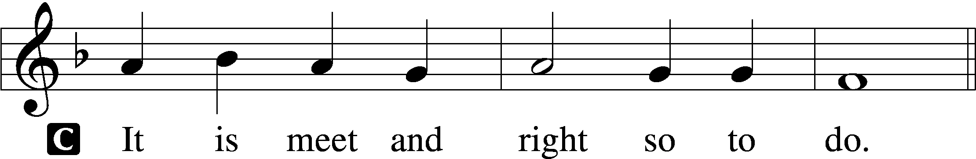

P It is truly meet, right, and salutary that we should at all times and in all places give thanks to You, holy Lord, almighty Father, everlasting God, through Jesus Christ, our Lord, who on this day overcame death and the grave and by His glorious resurrection opened to us the way of everlasting life. Therefore with angels and archangels and with all the company of heaven we laud and magnify Your glorious name, evermore praising You and saying:

Sanctus LSB 195

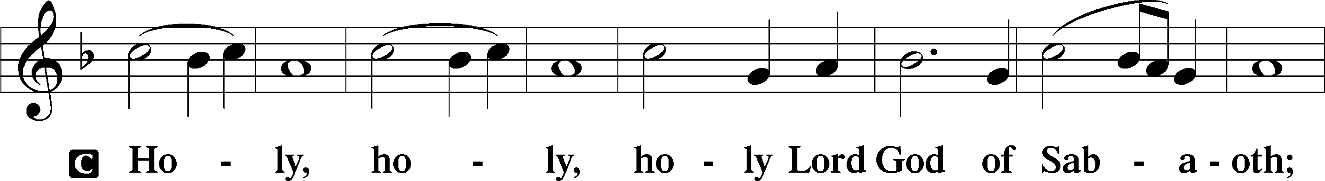

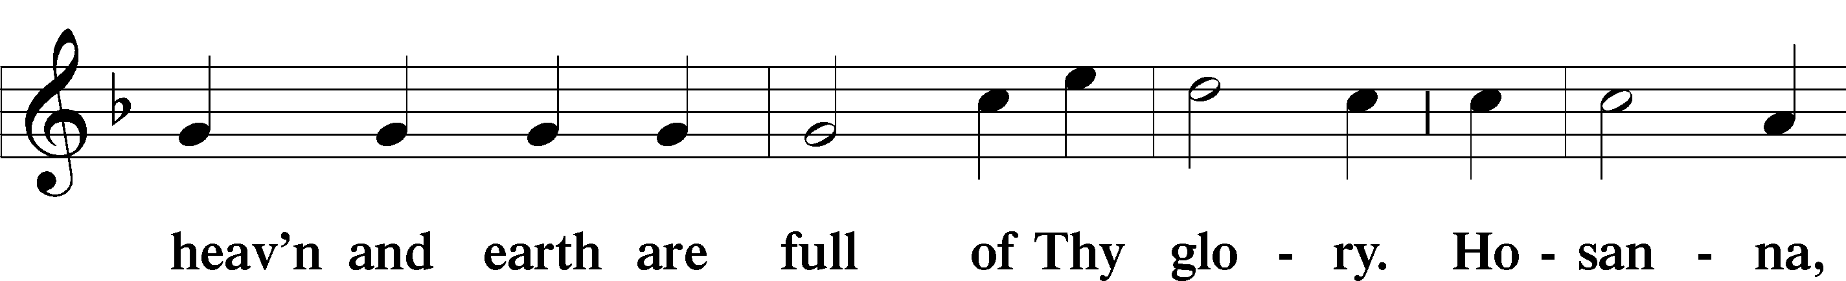

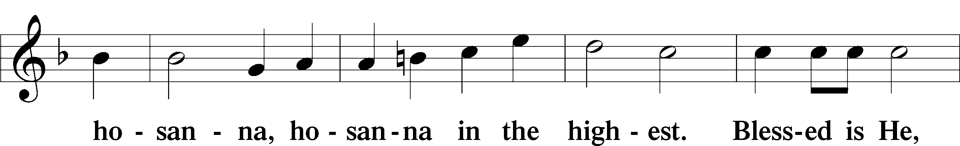

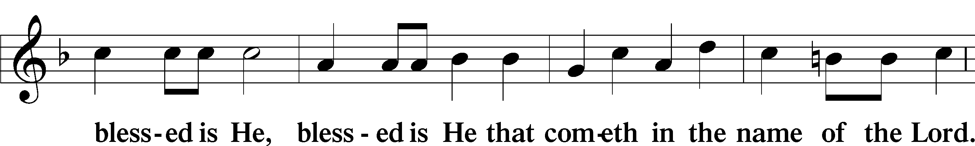

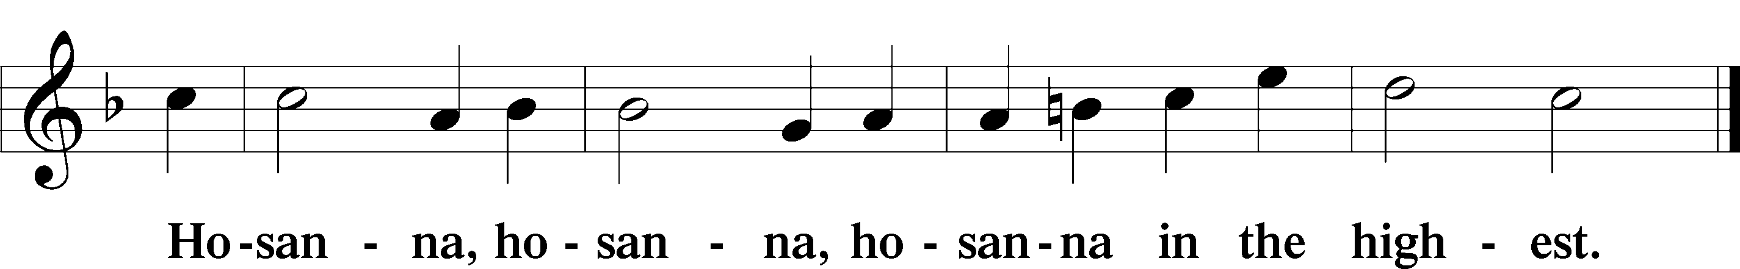

Lord’s Prayer LSB 196

P Our Father who art in heaven,

hallowed be Thy name,

Thy kingdom come,

Thy will be done on earth as it is in heaven;

give us this day our daily bread;

and forgive us our trespasses as we forgive those who trespass against us;

and lead us not into temptation,

but deliver us from evil.

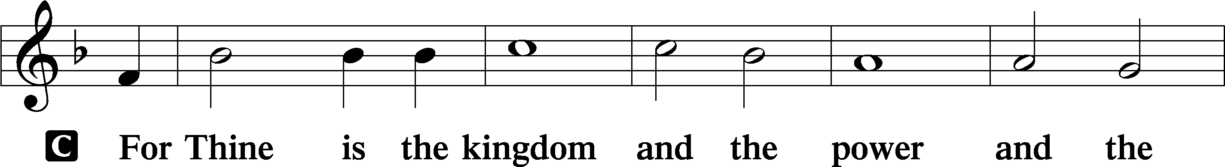

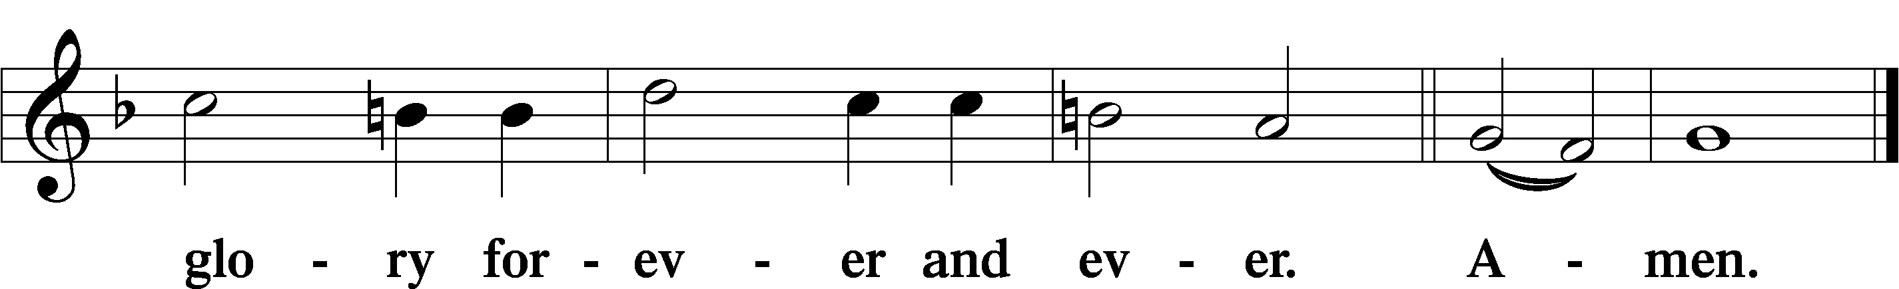

The Words of Our Lord LSB 197

P Our Lord Jesus Christ, on the night when He was betrayed, took bread, and when He had given thanks, He broke it and gave it to the disciples and said: “Take, eat; this is My T body, which is given for you. This do in remembrance of Me.”

In the same way also He took the cup after supper, and when He had given thanks, He gave it to them, saying: “Drink of it, all of you; this cup is the new testament in My T blood, which is shed for you for the forgiveness of sins. This do, as often as you drink it, in remembrance of Me.”

Pax Domini LSB 197

P The peace of the Lord be with you always.

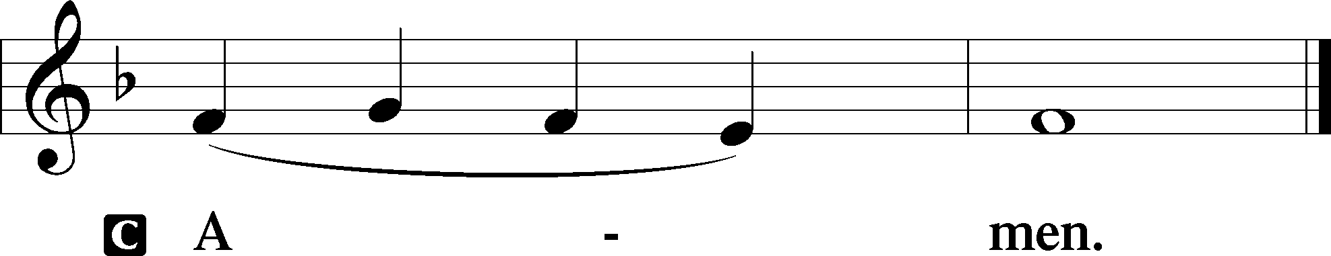

Agnus Dei LSB 198

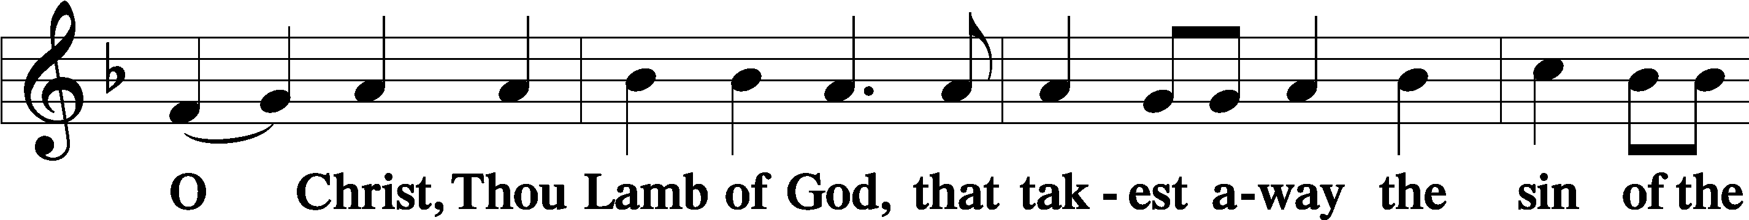

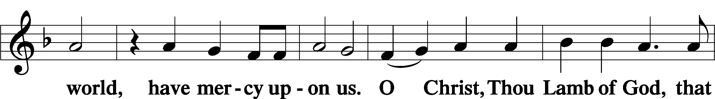

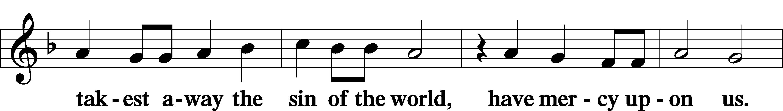

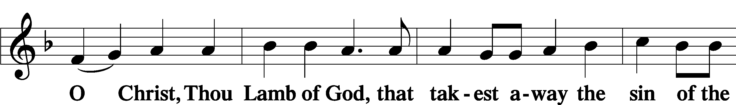

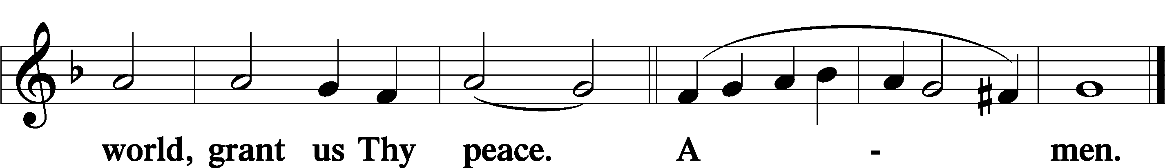

Sit

Distribution

532 The Head That Once Was Crowned with Thorns

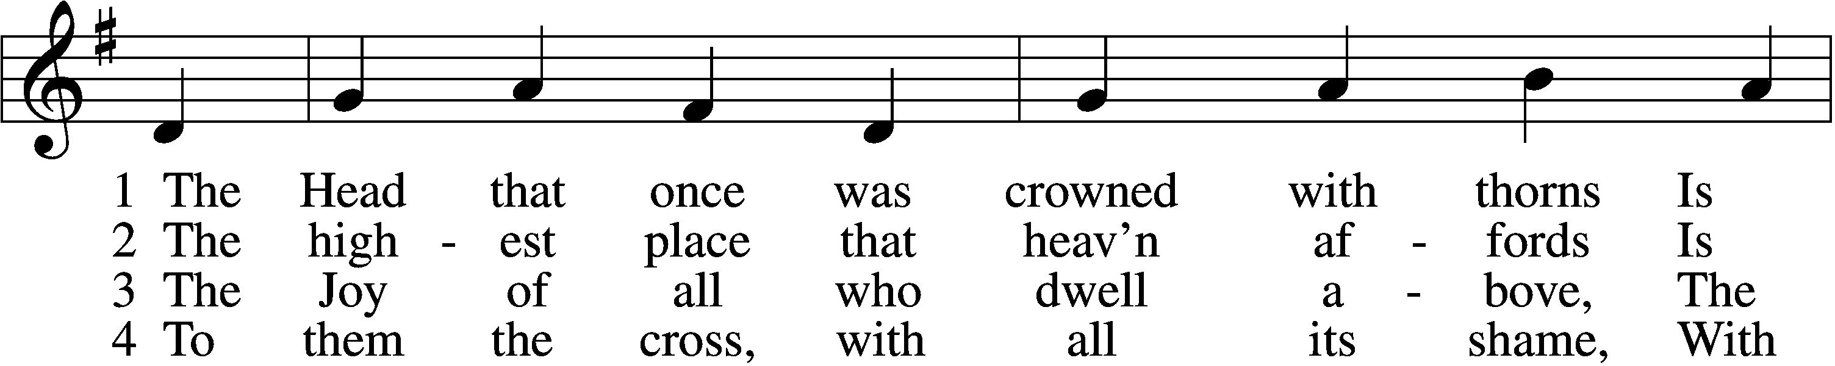

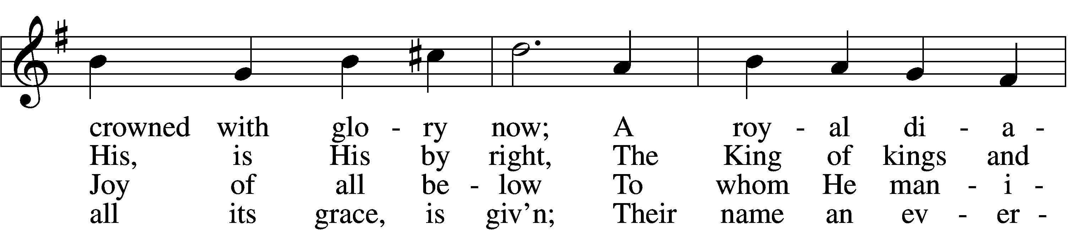

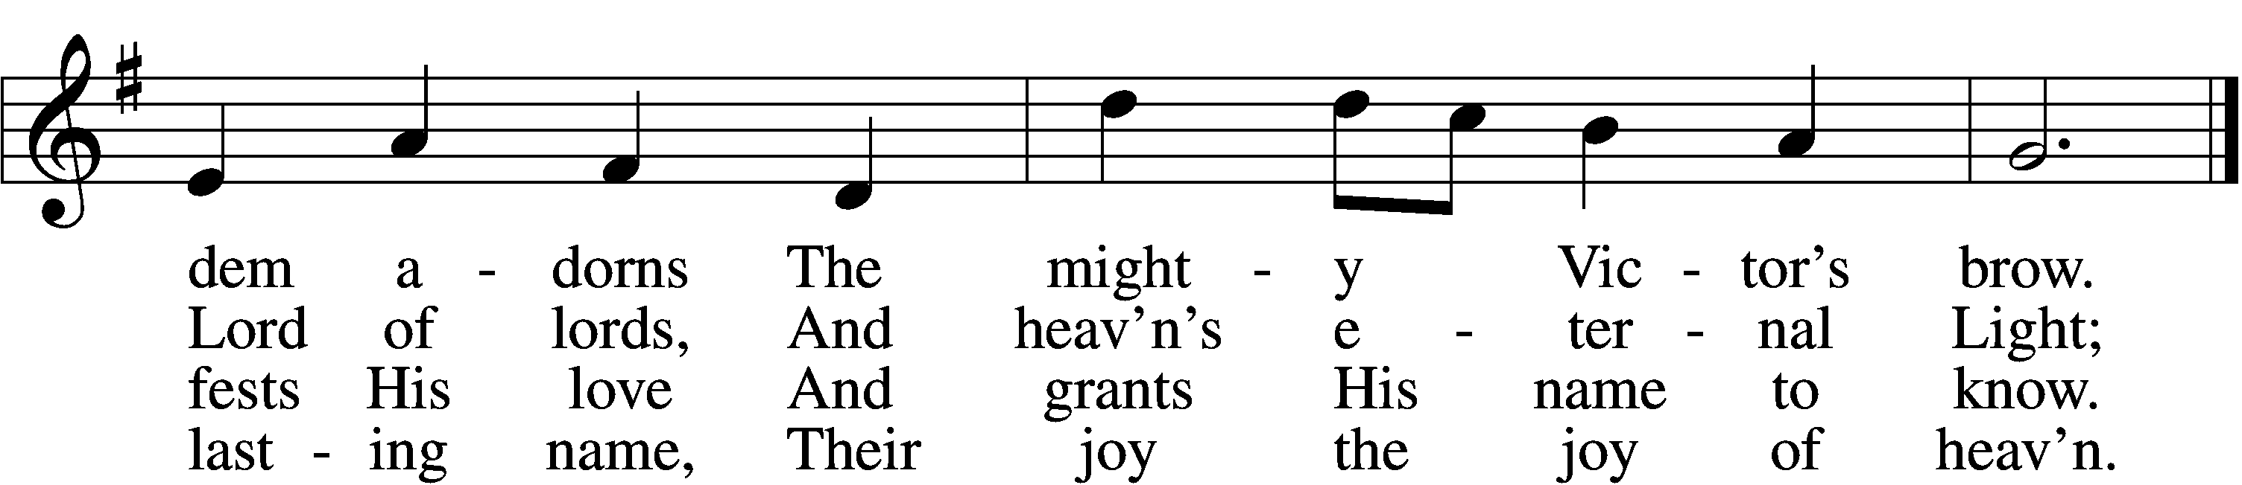

5 They suffer with their Lord below,  
 They reign with Him above,  
Their profit and their joy to know  
 The myst’ry of His love.

6 The cross He bore is life and health,  
 Though shame and death to Him:  
His people’s hope, His people’s wealth,  
 Their everlasting theme.

Text: Thomas Kelly, 1769–1855 Tune: Jeremiah Clarke, c. 1674–1707 Text and tune: Public domain

594 God’s Own Child, I Gladly Say It

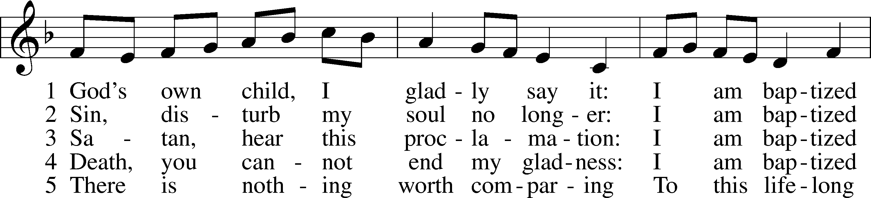

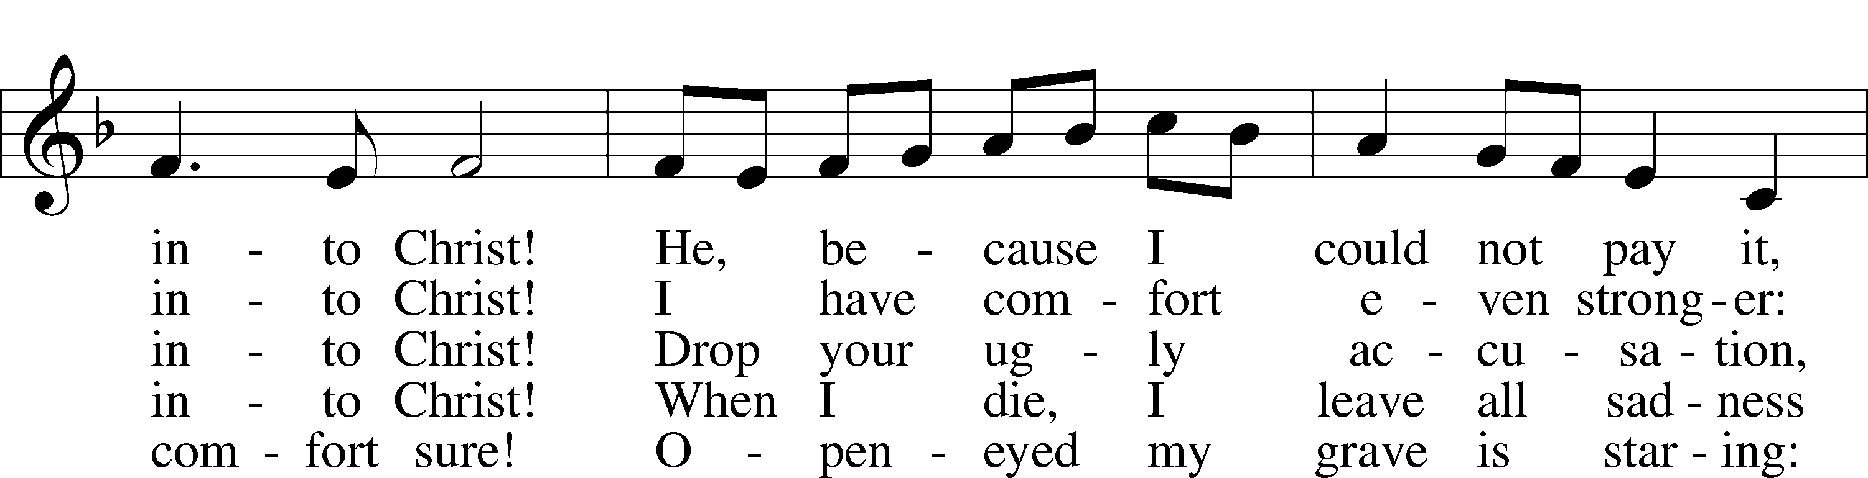

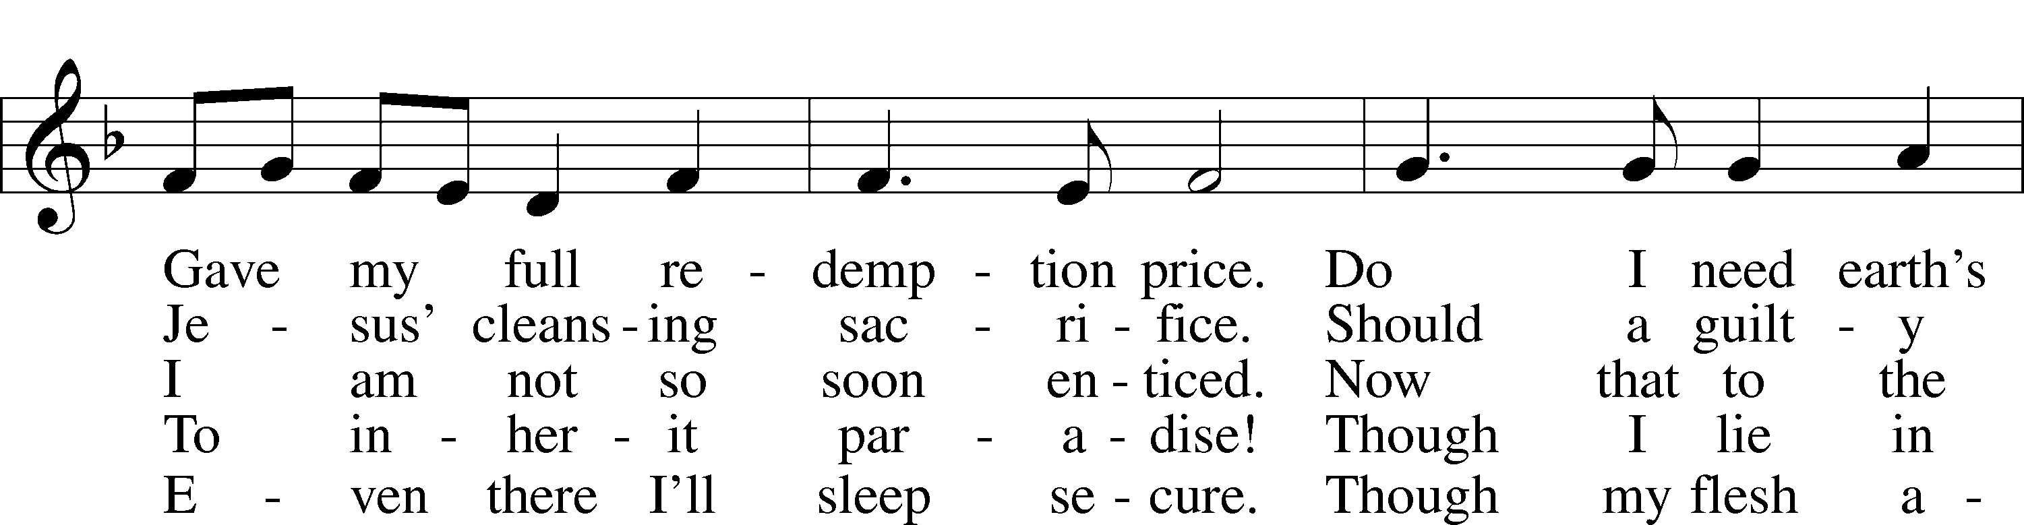

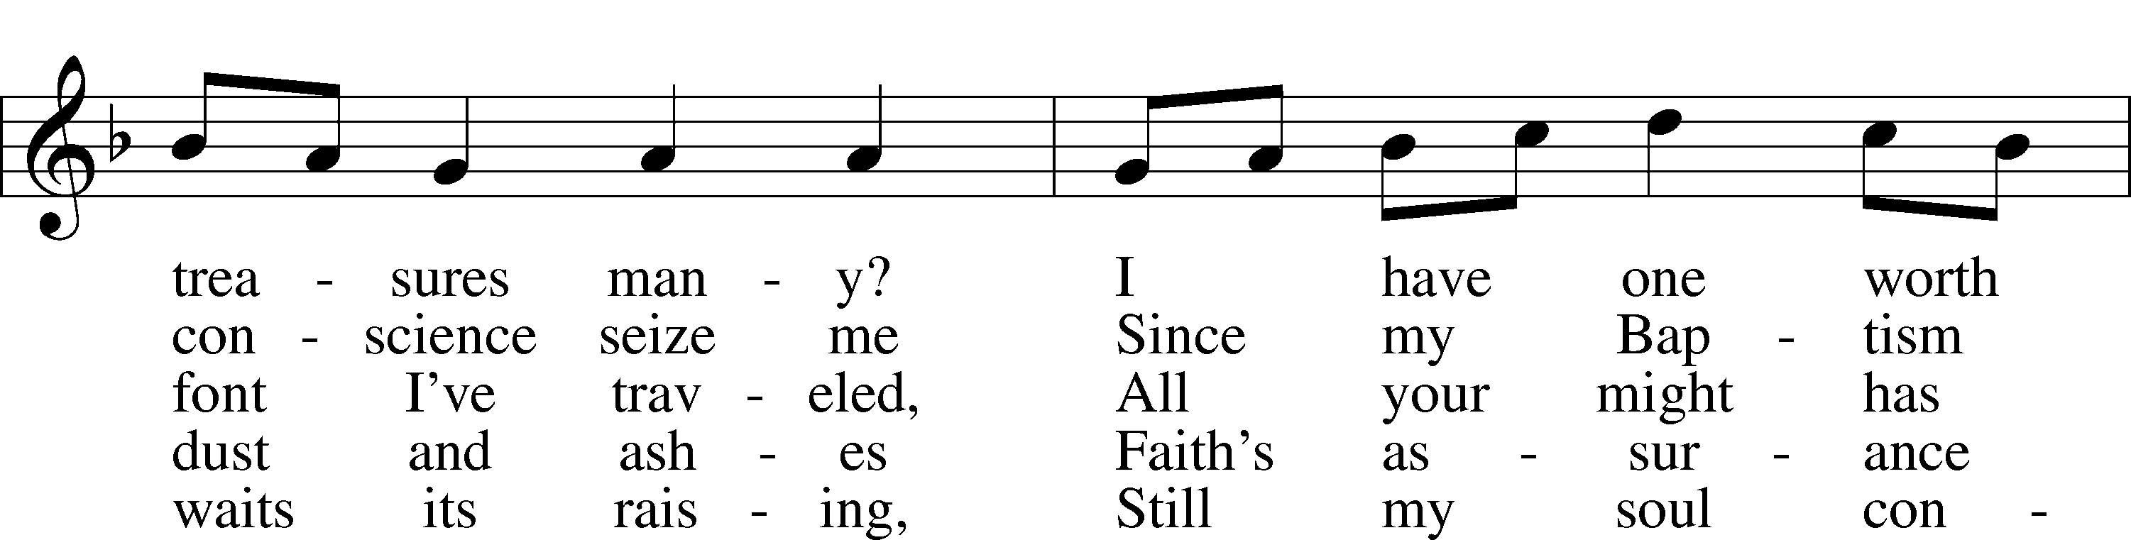

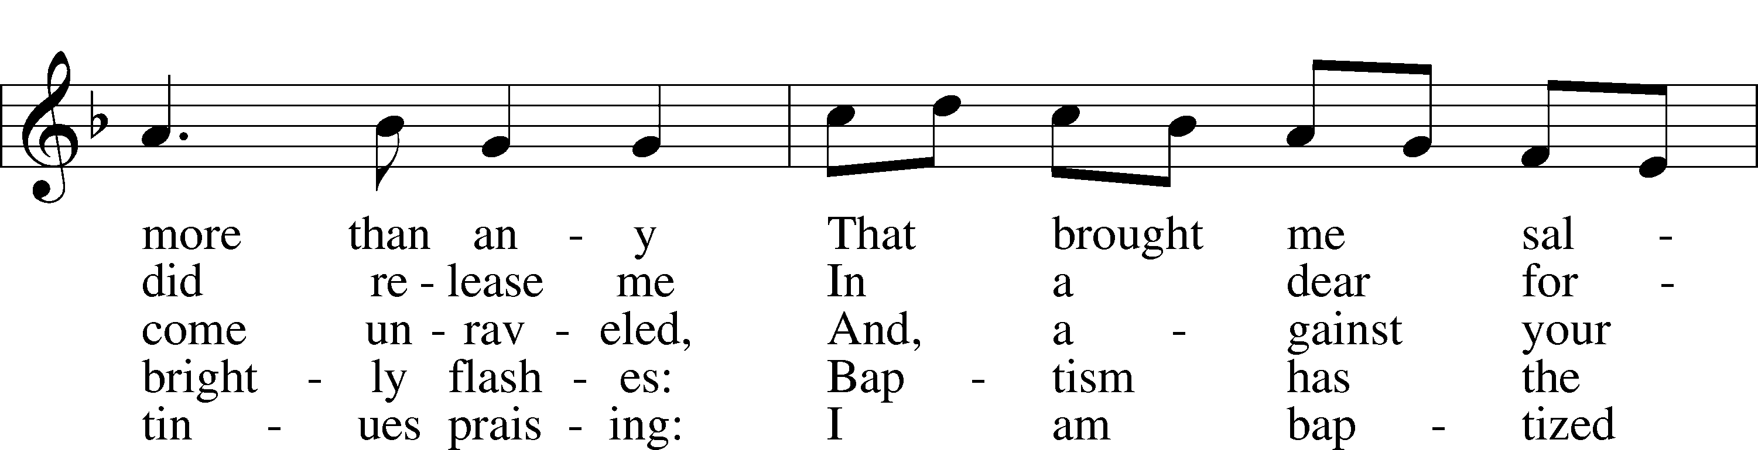

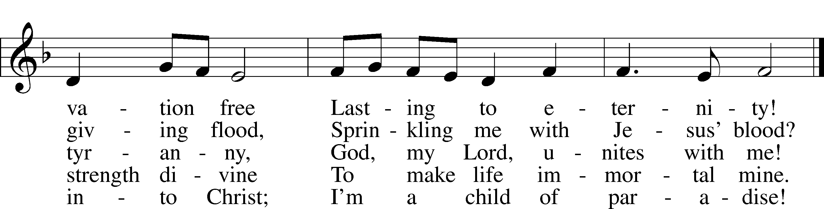

Text: Erdmann Neumeister, 1671–1756; tr. Robert E. Voelker, 1957  
Tune: Johann Caspar Bachofen, 1695–1755, alt.  
Text: © 1991 Robert E. Voelker. Used by permission: LSB Hymn License no. 110004388 Tune: Public domain

685 Let Us Ever Walk with Jesus

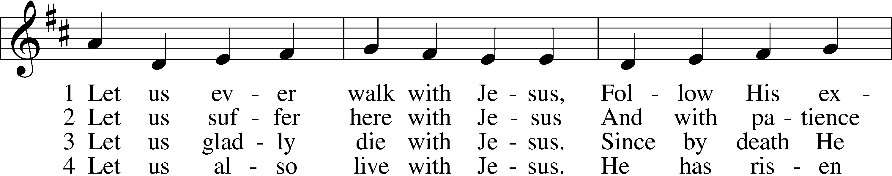

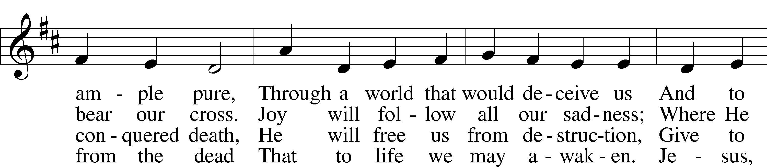

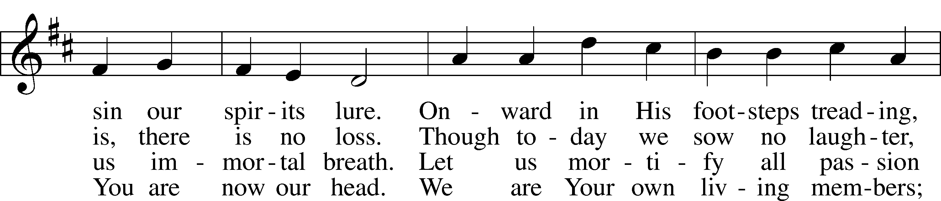

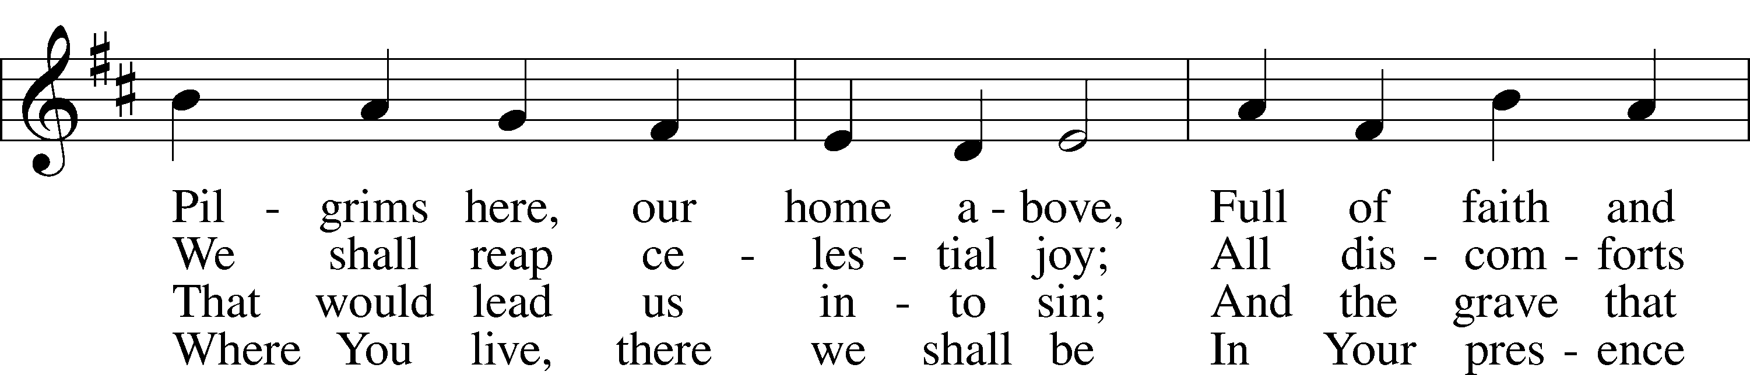

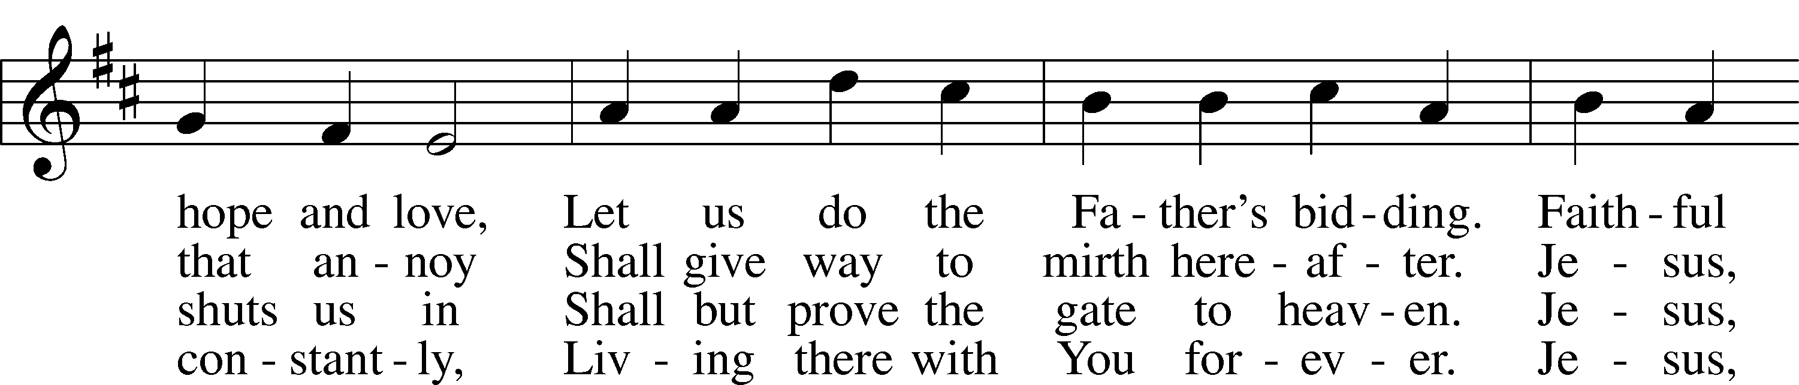

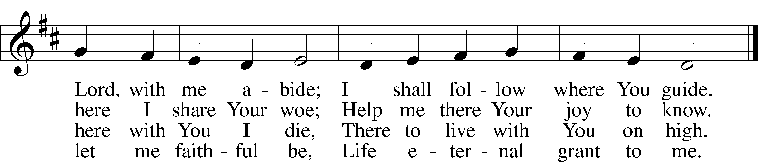

Text: Sigismund von Birken, 1626–81; tr. Lutheran Book of Worship, 1978, alt. Tune: Georg G. Boltze, 18th cent. Text: © 1978 Lutheran Book of Worship. Used by permission: LSB Hymn License no. 110004388 Tune: Public domain

Stand

Nunc Dimittis LSB 199

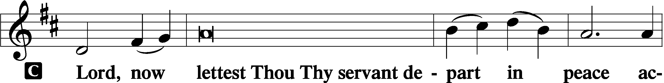

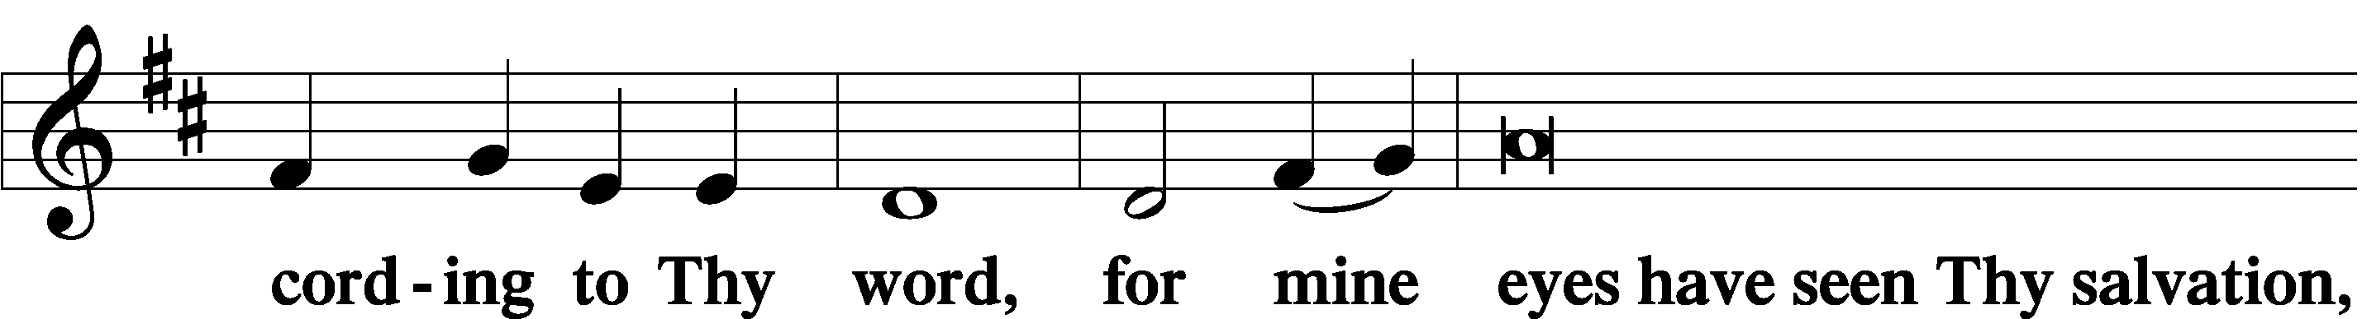

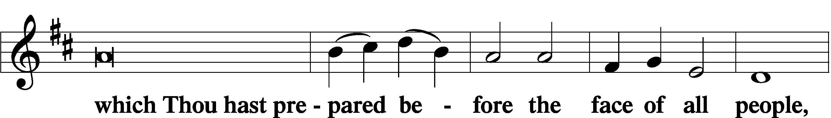

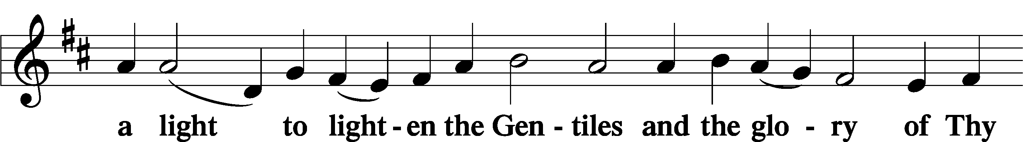

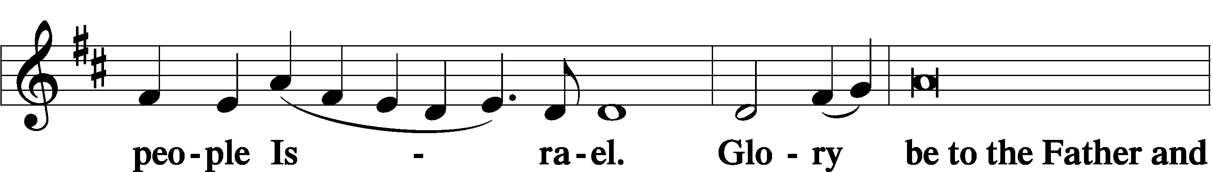

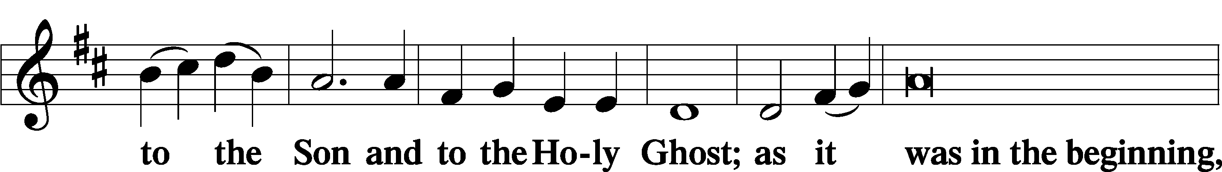

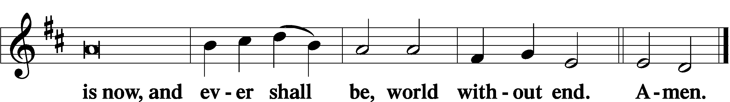

Thanksgiving LSB 200

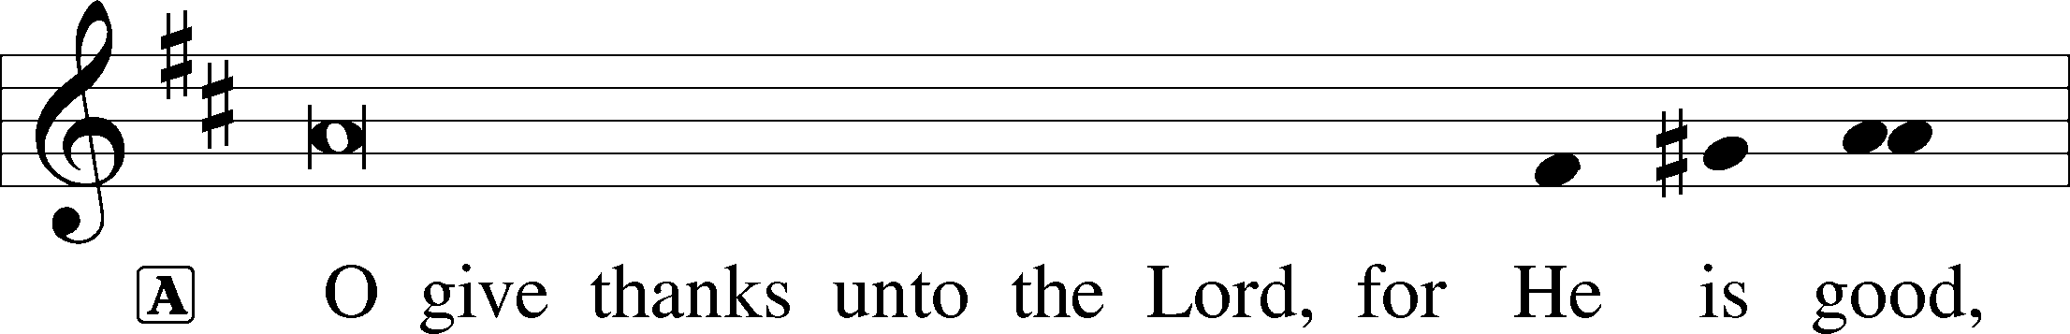

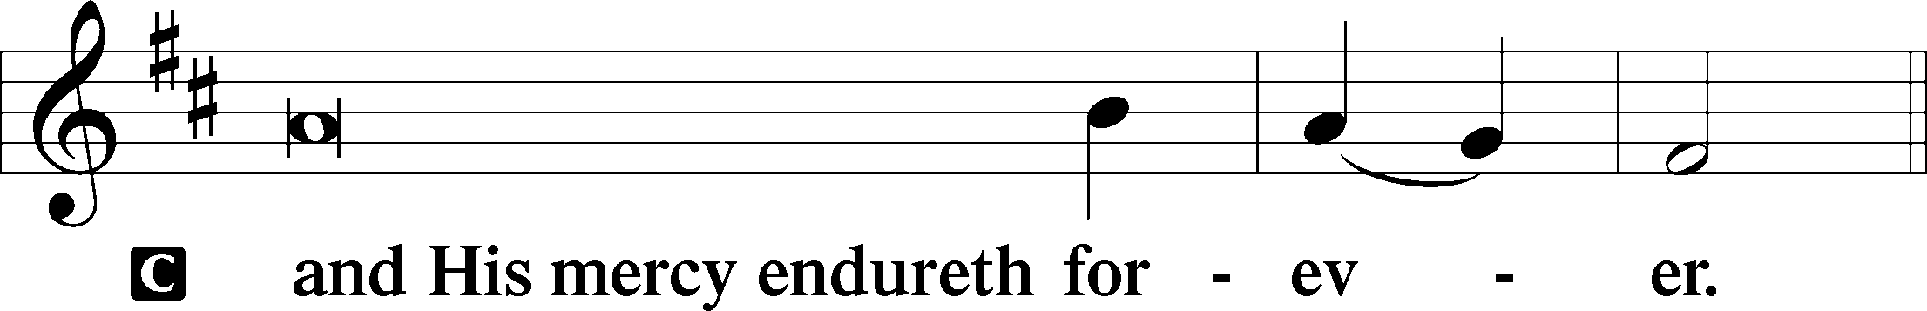

A Let us pray.

We give thanks to You, almighty God, that You have refreshed us through this salutary gift, and we implore You that of Your mercy You would strengthen us through the same in faith toward You and in fervent love toward one another; through Jesus Christ, Your Son, our Lord, who lives and reigns with You and the Holy Spirit, one God, now and forever.

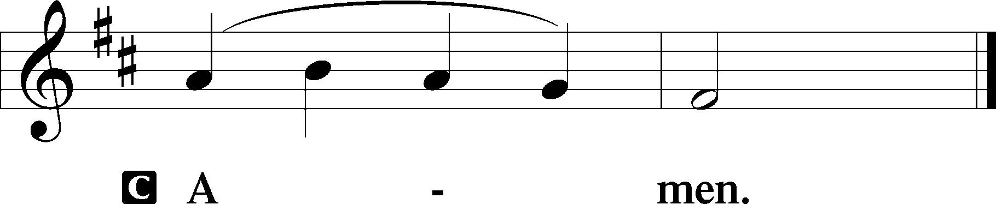

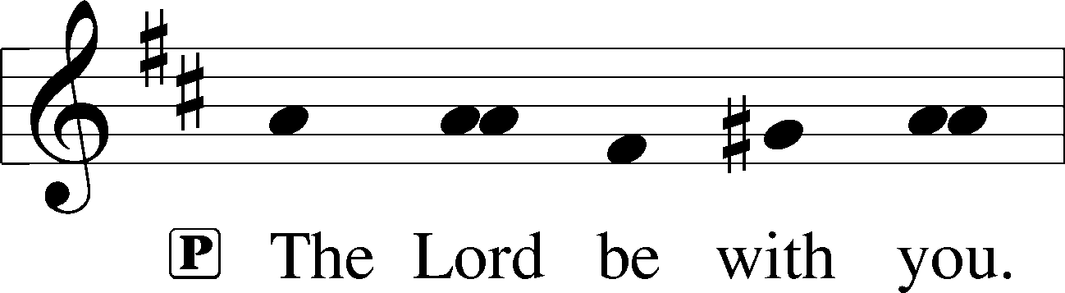

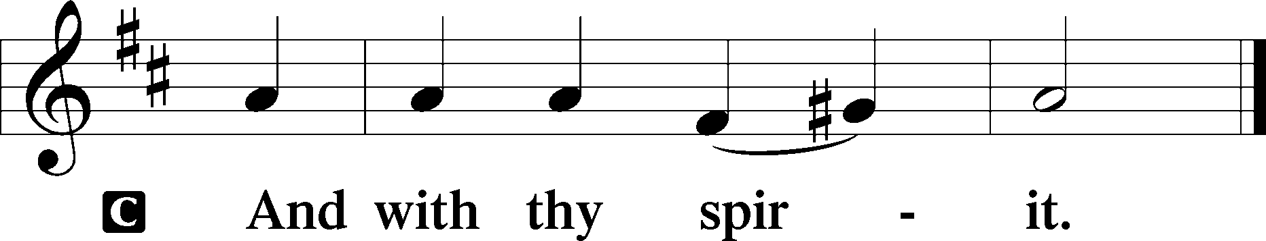

Benedicamus LSB 202

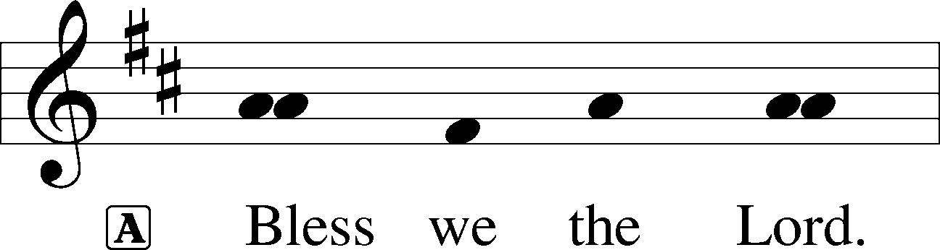

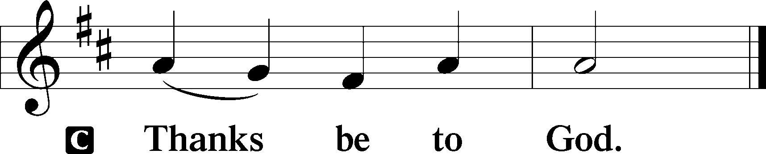

Benediction LSB 202

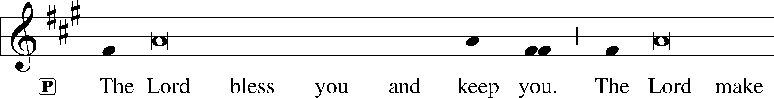

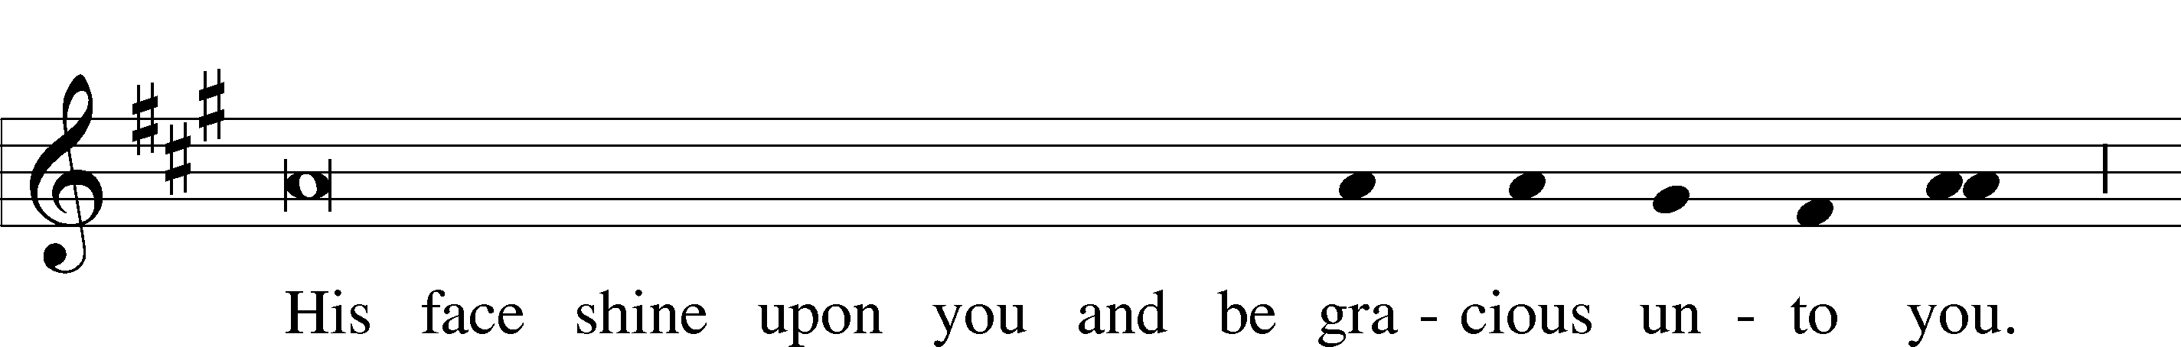

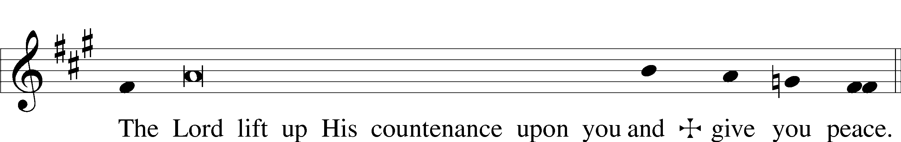

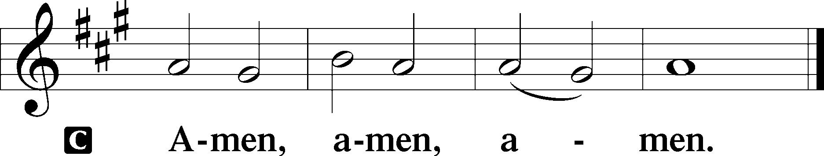

922 Go, My Children, with My Blessing sts. 1–4

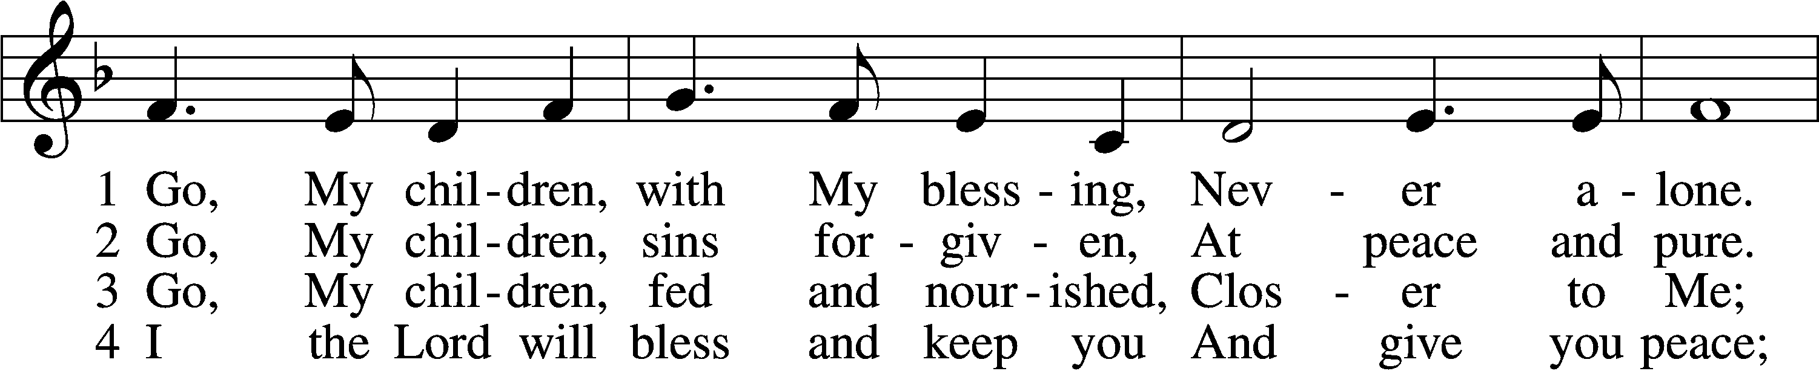

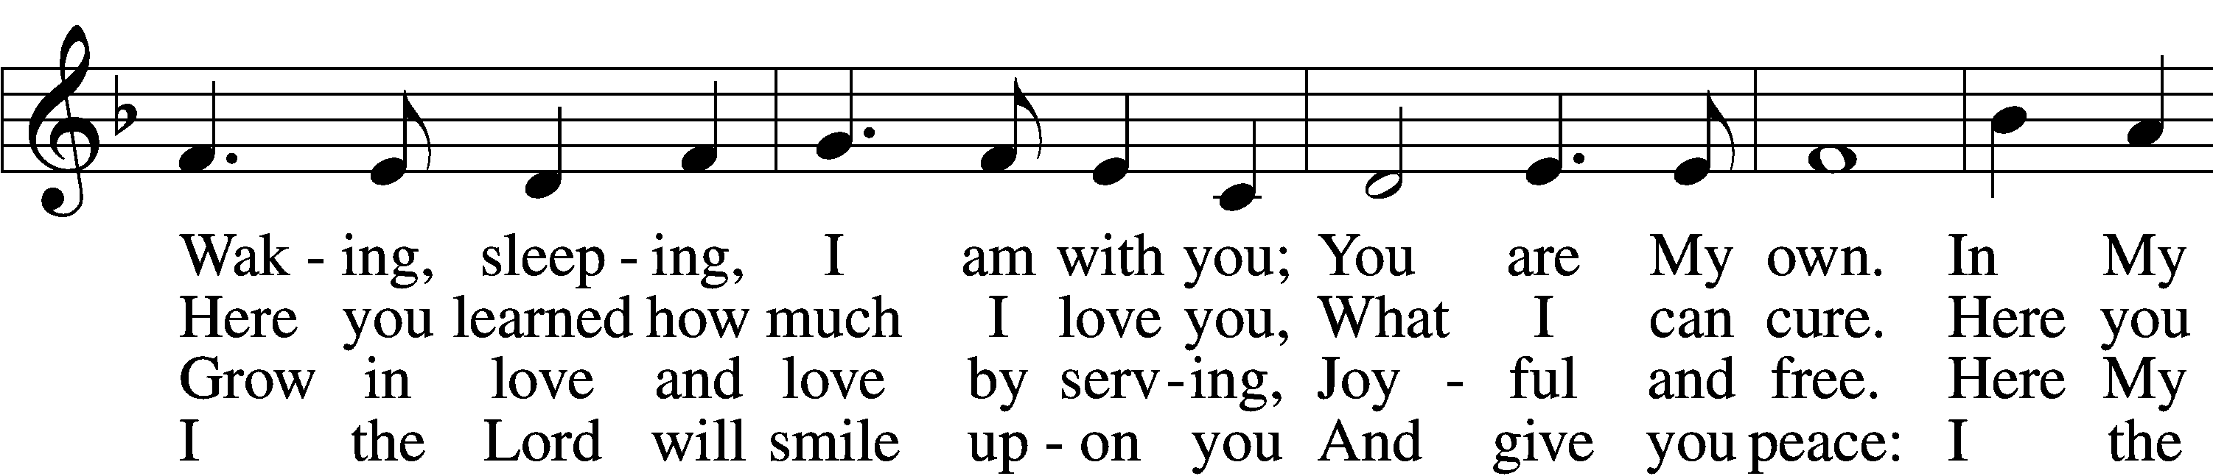

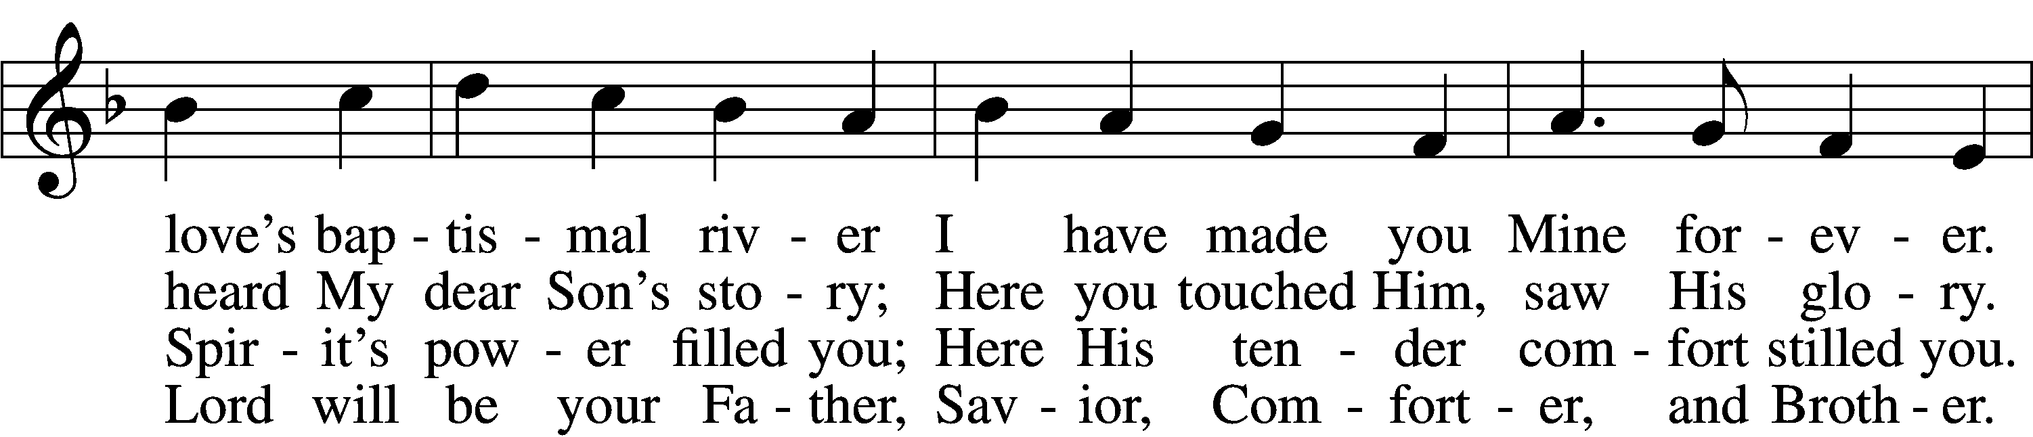

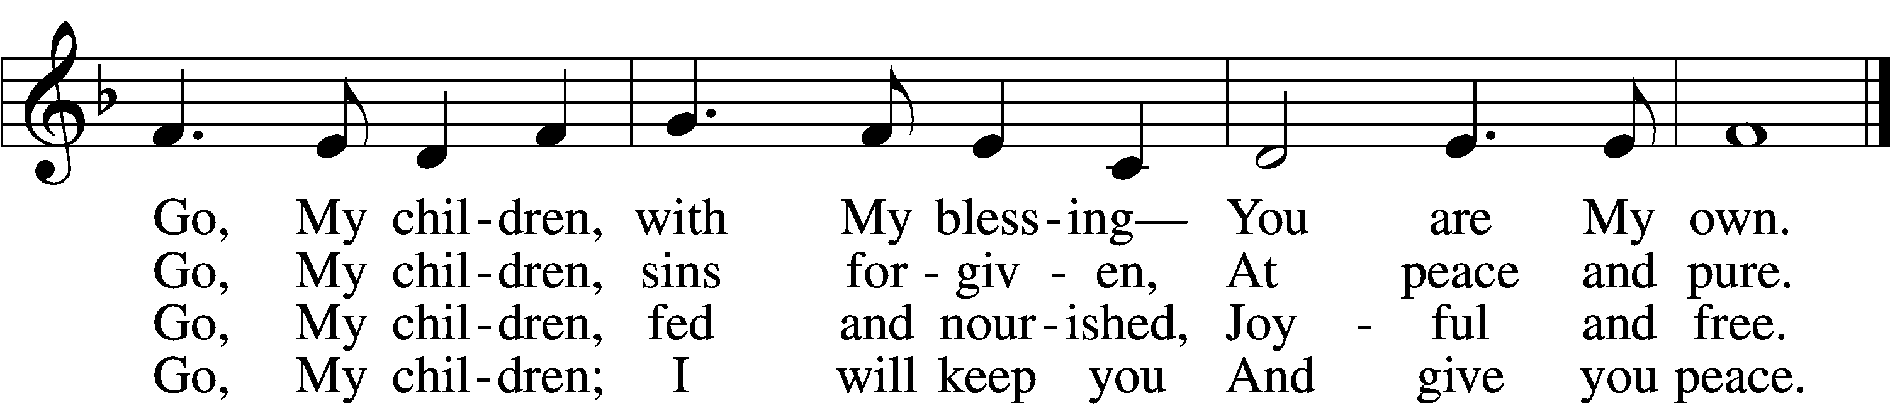

Text: Jaroslav J. Vajda, 1919–2008  
Tune: Welsh, 18th cent.  
Text: © 1983 Concordia Publishing House. Used by permission: LSB Hymn License no. 110004388  
Tune: Public domain

Acknowledgments

Divine Service, Setting Three from Lutheran Service Book

Unless otherwise indicated, Scripture quotations are from the ESV® Bible (The Holy Bible, English Standard Version®), copyright © 2001 by Crossway, a publishing ministry of Good News Publishers. Used by permission. All rights reserved.

Created by Lutheran Service Builder © 2024 Concordia Publishing House.