**Second Sunday after the Epiphany**

**January 19, 2025**



“This, the first of his signs, Jesus did at Cana in Galilee, and manifested his glory. And his disciples believed in him”

**PEACE LUTHERAN CHURCH**

1451 Ebenezer Rd + Cincinnati, OH 45233 + 513-941-5177

[**www.peacechurchlink.com**](http://www.peacechurchlink.com)

**About This Service**

The season of Christmas comes to a close with Epiphany (January 6th). The word “Epiphany” comes from the Greek epiphaneia, meaning “manifestation.” The salvation of the Gentiles (not just the Jews) is made manifest in the coming of the Magi to worship Jesus. We are reminded that Jesus comes not only to make atonement for our sins, but also to make all things new. This includes a new human race that is born, not of the flesh, but of God, of water and Spirit, and we are – even now – being formed for all eternity into His Image.

The time before the Divine Service begins is a time for meditation and prayer. It’s a time for us to prepare our hearts and minds to hear God’s Word and receive His gifts. Therefore, we ask that you would please remain silent as you enter the sanctuary out of reverence for God and respect for one another.

**Are My Children Welcome?**

In God’s eyes we’re all children. Yes, your little ones are more than welcome! If your child needs a little extra room to “make a joyful noise” you’re welcome to take them out of the sanctuary and into the narthex or the Fellowship Hall.

**How Do I Become a Lutheran Christian?**

If you’re exploring the Lutheran Church, Pastor Shaw would be happy to offer guidance or answer your questions. Our website peacechurchlink.com is also a good resource. When you’re ready, there’s a formal process of reading, study, and prayer that culminates in being received into the Lutheran Church.

**Can I Take Communion?**

The Lord’s Supper is celebrated at this congregation in the confession and glad confidence that, as our Lord says, He gives into our mouths not only bread and wine but His very body and blood to eat and to drink for the forgiveness of sins and to strengthen our union with Him and with one another. Our Lord invites to His table those who trust His Words, repent of all sins, and set aside any refusal to forgive and love as He forgives and loves us, that they may show forth His death until He comes. Holy Communion is a confession of the faith which is confessed at this altar, any who are not yet instructed, in doubt, or who hold a confession differing from that of this congregation and the Lutheran Church – Missouri Synod, are asked to first speak with the pastor before communing.

398 Hail to the Lord’s Anointed

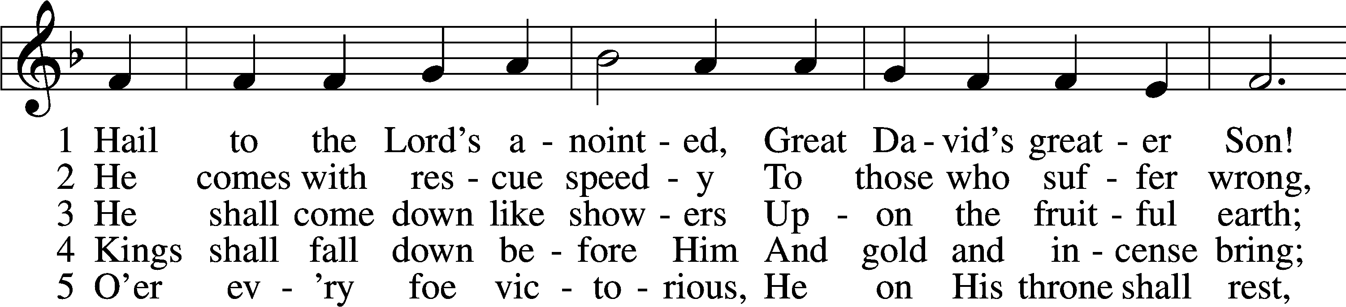

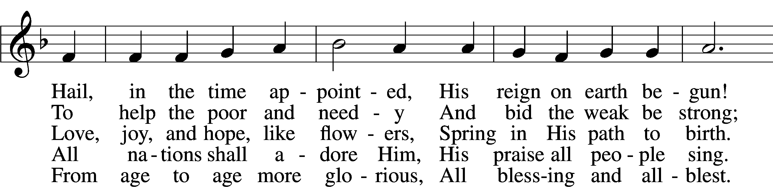

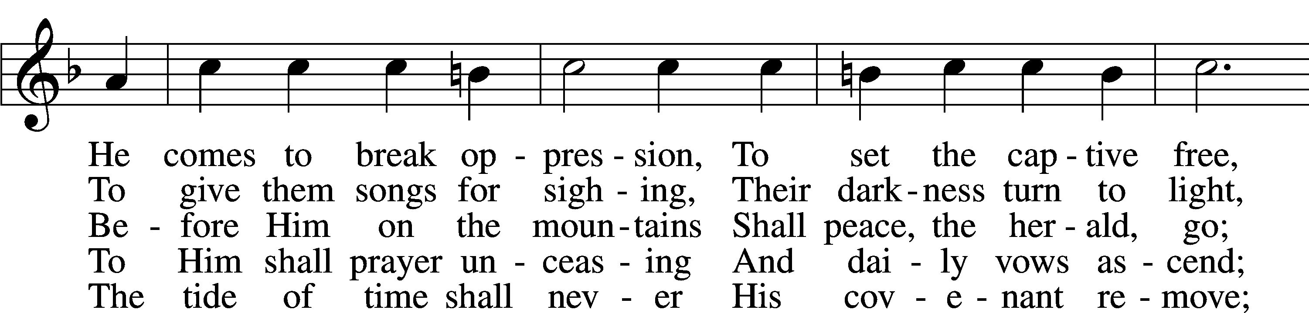

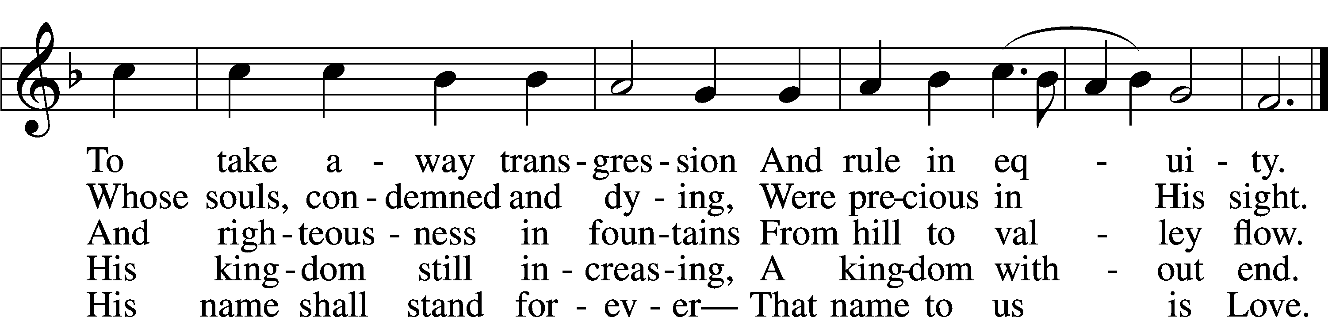

Text: James Montgomery, 1771–1854, alt. Tune: Leonhart Schröter, c. 1532–c. 1601 Text and tune: Public domain

# Confession and Absolution

Stand

The sign of the cross may be made by all in remembrance of their Baptism.

Invocation

P In the name of the Father and of the T Son and of the Holy Spirit.

C **Amen.**

Exhortation LSB 151

P If we say we have no sin, we deceive ourselves, and the truth is not in us.

C **But if we confess our sins, God, who is faithful and just, will forgive our sins and cleanse us from all unrighteousness.**

Silence for reflection on God’s Word and for self-examination.

Confession of Sins LSB 151

P Let us then confess our sins to God our Father.

C **Most merciful God, we confess that we are by nature sinful and unclean. We have sinned against You in thought, word, and deed, by what we have done and by what we have left undone. We have not loved You with our whole heart; we have not loved our neighbors as ourselves. We justly deserve Your present and eternal punishment. For the sake of Your Son, Jesus Christ, have mercy on us. Forgive us, renew us, and lead us, so that we may delight in Your will and walk in Your ways to the glory of Your holy name. Amen.**

Absolution LSB 151

P Almighty God in His mercy has given His Son to die for you and for His sake forgives you all your sins. As a called and ordained servant of Christ, and by His authority, I therefore forgive you all your sins in the name of the Father and of the T Son and of the Holy Spirit.

C **Amen.**

# Service of the Word

Introit Psalm 36:5–9; antiphon: Song of Solomon 2:4

[The Lord] brought me to the banqueting house,  
 **and his banner over me was love.**Your steadfast love, O Lord, extends to the heavens,  
 **your faithfulness to the clouds.**Your righteousness is like the mountains of God;  
 **your judgments are like the great deep; man and beast you save, O Lord.**How precious is your steadfast love, O God!  
 **The children of mankind take refuge in the shadow of your wings.**They feast on the abundance of your house,  
 **and you give them drink from the river of your delights.**For with you is the fountain of life;  
 **in your light do we see light.  
Glory be to the Father and to the Son**  
 **and to the Holy Spirit;**  
**as it was in the beginning,**  
 **is now, and will be forever. Amen.**  
[The Lord] brought me to the banqueting house,  
 **and his banner over me was love.**

Kyrie LSB 152



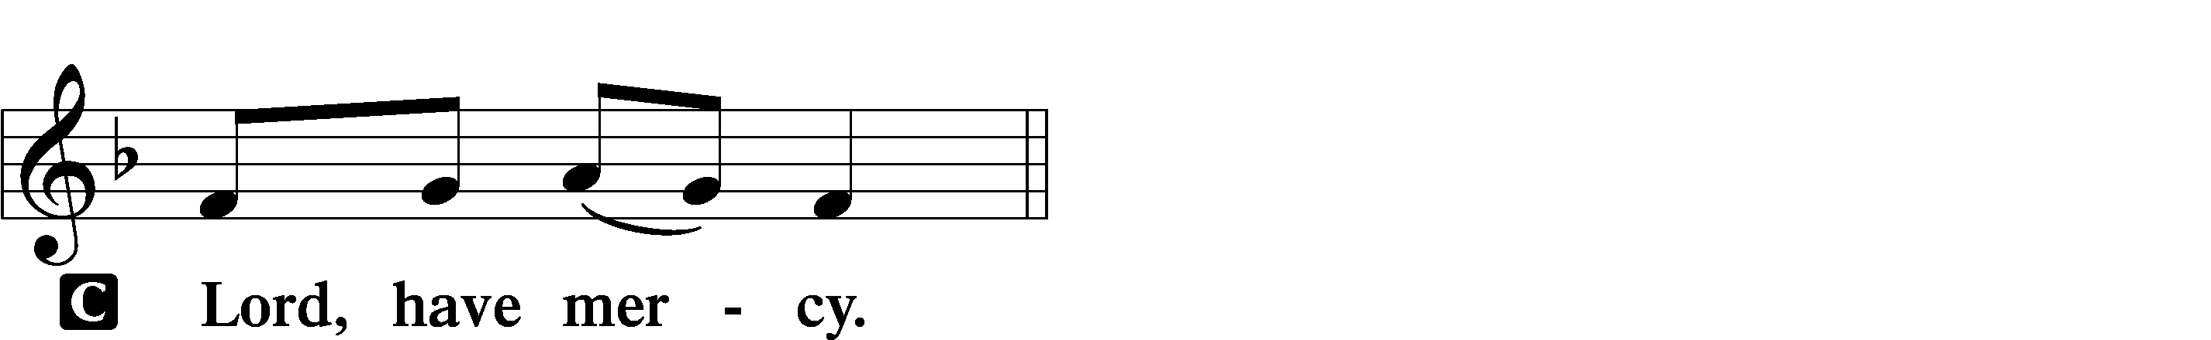

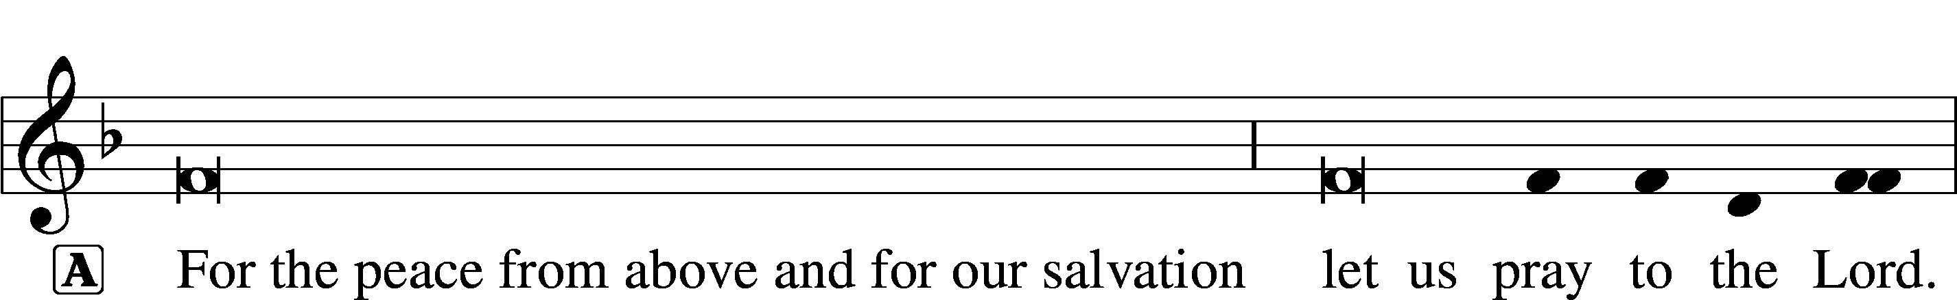

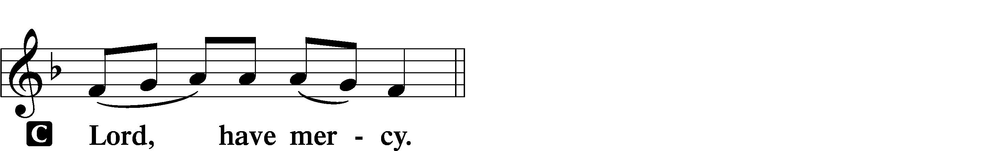

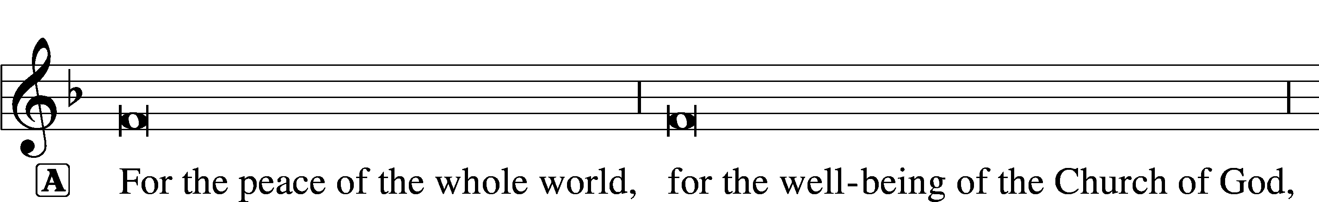

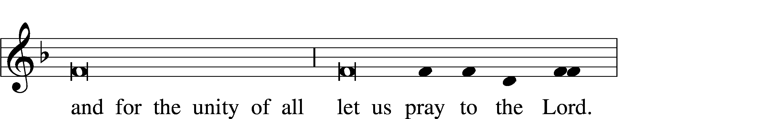

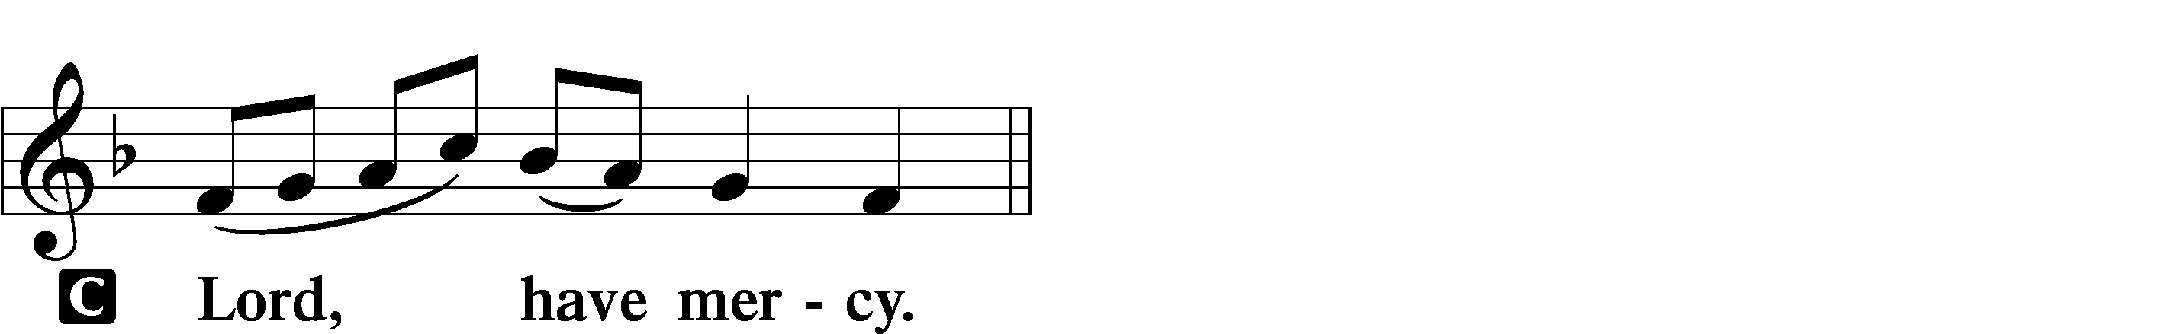

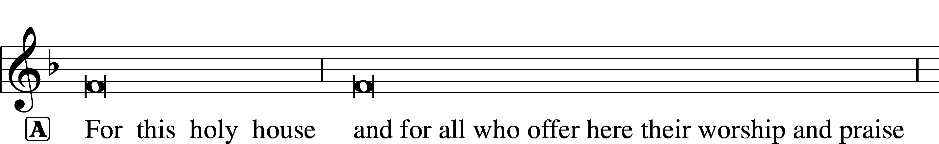



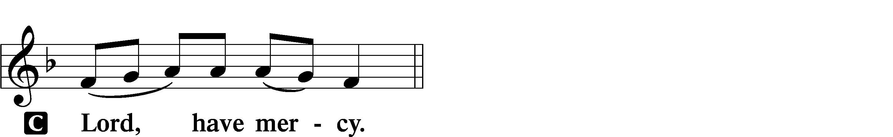





This Is the Feast LSB 155

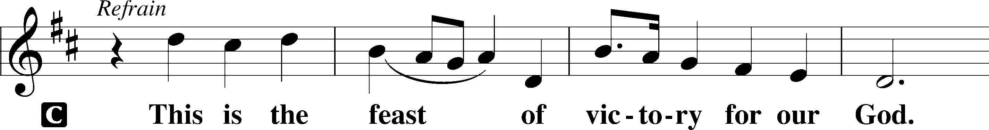

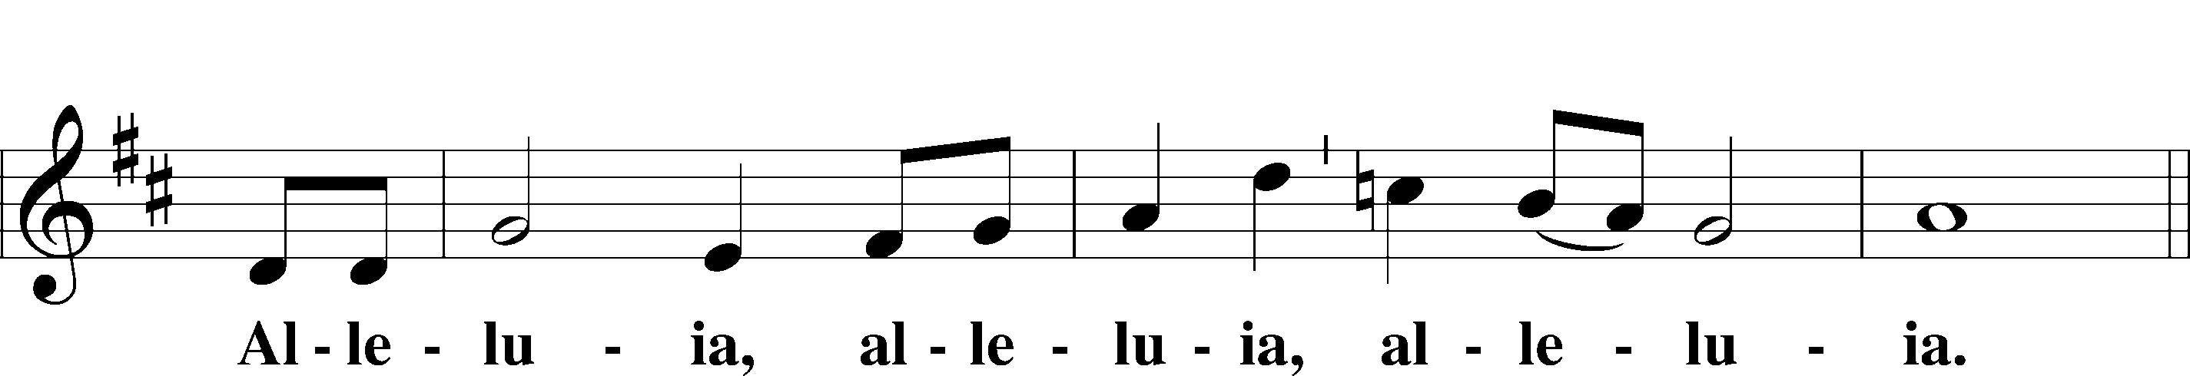

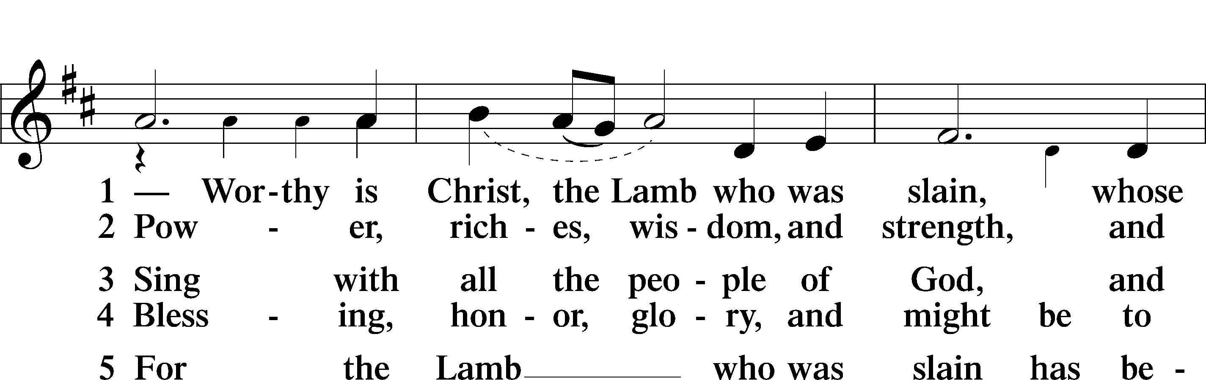

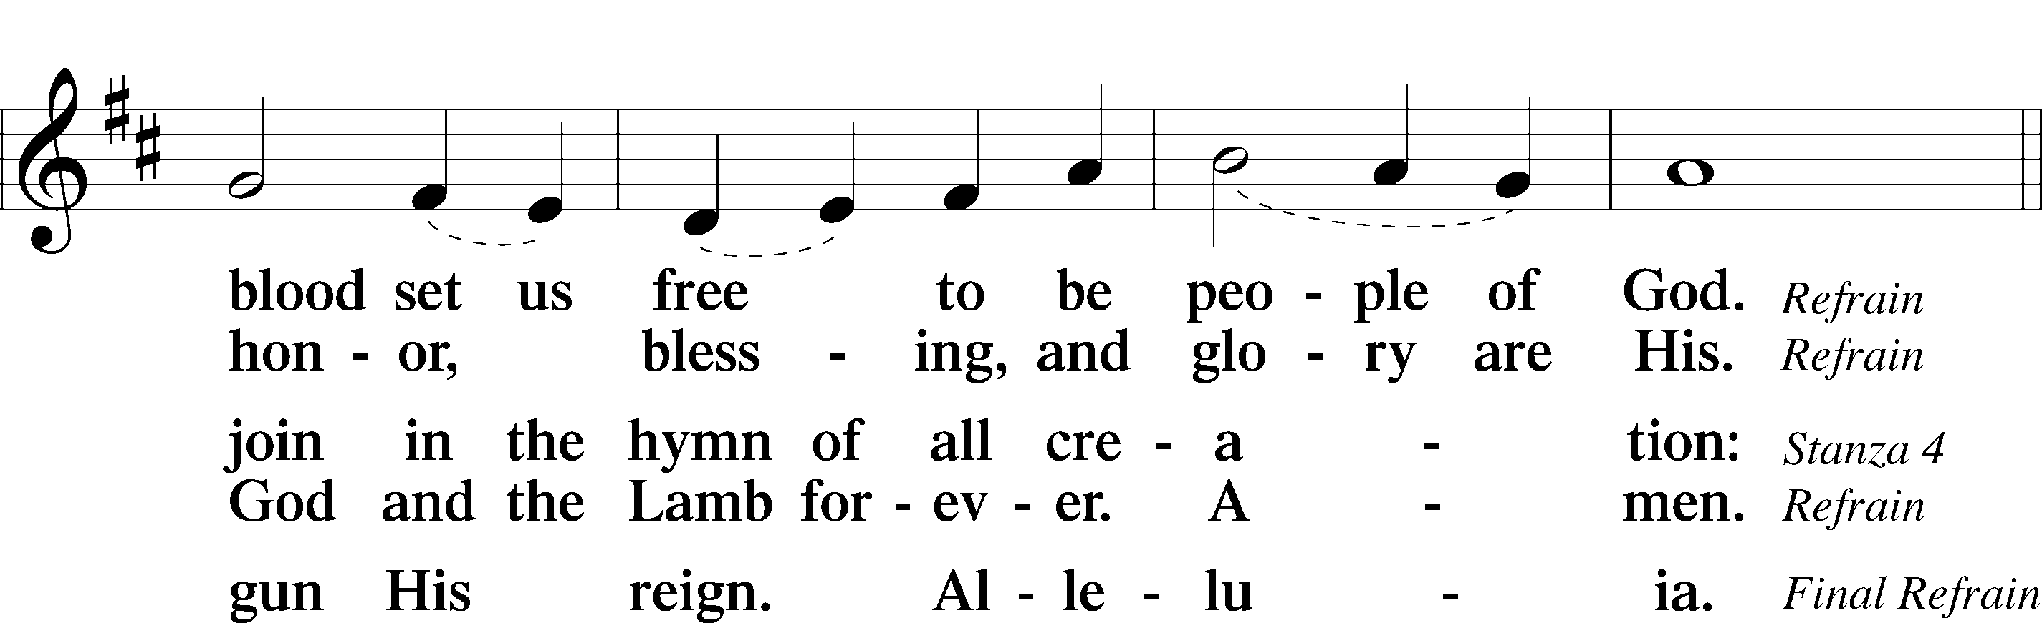

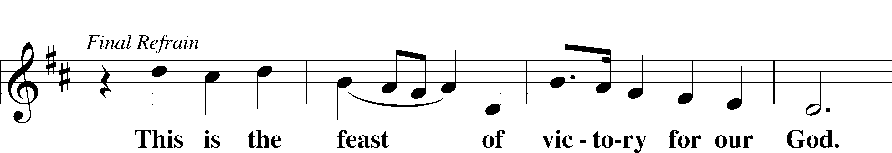

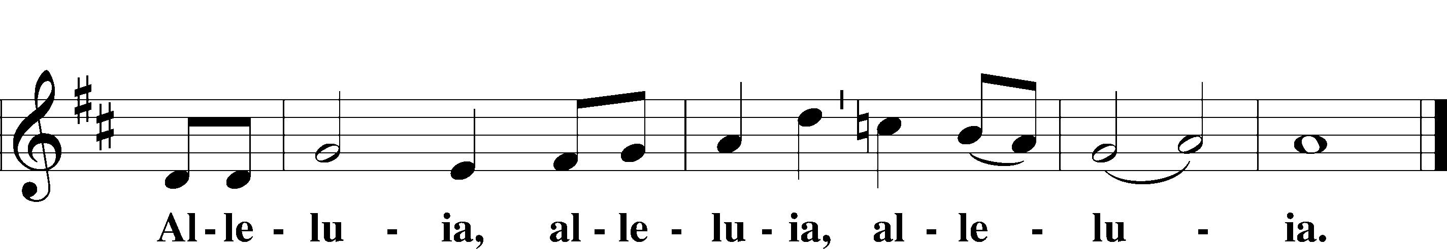

Salutation and Collect of the Day

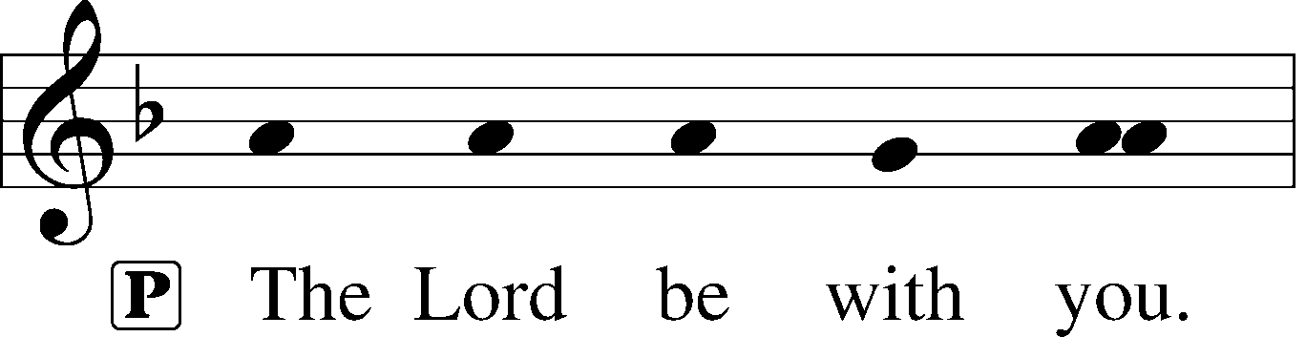

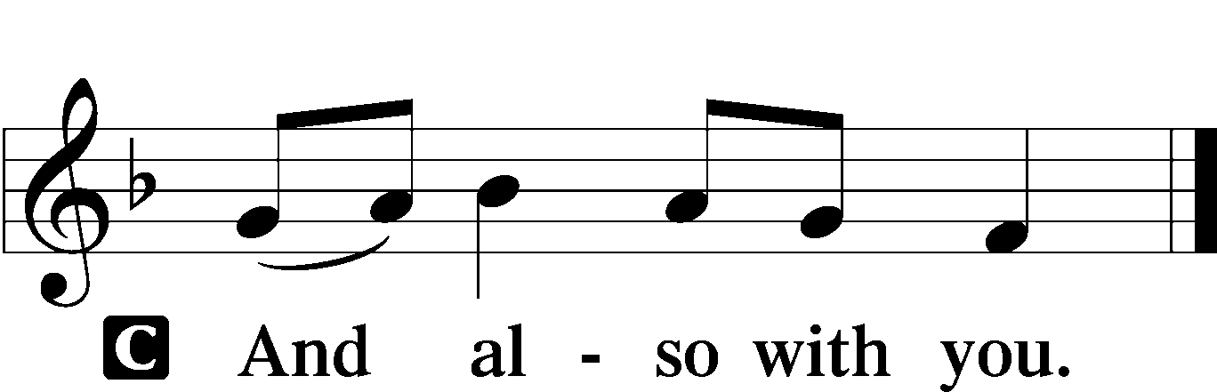

P Let us pray.

Almighty and everlasting God, who governs all things in heaven and on earth, mercifully hear the prayers of Your people and grant us Your peace through all our days; through Jesus Christ, Your Son, our Lord, who lives and reigns with You and the Holy Spirit, one God, now and forever.

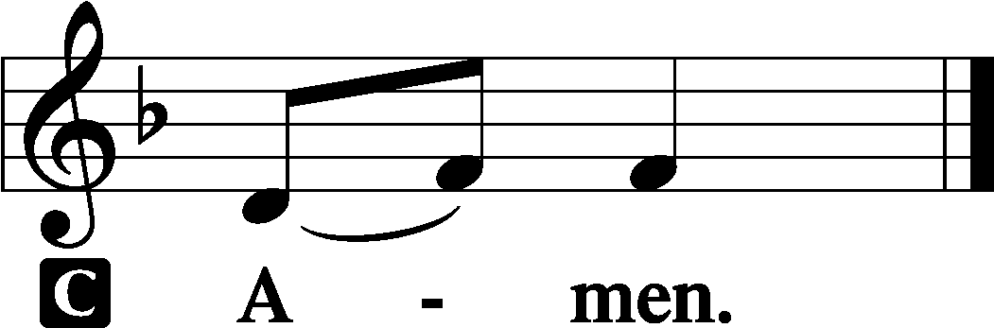

Sit

Old Testament Reading Isaiah 62:1–5

1For Zion’s sake I will not keep silent,  
 and for Jerusalem’s sake I will not be quiet,  
until her righteousness goes forth as brightness,  
 and her salvation as a burning torch.  
2The nations shall see your righteousness,  
 and all the kings your glory,  
and you shall be called by a new name  
 that the mouth of the Lord will give.  
3You shall be a crown of beauty in the hand of the Lord,  
 and a royal diadem in the hand of your God.  
4You shall no more be termed Forsaken,  
 and your land shall no more be termed Desolate,  
but you shall be called My Delight Is in Her,  
 and your land Married;  
for the Lord delights in you,  
 and your land shall be married.  
5For as a young man marries a young woman,  
 so shall your sons marry you,  
and as the bridegroom rejoices over the bride,  
 so shall your God rejoice over you.

A This is the Word of the Lord.

C **Thanks be to God.**

Epistle 1 Corinthians 12:1–11

1Now concerning spiritual gifts, brothers, I do not want you to be uninformed. 2You know that when you were pagans you were led astray to mute idols, however you were led. 3Therefore I want you to understand that no one speaking in the Spirit of God ever says “Jesus is accursed!” and no one can say “Jesus is Lord” except in the Holy Spirit.

4Now there are varieties of gifts, but the same Spirit; 5and there are varieties of service, but the same Lord; 6and there are varieties of activities, but it is the same God who empowers them all in everyone. 7To each is given the manifestation of the Spirit for the common good. 8To one is given through the Spirit the utterance of wisdom, and to another the utterance of knowledge according to the same Spirit, 9to another faith by the same Spirit, to another gifts of healing by the one Spirit, 10to another the working of miracles, to another prophecy, to another the ability to distinguish between spirits, to another various kinds of tongues, to another the interpretation of tongues. 11All these are empowered by one and the same Spirit, who apportions to each one individually as he wills.

A This is the Word of the Lord.

C **Thanks be to God.**

Come Holy Spirit, Creator Blest (Bedford) Choir

*Stand*

Holy Gospel John 2:1–11

P The Holy Gospel according to St. John, the second chapter.

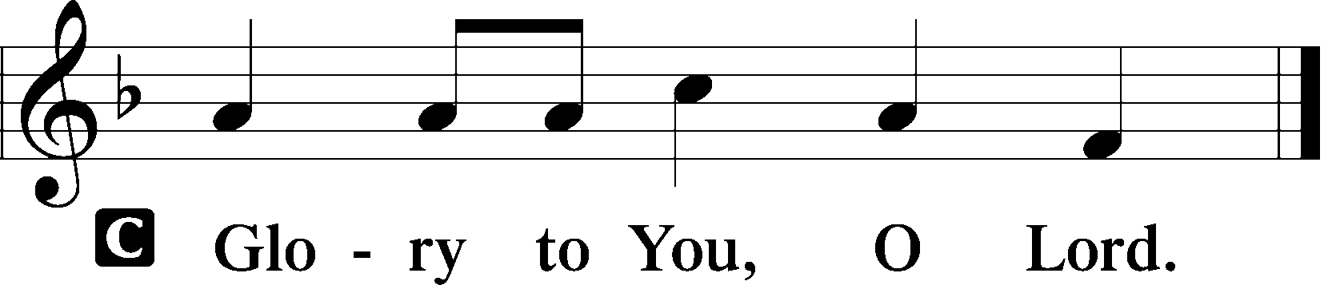

1On the third day there was a wedding at Cana in Galilee, and the mother of Jesus was there. 2Jesus also was invited to the wedding with his disciples. 3When the wine ran out, the mother of Jesus said to him, “They have no wine.” 4And Jesus said to her, “Woman, what does this have to do with me? My hour has not yet come.” 5His mother said to the servants, “Do whatever he tells you.”

6Now there were six stone water jars there for the Jewish rites of purification, each holding twenty or thirty gallons. 7Jesus said to the servants, “Fill the jars with water.” And they filled them up to the brim. 8And he said to them, “Now draw some out and take it to the master of the feast.” So they took it. 9When the master of the feast tasted the water now become wine, and did not know where it came from (though the servants who had drawn the water knew), the master of the feast called the bridegroom 10and said to him, “Everyone serves the good wine first, and when people have drunk freely, then the poor wine. But you have kept the good wine until now.” 11This, the first of his signs, Jesus did at Cana in Galilee, and manifested his glory. And his disciples believed in him.

P This is the Gospel of the Lord.

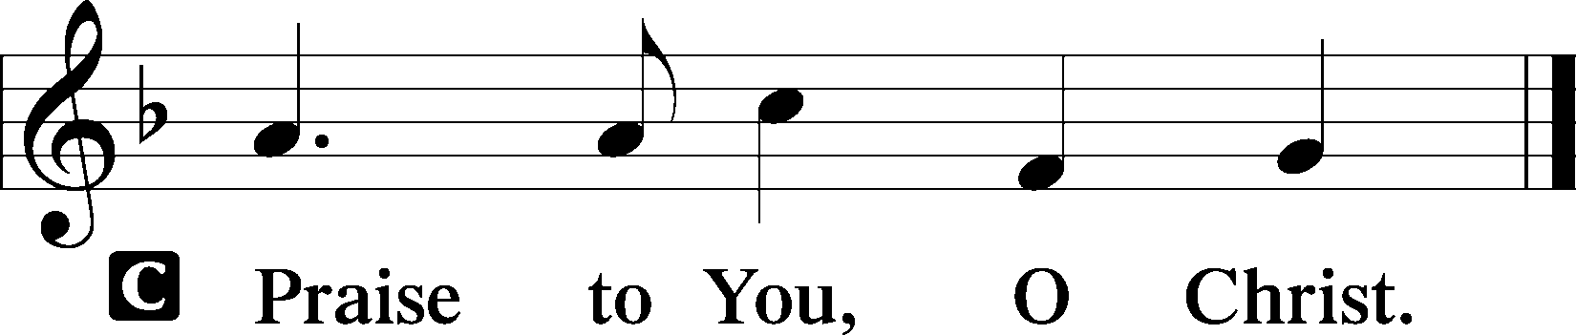

Nicene Creed

C **I believe in one God, the Father Almighty, maker of heaven and earth and of all things visible and invisible.**

**And in one Lord Jesus Christ, the only-begotten Son of God, begotten of His Father before all worlds, God of God, Light of Light, very God of very God, begotten, not made, being of one substance with the Father, by whom all things were made; who for us men and for our salvation came down from heaven and was incarnate by the Holy Spirit of the virgin Mary and was made man; and was crucified also for us under Pontius Pilate. He suffered and was buried. And the third day He rose again according to the Scriptures and ascended into heaven and sits at the right hand of the Father. And He will come again with glory to judge both the living and the dead, whose kingdom will have no end.**

**And I believe in the Holy Spirit, the Lord and giver of life, who proceeds from the Father and the Son, who with the Father and the Son together is worshiped and glorified, who spoke by the prophets. And I believe in one holy Christian and apostolic Church, I acknowledge one Baptism for the remission of sins, and I look for the resurrection of the dead and the life** T **of the world to come. Amen.**

Sit

408 Come, Join in Cana’s Feast

*Stand for Stanza 5*

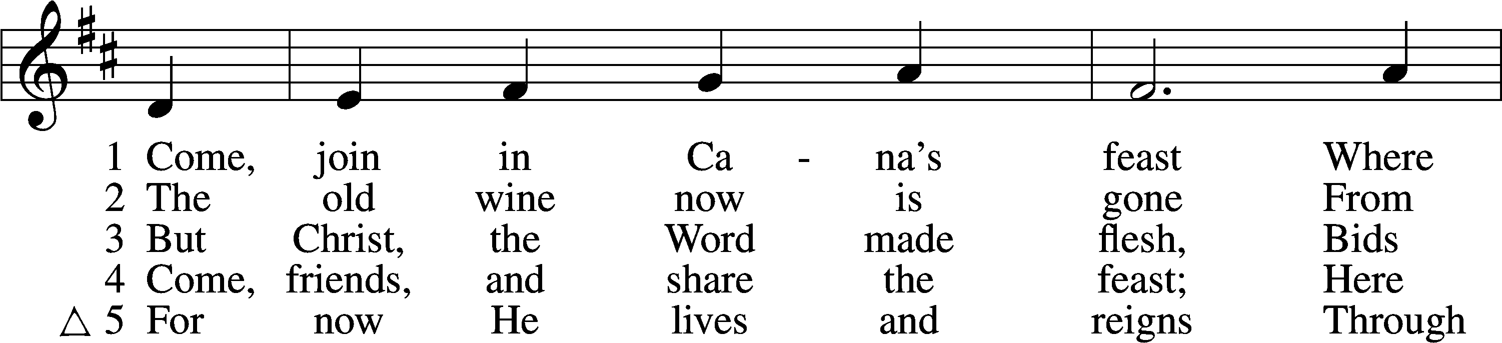

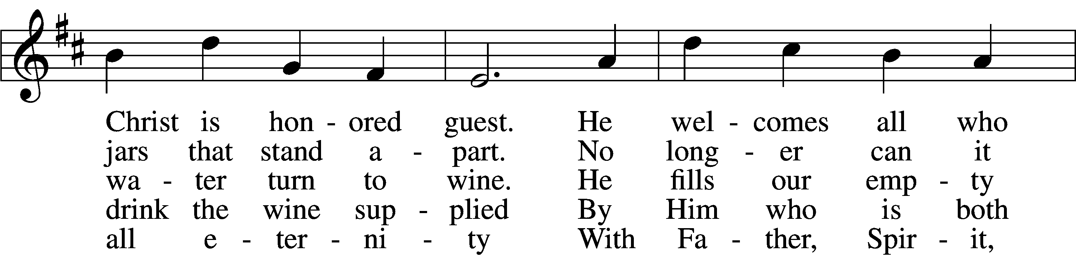

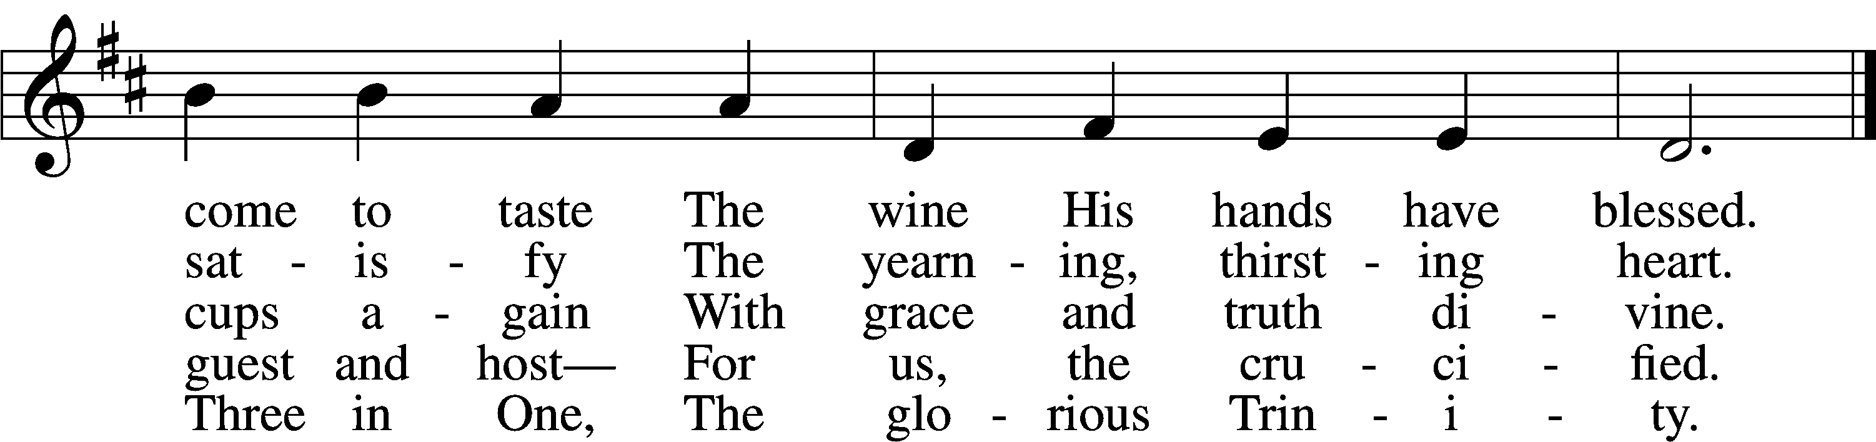

Text: Herman G. Stuempfle, Jr., 1923–2007 Tune: Johann Balthasar König, 1691–1758; adapt. William H. Havergal, 1793–1870 Text: © 1993 The Hymn Society, admin. Hope Publishing Co. Used by permission: LSB Hymn License no. 110004388 Tune: Public domain

*Sit*

Sermon: “The Hour Is Coming” *John 2:1-11*

Offering

Stand

Offertory LSB 159

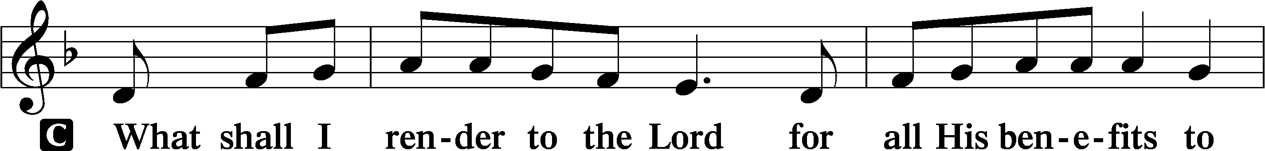

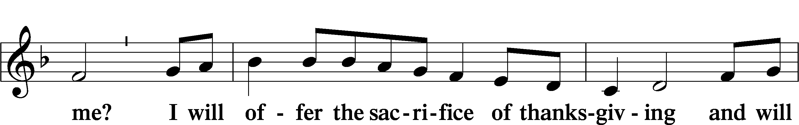

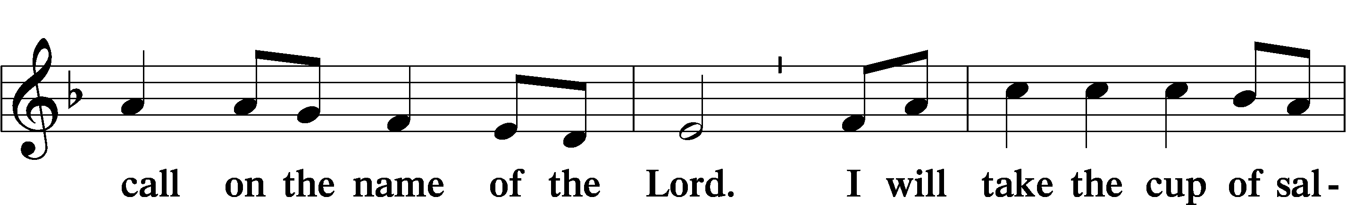

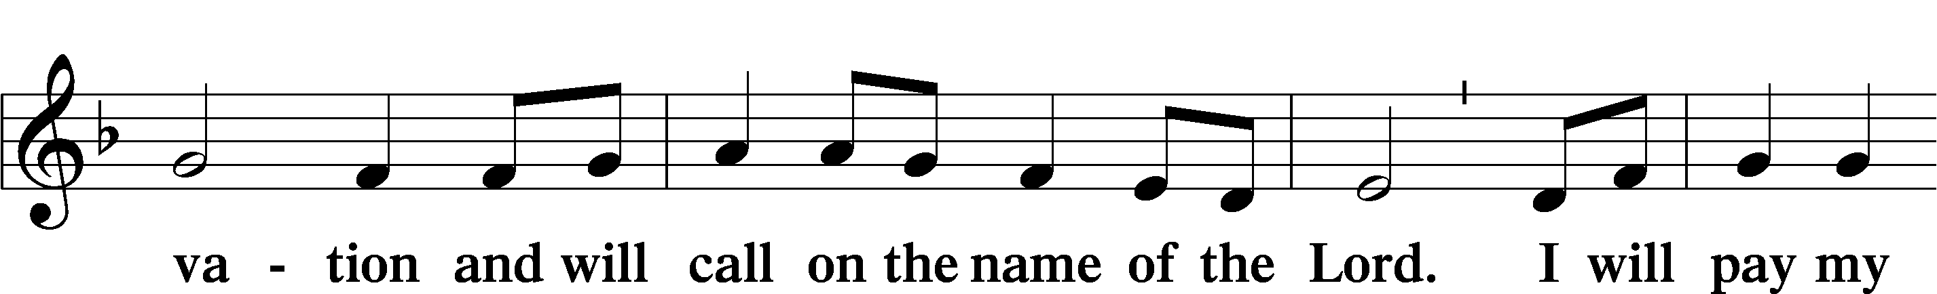

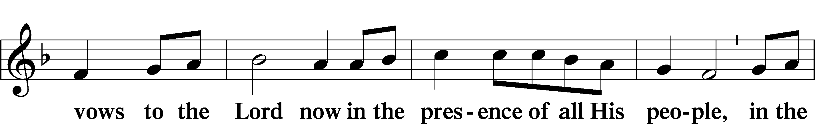

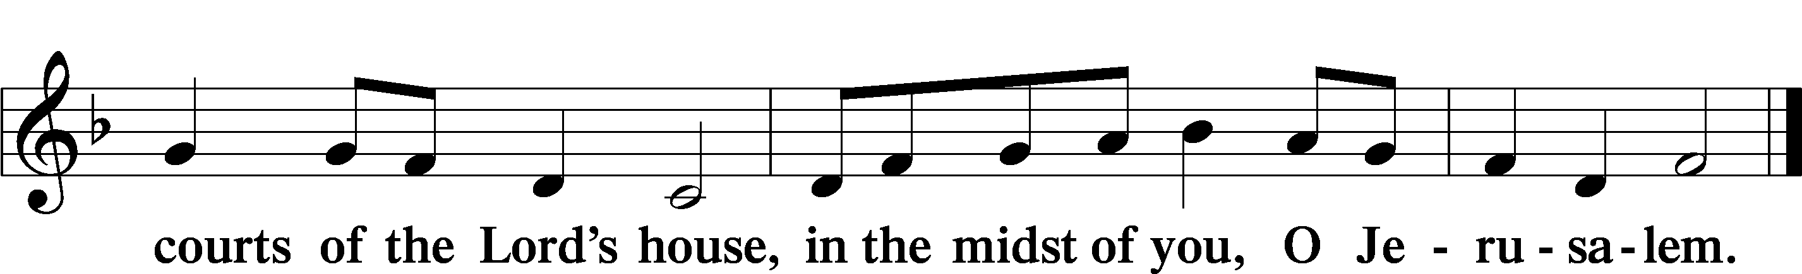

Prayer of the Church

# Service of the Sacrament

Preface LSB 160

P The Lord be with you.



P Lift up your hearts.



P Let us give thanks to the Lord our God.

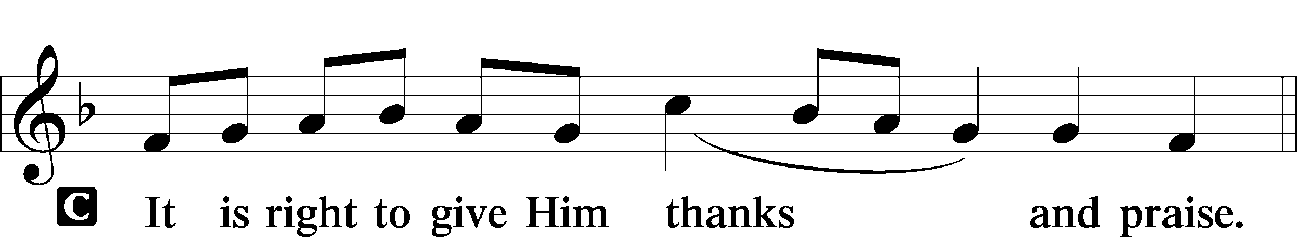

Proper Preface

P It is truly good, right, and salutary that we should at all times and in all places give thanks to You, holy Lord, almighty Father, everlasting God, through Jesus Christ, our Lord; for what had been hidden from before the foundation of the world You have made known to the nations in Your Son. In Him, being found in the substance of our mortal nature, You have manifested the fullness of Your glory. Therefore with angels and archangels and with all the company of heaven we laud and magnify Your glorious name, evermore praising You and saying:

Sanctus LSB 161

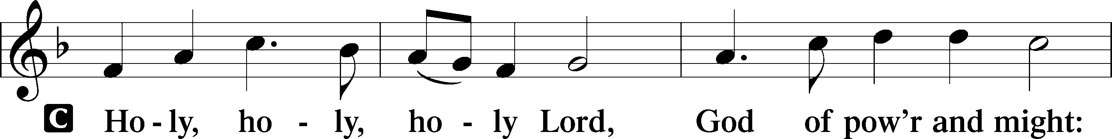

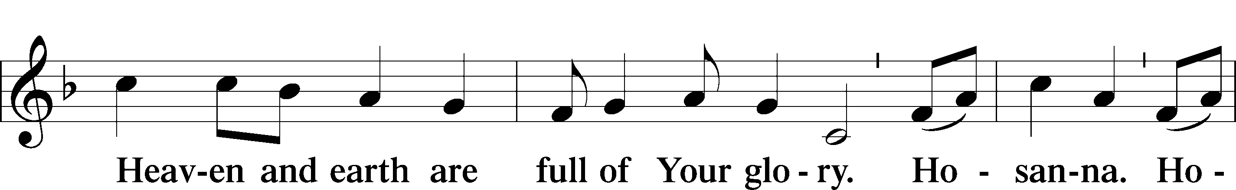

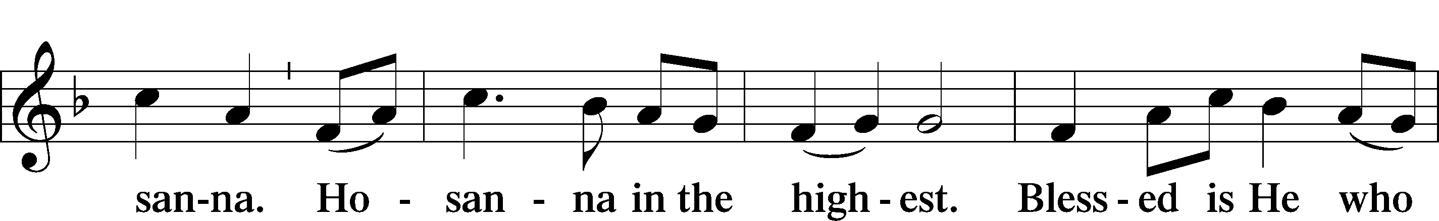

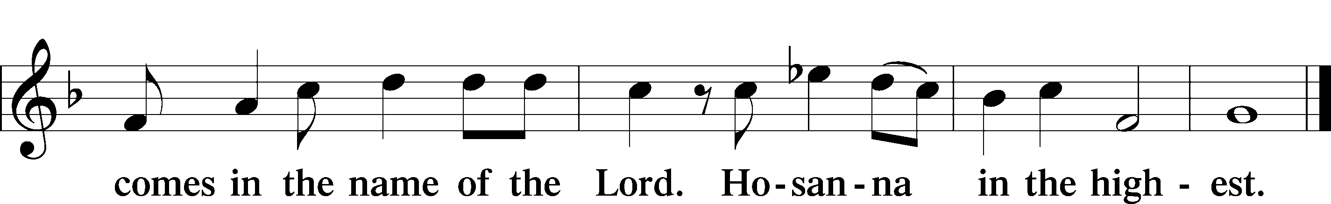

Prayer of Thanksgiving LSB 161

P Blessed are You, Lord of heaven and earth, for You have had mercy on those whom You created and sent Your only-begotten Son into our flesh to bear our sin and be our Savior. With repentant joy we receive the salvation accomplished for us by the all-availing sacrifice of His body and His blood on the cross.

Gathered in the name and the remembrance of Jesus, we beg You, O Lord, to forgive, renew, and strengthen us with Your Word and Spirit. Grant us faithfully to eat His body and drink His blood as He bids us do in His own testament. Gather us together, we pray, from the ends of the earth to celebrate with all the faithful the marriage feast of the Lamb in His kingdom, which has no end. Graciously receive our prayers; deliver and preserve us. To You alone, O Father, be all glory, honor, and worship, with the Son and the Holy Spirit, one God, now and forever.

C **Amen.**

The Words of Our Lord

P Our Lord Jesus Christ, on the night when He was betrayed, took bread, and when He had given thanks, He broke it and gave it to the disciples and said: “Take, eat; this is My T body, which is given for you. This do in remembrance of Me.”

In the same way also He took the cup after supper, and when He had given thanks, He gave it to them, saying: “Drink of it, all of you; this cup is the new testament in My T blood, which is shed for you for the forgiveness of sins. This do, as often as you drink it, in remembrance of Me.”

P As often as we eat this bread and drink this cup, we proclaim the Lord’s death until He comes.

C **Amen. Come, Lord Jesus.**

P O Lord Jesus Christ, only Son of the Father, in giving us Your body and blood to eat and to drink, You lead us to remember and confess Your holy cross and passion, Your blessed death, Your rest in the tomb, Your resurrection from the dead, Your ascension into heaven, and Your coming for the final judgment. So remember us in Your kingdom and teach us to pray:

Lord’s Prayer

C **Our Father who art in heaven, hallowed be Thy name, Thy kingdom come, Thy will be done on earth as it is in heaven; give us this day our daily bread; and forgive us our trespasses as we forgive those who trespass against us; and lead us not into temptation, but deliver us from evil. For Thine is the kingdom and the power and the glory forever and ever. Amen.**

Pax Domini LSB 163

P The peace of the Lord be with you always.



Agnus Dei LSB 163

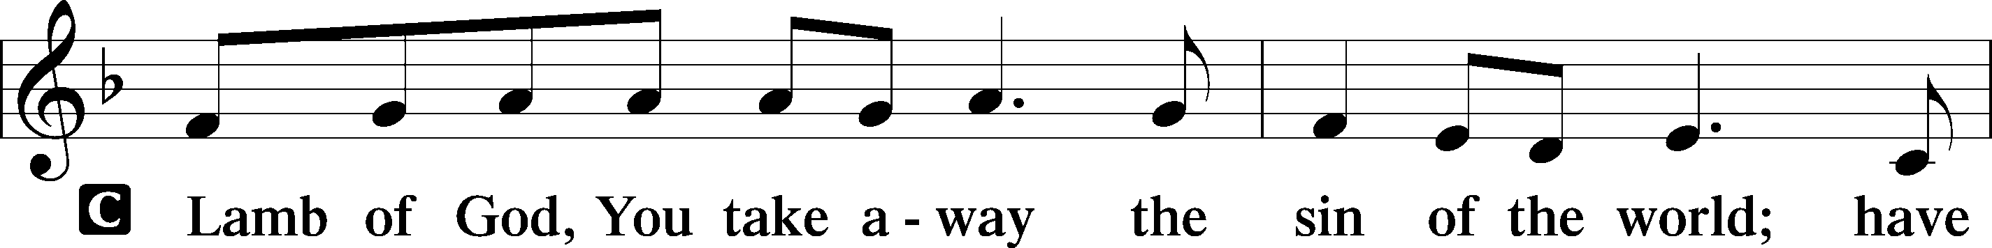

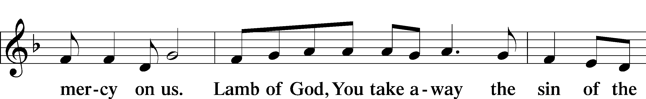

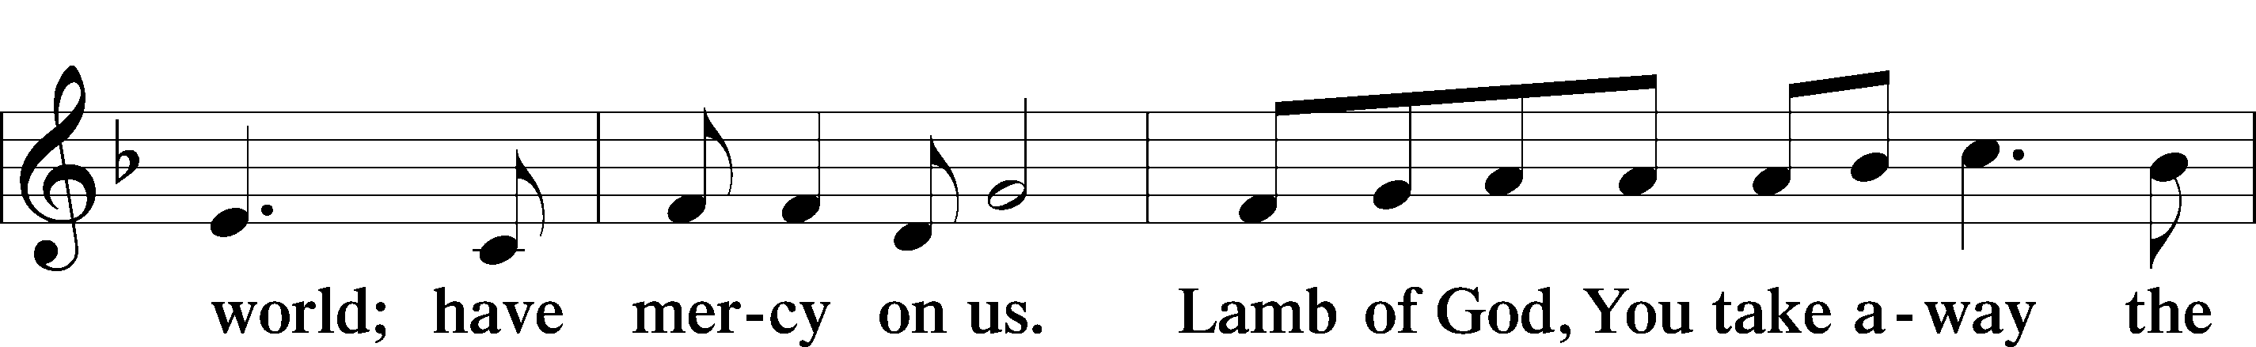

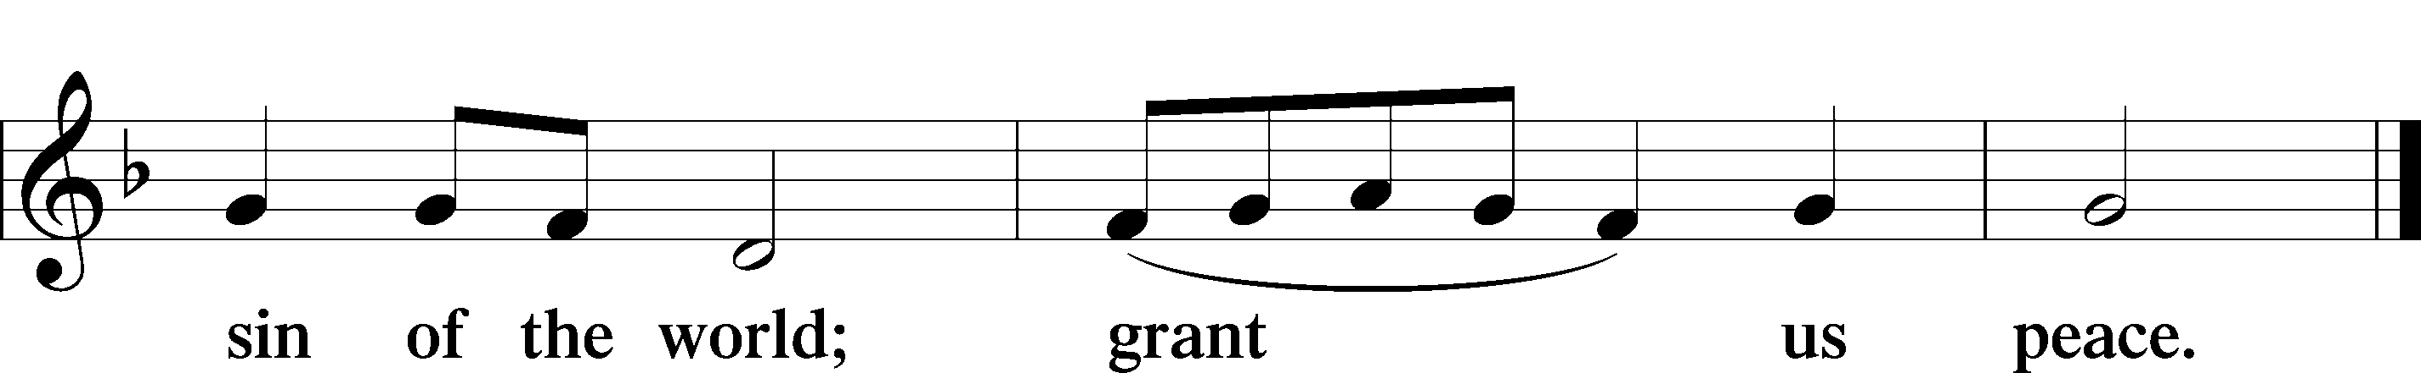

Sit

Distribution

404 Jesus, Once with Sinners Numbered

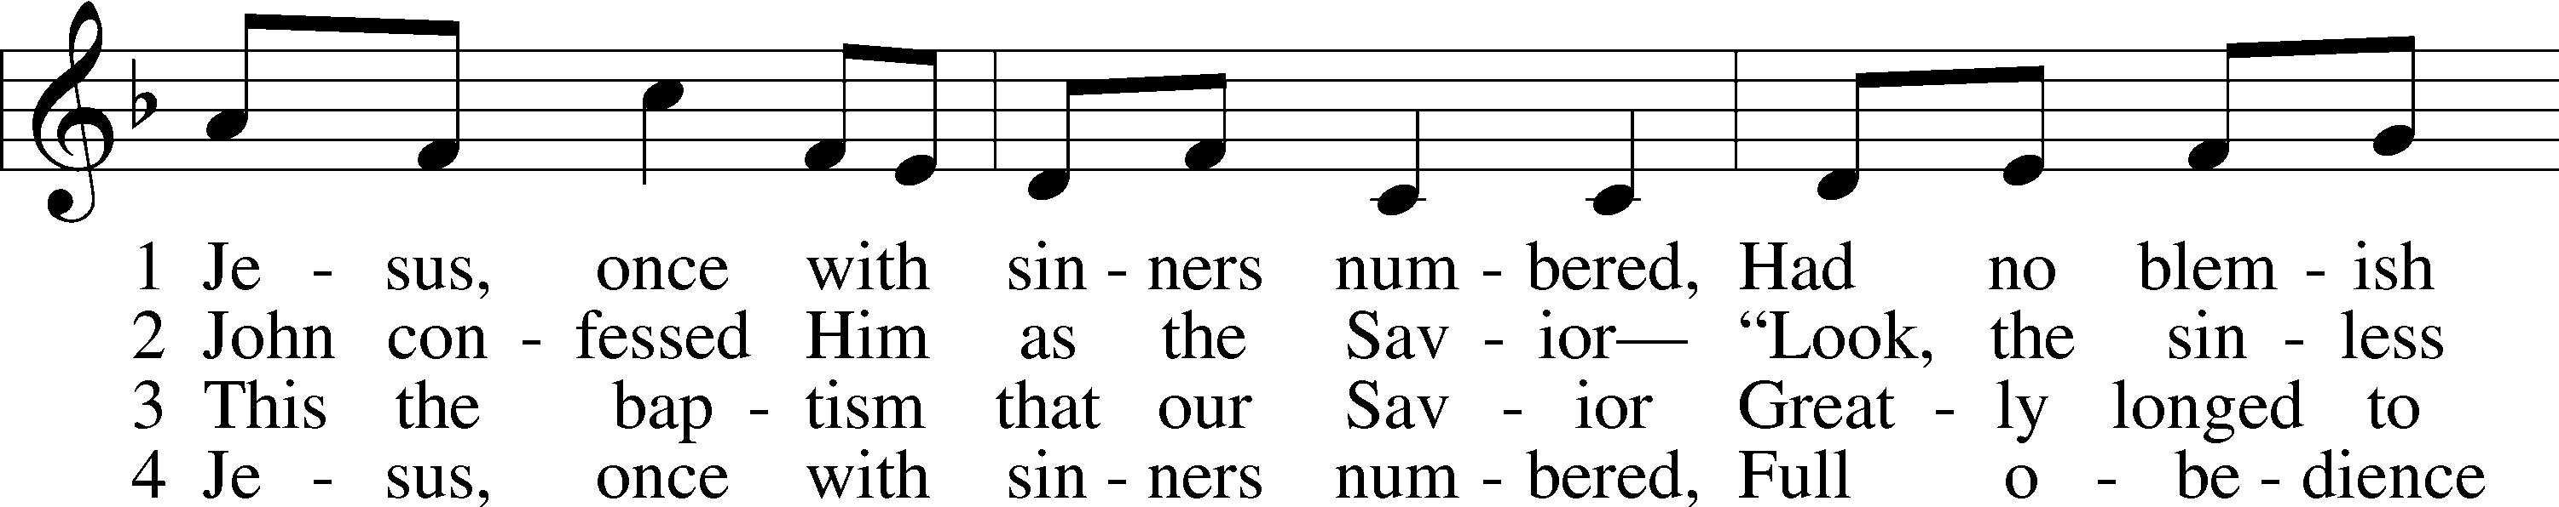

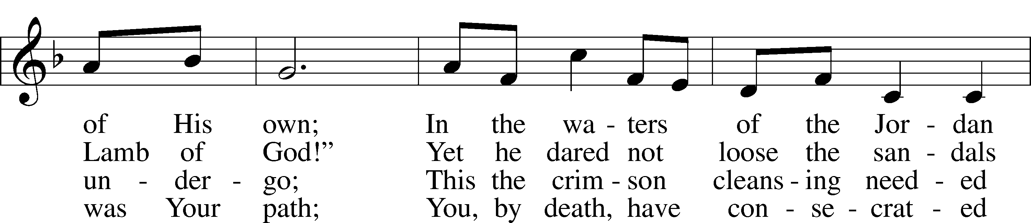

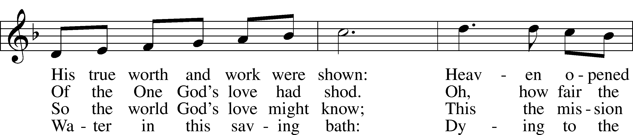

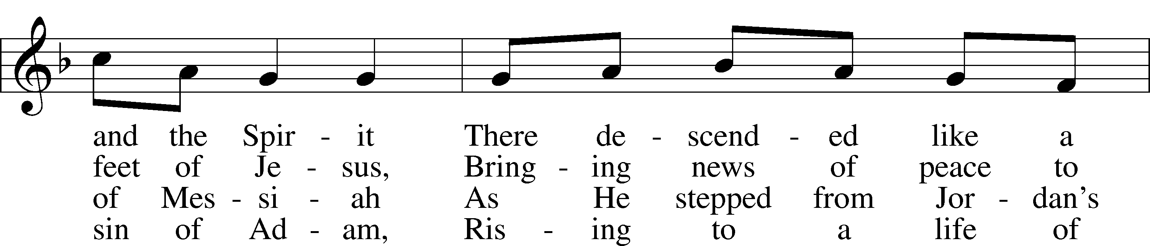

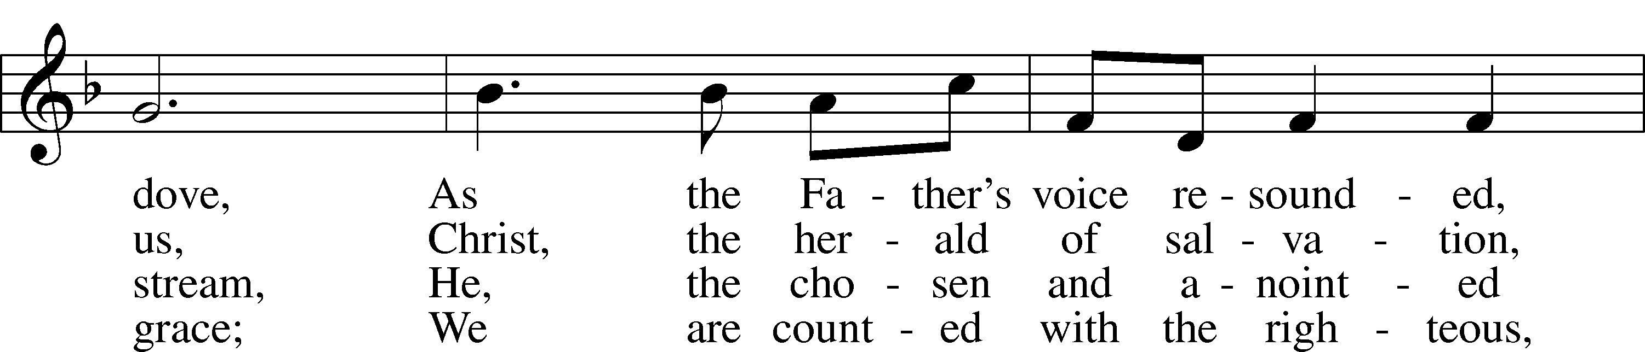

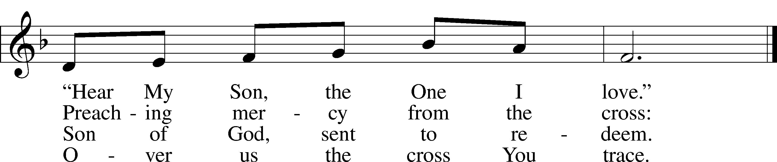

Text: Stephen P. Starke, 1955  
Tune: William B. Roberts, 1947  
Text: © 1999 Stephen P. Starke, admin. Concordia Publishing House. Used by permission: LSB Hymn License no. 110004388  
Tune: © 1995 Augsburg Fortress. Used by permission: LSB Hymn License no. 110004388

523 O Word of God Incarnate

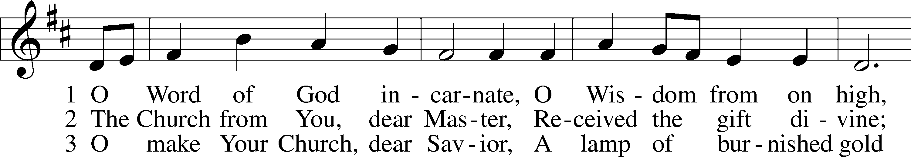

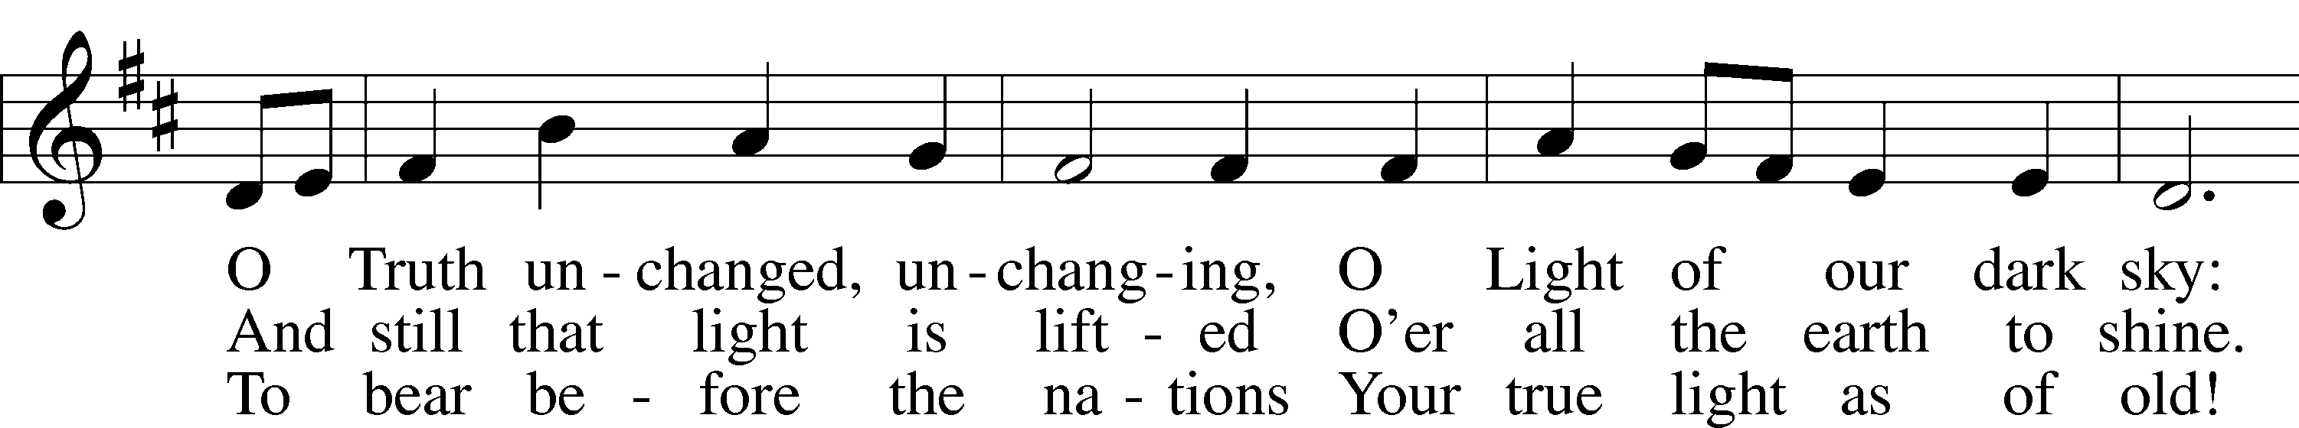

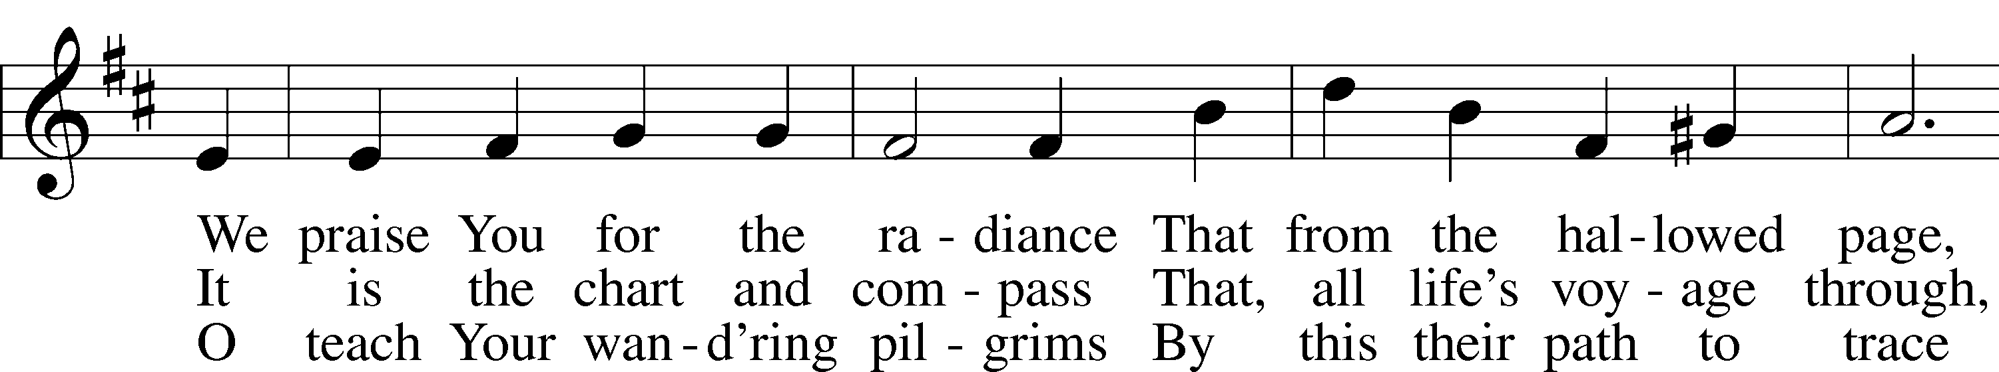

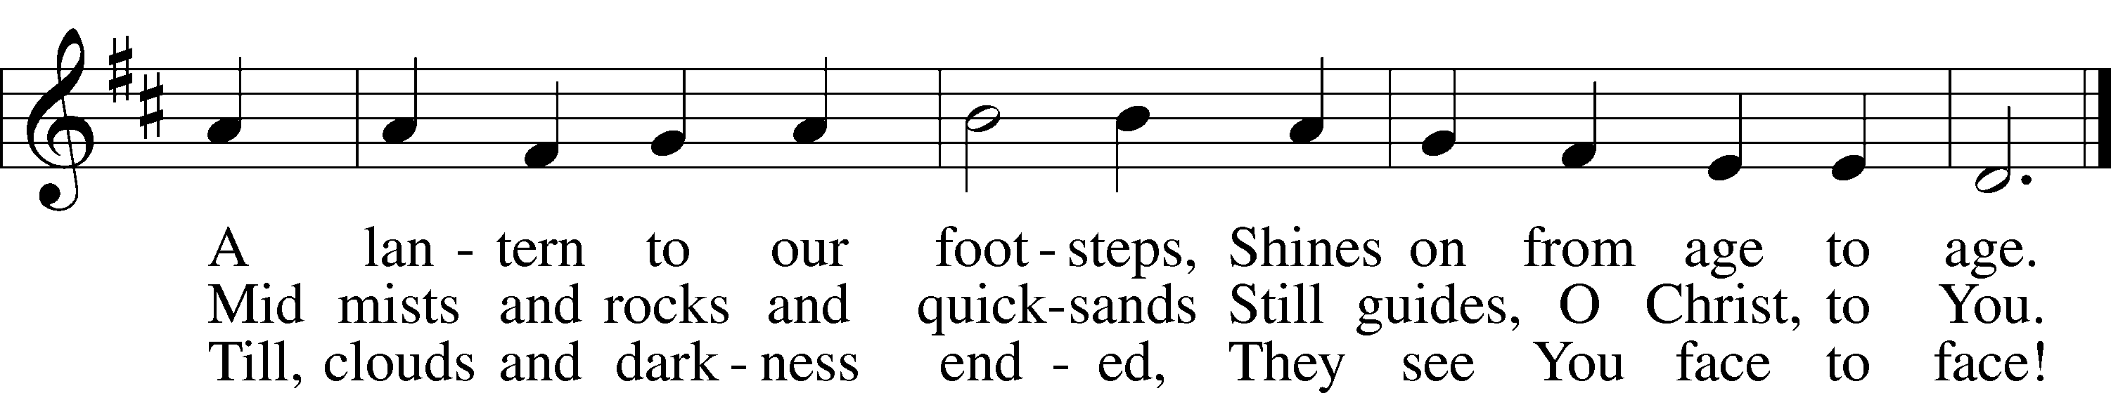

Text: William W. How, 1823–97, alt.  
Tune: Neu-vermehrtes . . . Gesangbuch, 1693, 3rd ed., Meiningen  
Text and tune: Public domain

620 Jesus Comes Today with Healing

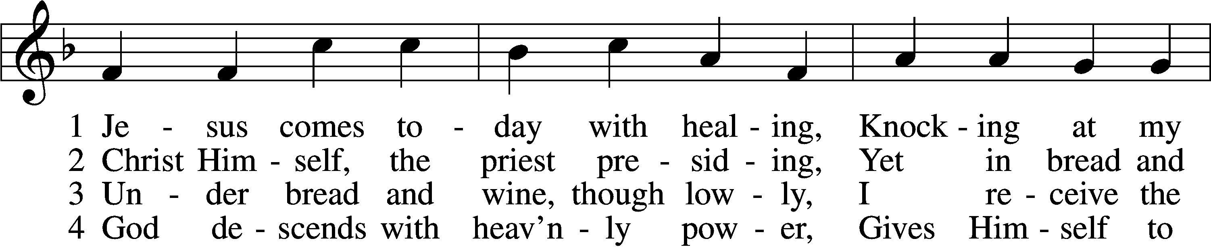

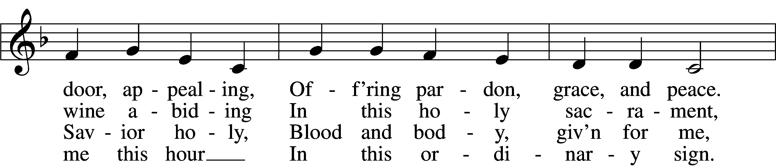

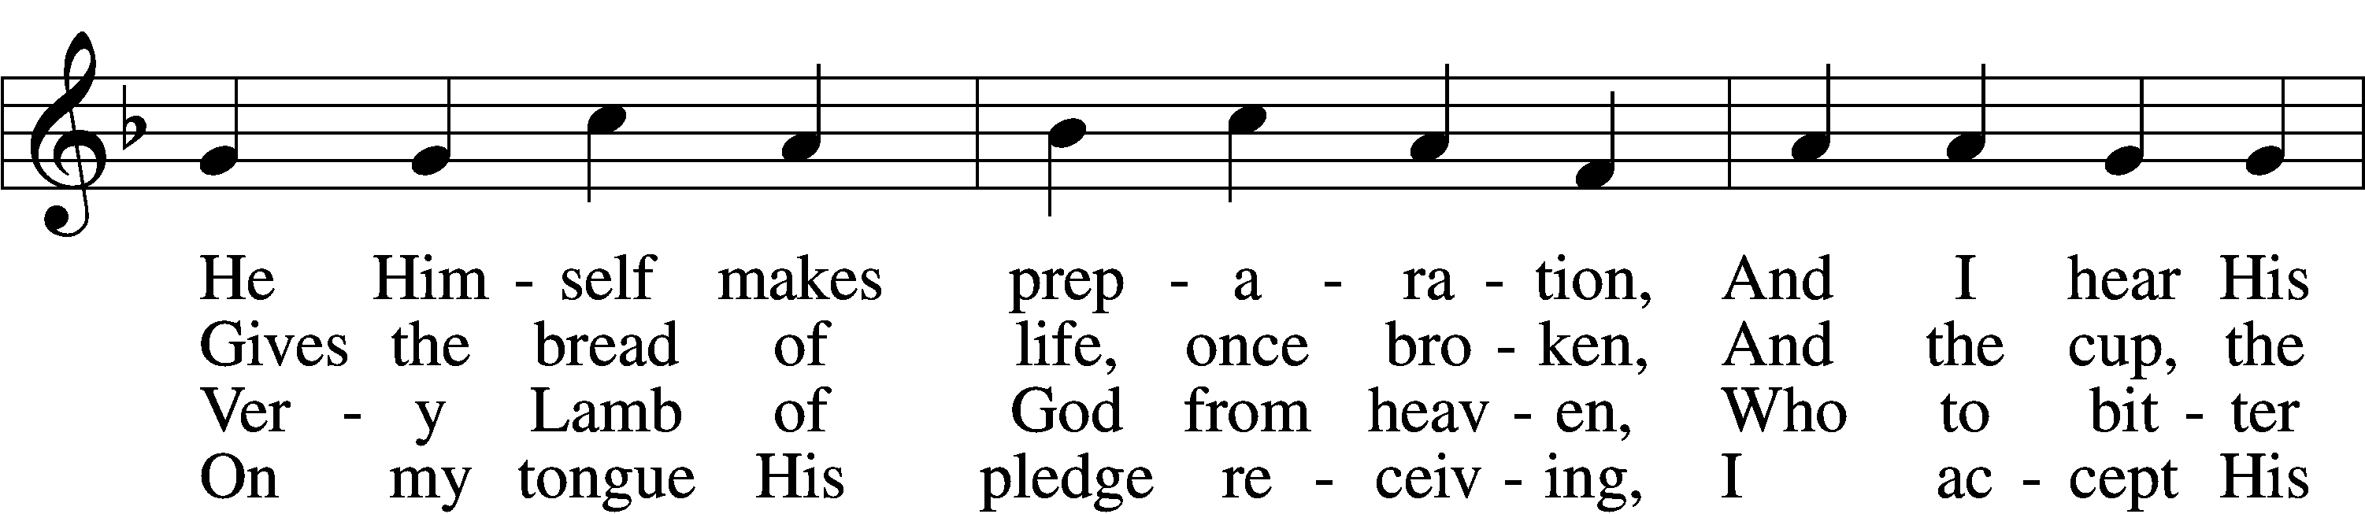

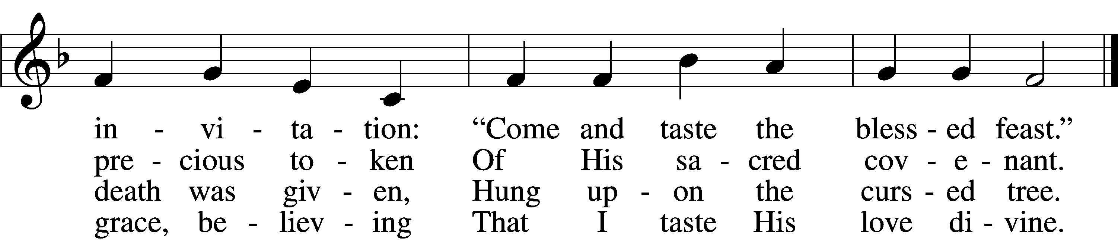

5 Let me praise God’s boundless favor,  
Whose own feast of love I savor,  
 Bidden by His gracious call.  
Wedding garments He provides me,  
With a robe of white He hides me,  
 Fits me for the royal hall.

6 Now have I found consolation,  
Comfort in my tribulation,  
 Balm to heal the troubled soul.  
God, my shield from ev’ry terror,  
Cleanses me from sin and error,  
 Makes my wounded spirit whole.

Text: Heinrich Puchta, 1808–58; tr. David W. Rogner, 1960  
Tune: Johann Löhner, 1645–1705; adapt. Johann Balthasar König, 1691–1758  
Text: © David W. Rogner. Used by permission: LSB Hymn License no. 110004388  
Tune: Public domain

Stand

Thank the Lord LSB 164

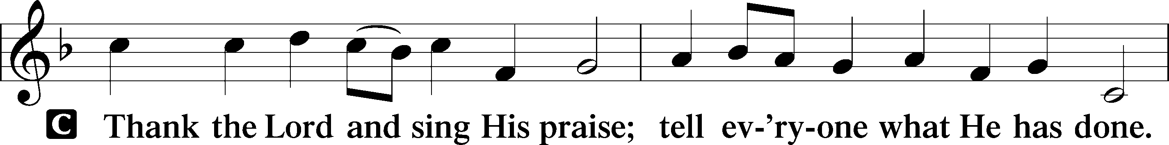

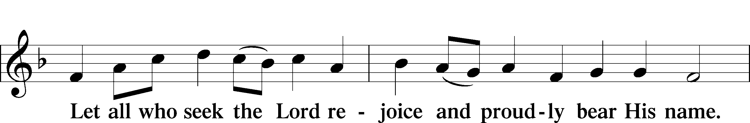

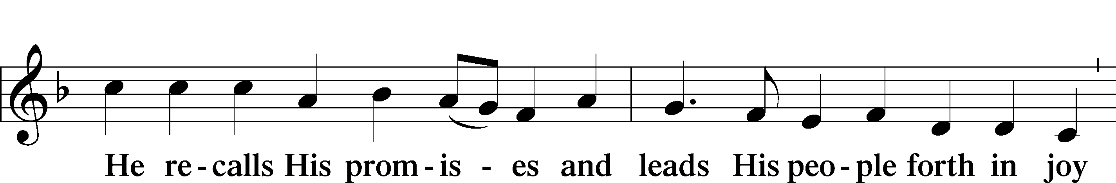

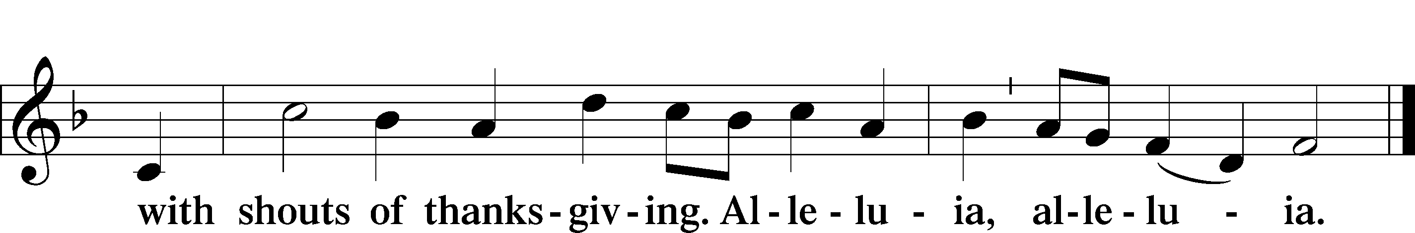

Post-Communion Collect

A Let us pray.

We give thanks to You, almighty God, that You have refreshed us through this salutary gift, and we implore You that of Your mercy You would strengthen us through the same in faith toward You and in fervent love toward one another; through Jesus Christ, Your Son, our Lord, who lives and reigns with You and the Holy Spirit, one God, now and forever.



Benediction LSB 166

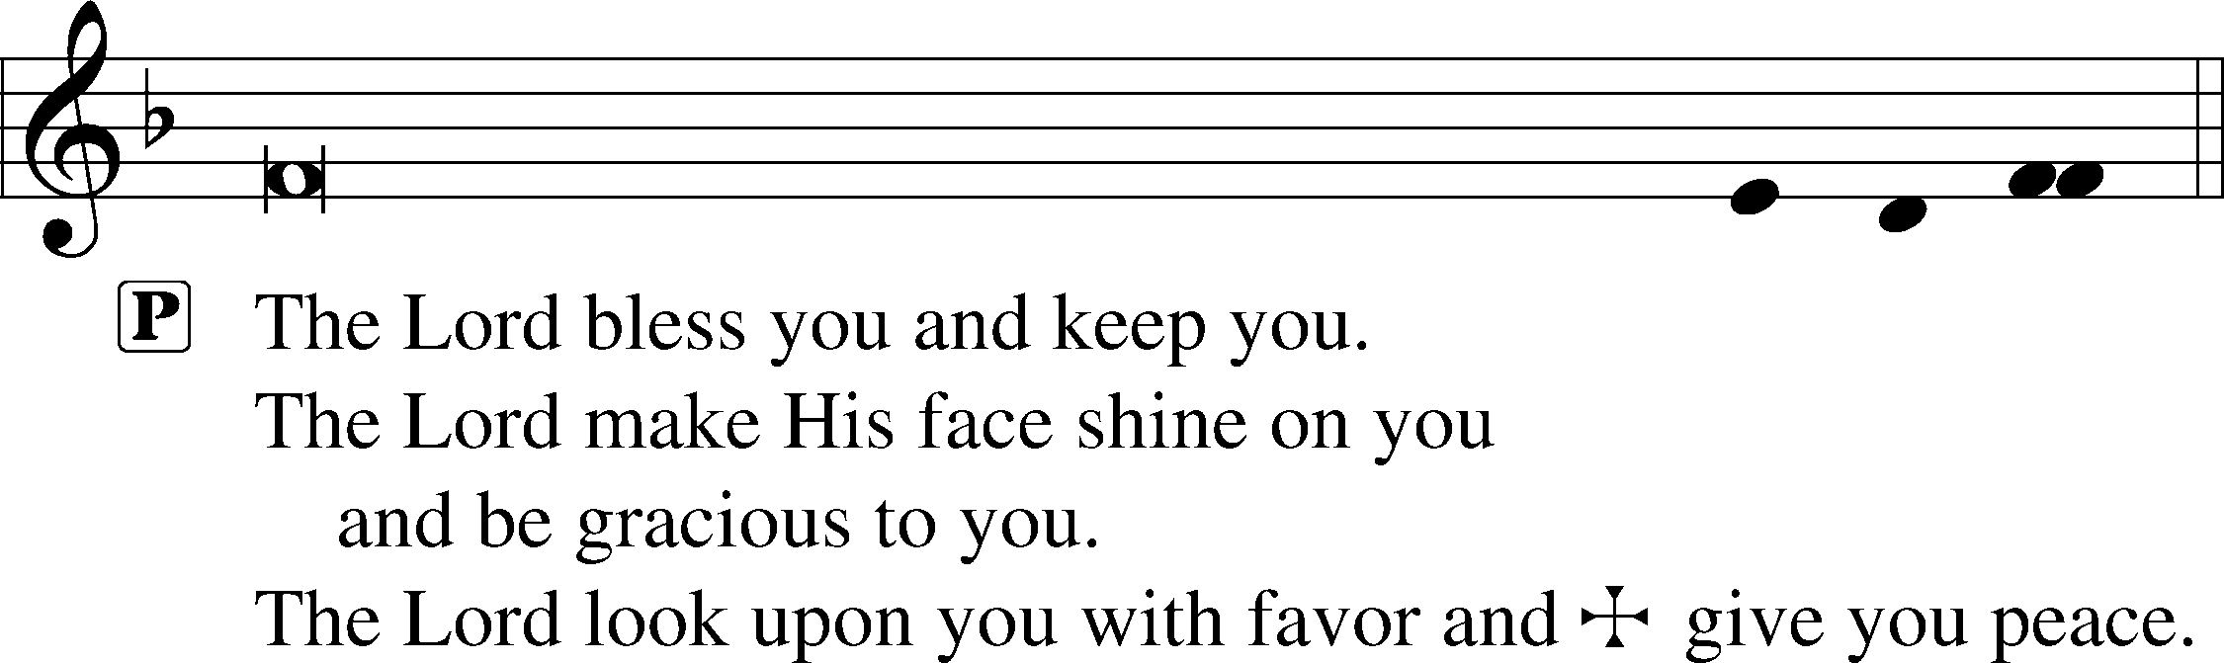



403 O Savior of Our Fallen Race sts. 1–5

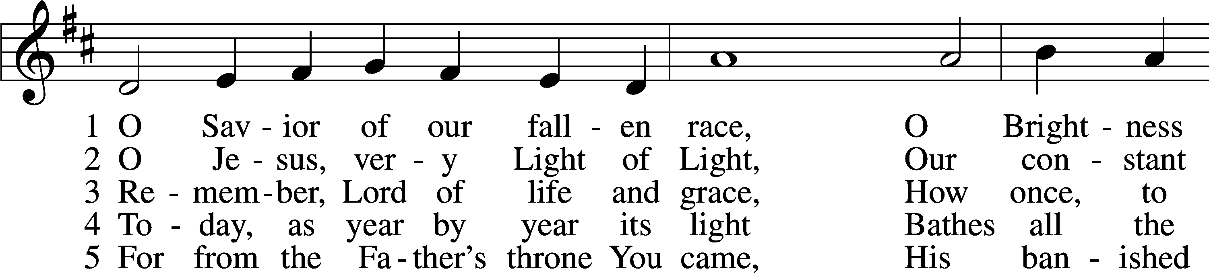

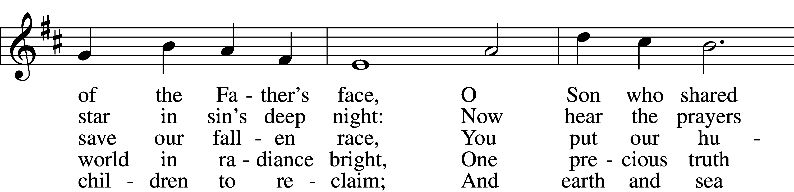

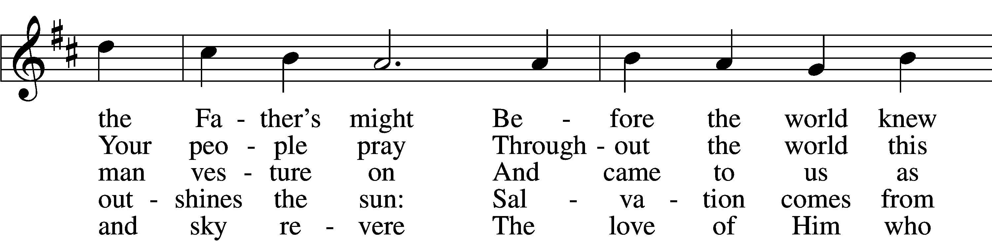

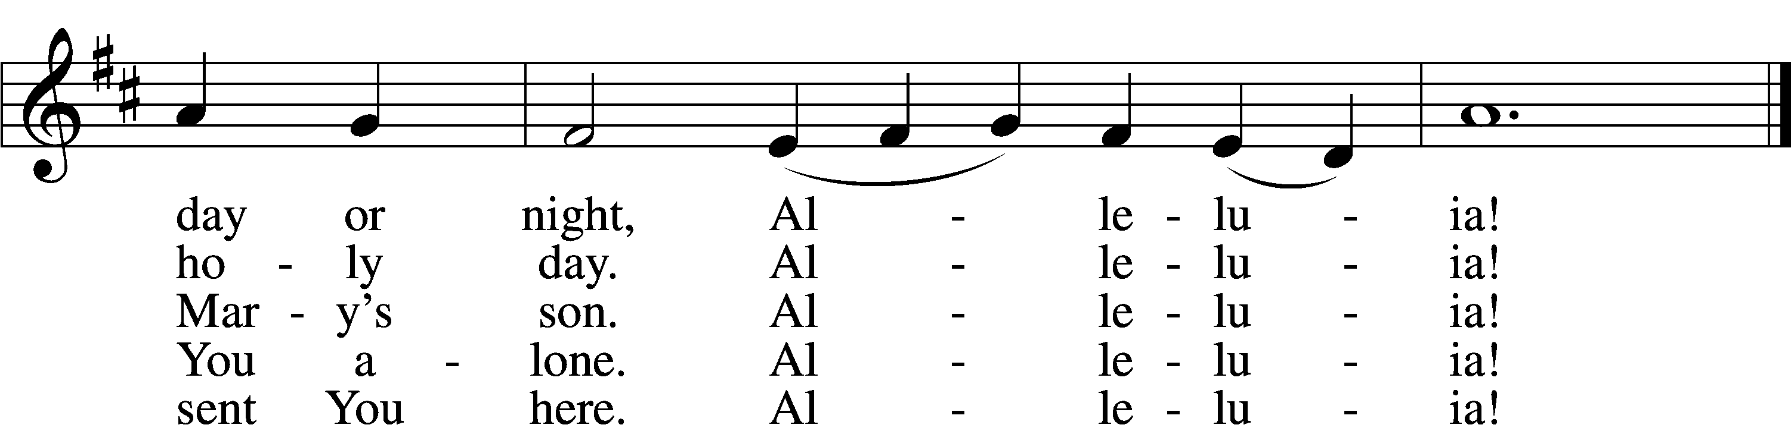

Text: Latin, c. 5th–10th cent.; tr. Gilbert E. Doan, 1930–2024  
Tune: Stephen R. Johnson, 1966  
Text: © 1978 Lutheran Book of Worship. Used by permission: LSB Hymn License no. 110004388  
Tune: © 2002 Stephen R. Johnson. Used by permission: LSB Hymn License no. 110004388

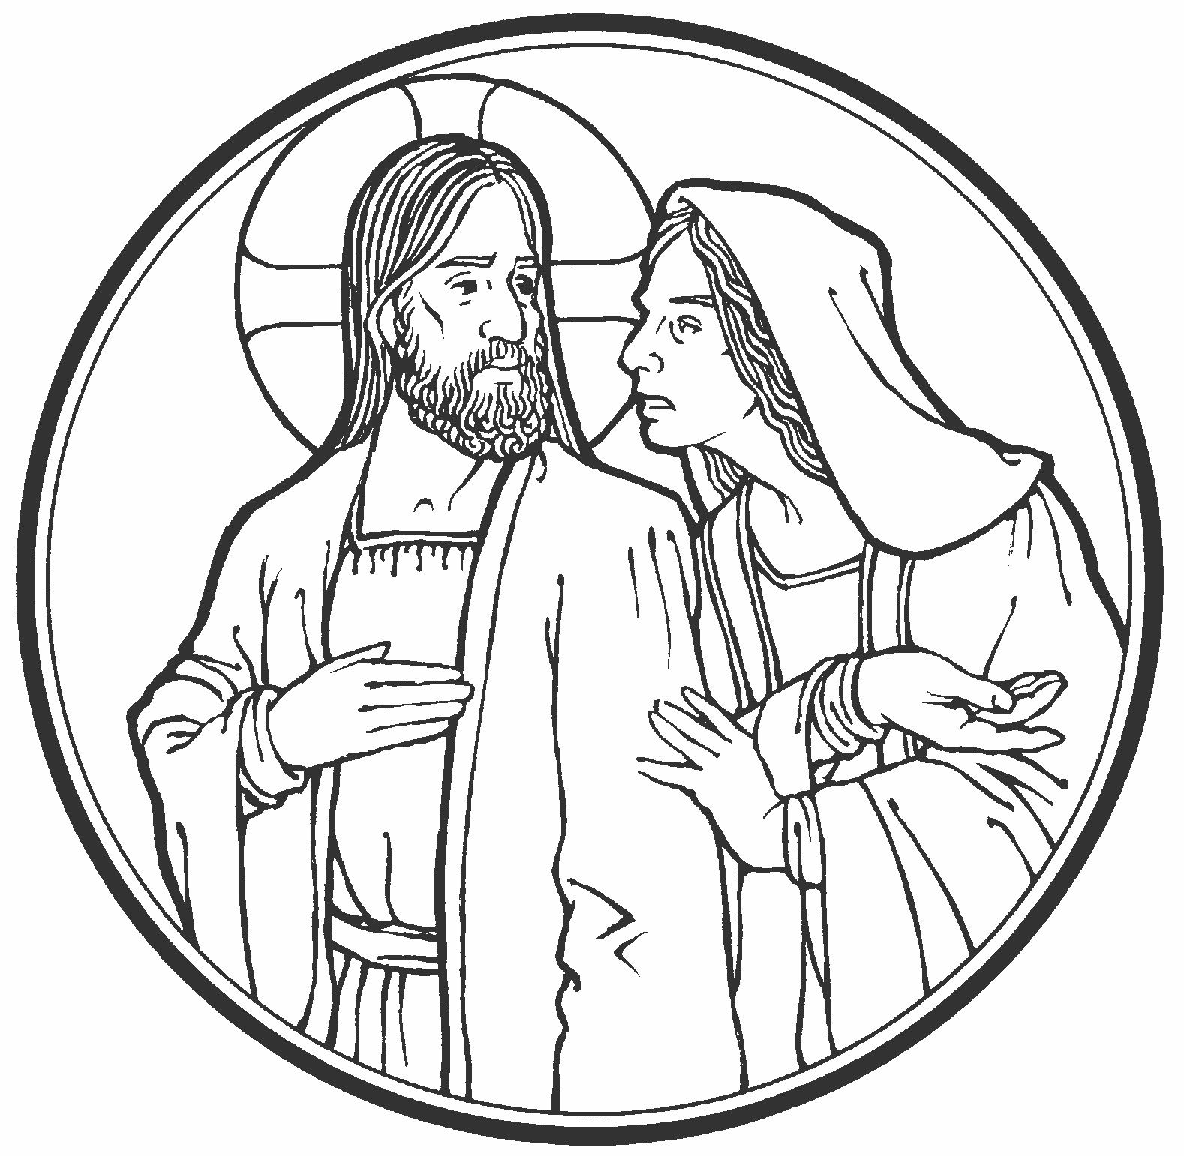

Acknowledgments

Divine Service, Setting One from Lutheran Service Book

Unless otherwise indicated, Scripture quotations are from the ESV® Bible (The Holy Bible, English Standard Version®), copyright © 2001 by Crossway, a publishing ministry of Good News Publishers. Used by permission. All rights reserved.

Created by Lutheran Service Builder © 2024 Concordia Publishing House.