**The Third Sunday in Advent**

**December 15, 2024**



“Blessed is the one who is not offended by me”

**PEACE LUTHERAN CHURCH**

1451 Ebenezer Rd + Cincinnati, OH 45233 + 513-941-5177

[**www.peacechurchlink.com**](http://www.peacechurchlink.com)

**About This Service**

For many centuries the Church has celebrated the season of Advent as the beginning of a new church year and as a time of preparation for Christmas. Advent means “coming” and gives us opportunity to meditate on the Incarnation (the coming of God in human flesh for our salvation) and the Parousia (His coming again, in glory, to judge the world).

**Are My Children Welcome?**

In God’s eyes we’re all children. Yes, your little ones are more than welcome! If your child needs a little extra room to “make a joyful noise” you’re welcome to take them out of the sanctuary and into the narthex or the Fellowship Hall.

**How Do I Become a Lutheran Christian?**

If you’re exploring the Lutheran Church, Pastor Shaw would be happy to offer guidance or answer your questions. Our website peacechurchlink.com is also a good resource. When you’re ready, there’s a formal process of reading, study, and prayer that culminates in being received into the Lutheran Church.

**Can I Take Communion?**

The Lord’s Supper is celebrated at this congregation in the confession and glad confidence that, as our Lord says, He gives into our mouths not only bread and wine but His very body and blood to eat and to drink for the forgiveness of sins and to strengthen our union with Him and with one another. Our Lord invites to His table those who trust His Words, repent of all sins, and set aside any refusal to forgive and love as He forgives and loves us, that they may show forth His death until He comes. Holy Communion is a confession of the faith which is confessed at this altar, any who are not yet instructed, in doubt, or who hold a confession differing from that of this congregation and the Lutheran Church – Missouri Synod, are asked to first speak with the pastor before communing.

Preservice Music

“Light One Candle" *Sunday School Children and Congregation*

Light one candle for Hope,  
 One bright candle for Hope!  
He brings Hope to every heart,  
 He comes, He comes!

Light one candle for Peace,  
 One bright candle for Peace!  
He brings Peace to every heart,  
 He comes, He comes!

Light one candle for Joy,

One bright candle for Joy!

Ev’ry nation will find salvation

In Bethlehem’s baby boy.

*The first, second, and third candles on the Advent wreath are lit.*

345 Hark! A Thrilling Voice Is Sounding

*Stand for Stanza 5*

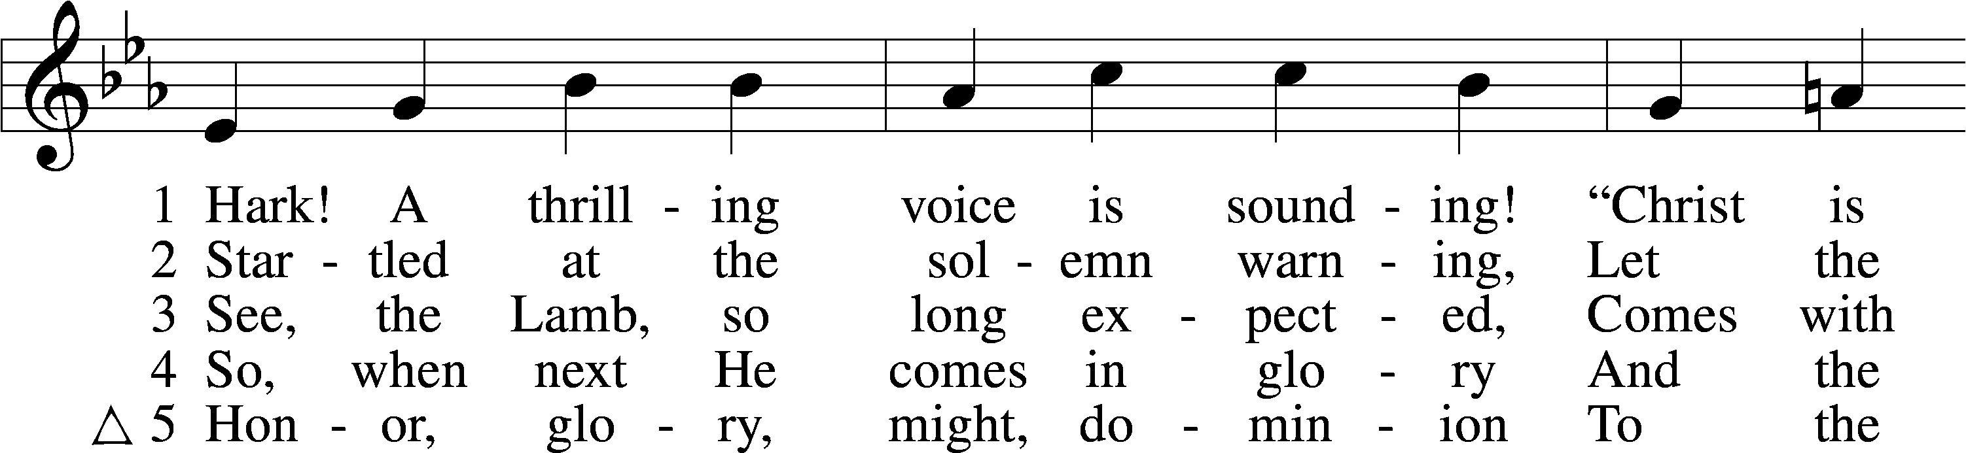

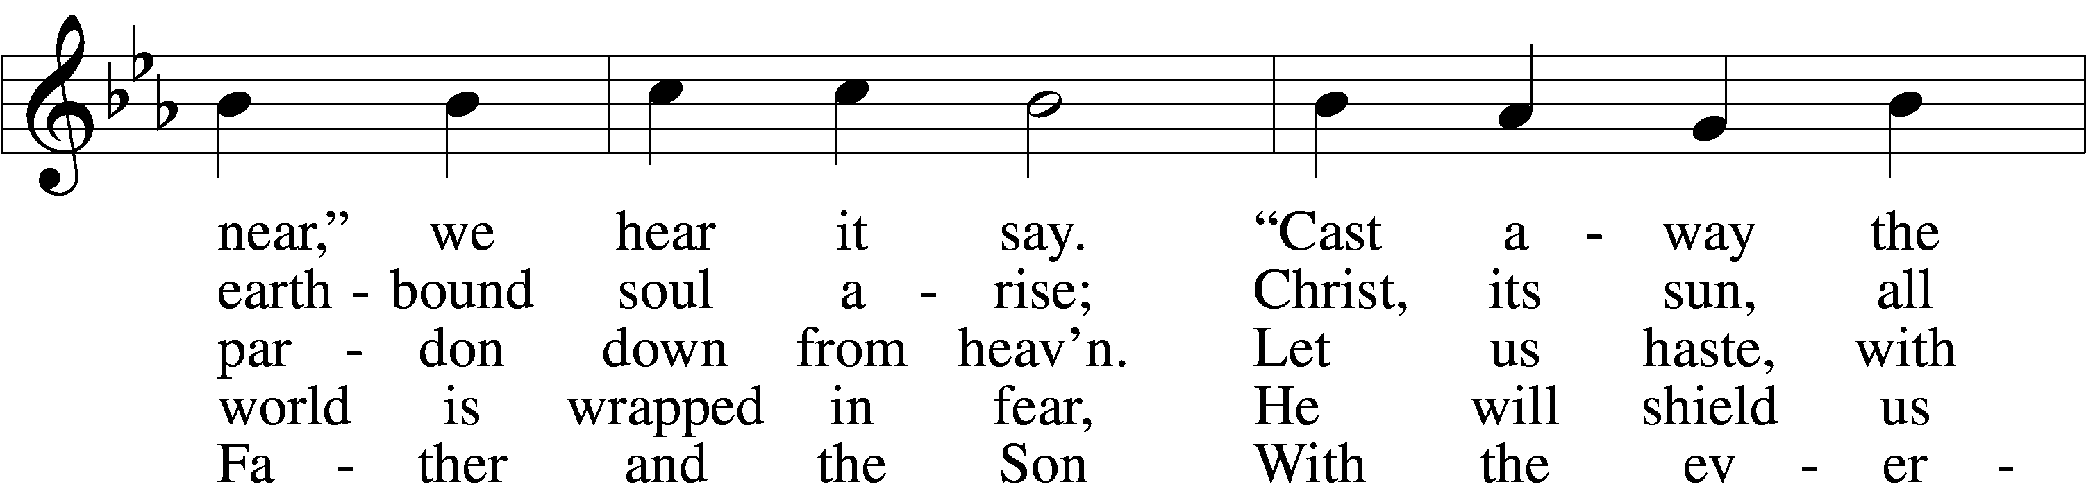

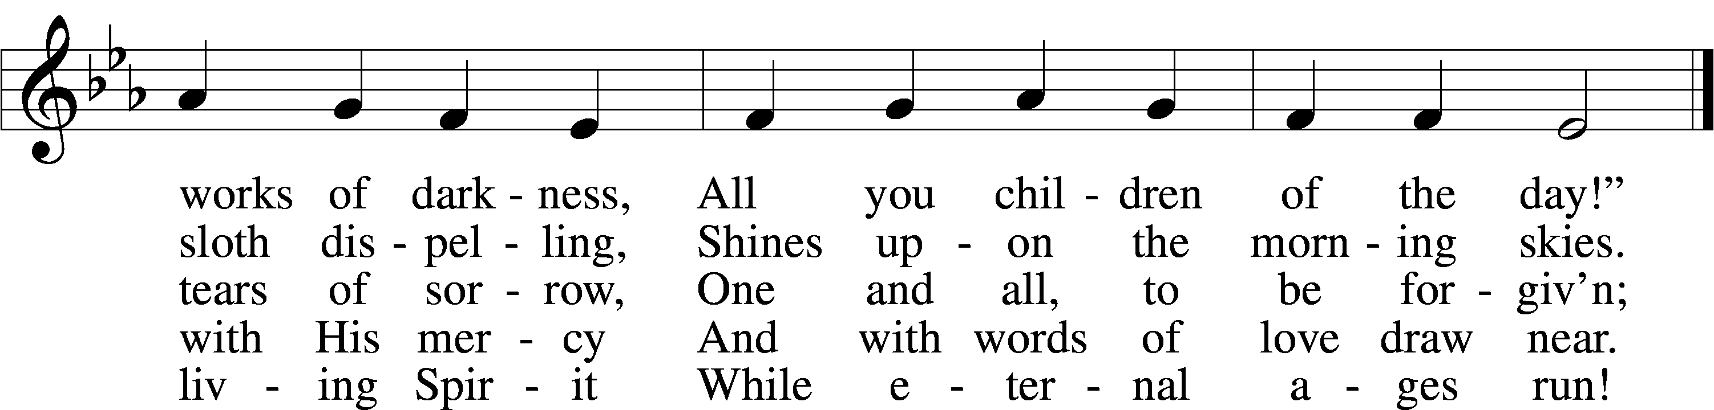

Text: Latin, c. 5th–10th cent.; tr. Edward Caswall, 1814–78, alt.  
Tune: William H. Monk, 1823–89  
Text and tune: Public domain

# Confession and Absolution

The sign of the cross may be made by all in remembrance of their Baptism.

Invocation

P In the name of the Father and of the T Son and of the Holy Spirit.

C **Amen.**

Exhortation LSB 203

P Our help is in the name of the Lord,

C **who made heaven and earth.**

P If You, O Lord, kept a record of sins, O Lord, who could stand?

C **But with You there is forgiveness; therefore You are feared.**

P Since we are gathered to hear God’s Word, call upon Him in prayer and praise, and receive the body and blood of our Lord Jesus Christ in the fellowship of this altar, let us first consider our unworthiness and confess before God and one another that we have sinned in thought, word, and deed, and that we cannot free ourselves from our sinful condition. Together as His people let us take refuge in the infinite mercy of God, our heavenly Father, seeking His grace for the sake of Christ, and saying: God, be merciful to me, a sinner.

Confession of Sins LSB 203

C **Almighty God, have mercy upon us, forgive us our sins, and lead us to everlasting life. Amen.**

Absolution LSB 203

P Almighty God in His mercy has given His Son to die for you and for His sake forgives you all your sins. As a called and ordained servant of Christ, and by His authority, I therefore forgive you all your sins in the name of the Father and of the T Son and of the Holy Spirit.

C **Amen.**

# Service of the Word

Introit Psalm 146:5–8; antiphon: Philippians 4:4

Rejoice in the Lord always;  
 **again I will say, Rejoice.**Blessèd is he whose help is the God of Jacob,  
 **whose hope is in the Lord his God,**

who made heaven and earth, the sea, and all that is in them,  
 **who keeps faith forever;**who executes justice for the oppressed,  
 **who gives food to the hungry.**The Lord sets the prisoners free; the Lord opens the eyes of the blind.  
 **The Lord lifts up those who are bowed down; the Lord loves the righteous.  
Glory be to the Father and to the Son**  
 **and to the Holy Spirit;**  
**as it was in the beginning,**  
 **is now, and will be forever. Amen.**  
Rejoice in the Lord always;  
 **again I will say, Rejoice.**

Kyrie LSB 204

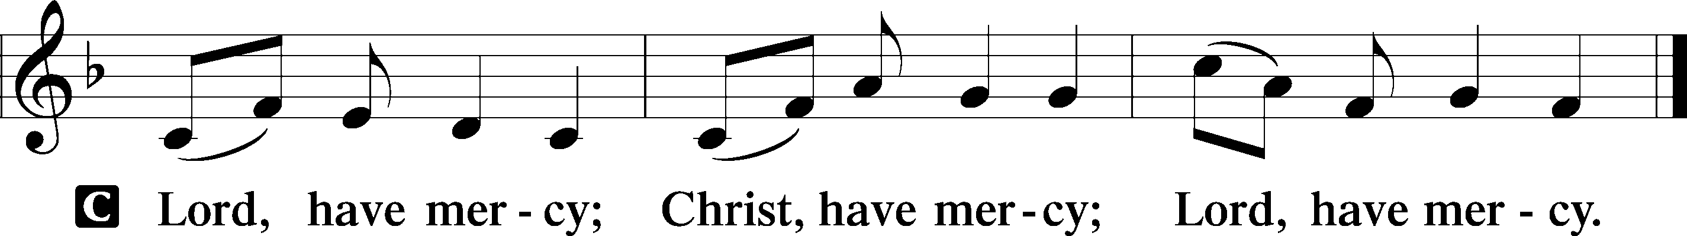

Salutation and Collect of the Day

P The Lord be with you.

C **And also with you.**

P Let us pray.

Lord Jesus Christ, we implore You to hear our prayers and to lighten the darkness of our hearts by Your gracious visitation; for You live and reign with the Father and the Holy Spirit, one God, now and forever.

C **Amen.**

Sit

Old Testament Reading Zephaniah 3:14–20

14Sing aloud, O daughter of Zion;  
 shout, O Israel!  
Rejoice and exult with all your heart,  
 O daughter of Jerusalem!  
15The Lord has taken away the judgments against you;  
 he has cleared away your enemies.  
The King of Israel, the Lord, is in your midst;  
 you shall never again fear evil.  
16On that day it shall be said to Jerusalem:  
“Fear not, O Zion;  
 let not your hands grow weak.  
17The Lord your God is in your midst,  
 a mighty one who will save;  
he will rejoice over you with gladness;  
 he will quiet you by his love;  
he will exult over you with loud singing.  
18I will gather those of you who mourn for the festival,  
 so that you will no longer suffer reproach.  
19Behold, at that time I will deal  
 with all your oppressors.  
And I will save the lame  
 and gather the outcast,  
and I will change their shame into praise  
 and renown in all the earth.  
20At that time I will bring you in,  
 at the time when I gather you together;  
for I will make you renowned and praised  
 among all the peoples of the earth,  
when I restore your fortunes  
 before your eyes,” says the Lord.

A This is the Word of the Lord.

C **Thanks be to God.**

Epistle Philippians 4:4–7

4Rejoice in the Lord always; again I will say, Rejoice. 5Let your reasonableness be known to everyone. The Lord is at hand; 6do not be anxious about anything, but in everything by prayer and supplication with thanksgiving let your requests be made known to God. 7And the peace of God, which surpasses all understanding, will guard your hearts and your minds in Christ Jesus.

A This is the Word of the Lord.

C **Thanks be to God.**

Prepare the Way of the Lord (Rowan) Choir

Stand

Holy Gospel Luke 7:18–28

P The Holy Gospel according to St. Luke, the seventh chapter.

C **Glory to You, O Lord.**

18The disciples of John reported all these things to him. And John, 19calling two of his disciples to him, sent them to the Lord, saying, “Are you the one who is to come, or shall we look for another?” 20And when the men had come to him, they said, “John the Baptist has sent us to you, saying, ‘Are you the one who is to come, or shall we look for another?’” 21In that hour he healed many people of diseases and plagues and evil spirits, and on many who were blind he bestowed sight. 22And he answered them, “Go and tell John what you have seen and heard: the blind receive their sight, the lame walk, lepers are cleansed, and the deaf hear, the dead are raised up, the poor have good news preached to them. 23And blessed is the one who is not offended by me.”

24When John’s messengers had gone, Jesus began to speak to the crowds concerning John: “What did you go out into the wilderness to see? A reed shaken by the wind? 25What then did you go out to see? A man dressed in soft clothing? Behold, those who are dressed in splendid clothing and live in luxury are in kings’ courts. 26What then did you go out to see? A prophet? Yes, I tell you, and more than a prophet. 27This is he of whom it is written,

“‘Behold, I send my messenger before your face,  
 who will prepare your way before you.’

28I tell you, among those born of women none is greater than John. Yet the one who is least in the kingdom of God is greater than he.”

P This is the Gospel of the Lord.

C **Praise to You, O Christ.**

Nicene Creed

C **I believe in one God, the Father Almighty, maker of heaven and earth and of all things visible and invisible.**

**And in one Lord Jesus Christ, the only-begotten Son of God, begotten of His Father before all worlds, God of God, Light of Light, very God of very God, begotten, not made, being of one substance with the Father, by whom all things were made; who for us men and for our salvation came down from heaven and was incarnate by the Holy Spirit of the virgin Mary and was made man; and was crucified also for us under Pontius Pilate. He suffered and was buried. And the third day He rose again according to the Scriptures and ascended into heaven and sits at the right hand of the Father. And He will come again with glory to judge both the living and the dead, whose kingdom will have no end.**

**And I believe in the Holy Spirit, the Lord and giver of life, who proceeds from the Father and the Son, who with the Father and the Son together is worshiped and glorified, who spoke by the prophets. And I believe in one holy Christian and apostolic Church, I acknowledge one Baptism for the remission of sins, and I look for the resurrection of the dead and the life** T **of the world to come. Amen.**

Sit

737 Rejoice, My Heart, Be Glad and Sing sts. 1–6

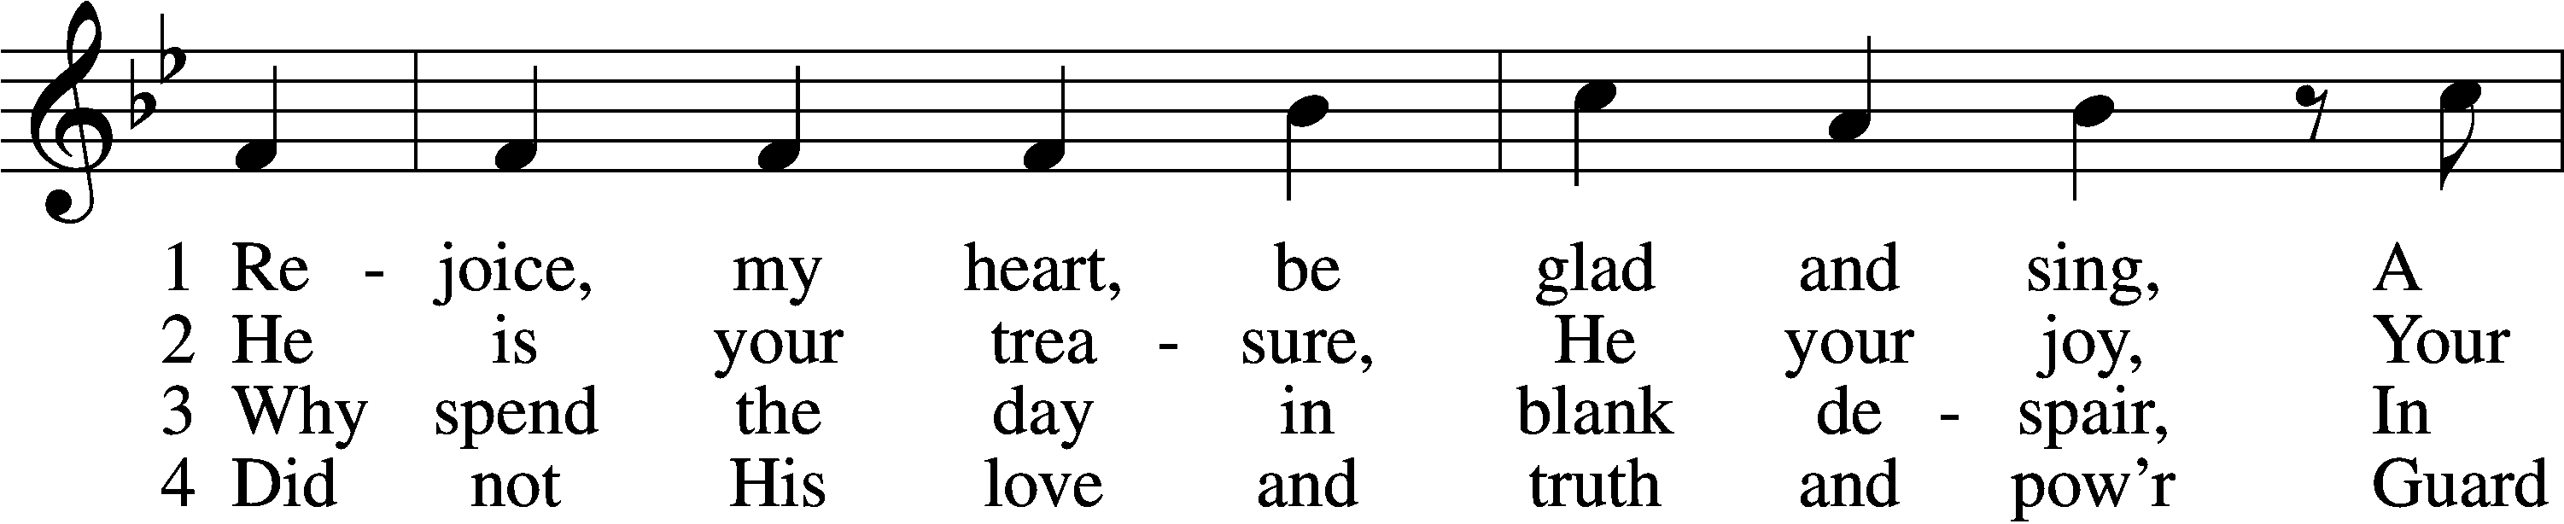

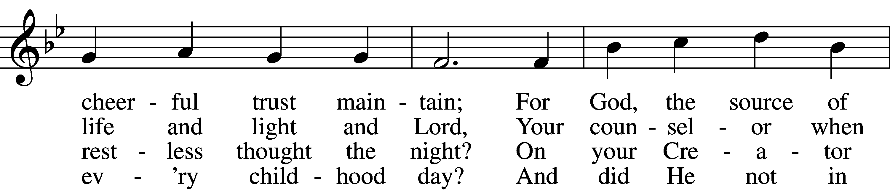

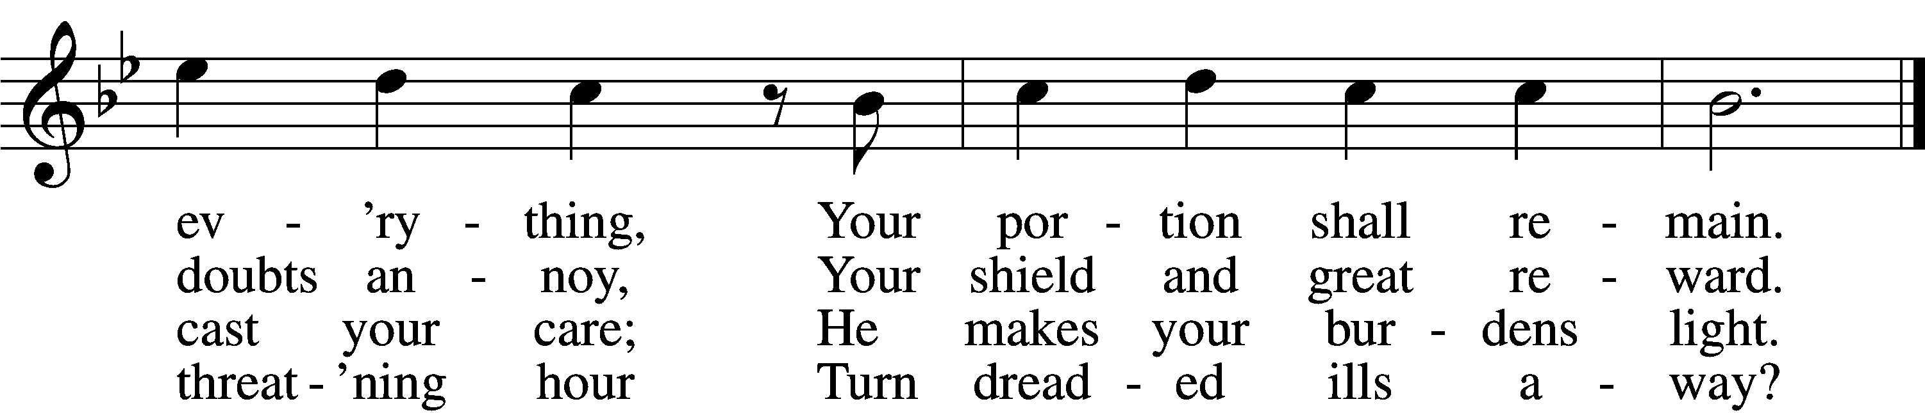

5 He only will with patience chide,  
 His rod falls gently down;  
And all your sins He casts aside  
 In ocean depths to drown.

6 His wisdom never plans in vain  
 Nor falters nor mistakes.  
All that His counsels may ordain  
 A blessèd ending makes.

Text: tr. John Kelly, 1833–90, alt.; Paul Gerhardt, 1607–76  
Tune: Harmonischer Lieder-Schatz, 1738, Frankfurt  
Text and tune: Public domain

Sermon: “A Picture of Biblical Masculinity” *Luke 7:18-28*

Offering

Stand

Prayer of the Church

# Service of the Sacrament

Preface LSB 208

P The Lord be with you.

C **And also with you.**

P Lift up your hearts.

C **We lift them to the Lord.**

P Let us give thanks to the Lord our God.

C **It is right to give Him thanks and praise.**

P It is truly good, right, and salutary that we should at all times and in all places give thanks to You, O Lord, holy Father, almighty and everlasting God, for the countless blessings You so freely bestow on us and all creation. Above all, we give thanks for Your boundless love shown to us when You sent Your only-begotten Son, Jesus Christ, into our flesh and laid on Him our sin, giving Him into death that we might not die eternally. Because He is now risen from the dead and lives and reigns to all eternity, all who believe in Him will overcome sin and death and will rise again to new life. Therefore with angels and archangels and with all the company of heaven we laud and magnify Your glorious name, evermore praising You and saying:

Sanctus LSB 208

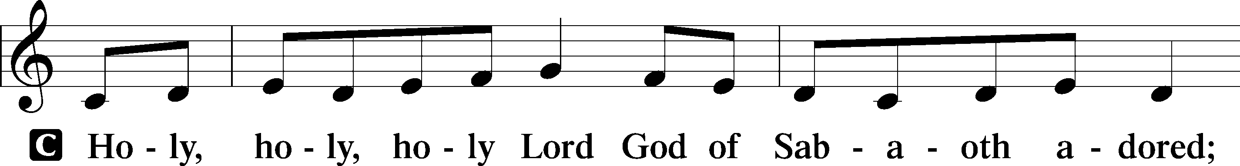

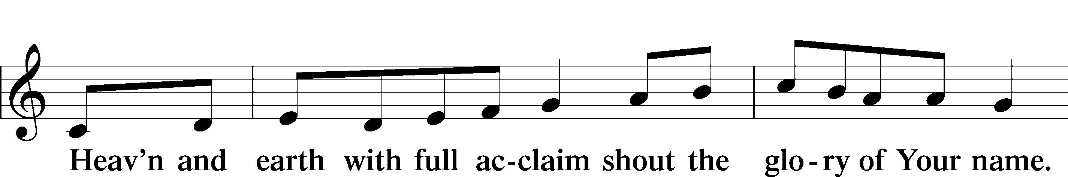

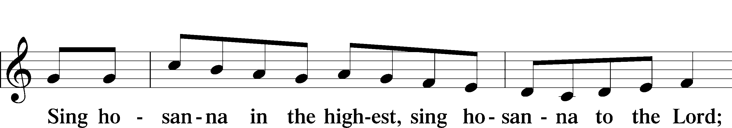

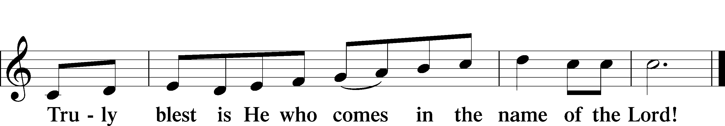

Text: Stephen P. Starke

Prayer of Thanksgiving

P Blessed are You, O Lord our God, king of all creation, for You have had mercy on us and given Your only-begotten Son that whoever believes in Him should not perish but have eternal life.

In Your boundless mercy You sent Your servant, John the Baptist, to proclaim that in Christ the kingdom of heaven draws near.

With thankful hearts we pray, “Come, Lord Jesus,” confident that in His body and blood, given us to eat and drink, we receive the forgiveness of sins and so proclaim His death until He comes again in glory.

Hear us as we pray in His name and as He has taught us:

Lord’s Prayer

C **Our Father who art in heaven, hallowed be Thy name, Thy kingdom come, Thy will be done on earth as it is in heaven; give us this day our daily bread; and forgive us our trespasses as we forgive those who trespass against us; and lead us not into temptation, but deliver us from evil. For Thine is the kingdom and the power and the glory forever and ever. Amen.**

The Words of Our Lord

P Our Lord Jesus Christ, on the night when He was betrayed, took bread, and when He had given thanks, He broke it and gave it to the disciples and said: “Take, eat; this is My T body, which is given for you. This do in remembrance of Me.”

In the same way also He took the cup after supper, and when He had given thanks, He gave it to them, saying: “Drink of it, all of you; this cup is the new testament in My T blood, which is shed for you for the forgiveness of sins. This do, as often as you drink it, in remembrance of Me.”

Pax Domini

P The peace of the Lord be with you always.

C **Amen.**

Agnus Dei LSB 210

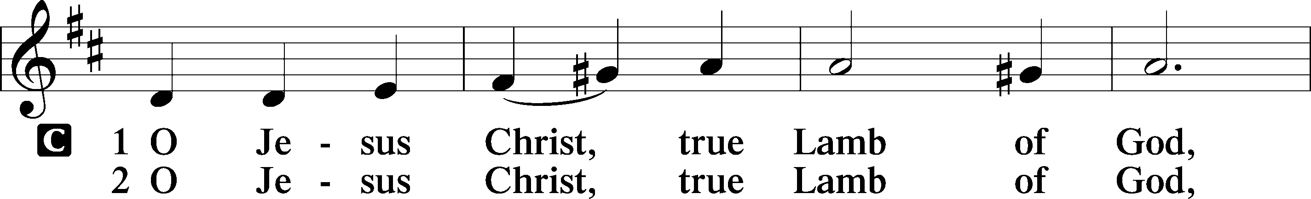

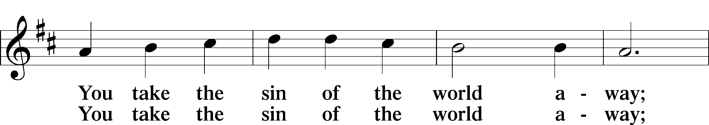

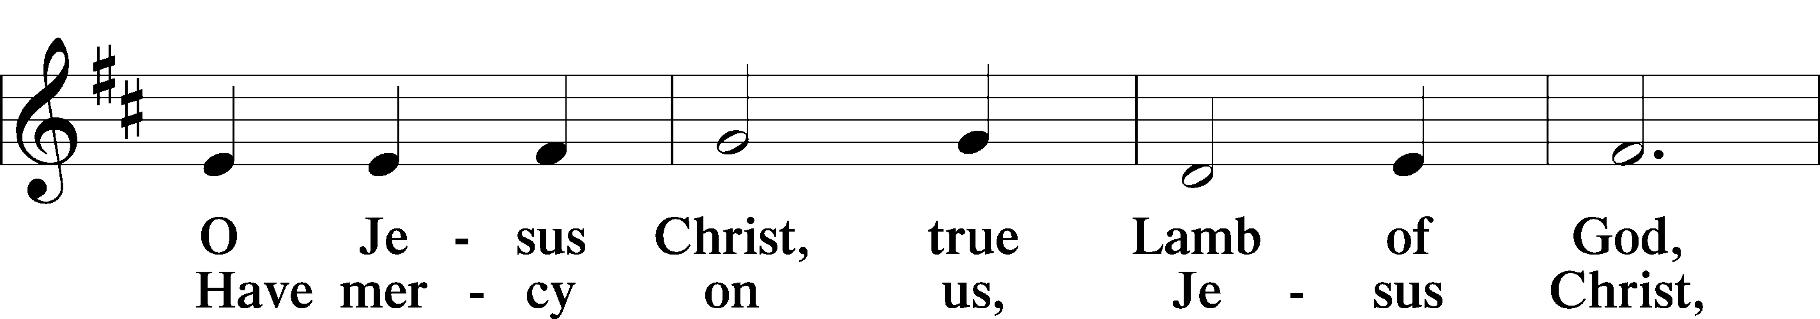

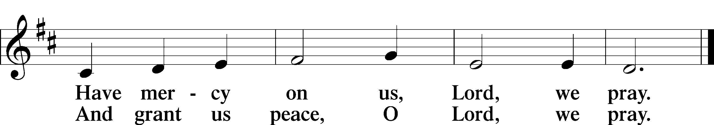

Text: Stephen P. Starke

Sit

Distribution

335 O Bride of Christ, Rejoice

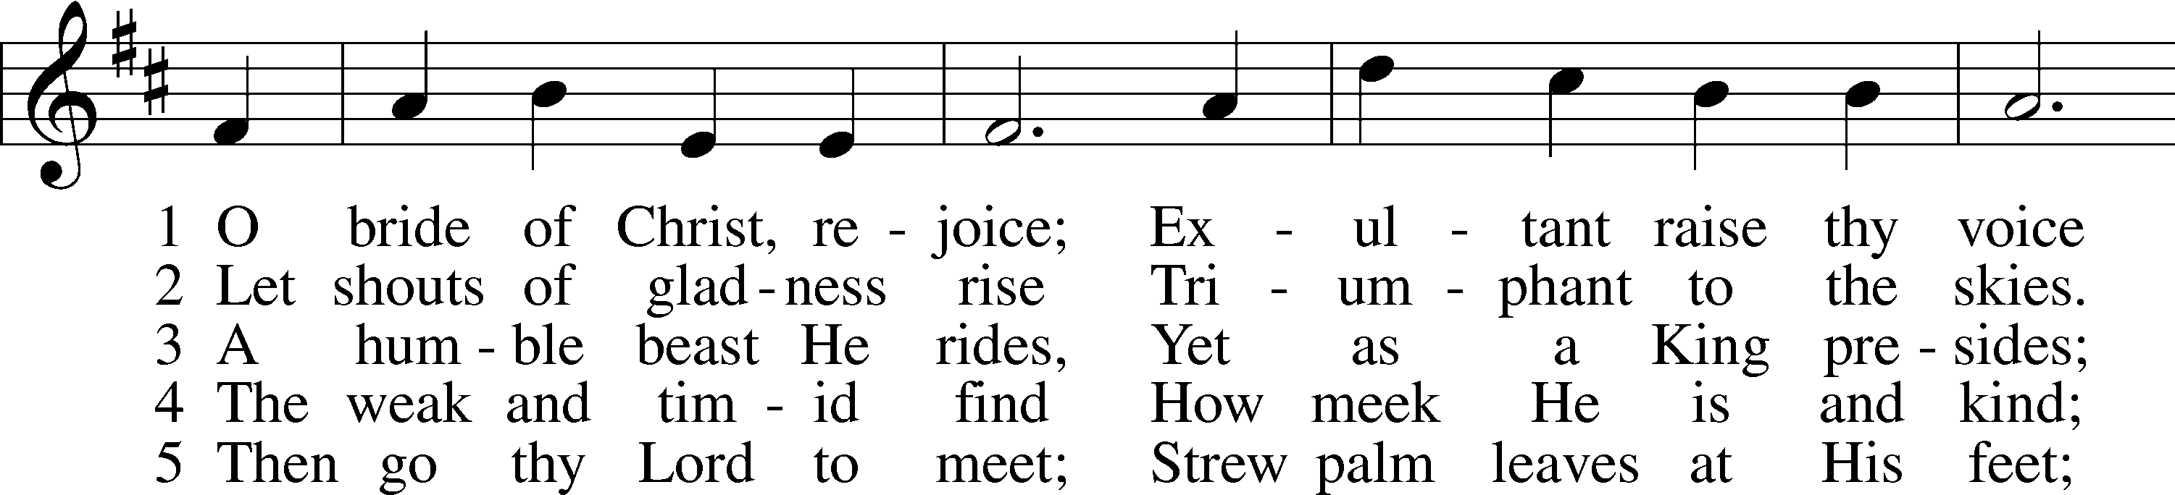

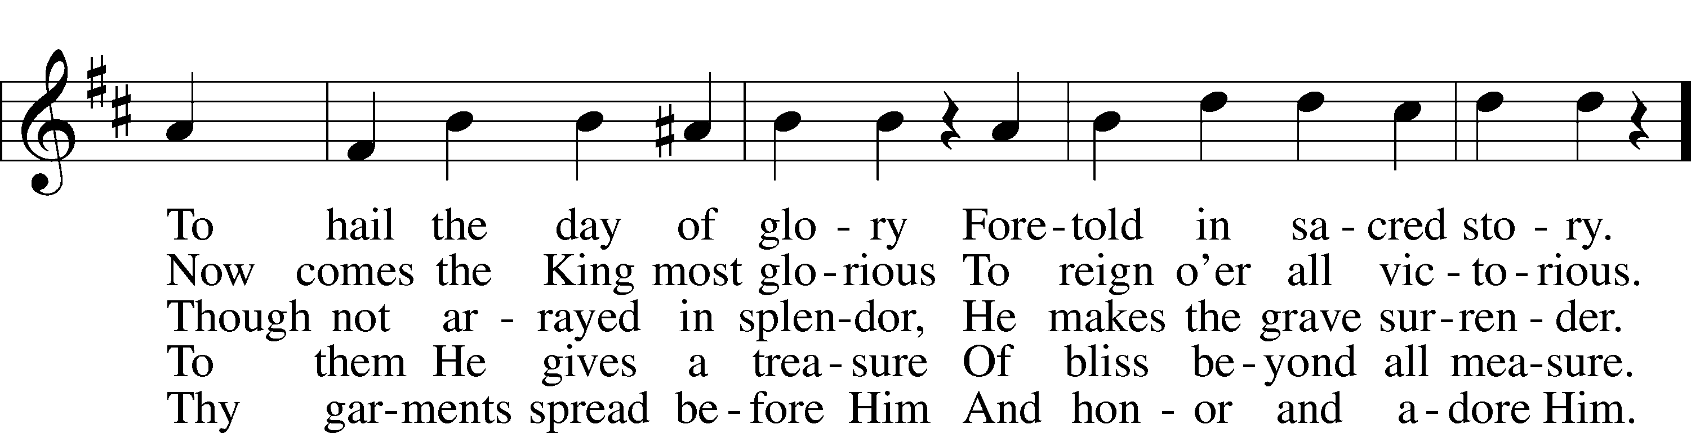

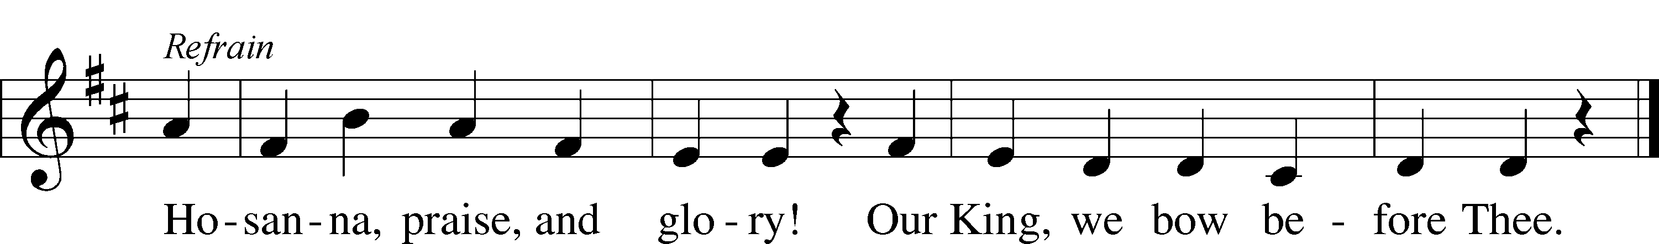

Text: Danish, c. 1600; tr. Victor O. Petersen, 1864–1929, alt.  
Tune: Der Bussfertige Sünder, 1679, Nürnberg  
Text and tune: Public domain

354 Arise, O Christian People

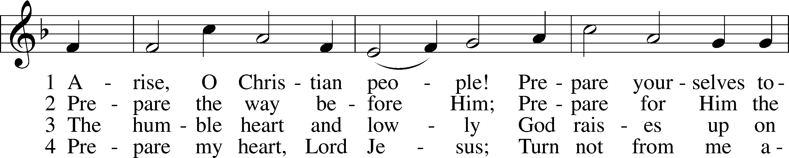

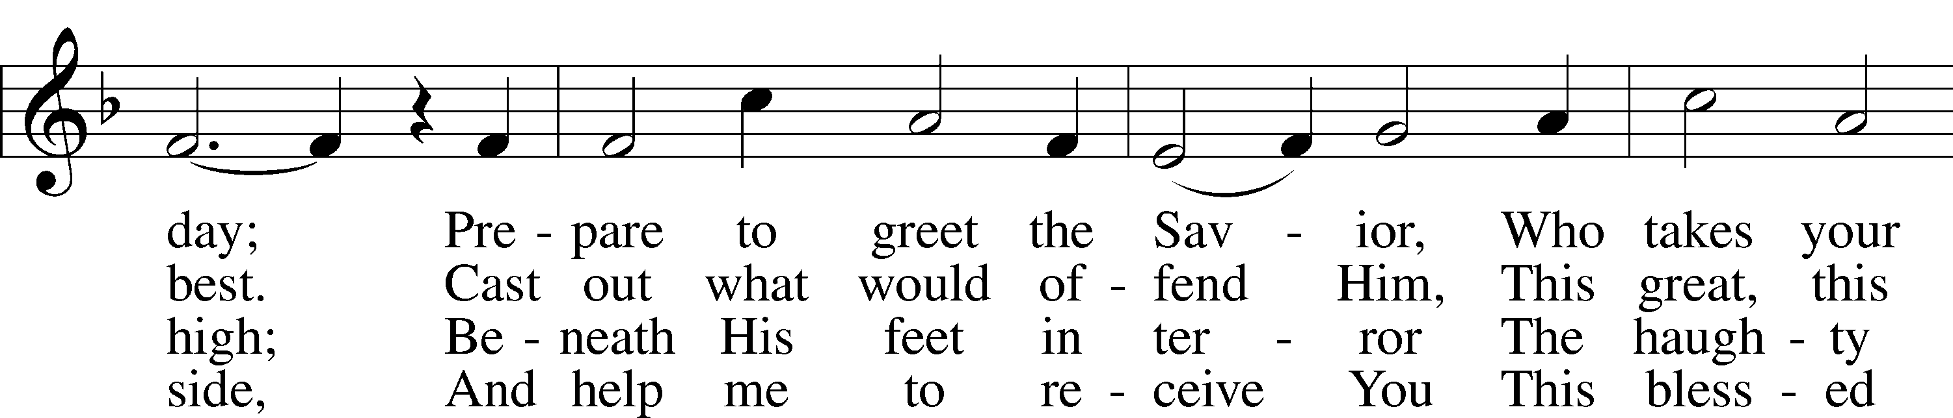

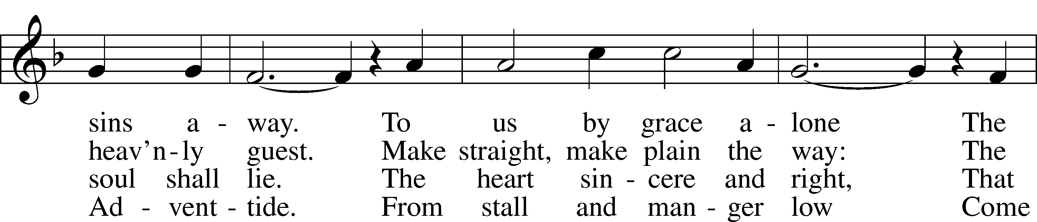

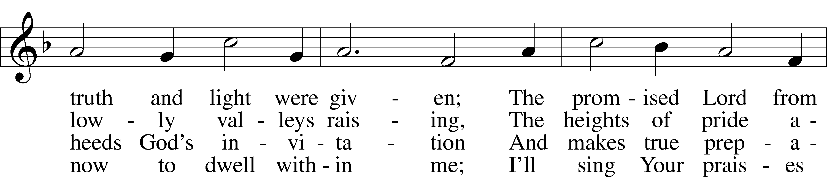

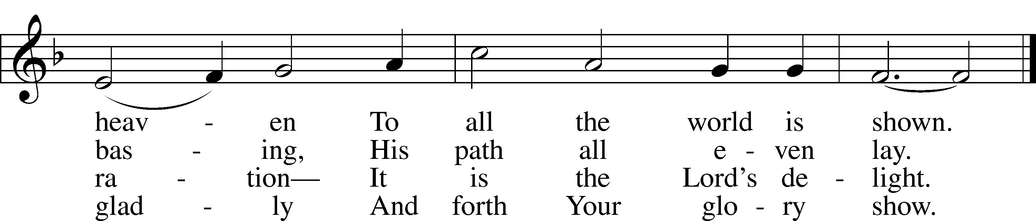

Text: Valentin Thilo, 1607–62; tr. Arthur T. Russell, 1806–74, alt.  
Tune: New Catechismus Gesangbüchlein, 1598, Hamburg, alt.  
Text and tune: Public domain

763 When Peace, like a River

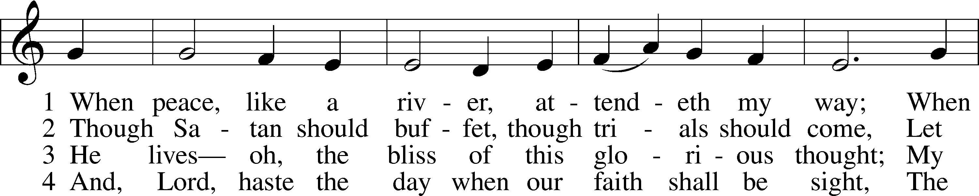

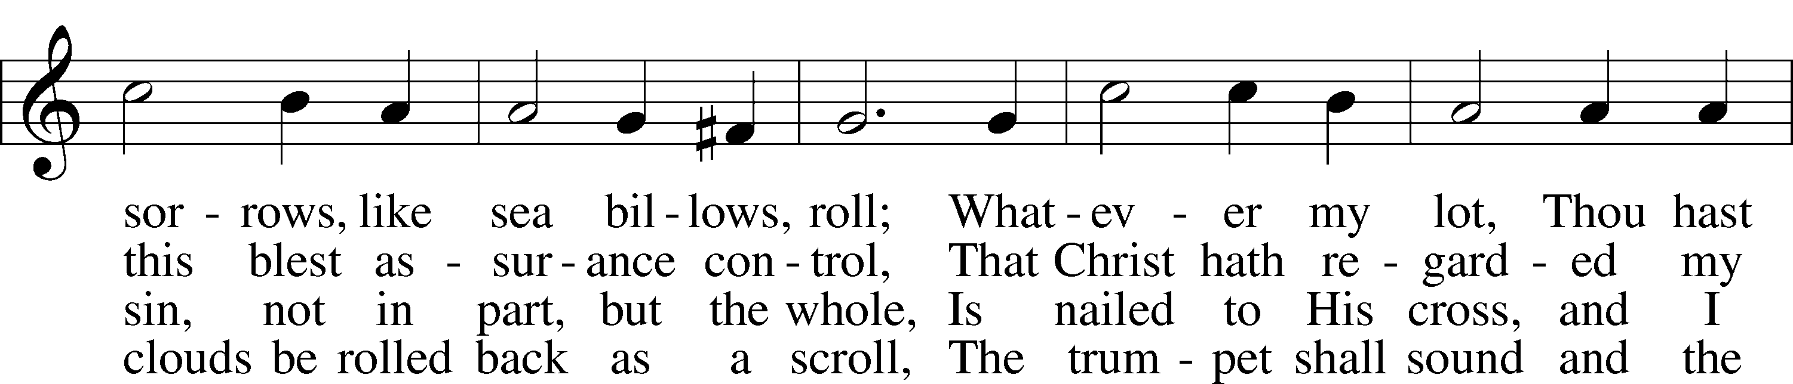

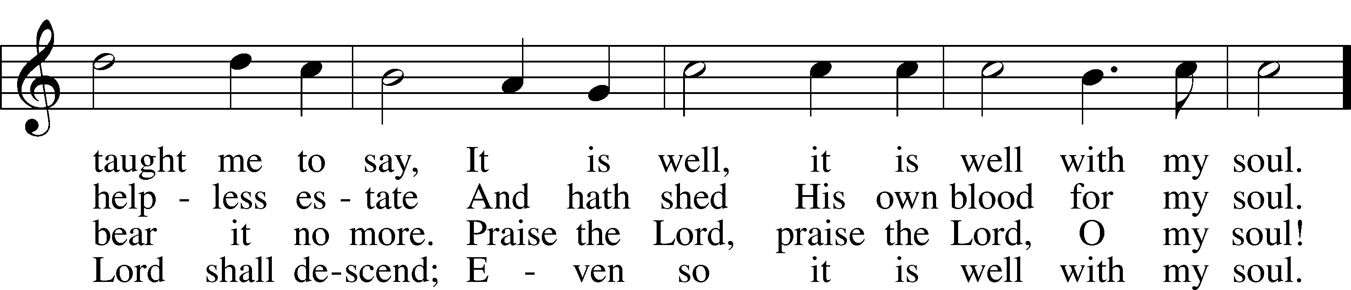

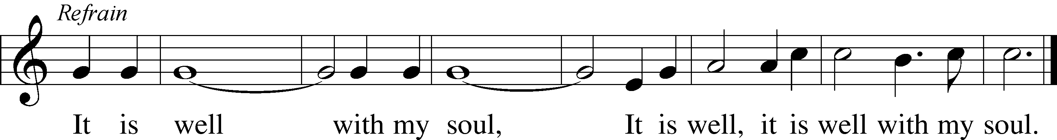

Text: Horatio G. Spafford, 1828–88, alt.  
Tune: Philip P. Bliss, 1838–76  
Text and tune: Public domain

Stand

Nunc Dimittis LSB 211

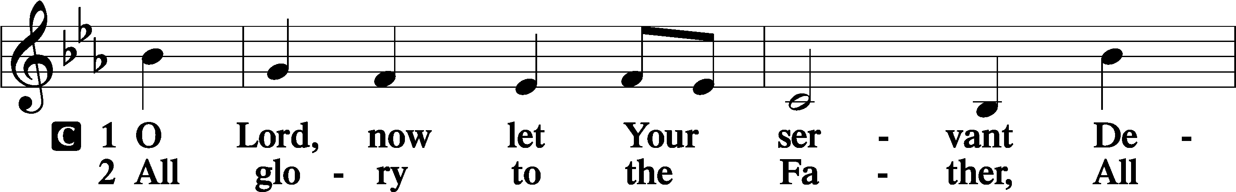

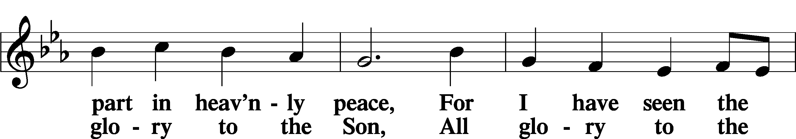

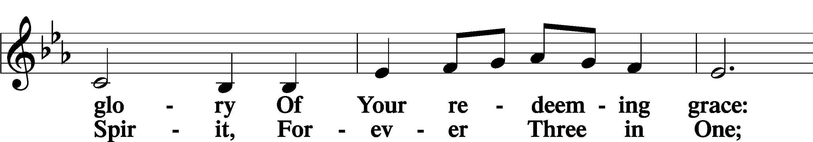

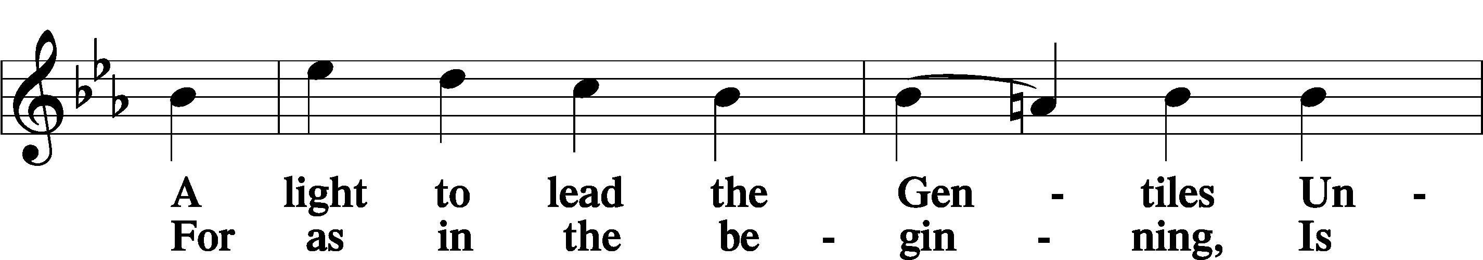

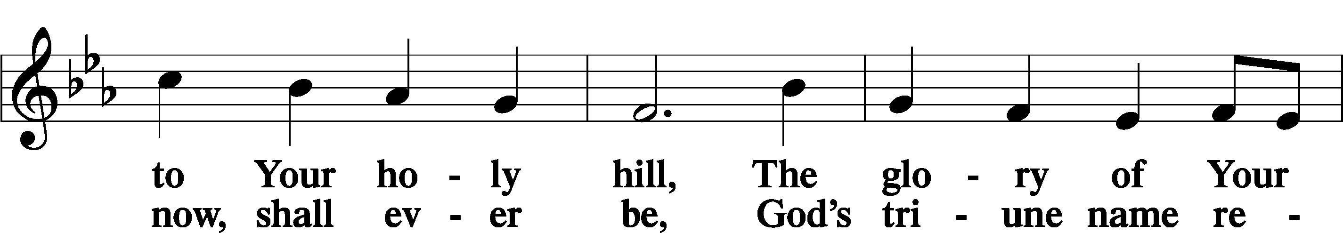

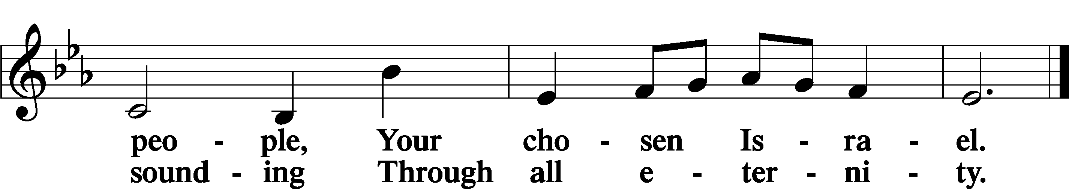

Post-Communion Collect

A Let us pray.

We give thanks to You, almighty God, that You have refreshed us through this salutary gift, and we implore You that of Your mercy You would strengthen us through the same in faith toward You and in fervent love toward one another; through Jesus Christ, Your Son, our Lord, who lives and reigns with You and the Holy Spirit, one God, now and forever.

C **Amen.**

Benedicamus LSB 212

A Let us bless the Lord.

C **Thanks be to God.**

Benediction

P The Lord bless you and keep you.

The Lord make His face shine on you and be gracious to you.

The Lord look upon you with favor and T give you peace.

C **Amen.**



338 Come, Thou Long-Expected Jesus

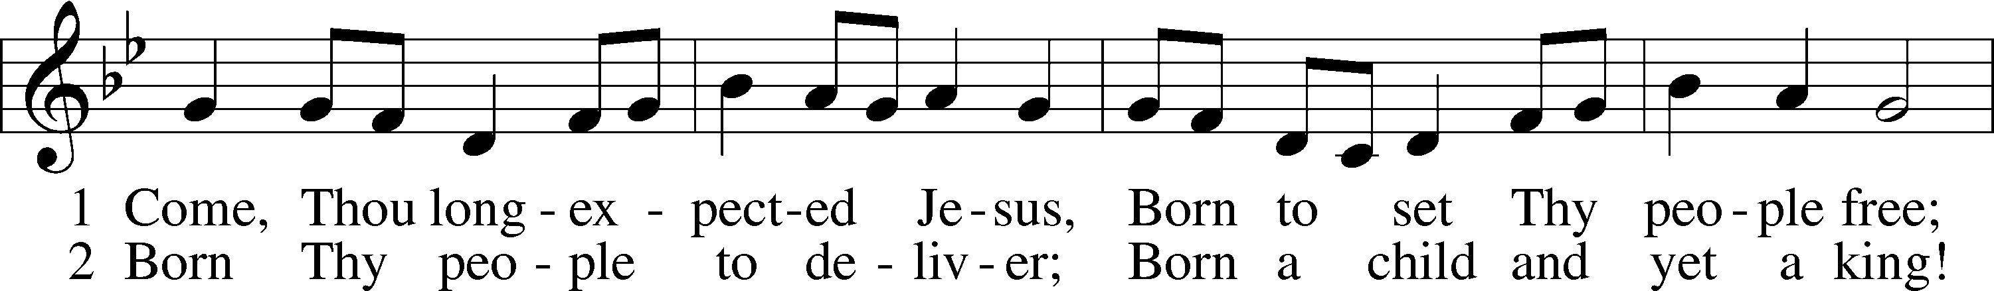

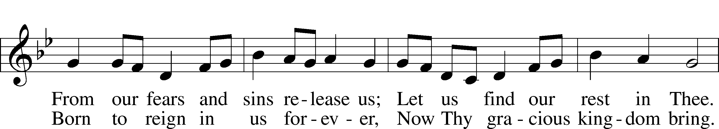

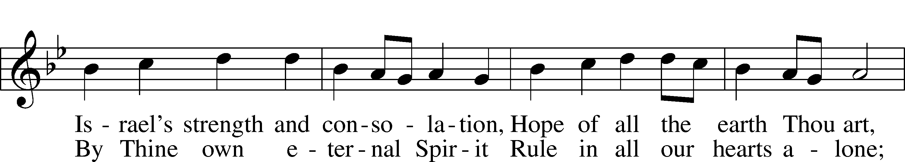

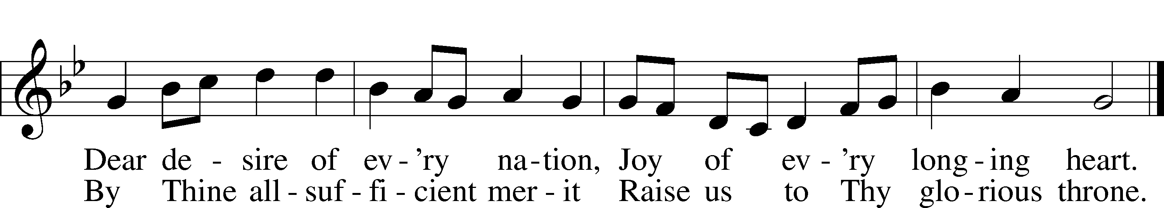

Text: Charles Wesley, 1707–88, alt.  
Tune: Southern Harmony, 1835, New Haven  
Text and tune: Public domain

Acknowledgments

Divine Service, Setting Four from Lutheran Service Book

Unless otherwise indicated, Scripture quotations are from the ESV® Bible (The Holy Bible, English Standard Version®), copyright © 2001 by Crossway, a publishing ministry of Good News Publishers. Used by permission. All rights reserved.

Created by Lutheran Service Builder © 2024 Concordia Publishing House.