**THE SECOND SUNDAY IN LENT**

# March 16, 2025 ATD



“But our citizenship is in heaven, and from it we await a Savior, the Lord Jesus Christ”

**PEACE LUTHERAN CHURCH**

1451 Ebenezer Rd T Cincinnati, OH 45233 T 513-941-5177

[**www.peacechurchlink.com**](http://www.peacechurchlink.com)

**About This Service**

The Sundays of Lent are named after the first word of the assigned Introit (Entrance Psalm). The Introit for the second Sunday in Lent (One-Year Lectionary) is taken from Psalm 25 and begins with the Latin word Reminiscere (rem-in-ISS-ker-ray) which is translated, “Remember [your mercy, O Lord]” (ESV). We pray that God would not look upon our sins or deny our prayers because of them, but rather remember His mercy in Christ Jesus and so blot out our transgressions and graciously receive our prayers.

The time before the Divine Service begins is a time for meditation and prayer. It’s a time for us to prepare our hearts and minds to hear God’s Word and receive His gifts. Therefore, we ask that you would please remain silent as you enter the sanctuary out of reverence for God and respect for one another.

**Are My Children Welcome?**

In God’s eyes we’re all children. Yes, your little ones are more than welcome! If your child needs a little extra room to “make a joyful noise” you’re welcome to take them out of the sanctuary and into the narthex or the Fellowship Hall.

**How Do I Become a Lutheran Christian?**

If you’re exploring the Lutheran Church, Pastor Shaw would be happy to offer guidance or answer your questions. Our website peacechurchlink.com is also a good resource. When you’re ready, there’s a formal process of reading, study, and prayer that culminates in being received into the Lutheran Church.

**Can I Take Communion?**

The Lord’s Supper is celebrated at this congregation in the confession and glad confidence that, as our Lord says, He gives into our mouths not only bread and wine but His very body and blood to eat and to drink for the forgiveness of sins and to strengthen our union with Him and with one another. Our Lord invites to His table those who trust His Words, repent of all sins, and set aside any refusal to forgive and love as He forgives and loves us, that they may show forth His death until He comes. Holy Communion is a confession of the faith which is confessed at this altar, any who are not yet instructed, in doubt, or who hold a confession differing from that of this congregation and the Lutheran Church – Missouri Synod, are asked to first speak with the pastor before communing.

422 ON MY HEART IMPRINT YOUR IMAGE

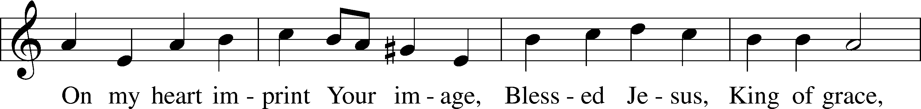

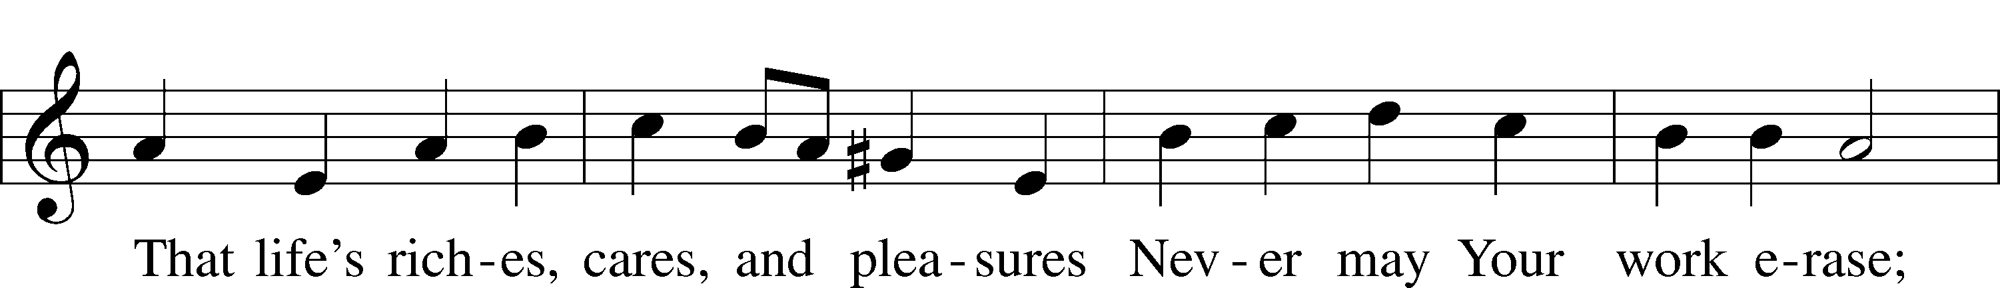

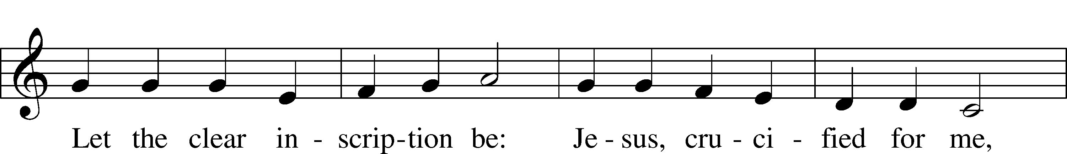

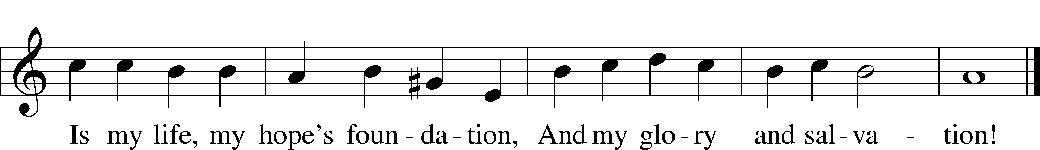

Text: Thomas Hansen Kingo, 1634–1703; tr. Peer O. Strömme, 1856–1921, alt.  
Tune: Johann Balthasar König, 1691–1758  
Text and tune: Public domain

# CONFESSION AND ABSOLUTION

Stand

The sign of the cross may be made by all in remembrance of their Baptism.

INVOCATION

P In the name of the Father and of the T Son and of the Holy Spirit.

C **Amen.**

EXHORTATION LSB 184

P Beloved in the Lord! Let us draw near with a true heart and confess our sins unto God our Father, beseeching Him in the name of our Lord Jesus Christ to grant us forgiveness.

P Our help is in the name of the Lord,

C **who made heaven and earth.**

P I said, I will confess my transgressions unto the Lord,

C **and You forgave the iniquity of my sin.**

Silence for reflection on God’s Word and for self-examination.

CONFESSION OF SINS LSB 184

P O almighty God, merciful Father,

C **I, a poor, miserable sinner, confess unto You all my sins and iniquities with which I have ever offended You and justly deserved Your temporal and eternal punishment. But I am heartily sorry for them and sincerely repent of them, and I pray You of Your boundless mercy and for the sake of the holy, innocent, bitter sufferings and death of Your beloved Son, Jesus Christ, to be gracious and merciful to me, a poor, sinful being.**

ABSOLUTION LSB 185

P Upon this your confession, I, by virtue of my office, as a called and ordained servant of the Word, announce the grace of God unto all of you, and in the stead and by the command of my Lord Jesus Christ I forgive you all your sins in the name of the Father and of the T Son and of the Holy Spirit.

C **Amen.**

# SERVICE OF THE WORD

INTROIT Psalm 74:1–3; antiphon: Psalm 69:9

For zeal for your house has consumed me,  
 **and the reproaches of those who reproach you have fallen on me.**O God, why do you cast us off forever?  
 **Why does your anger smoke against the sheep of your pasture?**Remember your congregation, which you have purchased of old, which you have redeemed to be the tribe of your heritage!  
 **Remember Mount Zion, where you have dwelt.**

Direct your steps to the perpetual ruins;  
 **the enemy has destroyed everything in the sanctuary!**

GLORIAPATRI LSB 186

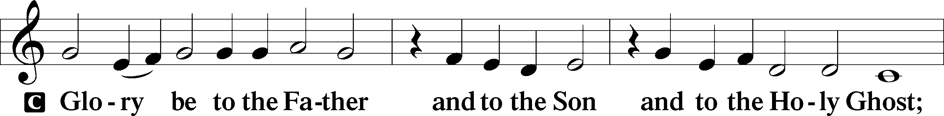

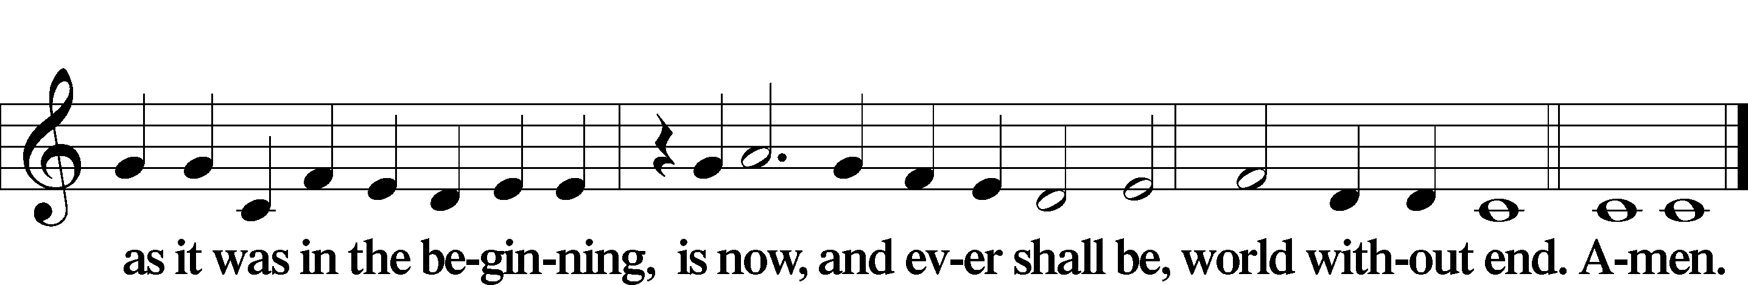

KYRIE LSB 186

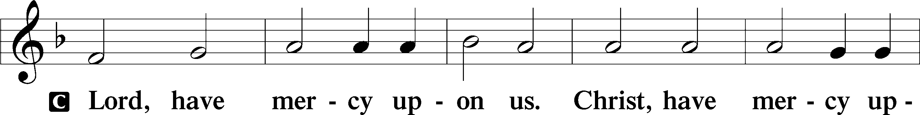

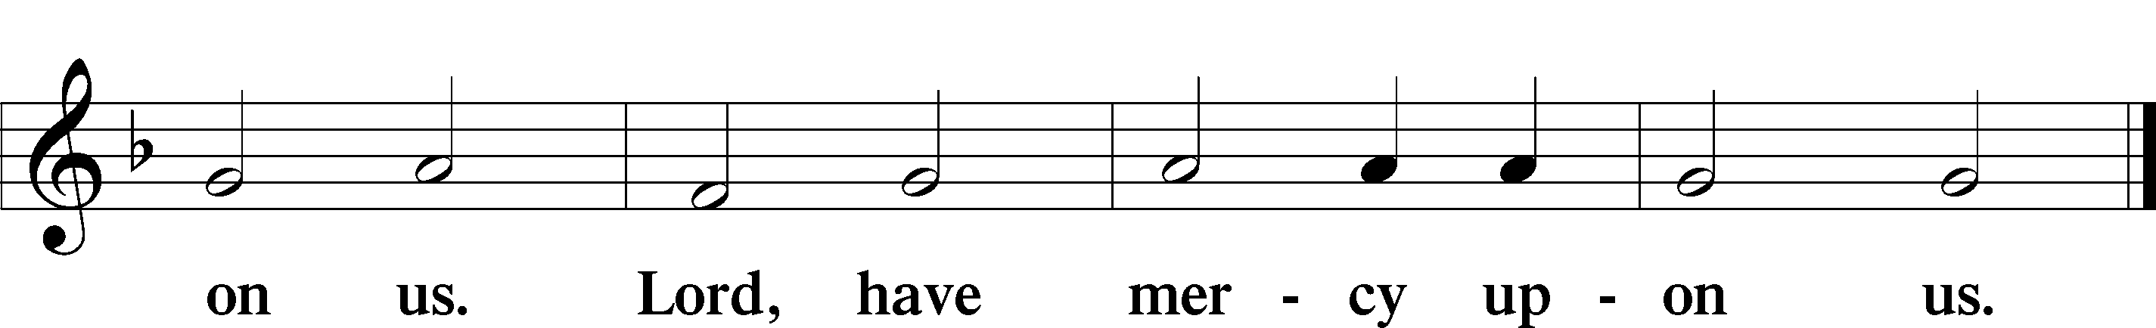

SALUTATION AND COLLECT OF THE DAY

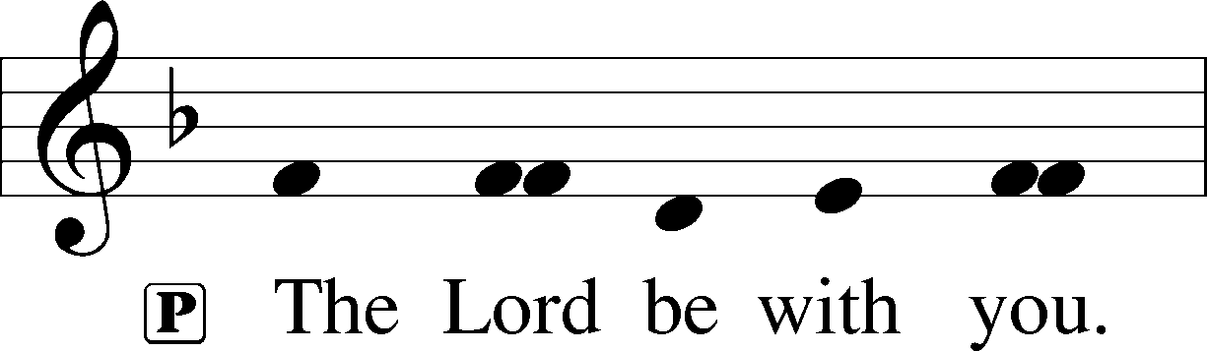

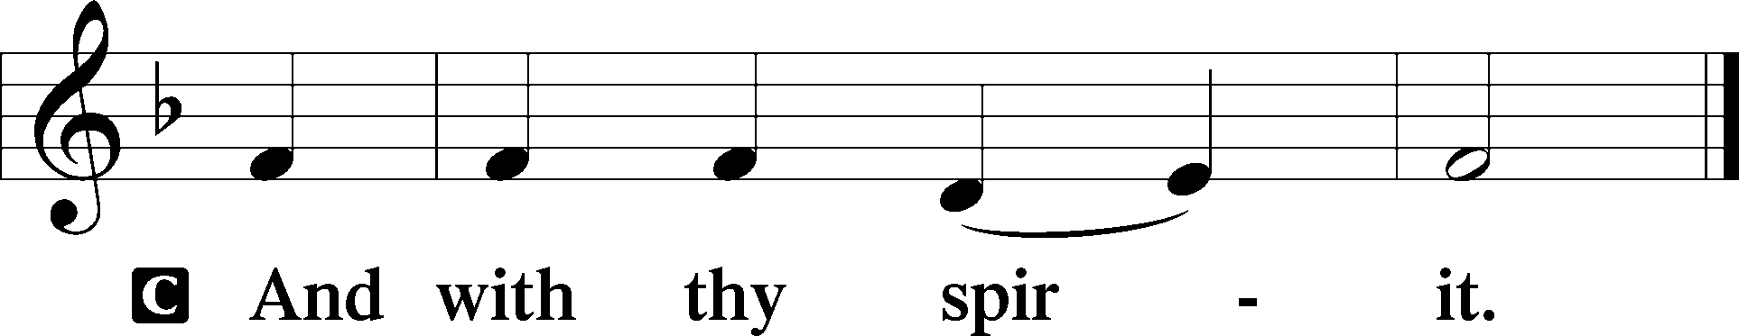

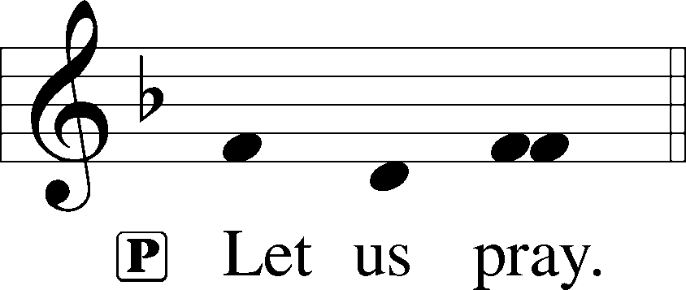

P O God, You see that of ourselves we have no strength. By Your mighty power defend us from all adversities that may happen to the body and from all evil thoughts that may assault and hurt the soul; through Jesus Christ, Your Son, our Lord, who lives and reigns with You and the Holy Spirit, one God, now and forever.

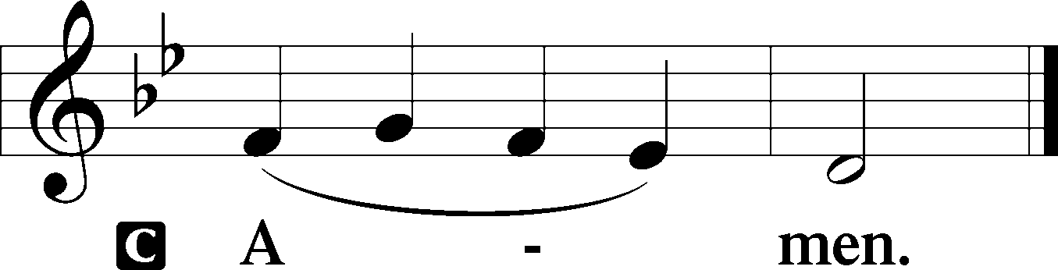

Sit

OLD TESTAMENT READING Jeremiah 26:8–15

8When Jeremiah had finished speaking all that the Lord had commanded him to speak to all the people, then the priests and the prophets and all the people laid hold of him, saying, “You shall die! 9Why have you prophesied in the name of the Lord, saying, ‘This house shall be like Shiloh, and this city shall be desolate, without inhabitant’?” And all the people gathered around Jeremiah in the house of the Lord.

10When the officials of Judah heard these things, they came up from the king’s house to the house of the Lord and took their seat in the entry of the New Gate of the house of the Lord. 11Then the priests and the prophets said to the officials and to all the people, “This man deserves the sentence of death, because he has prophesied against this city, as you have heard with your own ears.”

12Then Jeremiah spoke to all the officials and all the people, saying, “The Lord sent me to prophesy against this house and this city all the words you have heard. 13Now therefore mend your ways and your deeds, and obey the voice of the Lord your God, and the Lord will relent of the disaster that he has pronounced against you. 14But as for me, behold, I am in your hands. Do with me as seems good and right to you. 15Only know for certain that if you put me to death, you will bring innocent blood upon yourselves and upon this city and its inhabitants, for in truth the Lord sent me to you to speak all these words in your ears.”

A This is the Word of the Lord.

C **Thanks be to God.**

EPISTLE Philippians 3:17—4:1

17Brothers, join in imitating me, and keep your eyes on those who walk according to the example you have in us. 18For many, of whom I have often told you and now tell you even with tears, walk as enemies of the cross of Christ. 19Their end is destruction, their god is their belly, and they glory in their shame, with minds set on earthly things. 20But our citizenship is in heaven, and from it we await a Savior, the Lord Jesus Christ, 21who will transform our lowly body to be like his glorious body, by the power that enables him even to subject all things to himself.

1Therefore, my brothers, whom I love and long for, my joy and crown, stand firm thus in the Lord, my beloved.

A This is the Word of the Lord.

C **Thanks be to God.**

Stand

HOLY GOSPEL Luke 13:31–35

P The Holy Gospel according to St. Luke, the thirteenth chapter.

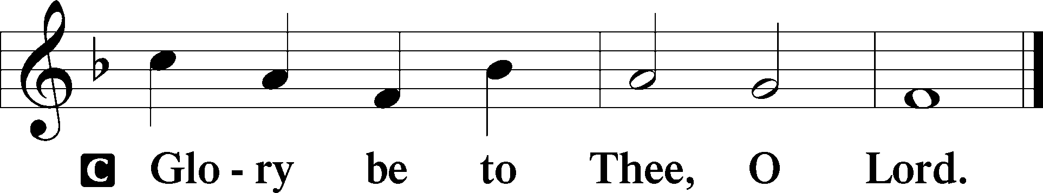

31At that very hour some Pharisees came and said to [Jesus], “Get away from here, for Herod wants to kill you.” 32And he said to them, “Go and tell that fox, ‘Behold, I cast out demons and perform cures today and tomorrow, and the third day I finish my course. 33Nevertheless, I must go on my way today and tomorrow and the day following, for it cannot be that a prophet should perish away from Jerusalem.’ 34O Jerusalem, Jerusalem, the city that kills the prophets and stones those who are sent to it! How often would I have gathered your children together as a hen gathers her brood under her wings, and you would not! 35Behold, your house is forsaken. And I tell you, you will not see me until you say, ‘Blessed is he who comes in the name of the Lord!’”

P This is the Gospel of the Lord.

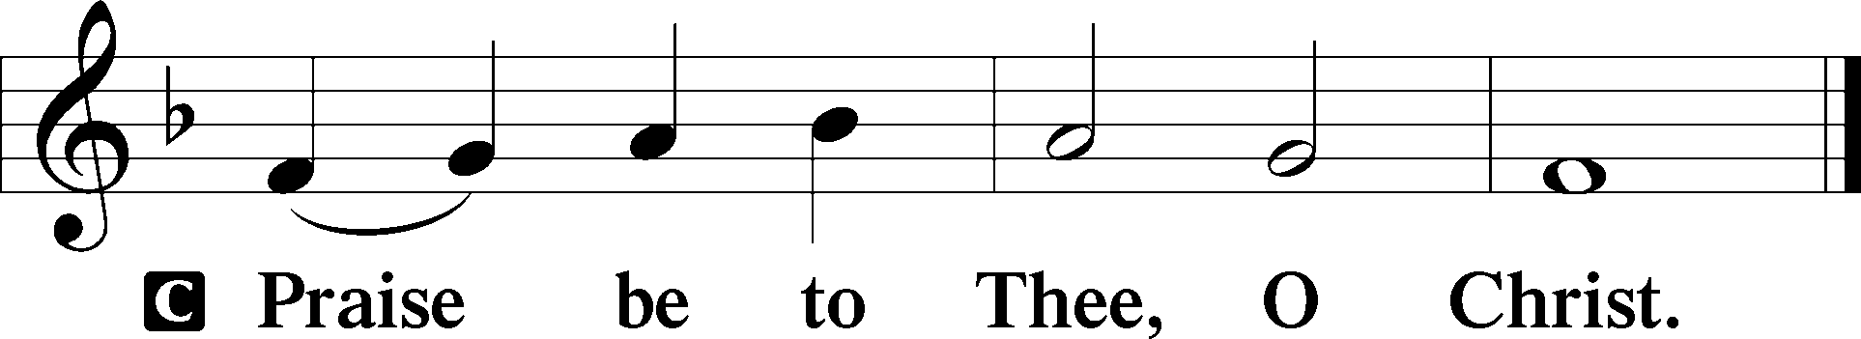

NICENE CREED

C **I believe in one God, the Father Almighty, maker of heaven and earth and of all things visible and invisible.**

**And in one Lord Jesus Christ, the only-begotten Son of God, begotten of His Father before all worlds, God of God, Light of Light, very God of very God, begotten, not made, being of one substance with the Father, by whom all things were made; who for us men and for our salvation came down from heaven and was incarnate by the Holy Spirit of the virgin Mary and was made man; and was crucified also for us under Pontius Pilate. He suffered and was buried. And the third day He rose again according to the Scriptures and ascended into heaven and sits at the right hand of the Father. And He will come again with glory to judge both the living and the dead, whose kingdom will have no end.**

**And I believe in the Holy Spirit, the Lord and giver of life, who proceeds from the Father and the Son, who with the Father and the Son together is worshiped and glorified, who spoke by the prophets. And I believe in one holy Christian and apostolic Church, I acknowledge one Baptism for the remission of sins, and I look for the resurrection of the dead and the life** T **of the world to come. Amen.**

Sit

748 I’M BUT A STRANGER HERE

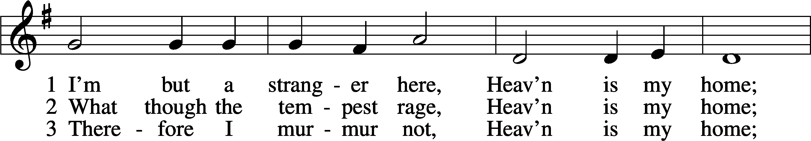

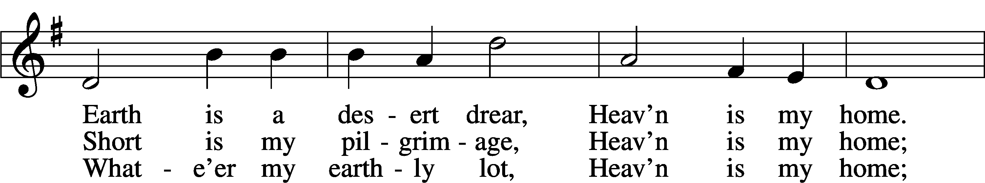

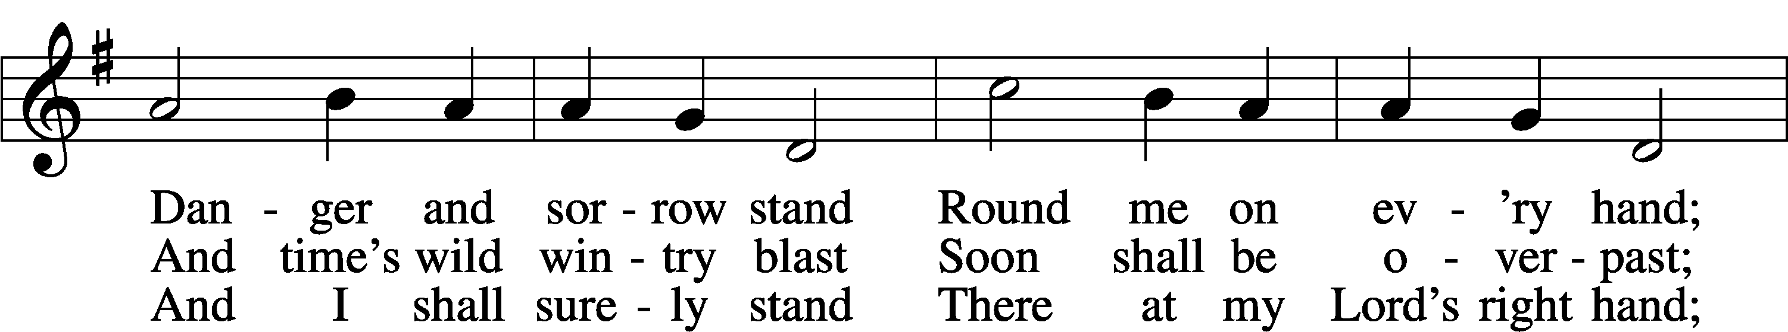

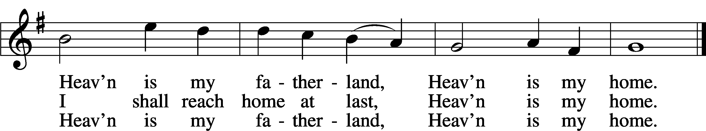

Text: Thomas R. Taylor, 1807–35  
Tune: Arthur S. Sullivan, 1842–1900  
Text and tune: Public domain

SERMON

OFFERING

Stand

OFFERTORY LSB 192

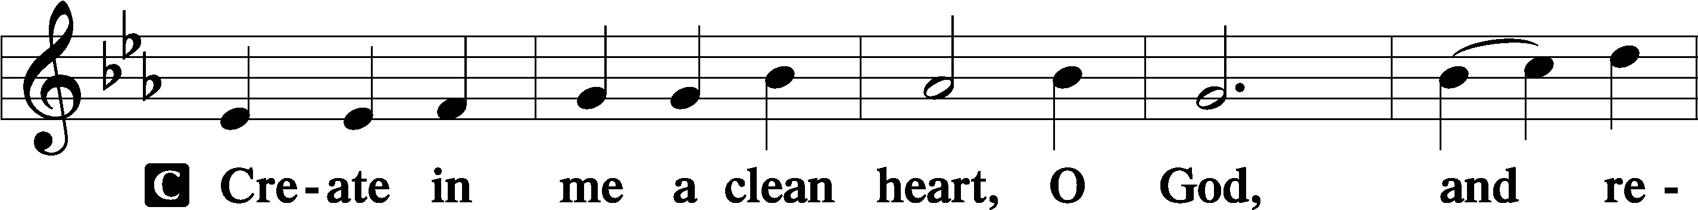

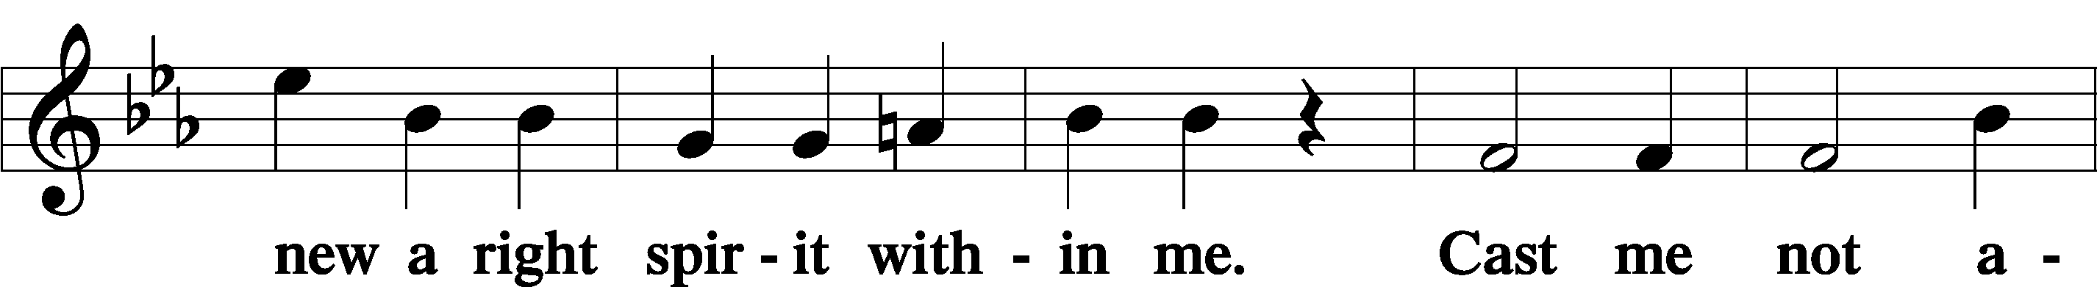

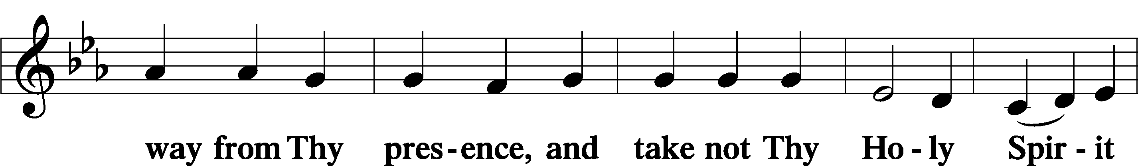

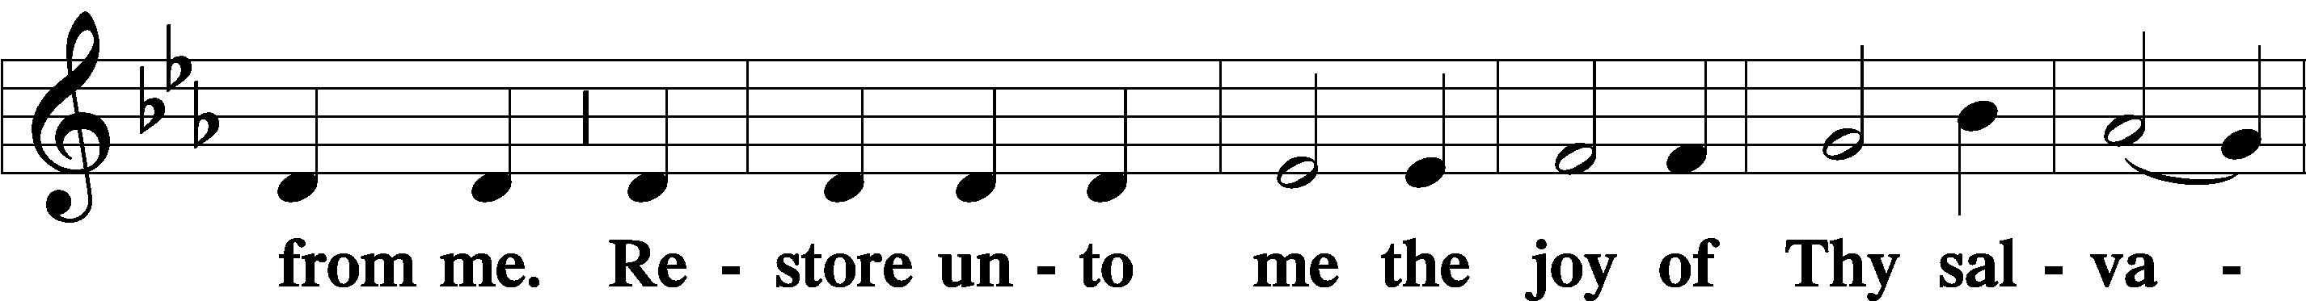

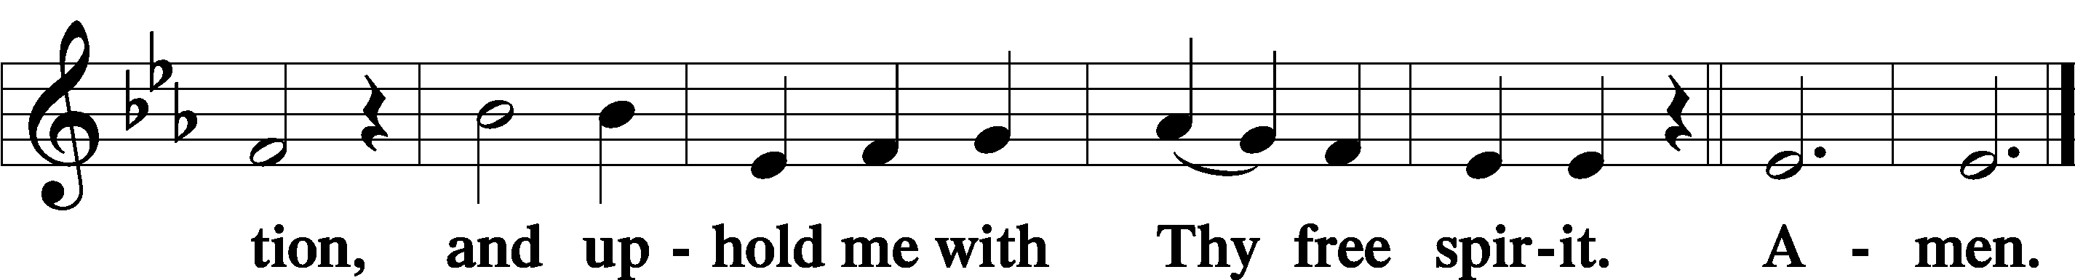

PRAYER OF THE CHURCH

# SERVICE OF THE SACRAMENT

PREFACE LSB 194

P The Lord be with you.

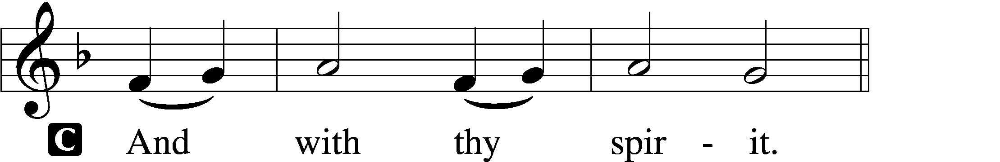

P Lift up your hearts.

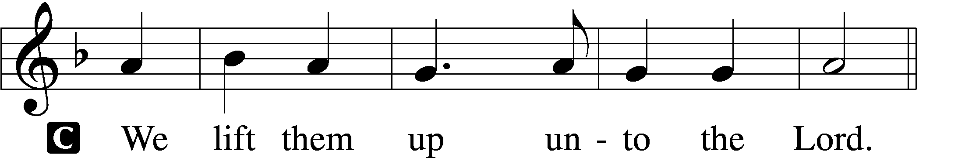

P Let us give thanks unto the Lord, our God.

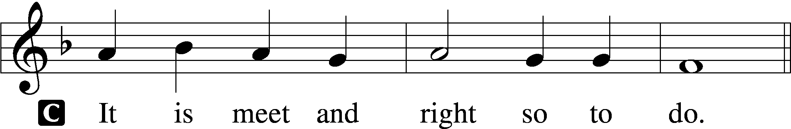

PROPER PREFACE

P It is truly meet, right, and salutary that we should at all times and in all places give thanks to You, holy Lord, almighty Father, everlasting God, through Jesus Christ, our Lord, who overcame the assaults of the devil and gave His life as a ransom for many that with cleansed hearts we might be prepared joyfully to celebrate the paschal feast in sincerity and truth. Therefore with angels and archangels and with all the company of heaven we laud and magnify Your glorious name, evermore praising You and saying:

SANCTUS LSB 195

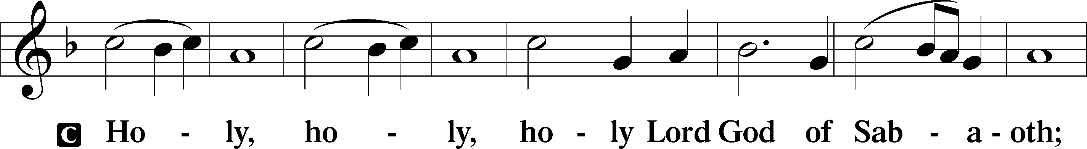

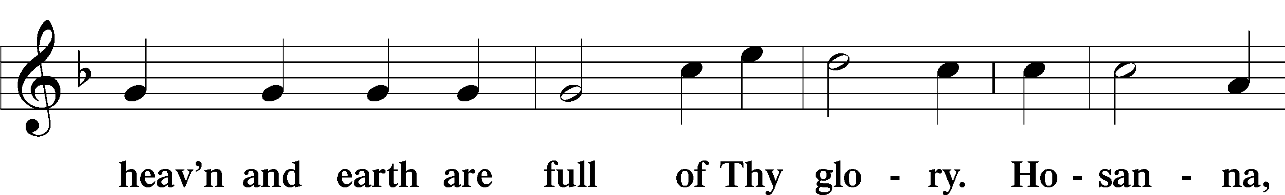

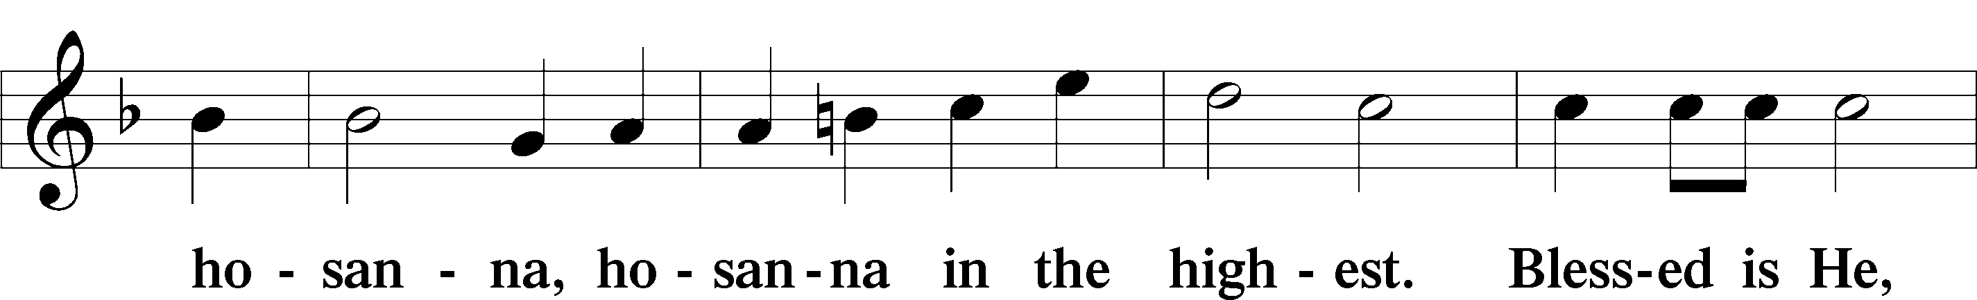

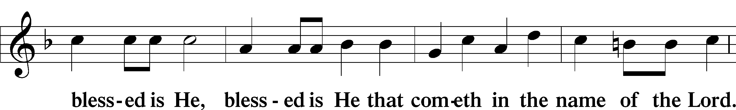

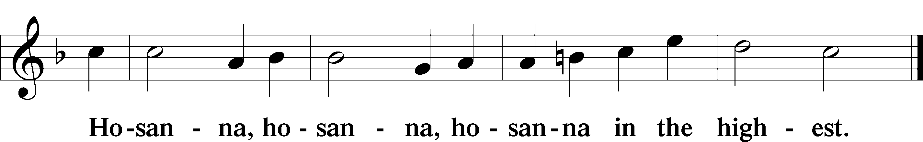

LORD’S PRAYER LSB 196

P Our Father who art in heaven,

hallowed be Thy name,

Thy kingdom come,

Thy will be done on earth as it is in heaven;

give us this day our daily bread;

and forgive us our trespasses as we forgive those who trespass against us;

and lead us not into temptation,

but deliver us from evil.

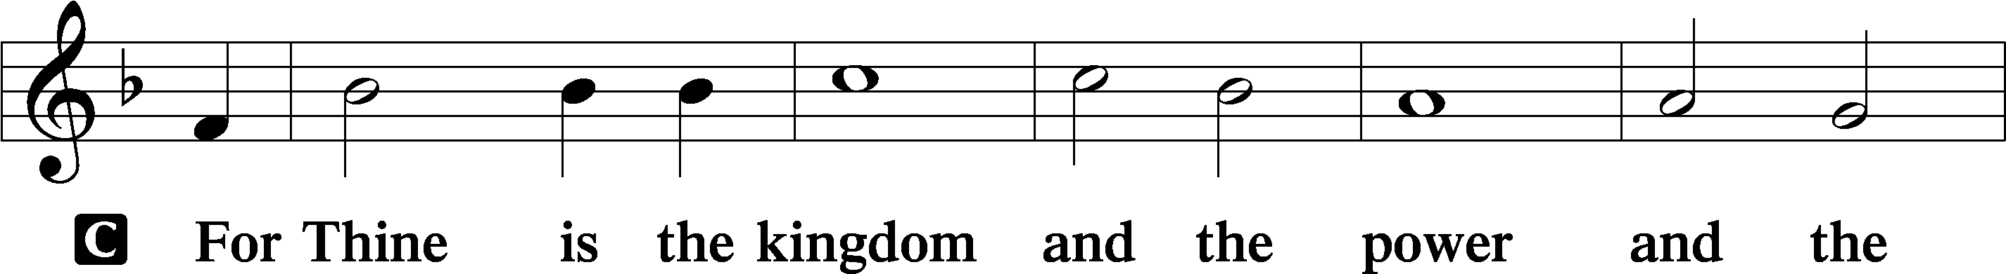

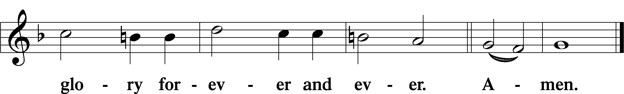

THE WORDS OF OUR LORD LSB 197

P Our Lord Jesus Christ, on the night when He was betrayed, took bread, and when He had given thanks, He broke it and gave it to the disciples and said: “Take, eat; this is My T body, which is given for you. This do in remembrance of Me.”

In the same way also He took the cup after supper, and when He had given thanks, He gave it to them, saying: “Drink of it, all of you; this cup is the new testament in My T blood, which is shed for you for the forgiveness of sins. This do, as often as you drink it, in remembrance of Me.”

PAX DOMINI LSB 197

P The peace of the Lord be with you always.

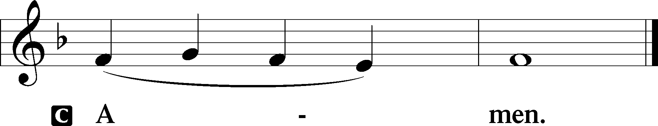

AGNUS DEI LSB 198

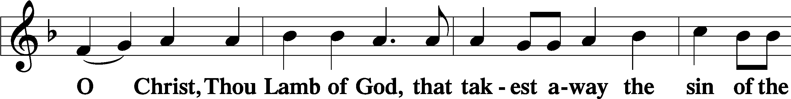

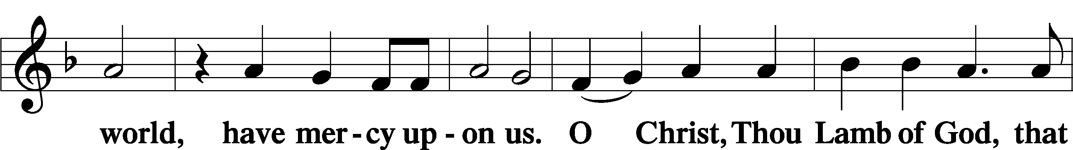

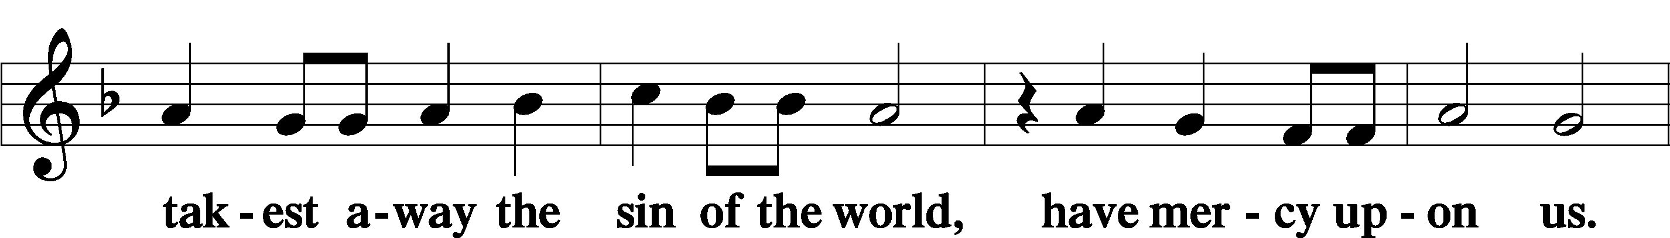

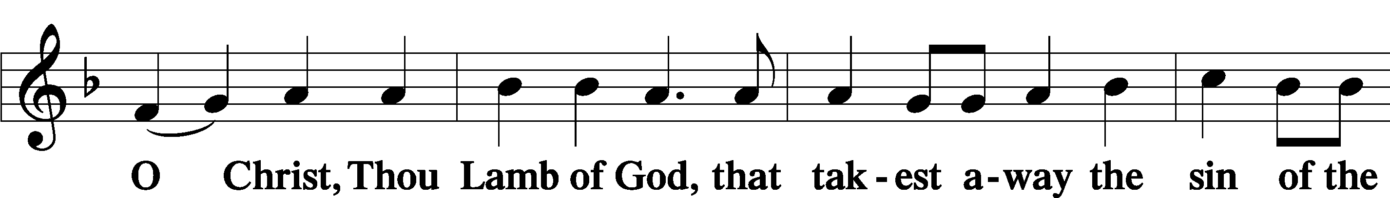

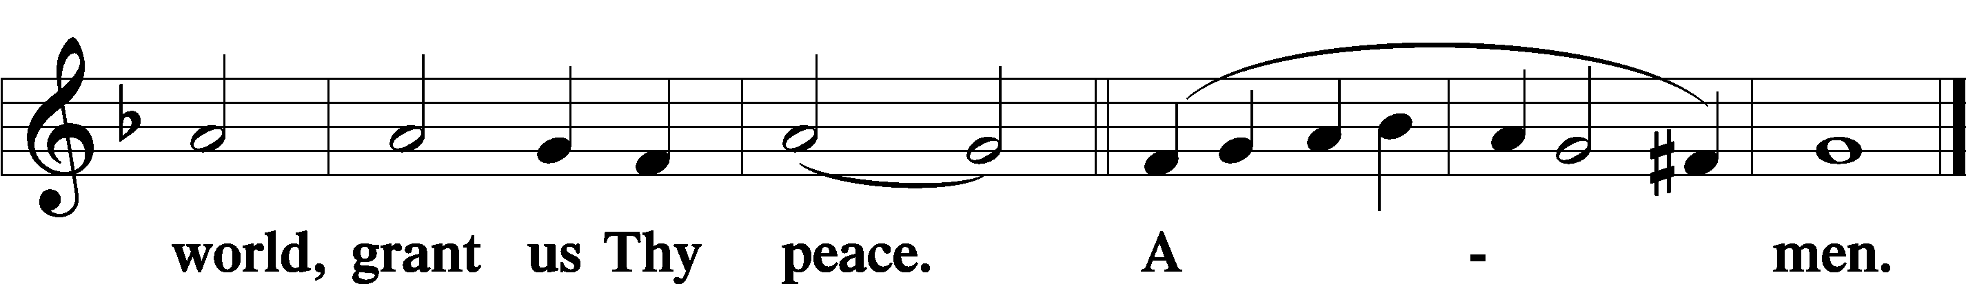

Sit

DISTRIBUTION

423 JESUS, REFUGE OF THE WEARY

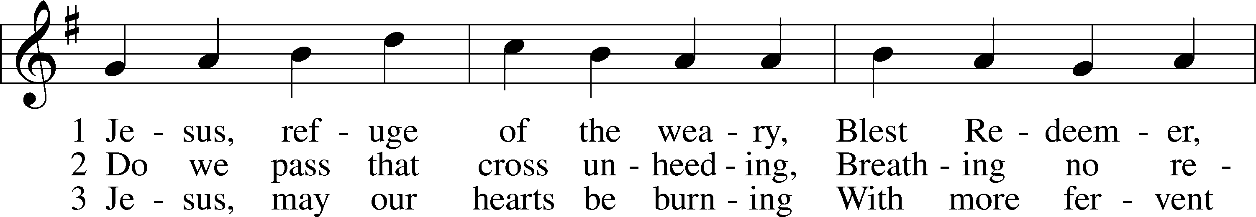

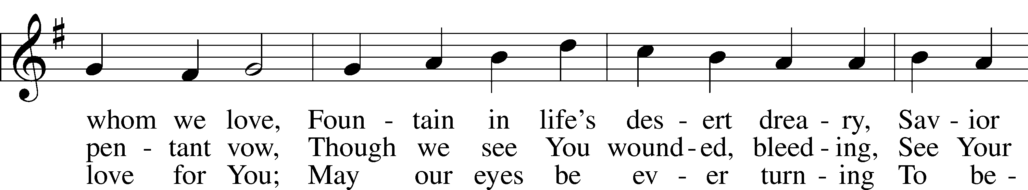

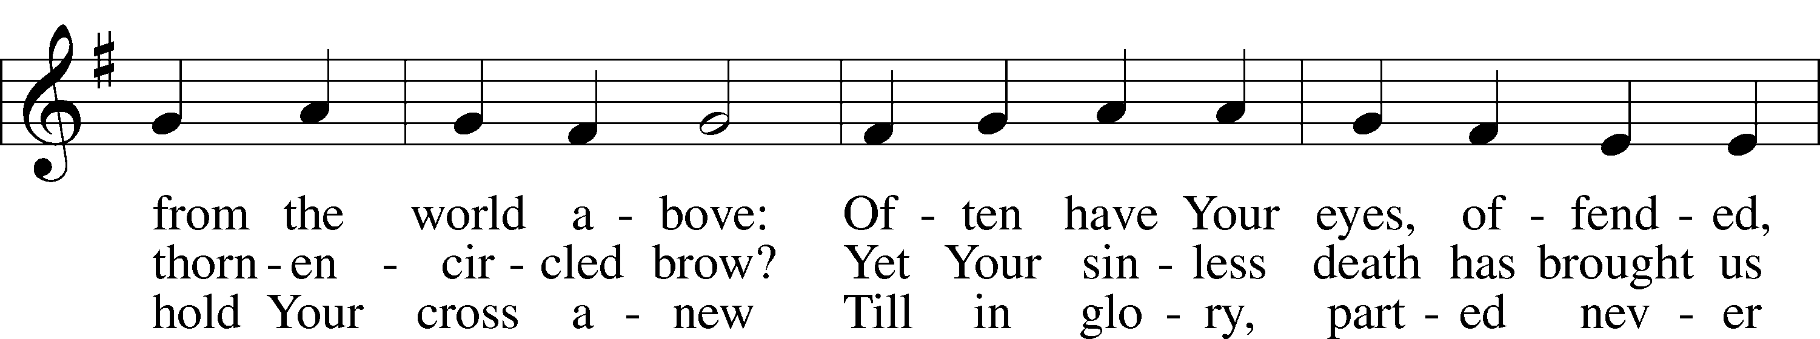

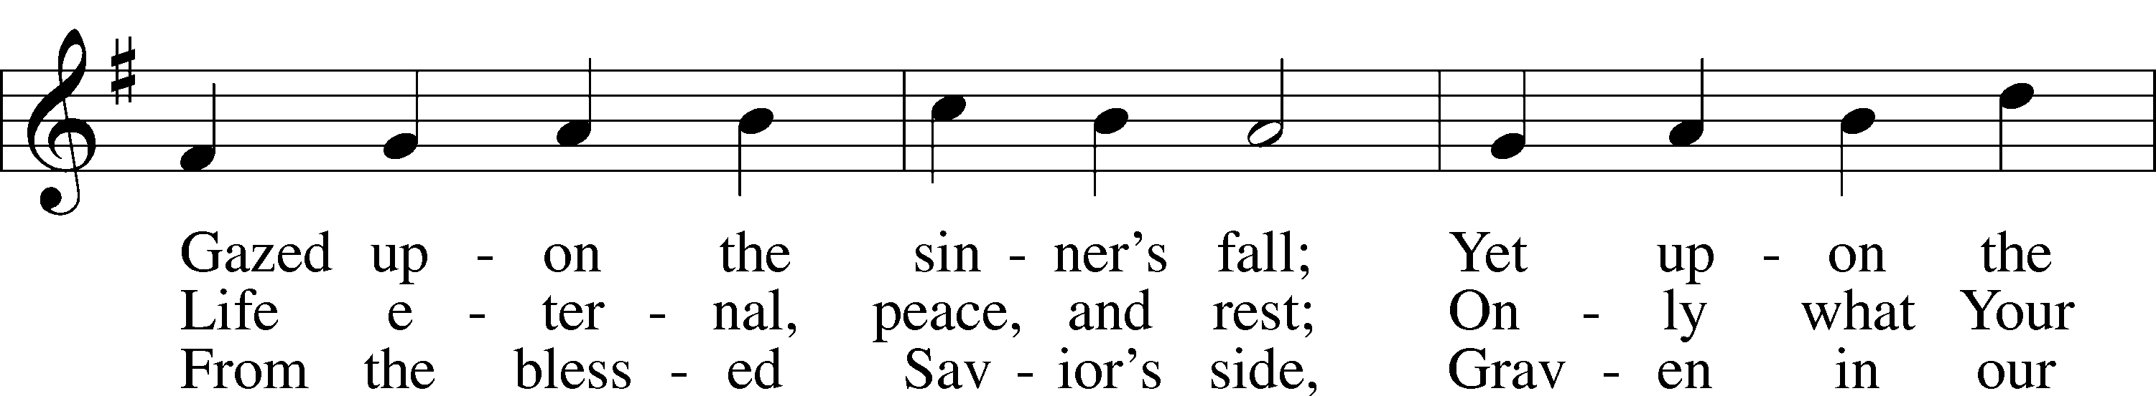

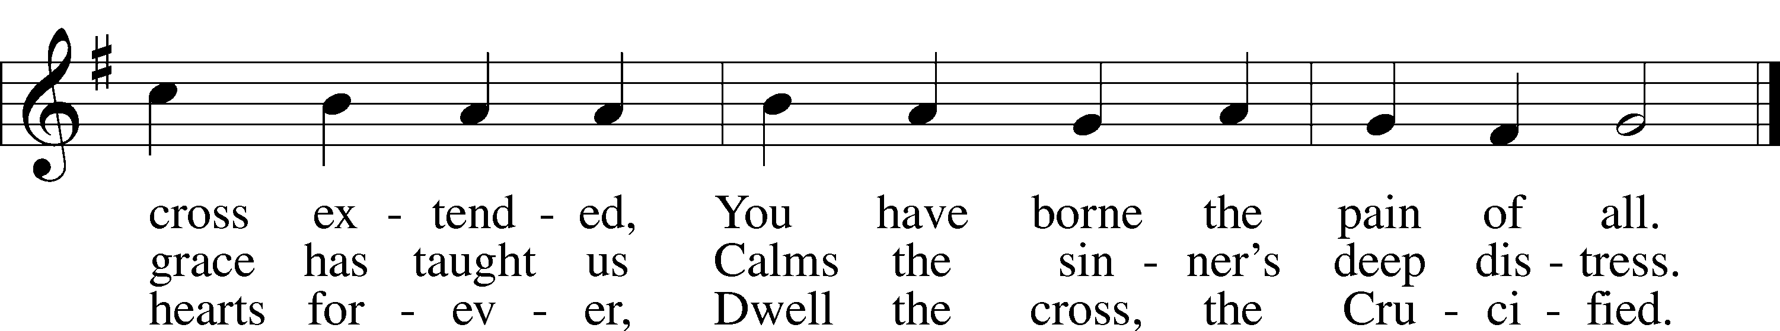

Text: Girolamo Savonarola, 1452–98; tr. Jane F. Wilde, 1826–96, alt.  
Tune: Erbaulicher Musicalischer Christen-Schatz, 1745, Basel  
Text and tune: Public domain

433 GLORY BE TO JESUS

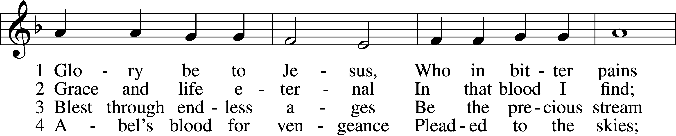

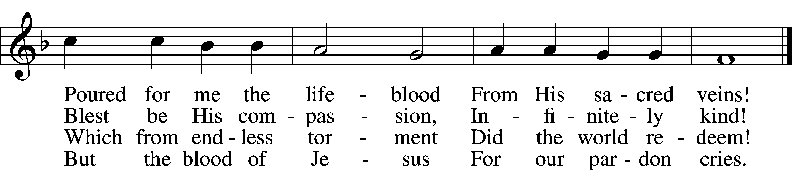

5 Oft as earth exulting  
 Wafts its praise on high,  
Angel hosts rejoicing  
 Make their glad reply.

6 Lift we, then, our voices,  
 Swell the mighty flood;  
Louder still and louder  
 Praise the precious blood!

Text: Italian, c. 18th cent.; tr. Edward Caswall, 1814–78, alt.  
Tune: Friedrich Filitz, 1804–76  
Text and tune: Public domain

756 WHY SHOULD CROSS AND TRIAL GRIEVE ME

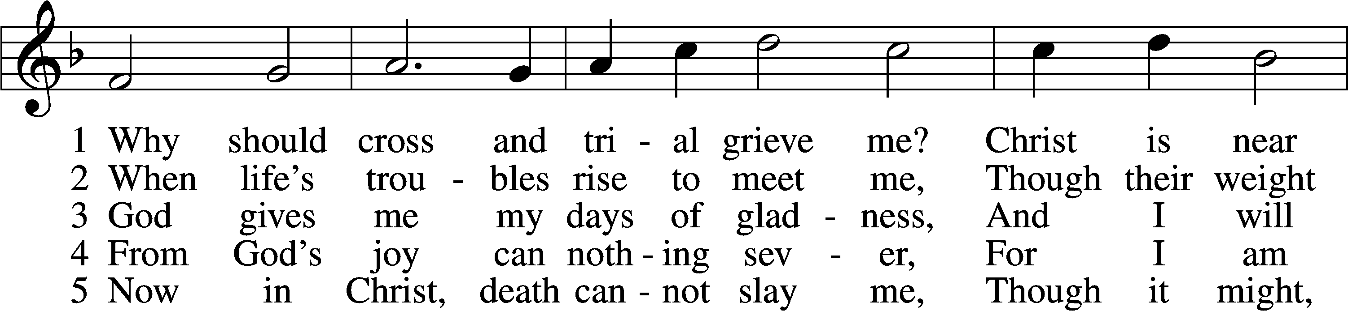

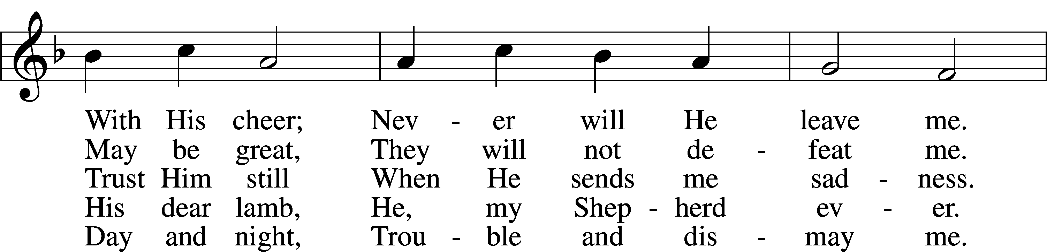

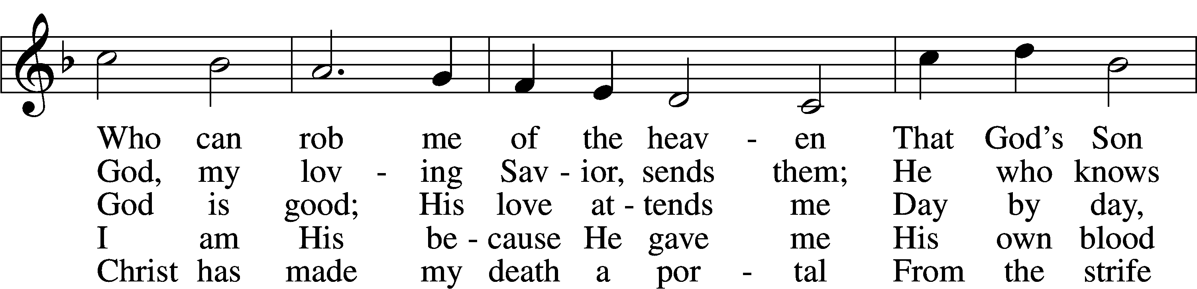

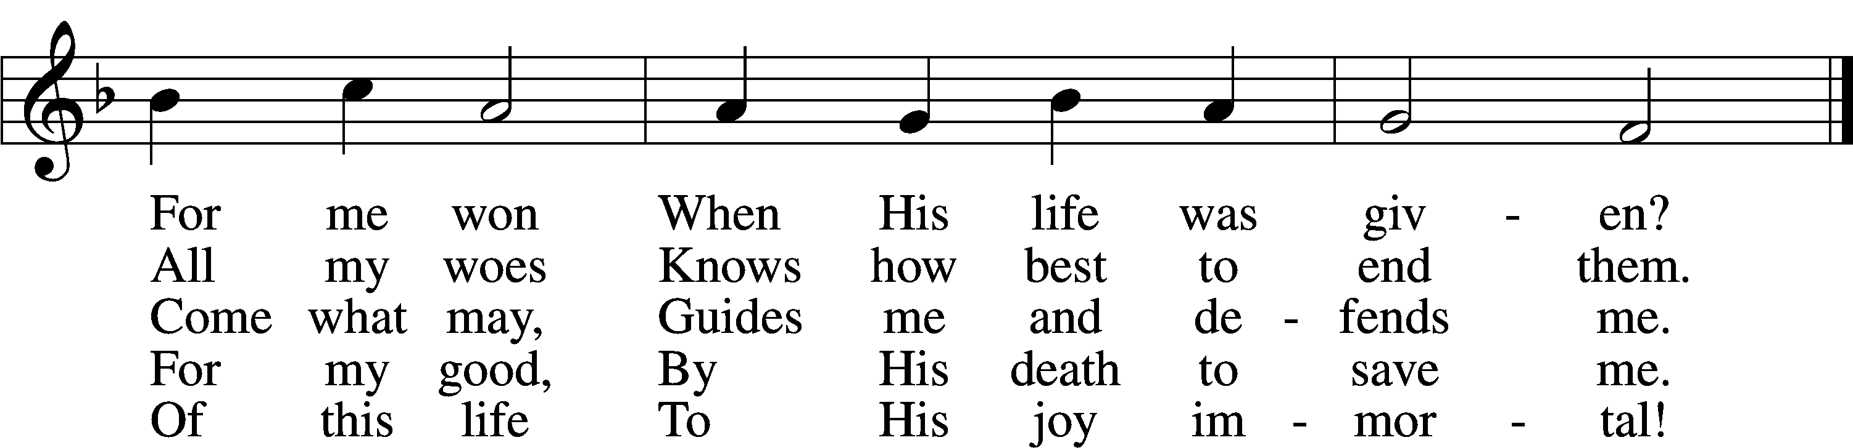

Text: Paul Gerhardt, 1607–76; (sts. 1–3): tr. Christian Worship, 1993; (sts. 4–5): tr. Stephen P. Starke, 1955  
Tune: Johann G. Ebeling, 1637–76  
Text (sts. 4–5): © 2004 Stephen P. Starke, admin. Concordia Publishing House. Used by permission: LSB Hymn License no. 110004388  
Text (sts. 1–3) and tune: Public domain

Stand

NUNC DIMITTIS LSB 199

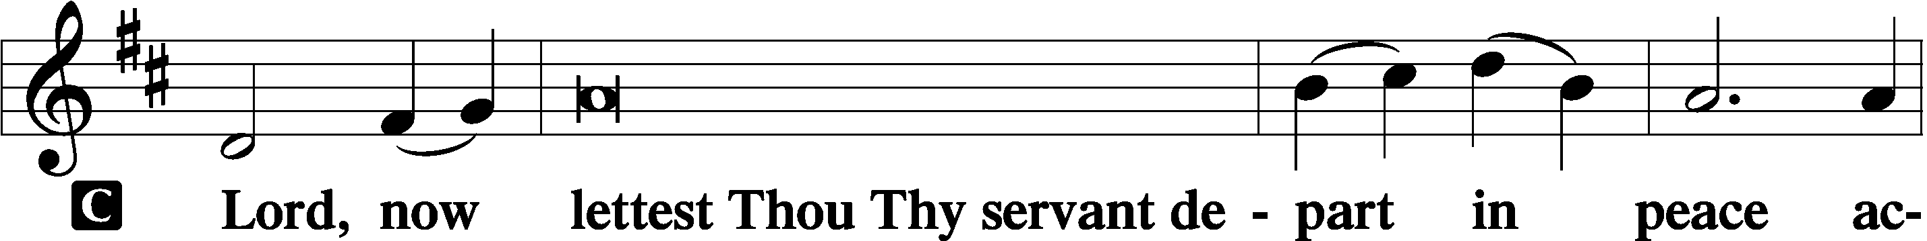

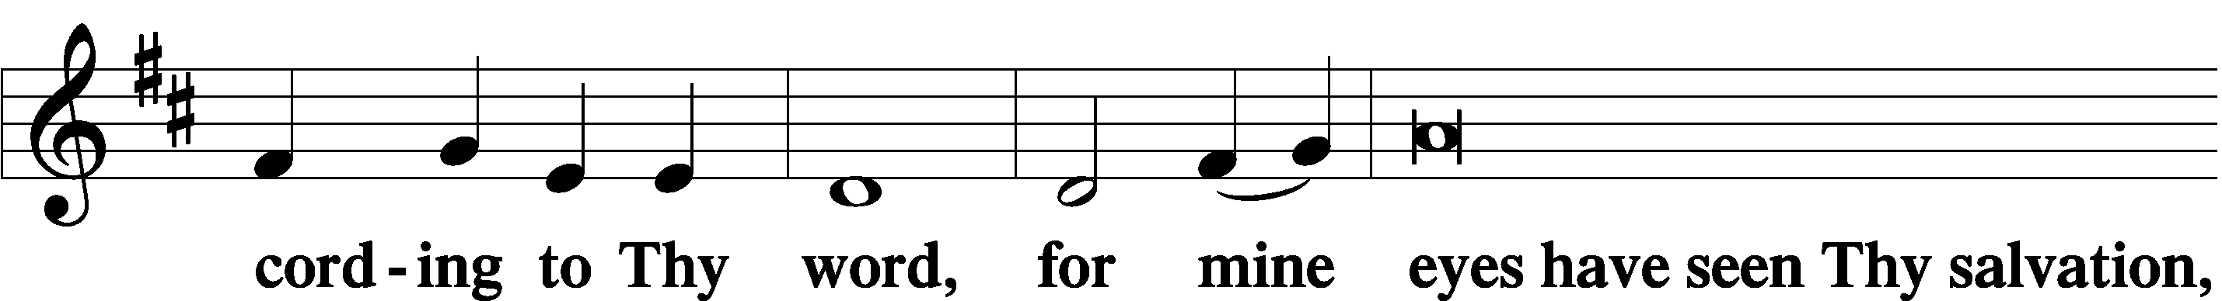

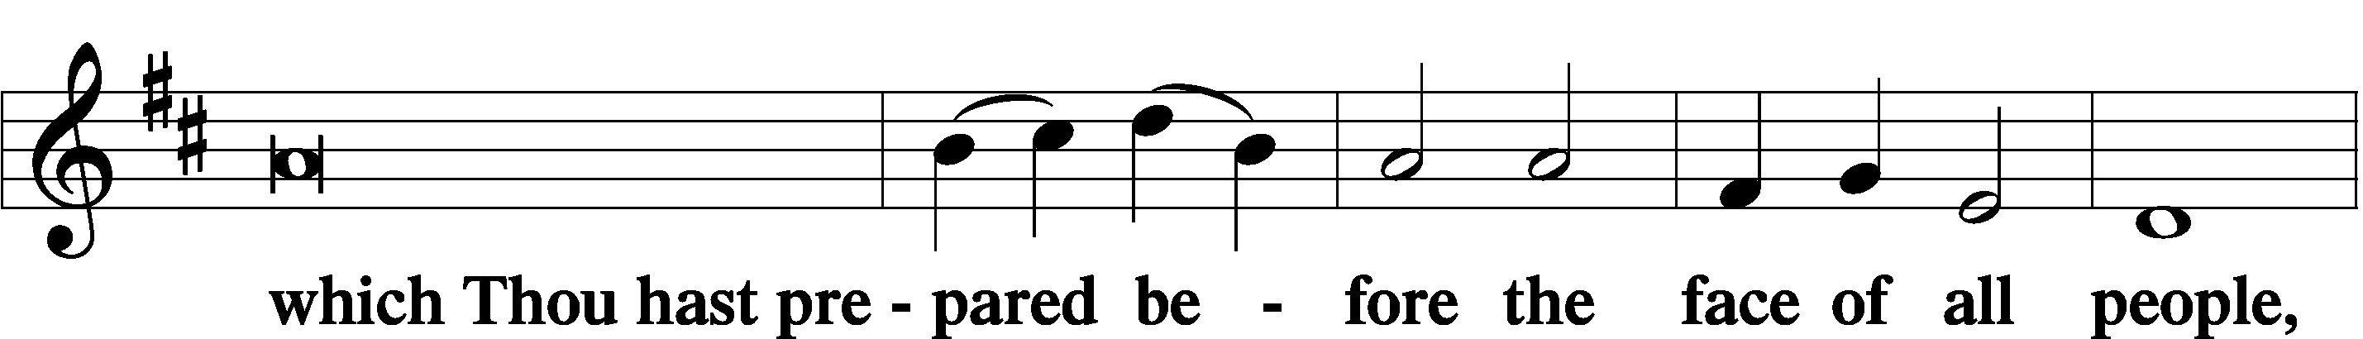

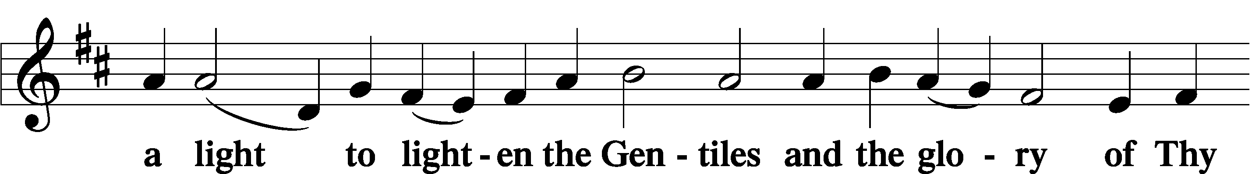

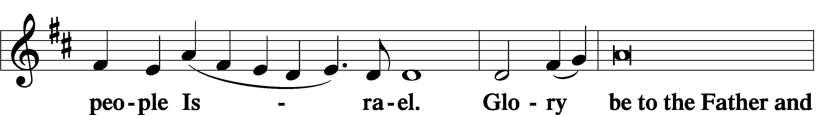

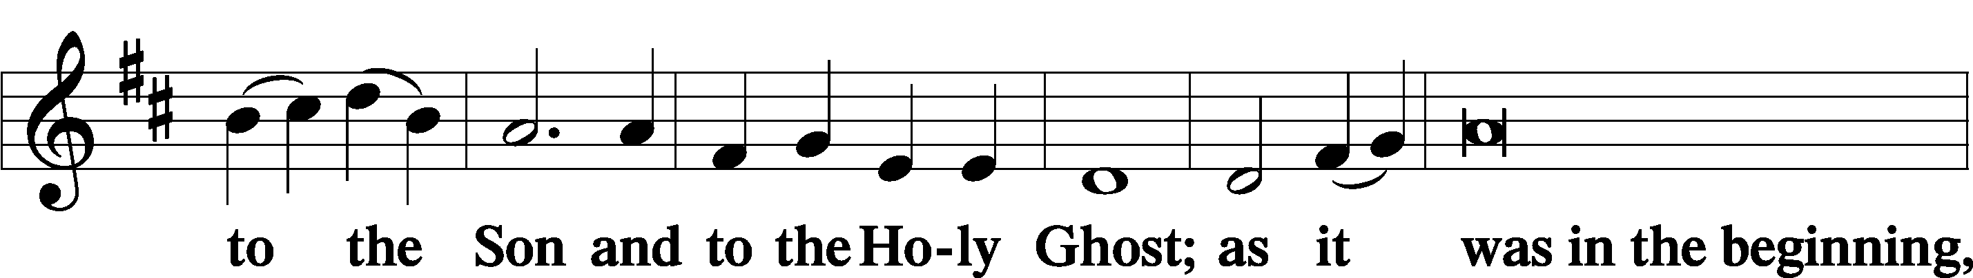

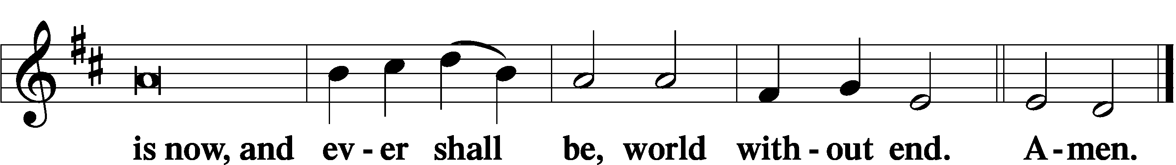

THANKSGIVING LSB 200

A O give thanks unto the Lord, for He is good,

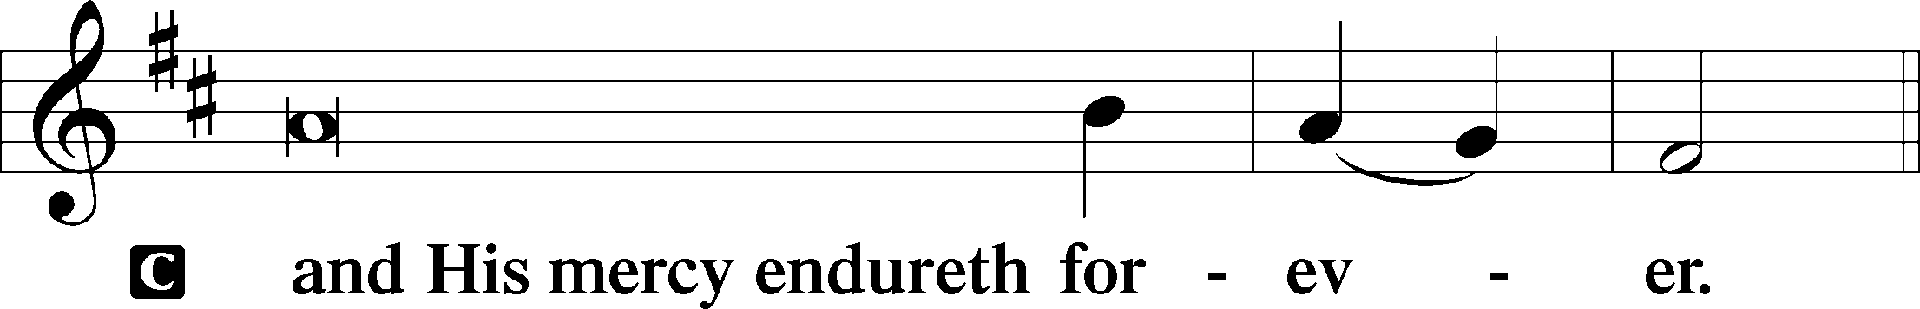

POST-COMMUNION COLLECT

A Let us pray.

We give thanks to You, almighty God, that You have refreshed us through this salutary gift, and we implore You that of Your mercy You would strengthen us through the same in faith toward You and in fervent love toward one another; through Jesus Christ, Your Son, our Lord, who lives and reigns with You and the Holy Spirit, one God, now and forever.

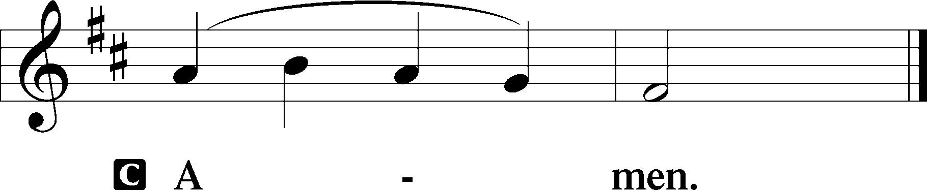

SALUTATION LSB 201

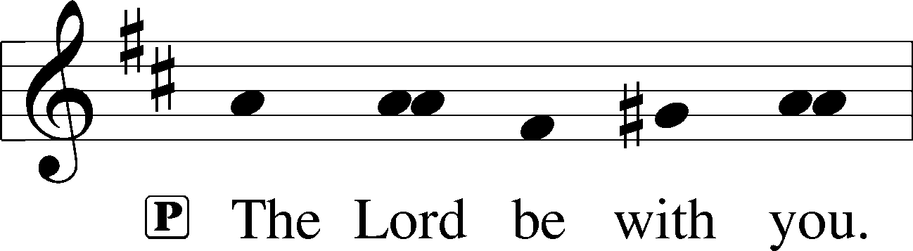

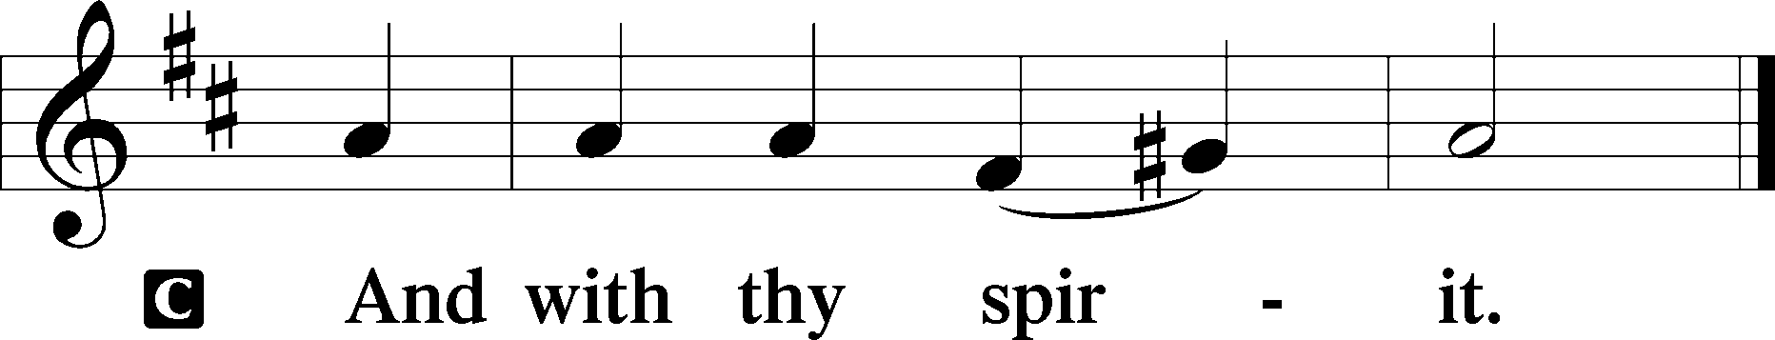

BENEDICAMUS LSB 202

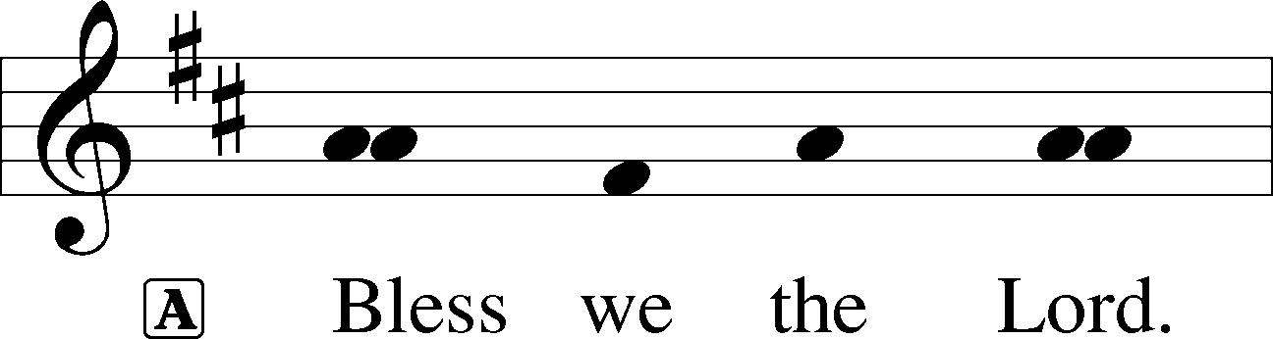

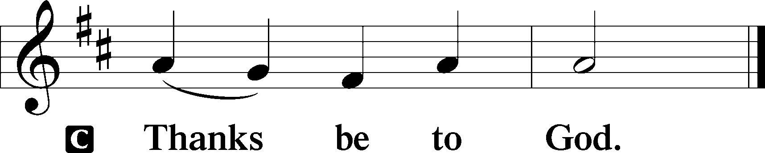

BENEDICTION LSB 202

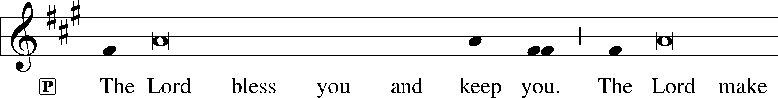

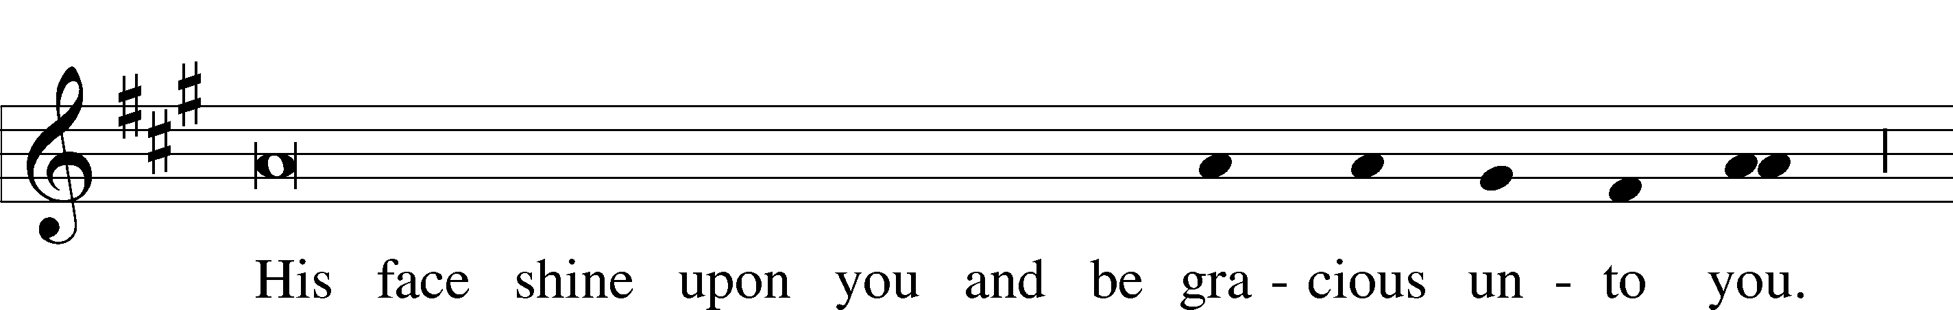

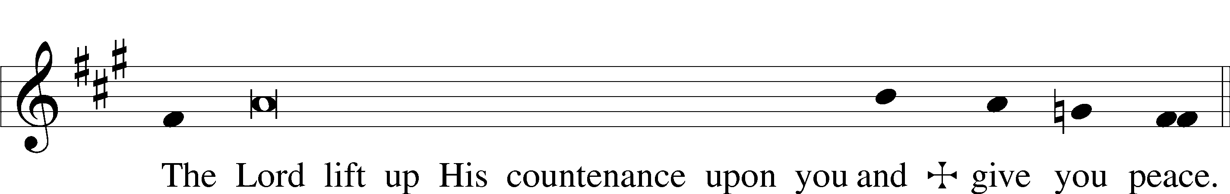

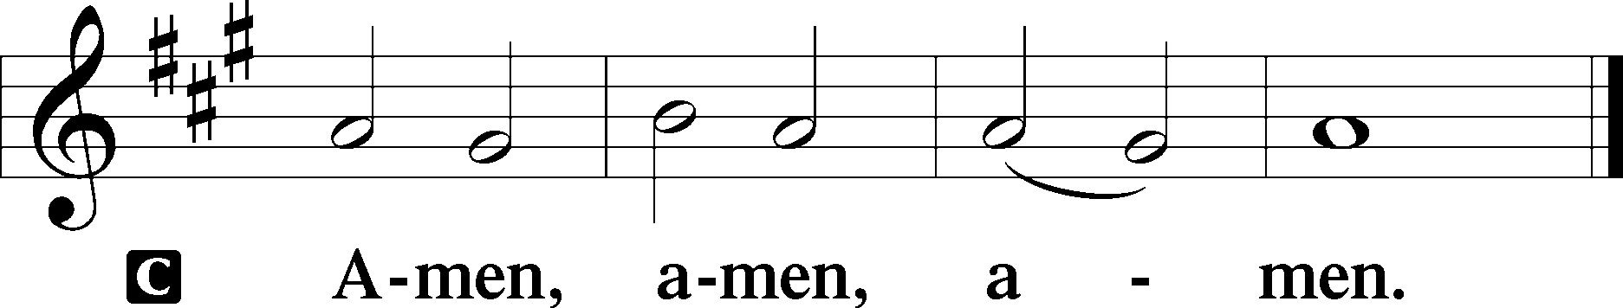

716 I WALK IN DANGER ALL THE WAY

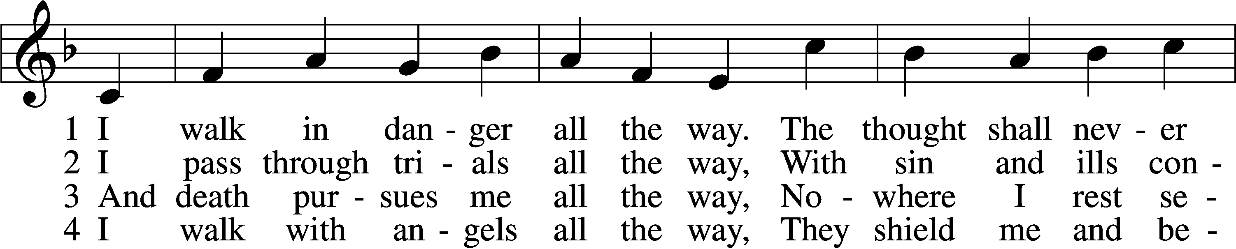

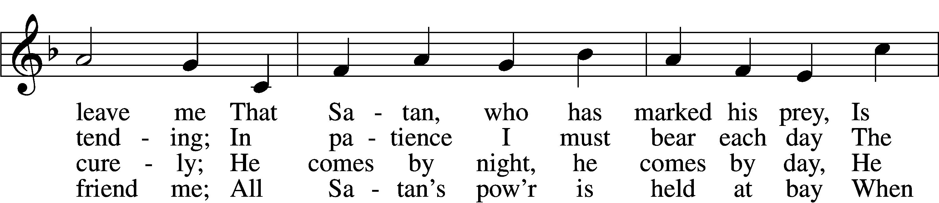

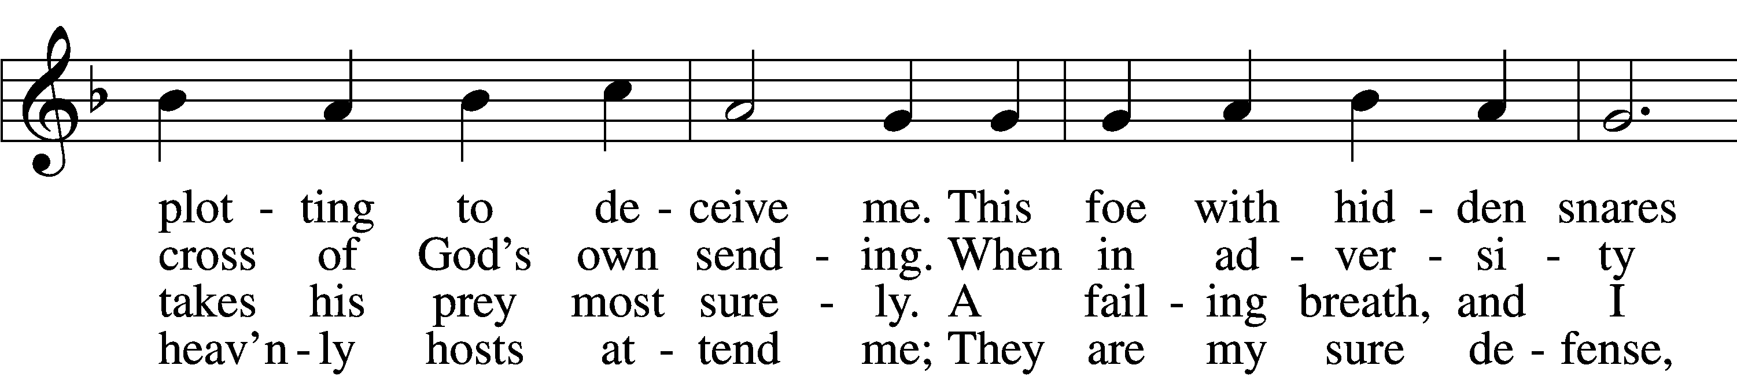

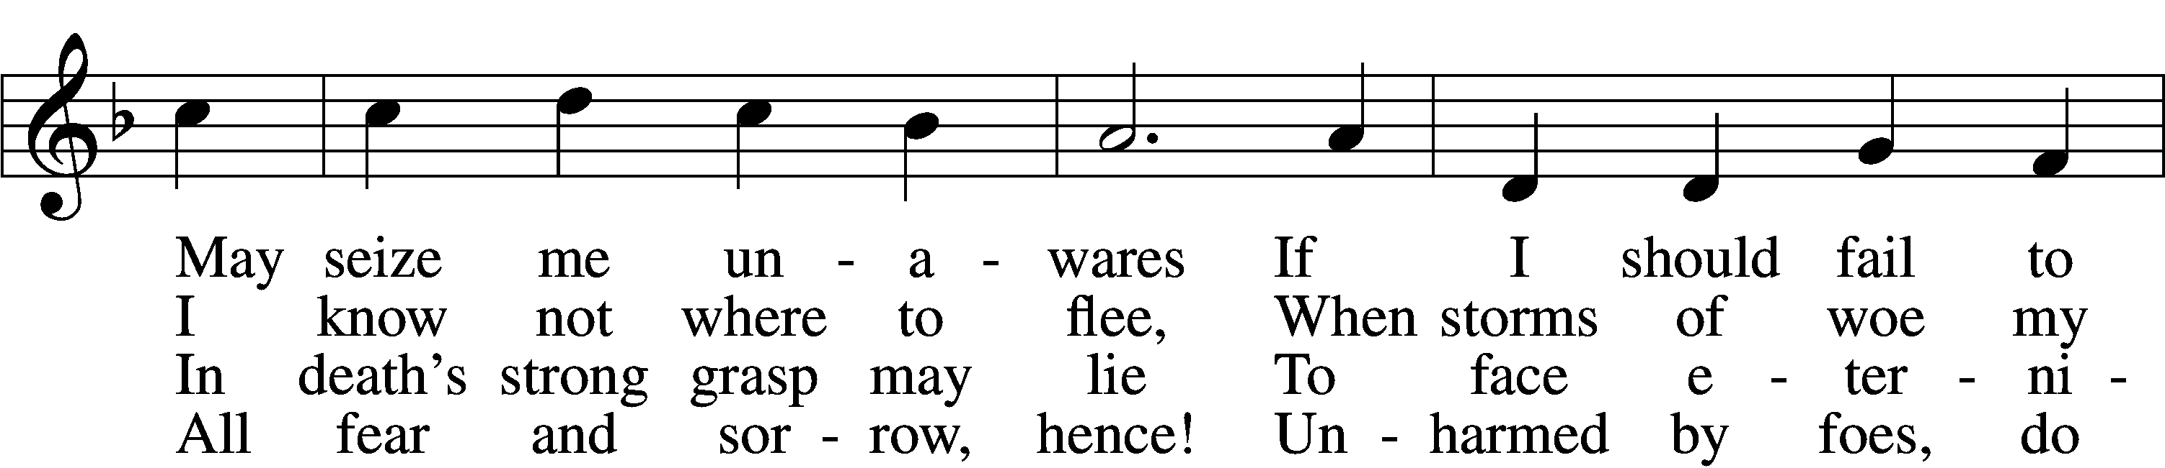

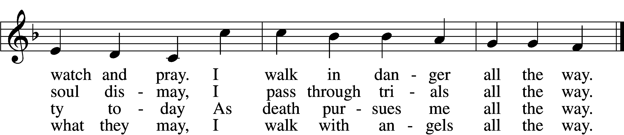

5 I walk with Jesus all the way,  
 His guidance never fails me;  
Within His wounds I find a stay  
 When Satan’s pow’r assails me;  
And by His footsteps led,  
My path I safely tread.  
 No evil leads my soul astray;  
 I walk with Jesus all the way.

6 My walk is heav’nward all the way;  
 Await, my soul, the morrow,  
When God’s good healing shall allay  
 All suff’ring, sin, and sorrow.  
Then, worldly pomp, begone!  
To heav’n I now press on.  
 For all the world I would not stay;  
 My walk is heav’nward all the way.

Text: Hans Adolf Brorson, 1694–1764; tr. Ditlef G. Ristad, 1863–1938, alt. Tune: Geist-reiches Gesang-Buch, 1708, 4th ed., Halle, ed. Johann A. Freylinghausen Text and tune: Public domain



Acknowledgments

Divine Service, Setting Three from Lutheran Service Book

Unless otherwise indicated, Scripture quotations are from the ESV® Bible (The Holy Bible, English Standard Version®), copyright © 2001 by Crossway, a publishing ministry of Good News Publishers. Used by permission. All rights reserved.

Created by Lutheran Service Builder © 2025 Concordia Publishing House.

**Lent Midweek Services**

Wednesdays in Lent T 7 pm

Meal T 5:45-6:30pm

**“The Lord’s Prayer”**

Ash Wednesday: *“Our Father Who Art In Heaven”*

Midweek 1: *“Hallowed Be Thy Name”*

Midweek 2: *“Thy Kingdom Come”*

Midweek 3: *“Thy Will Be Done…”*

Midweek 4: *“Give Us This Day Our Daily Bread”*

Midweek 5: *“And Forgive Us Our Trespasses…”*

Maundy Thursday: *“And Lead Us Not Into Temptation”*

Good Friday: *“But Deliver Us From Evil”*

Easter Sunday: *“For Thine Is The Kingdom, And The Power, And The Glory, Forever And Ever. Amen.”*

*“The Lord’s Prayer, because it arises from the Lord, is without question the highest, noblest and best. For if He had known a better, the holy faithful school-master that He was, He would have taught us that also. There is on earth no nobler prayer to be found, it is the highest under the sun. It is a wall and bulwark of the Church, a strong weapon for all godly Christians, a prayer above all prayers.” (Martin Luther)*